C
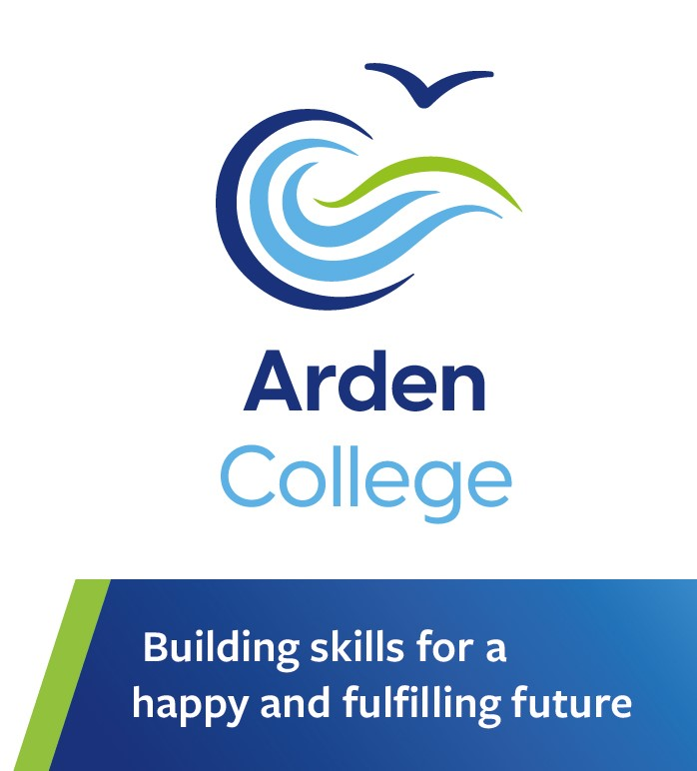
Curriculum Booklet
2025-2026

Contents

The Overarching Curriculum 3
Curriculum Intent 5
Intent: Agreeing the Destination 6
Intent: Long term Planning 8
Intent: Medium term Planning 9
Implementing the Curriculum 10
Impact 16

The Arden College Overarching Curriculum has been designed to ensure a broad, balanced and progressive learning experience for all students regardless of age, ability or any barriers to learning they may face. All students have a bespoke and individual curriculum designed on entry to the college and the Arden College Overarching Curriculum is flexible in its design to facilitate this. The curriculum supports the holistic development of students and prepares them to live their best future beyond Arden College.

The Overarching Curriculum
Overarching Curriculum 2024-25
 | RARPA | Accredited
Targeted Learning | Literacy  Numeracy  SMSC  Employability skills  Independence  Health  Community  Emotional Regulation  Communication  Skills development | English  Mathematics  Digital Skills  Employability skills  Occupational Studies  Vocational qualifications  Online Qualifications  Duke of Edinburgh
Assessment Tools | Teacher Assessment  Skills Builder Assessment Tool  Inner Circle Assessment Tool  AQA Unit Awards  SaLT Assessments  OT Assessments | NCFE exams/coursework  Online Qualifications  External assessment e.g. First aid, climbing instructor qualification  E- Duke of Edinburgh
Impact Tools | Databridge  Arden Awards  Skills Builder Certificates  AQA Certificates  Inner Circle Summary | Qualifications gained  Certificates
Arden College Core Values
The Arden College Core Values permeate everything we do and underpin the planned and incidental experiences afforded to our students.
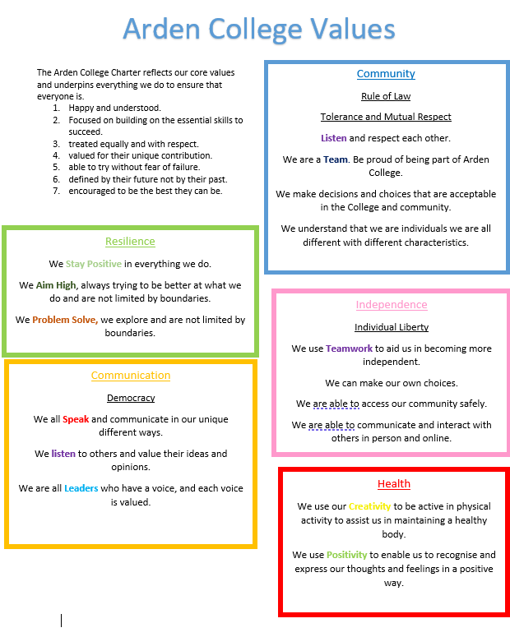
We believe our students have a right to belong; to be established in a community, to develop resilience, to communicate effectively, to be healthy and to develop independence now and for the future. Our college values link closely to the British Values of modern society. Arden College students focus on building their essential skills to succeed.
Each student has a bespoke curriculum designed by and for them. Their learning is based on the specific strengths, interests and areas for development which will have the greatest impact on their adult life. All students at Arden have a curriculum that is destination focused.

Curriculum Intent
Arden College is structured by phases. Phases relate to the identification of a student’s ability to regulate within social situations, their resilience and application of executive functioning.

Phase 1 – Students have autism, complex learning and communication needs and sensory processing difficulties, which make aspects of everyday life challenging for them. Most students have no, or very limited, verbal communication. Students require mutual support to manage their sensory and emotional regulation so they can engage in learning opportunities. Some students require support to manage their personal care. A high proportion of students present with physical aggression when dysregulated and require high levels of support to stay safe. They are likely to need significant levels of support and intervention in the future to maintain a safe and fulfilled adult life. Students’ academic attainment is at pre-entry or entry level and all students have previously been educated in maintained or independent special schools.

Phase 2 - Each student has a diagnosis of Autism and severe learning difficulties with a range of co-morbid conditions which also impact on learning and development. All students have receptive and expressive language difficulties and impaired social communication which makes developing and maintaining peer relationships very difficult. Students in Phase 2 need high levels of support to manage their sensory and emotional regulation. Many students struggle to tolerate the sensory behaviours of others in the phase with some unable to engage in any activities with peers. Students in Phase 2 have previously been educated in maintained or independent special schools and have often previously had failed placements. Most students are working within entry level.

Phase 3 – Students in Phase 3 have autism and typically work at Entry level 3 to Level 2 academic abilities but most students have attained significantly below their academic capability. Most students have typical receptive and expressive language skills but significantly impaired social communication skills. Most students have additional mental illness or poor mental health including generalised anxiety disorder, a trauma based or demand avoidant profile. Typically, students lack resilience and have poor self-esteem and confidence. Most students have had at least one failed educational placement and many are not in employment, education or training for extensive periods before coming to Arden. Phase 3 supports at least the first year of students’ placement at Arden and focusses on offering the nurture they need to develop confidence, resilience and a belief in themselves so they can set and achieve ambitious life goals.

Phase 4 – Students progress from Phase 3 to 4 at the end of their first year if they feel ready to do so. The code of conduct for Phase 4 acts as a clear benchmark of the expectations upon students so they can make an informed choice about their readiness to progress to the phase. Students progress to Phase 4 (or enter directly if appropriate) when they have developed greater competence in emotional regulation strategies, social confidence, resilience and executive functioning skills. There is a greater emphasis on students engaging in accredited learning and/or employment skills.

Intent: Agreeing the Destination

The design of each student’s individual curriculum begins with identifying an appropriate destination. The most aspirational destination within the student’s potential is agreed with Local Authority (High Needs Funding Application), families and the student if possible. This forms the intent of the individualised curriculum and planning then begins to create an appropriate curriculum implementation for that student based on the overarching curriculum offer.
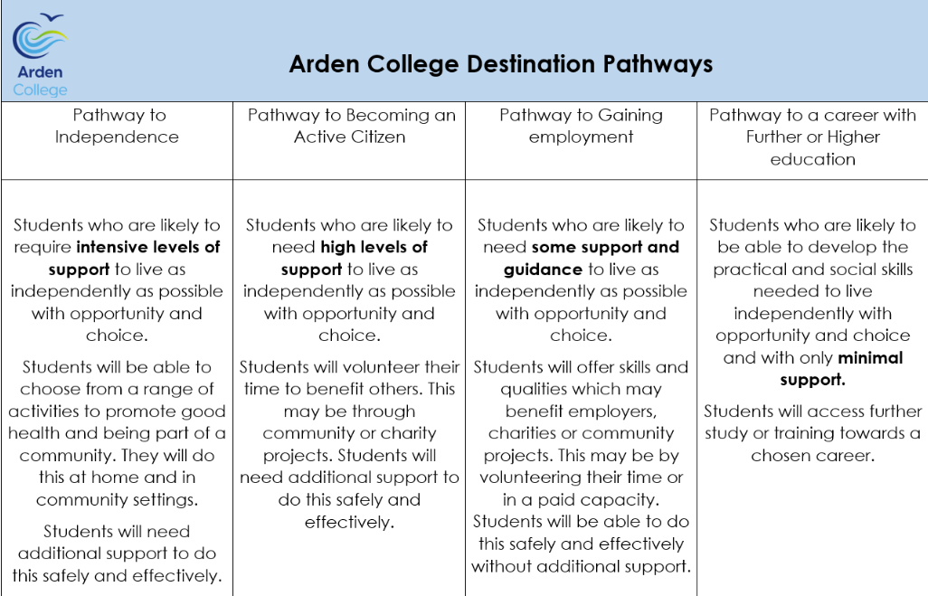

Intent: Long term Planning

Person Centred Planning (PCP)
Our curriculum is person centered and focusses on development of the four areas of the Preparing for Adulthood agenda plus two core aspects of impairment in autism; Communication and Emotional Regulation.
Prior to the start of the placement at Arden, and annually thereafter, students and their families are given the opportunity to collaborate in the planning of the student’s curriculum. The Person Centred Plan (PCP) includes long term, destination focused targets in six areas:- Developing Independence; Being healthy; Developing Employment skills and making a positive contribution to society; Being part of a community and having positive relationships; Developing communication skills; Developing emotional regulation skills.
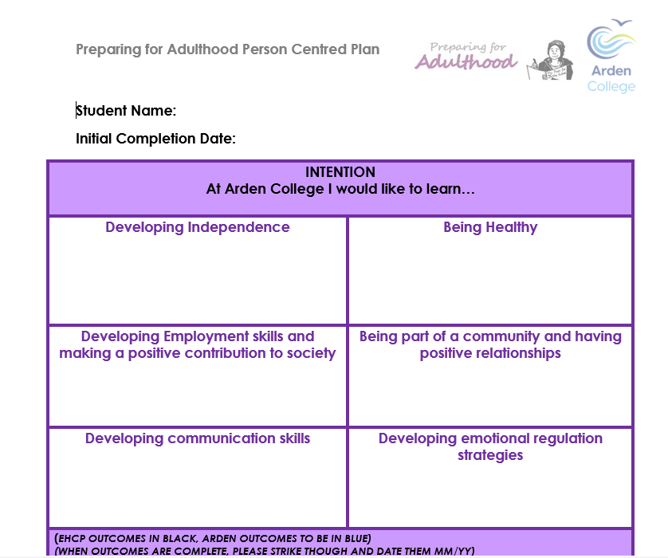

Intent: Medium term Planning

Individual Learner Journey (ILJ)
Once the PCP is agreed, and long-term targets set, medium term targets are planned in each of the six areas. This is known as the Individual learner journey (ILJ). Targets are usually designed to be achieved within one term but are reviewed more frequently and amended or new targets set if achieved.
Activities and Session are the planned using the Activity Planner (see below) with the targets in mind and this then forms an individual timetable for the student.
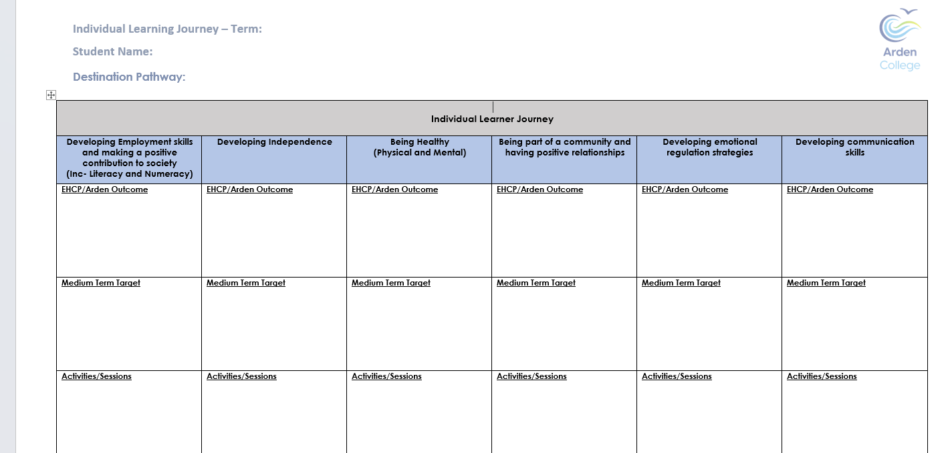

Implementing the Curriculum

Activity Planner
We know that students engage most readily and learn most effectively when they enjoy what they do, feel happy, calm and safe. The Activity Planner offers students a suite of over 130 activities to choose from as a starting point and they are encouraged to identify whether they definitely do want to include an activity in their timetable, definitely don’t or may like to try it. This encourages students to have autonomy of their own learning and to try things they may not have previously experienced. The range of activities includes:- sport and exercise; art, craft & design; independence skills; performing arts; computing and digital media; special interests; relaxation; sensory activities and work experience opportunities.
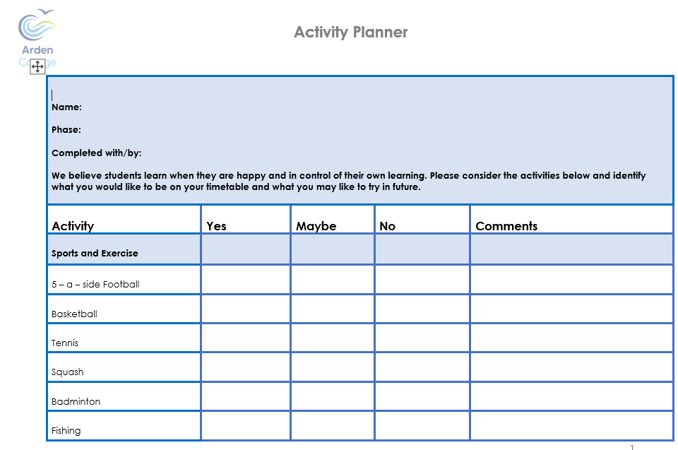

The Access to Learning Circles
The blue circle identifies the core impairments in autism, and the potential intrinsic barriers to learning, our students experience. Typically developing young people often gain competence in these areas through the natural course of maturation, through trial and error or by generalising knowledge and skills. As these areas of development are impaired in autism, targeted intervention is often required so students can gain the knowledge and skills to their greatest potential.
The yellow circle includes the transactional support, therapies, and interventions we use to support the implementation of an effective curriculum. Transactional supports (yellow) can facilitate the development of the inner circle (blue) and the development of the outer circle (green).
The green circle forms the areas of learning and development available to our students. With the right support in the blue and yellow zones, students should be able to access a wider range of options in the green zone enabling a broad and balanced curriculum.
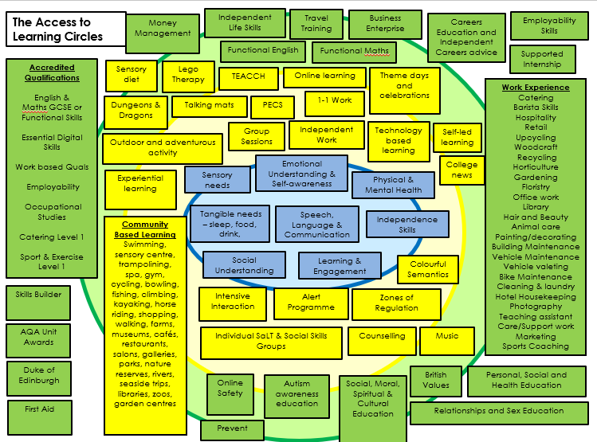

Accredited
Arden based Accredited Qualifications
Students have the option to pursue accredited qualifications including Functional Skills English and Mathematics, Digital skills, Catering, Employability Skills, Occupational Studies and Vocational Qualifications. We are also registered as a Duke of Edinburgh site and can support students to achieve up to the Gold Award. Our examination board is NCFE.
External Awards/Supported Qualifications
At Arden College we offer online learning courses on an individual basis, these courses are accessed online with monitoring and support from Arden tutors. The courses are accredited via the awarding body. Examples of courses taken are the CPD Certification Service ‘Animal Care Award’ Level 2 and ‘Customer Service Skills’ Level 2 Award.
We also offer support for students to access externally accredited courses to support their vocational destinations eg. First Aid, Indoor Climbing Wall Instructor, Paddleboard Instructor.
Duke of Edinburgh Awards
Duke of Edinburgh Awards is an established scheme which is available to everyone, aged 14 to 24 regardless of ability. It can be adapted to meet the needs of young people with a disability which means it can give an opportunity for all students to achieve an accredited award.
The Duke of Edinburgh framework can also be used as a conduit for the development of other targets in the student’s curriculum plan.
Arden College can support students to achieve the D of E programme at three levels:
- Bronze
- Silver
- Gold
The programme covers four distinct areas:- Volunteering, Physical activity, Developing a new skill and Completing an Expedition.
Each student has an online profile on E- D of E where evidence can be uploaded within each section.
RARPA Curriculum
AQA Unit Awards
The Unit Award Scheme (UAS) is a unique Record of achievement scheme, rather than an accredited qualification. The Unit Award Scheme is a unique way to record learner achievement. Its ‘can do’ approach is used to boost student confidence, engagement and motivation. It offers learners the opportunity to have their achievements formally recognised with a certificate each time a short unit of learning is successfully completed. In each unit there is a set of objectives that need to be achieved which can link in with the student’s individual curriculum targets. Unit Awards can be achieved at Pre-entry, Entry level and Levels 1, 2 and 3.
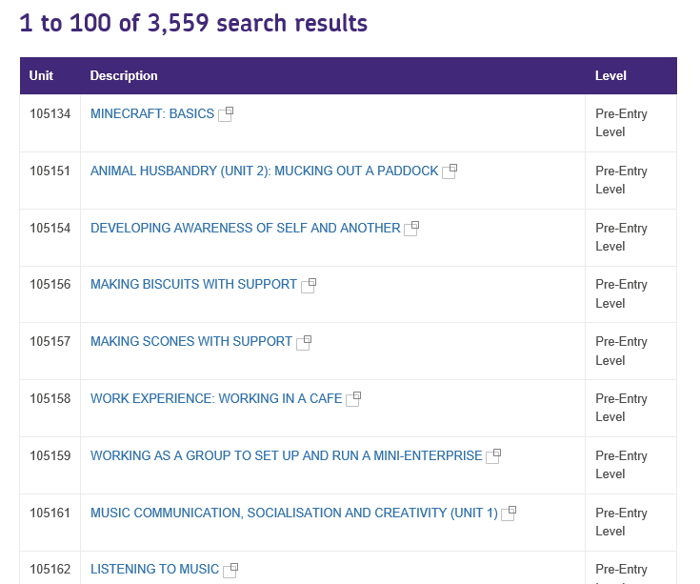

Communication and Social Skills
Students benefit from the support of a Speech and Language Therapist and a Communication Assistant. All students benefit from the Universal offer of the college which ensures a communication supportive environment.
Some students benefit from targeted interventions and this may be to develop language and communication skills through activities and groups.
A few students benefit from individual programmes of direct speech, language and communication work which is planned, delivered and assessed by the therapist
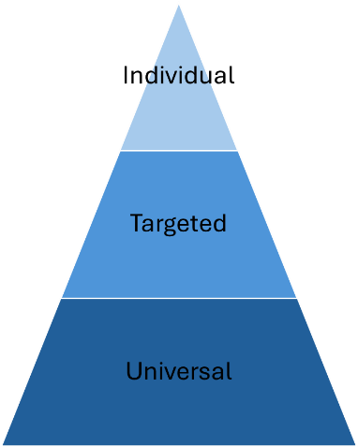
Occupational Therapy
The Occupational Therapist may work directly with a student to assess their needs and devise a programme of study to support development of specific targets. This is often within the ‘developing independence’, ‘promoting health’ or ‘developing emotional regulation’ areas of the curriculum.
SMSC
An Annual calendar of events is embedded throughout the college. This ensures the systematic coverage of a wide range of social, cultural, moral and spiritual events and practices are included in students’ learning experiences. SMSC events are celebrated by each phase and differentiated in ways the students can access them most effectively.
Relationships and Sex Education
Families and students (where possible) are asked when developing the PCP if they have been taught aspects of RSE and whether there are any areas of RSE they would like to include in the targeted learning for the student. Aspects of RSE are taught as necessary in the most effective way on an individual basis for each student. This may include social coaching for students navigating early friendships and relationships, supporting appropriate behaviours, understanding consent and teaching the concept of public and private etc. The Inner Circle Assessment Tool considers aspects of RSE.
Online Safety
Online safety is of paramount importance for our students who are particularly vulnerable due to their social naivety. Their impaired Theory of Mind can mean they often take social experiences at face value making them vulnerable to online manipulation for any number of reasons. Families and students (where possible) are asked when developing the PCP if they have been taught aspects of online safety and whether there are any areas of online safety they would like to include in the targeted learning for the student. Individual targets are set for students as appropriate and programmes of study are developed accordingly. Internet safety Week features in the SMSC calendar to ensure a college wide focus each year.
Online safety is an essential aspect of the Essential Digital Skills qualification.
Careers Education
Everyone at Arden College is fully committed to our statutory and moral obligation to provide a holistic careers service for students, highlighting the vocational and academic routes to their preferred career path. When it is deemed appropriate, students are given an opportunity to engage in internal and external Work Placements so they can develop the skills required for potential employment in the future. Our aim is to ensure that students are inspired and motivated and prepared for adulthood life, ensuring high aspirations for all.
Skills Development
All students’ individual curriculum planning, considers the skills they need to develop alongside the knowledge they gain. The SkillsBuilder areas of Listening, Speaking, Problem Solving, Creativity, Staying Positive, Aiming High, Leadership and Teamwork are embedded in the College Core Values and planning across Phase 3 and 4. Students know and understand how sessions develop their skills. Progress is assessed using the SkillsBuilder Framework, Inner circle assessment tool and by way of the ILJ review.

Impact

Person Centred assessment
Within the first half term of joining college, tutors complete a baseline assessment which provides a starting point of student attainment.

Students are continually assessed using formative and summative assessments against their planned targets through individual activities, group activities, examinations/coursework, therapy assessments, quizzes, BKSB (English and Maths), observations, tutorials and other completed work.

Students often achieve outside of the targeted learning and these achievements are recorded through Skills Builder, The Inner Circle Assessment tool or recorded as observations on Databridge.

We plan our lessons with clear learning intentions. These show progression throughout the year and across all groups and link to targets set out in students EHCPs. We strive to ensure that all tasks set are appropriate to each student’s current level of attainment.
Recording Methods
Assessment against targets is captured by Tutors, Therapists, TAs, parents, residential staff and students. Assessment can be evidenced in a range of ways including completed ‘work’, completed tasks eg. Preparing meal in catering, test/exam, photo or video evidence, witness statement eg. TA, Parent, Work placement supervisor or by self-assessment report. All assessment is recorded on target sheets and summary evidence is entered onto Databridge as evidence towards achieving medium term targets which inform progress towards long term targets of the EHCP.
Monitoring Progress
Students’ progress is closely monitored so that we can provide the best possible opportunities and highest levels of support for all students. Regular meetings are held with Phase teams during the year to discuss the progress of all students by referring to tutor knowledge and by looking at progress data. Points for action are made, and specific areas of support are identified. These meetings are integral to the students making the progress that is in line with their end destination.
Reporting
All students receive a termly report which summarises progress made towards the targets set in the previous term and identifies targets for the next term. Parents can then consult regarding the targets and can support the development and generalisation of them at home.
The annual review of the EHCP gives opportunity for the review of long term targets so all stakeholders can see the progress being made within the programme of study and towards the agreed destination.

