Aspris College North Wales

Local Procedure Title | Complaints
Service | Aspris College North Wales
ACS Policy number and title | A0P03
Local Procedure template reference | ACS LP: 31
Local Procedure date | 09/09/2025
Local Procedure review date | 09/09/2026
Local Procedure Author(s) | Carla Owen
Local Procedure Ratification | Checked and approved by: Daniele Kennaugh-Langford

Statement of Purpose
At Aspris Coleg North Wales we recognise that each service user is unique, and our purpose is to empower service users to take control of their lives through providing the highest quality of care and support to promote positive outcomes. We base our success on providing service users with:
- Individual programmes to meet their specific needs.
- Caring and nurturing environment.
- Rapid access to wide range of therapists.

There is also an internal complaint process for students to raise complaints to the Principal in the student handbook.

Definitions of Complaint
A complaint is defined as ‘an expression of dissatisfaction about a service that requires a response’.
Any complaint, whether it is of minor concern to the Young Person or stakeholder and can be dealt with immediately, or it is of more major concern to several parties, is an expression of dissatisfaction that requires a satisfactory and efficient resolution.
A young person, relative, visitor, funder, social worker, local authority regulatory body or any other interested party or stakeholder acting with the authority of a young person may raise a complaint.
Complaints may relate to any aspect of care, educational intervention, professional competencies or to any of the administrative or support services and may be made by telephone, in person, in writing or by email to any member of Aspris personnel.
A complaint by a representative of a young person will only be accepted in the following circumstances:
- Where the Young Person is able to consent to the complaint being accepted: a record is made of this either verbally or in writing within the young person’s records and/or the electronic reporting system.
OR
- Where the Young Person is unable to consent to the complaint being accepted: an acknowledgement is made of this within the young person’s records and/or the electronic reporting system.
AND
The representative is acting in the young person’s best interests i.e. where the matter complained about, if found to be true, would be detrimental to the young person. This may also require the young person’s legal representative being informed and asked to approve the proposed further action.

Objectives
The objectives of this policy, processes and forms are:
- To provide ease of access for young persons and key stakeholders to the complaints process.
- To instil young persons and key stakeholder confidence and goodwill in the way in which complaints are managed.
- To provide all stakeholders with transparent information on how to make a complaint and what to expect from the process.
- To have an honest, open and thorough approach to all investigations.
- To address all legitimate concerns raised by the complainant or the authorised representative.
- To adopt a fair and consistent approach to the investigation of all complainants.
- To separate complaints from disciplinary/grievance procedures, where appropriate.
- To effectively record, audit and cross-reference complaint data to other quality and risk management processes.
- To extract lessons learned from complaints to continually improve the quality of services provided and reduce incidents and risk to the business.
- To identify any shortfalls and/or failings in personal or professional conduct.
- To initiate a corporate drive towards excellence in complaint management.
- To signpost complainants, wherever appropriate, to other organisations that may aid and support in their pursuance of a complaint.

Key Principles
Accessibility and Simplicity - The complaints process is well publicised, easily accessible and clearly understood by Young Persons, colleagues and the public. Complaint Notices, explaining how a Young Person can access the complaints process and register comments and compliments are prominently displayed in the reception area of all services. Young Persons should also be directed to this notice board for details about local advocacy services. (See ACS45 Advocacy).
The Complaints Policy is available on the Aspris website – www.Aspris.com. The Aspris website provides an online email link for registering comments, compliments and complaints regarding services provided – Complaints@Aspris.com together with contact telephone numbers should Young Persons wish to discuss their concerns directly with a member of the Legal and Compliance (Complaint) Team.
Supplementary and Young Person friendly complaint literature will also be made available within Services (e.g. AOP Form: 18K (Easy Read) Making a Complaint (WALES).
Information on how to make a complaint can be made available upon request in other languages and in other formats e.g. braille transcriptions, large print and voice recordings by Complaints@Aspris.com.
A copy of AOP03A Complaints is distributed to Commissioners with all contracts for Aspris Services.
Aspris provides a separate process to enable colleagues to communicate any concerns that they may have about any practice or procedure. See AHR04.3 Grievance Policy and AOP21 Whistleblowing (Protected Disclosure).

Communication - early direct contact will be made with the complainant and this continues throughout the complaints process. Effective communication is required within the organisation and with the complainant and all other interested parties, recognising and addressing, as a priority, any perceived difficulty that may be posed by barriers such as language, culture or disability. To assist the complainant, a complaint form is located on the last page of this policy (Appendix 2), this form is also available to download from the Aspris Hub, under the Operational Forms section.

Record Keeping - There is an effective complaint recording and feedback system that will enable continual service improvements to be made. All complaints will be recorded on the Management Information system (Electronic Reporting System) feedback module within 48 hours of receipt and actioned in accordance with the process flowchart outlined in Appendix 1. Any action taken in dealing with a Young Person’s complaint must be recorded in the appropriate complaint records (but this must not form part of a Young Person’s personal Health, Care or Education record).
It is the responsibility the Principal to have a clear oversight of all complaints received by a service at any given time, as well as knowing the stage at which a complaint investigation sits within the complaint process. Whilst the Electronic Reporting System feedback module provides the primary complaint reporting functionality (with all complaints to be recorded on the Electronic Reporting System within 48 hours of receipt), it is recommended that each service maintain a separate complaint log summary that will be completed on a day-to-day basis by the assigned service Complaint Administrator (the person delegated to undertake this role within the service).

Credibility - The complaint process is closely managed and regularly reviewed by the Aspris Group Claims & Complaints Coordinator and Executive Committee in order to ensure that improvements and changes are identified and implemented for the benefit of all Young Persons and there is an effective quality assurance system in place to ensure that the complaints system and continual learning from it have a high profile across the Group

Accountability - Complaint information is provided in a clear, concise and open way and is properly managed with regular follow-up to complaint investigation and resolution in order to ensure decisions are properly and promptly implemented. There is regular monitoring of the complaint process to ensure that timescales and the complainant’s expectations are met. The complaint process is periodically reviewed, updated and any changes communicated to Young Persons, Aspris colleagues and all interested parties.

Timeliness - Clear timeframes are set and effectively communicated to all interested parties in relation to all aspects of the complaint investigation process.

Fairness and Impartiality - Roles and responsibilities are clearly defined. All complaints are dealt with in an open-minded and impartial way, with responses being proportionate to the concerns because ‘one size’ does not fit all.

Confidentiality - Young Person confidentiality will be maintained at all times in line with Aspris’ statutory obligations. See ALE06 Confidentiality.

Improvement in quality – Complaints provide an opportunity to closely review our services, care and practices and to ensure promotion of a culture of continual quality improvement and risk reduction. The outcome of complaint investigations enables improvement opportunities to be identified, and changes implemented across the service line or group through lessons learnt. Though not used to apportion blame, investigations may uncover information about serious matters that may indicate a need for disciplinary action.

Consent to disclose personal information – Across Aspris, Young Persons’ personal information is protected in line with the requirements of the EU General Data Protection Regulation and Caldicott principles. The Young Person to whom a complaint relates must give their consent before any information relating to their own care and/or education and/or treatment is shared with a third party and whilst this should be in a written form (by completion of AOP Form: 18D Statement of Authority to Access Young Person Records), verbal consent is permitted so long as it is recorded and logged. The complainant and/or Young Person are entitled to a full explanation as to why consent is being sought. If the complaint is not being made by the Young Person, AOP Form: 18C Statement of Authority to take up a Complaint on behalf of a Young Person must be completed by the Young Person prior to the disclosure of any Young Person confidential information.
Consent may not be needed in situations where the Young Person is unable to consent, for example if they are too young (assuming the complainant has parental responsibility), too ill or have died. In the case of any Young Person who has capacity at times and not at others (fluctuating capacity), no confidential information will be given to a third party unless deemed to be in the ‘best interest’ of the Young Person at the time and fully documented using AOP Form: 65 Mental Capacity Assessment and AOP Form: 65A Best Interests Decision.
In addition, refer to AOP03.1 Duty of Candour.

Complaint Process
Local resolution within the service - Some complaints represent a minor concern, which may include general comments, suggestions or criticisms about a service. Complaints falling into this category will normally be made verbally by the complainant to ‘front line colleagues’ and will be seen as issues that can be ‘fixed’ either immediately or relatively quickly. Colleagues receiving such complaints should note the details on AOP Form: 18G Complaint Record.
If the colleague to whom the complaint is made is unable to resolve the problem immediately or feels unable to give the assurances that the complainant is looking for, then the Registered Manager/Head Teacher (or their deputy) will take responsibility to resolve the complaint, by the next working day, in an informal and conciliatory manner (‘next working day’ excludes weekends and bank holidays).
Should a Registered Manager/Headteacher (or their deputy) be unable to resolve the matter quickly and to the complainants’ satisfaction, they must advise the complainant that their concerns will require further time to investigate prior to responding to the issues raised.
In cases where colleagues are able to satisfactorily address and resolve a minor concern by the next working day, the complainant should receive a full and positive response with the aim of assuring them that their concerns have been addressed. This should include an expression of regret and/or explanation to the complainants’ concerns. The Registered Manager/ Head Teacher will then ‘sign off’ the complaint, record brief details on the Electronic Reporting System feedback module (including details of resolution and any lessons learnt). If an AOP Form: 18G Complaint Record was completed, this should be signed by the complainant and retained as part of the complaint record to confirm that they are satisfied with the way in which the complaint was addressed and resolved.
Some concerns will be viewed as more serious or complex and it will not be possible to address and resolve these by local resolution. If possible, the complaint should be made in writing and escalated to Stage 1 of the Aspris complaint process as detailed below.
The Aspris process for resolution of all complaints consists of four stages:
- Stage 1 – Local Resolution
- Stage 2 – Internal Review via the Aspris Group Claims & Complaints Coordinator
- Stage 3 – Independent Complaints Panel
- Stage 4 – Ombudsmen
The four stages of resolution are described further in Sections 6 – 10 respectively.

Stage 1 – Local Resolution
Colleagues receiving a complaint either verbally or in writing (including email) must ensure that the date of receipt by the service is recorded and that it is passed immediately to the Registered Principal for recording and investigation purposes.
Once the Registered Manager/Head Teacher is assured that the complaint can be investigated i.e. matters of consent and representation have been considered and the complaint is not ‘out of time’ (refer to Section 6.14), full details of the complaint must be recorded on the Electronic Reporting System feedback module and a note made of the unique system generated Complaint Reference Number. An investigating officer must also be assigned.
Any complaints from MP’s and Officers of the Crown, complaints that may result in litigation, involve accidents and injury or that may involve a gesture of goodwill payment being made must be immediately emailed to the Aspris Group Claims & Complaints Coordinator and Aspris Director of Risk and Governance and General Counsel.
Letters from solicitors should be sent to the Aspris Legal Team to
legalmailbox@aspris.com on the day of receipt, who may then liaise with the company loss adjusters regarding the response if required.
A case file should be created in which copies of all complaint investigation related documentation will be held throughout the investigation. AOP Form: 18A – Complaints Process Checklist is designed to assist in this matter.
A letter of acknowledgment MUST be sent to the complainant, by the Registered Manager/Head Teacher or delegated colleague within two working days of the date on which the complaint was received. The only exception to the two working day deadline is for Aspris Education Services. When a complaint is received outside of term time, it will be considered to have been received the first day back after term. A copy of the signed letter must be kept in the case file. AOP Letter: 18A – Complaint Acknowledgement Letter Template, published on the Hub, is to be completed and used for this purpose. This letter MUST offer the complainant the opportunity to ‘meet’ with the Investigating Officer to clarify their specific concerns and will state that we aim to respond fully to all complaints within 20 working days of the date of receipt.
Any meeting or discussion (if preferred) with the complainant should clarify the purpose and the desired outcome, be fully documented/minuted and a copy of the record/minutes provided to the complainant as an accurate record of the discussions and making clear the agreed areas for investigation.
Should a complainant make subsequent contact (including via email or by telephone) following receipt of their original complaint, the Registered Manager/Head Teacher or delegated colleague MUST acknowledge this contact in writing within two working days of receipt. This will provide an assurance that we have received and noted any additional comments made or the issues raised and that these will be fully taken into account as part of the ongoing investigation.
If at working day 11, the investigation and response will not be complete within the agreed 14 working day timeframe a further letter will be issued informing the complainant of the reason for the delay and advising on a revised timeframe. AOP Letter: 18BW Holding Letter Template - Wales, published on the Hub, to be completed and used for this purpose.
The complaint investigation should be assigned to the investigating officer for their action, which requires production of an investigation report (AOP Form: 18P) and subsequent preparation of a draft response to the complainant. As part of the investigation, a decision must be made as to whether each head of complaint is (i) upheld; (ii) partially upheld or (iii) not upheld. In instances where the complaint is being upheld or partially upheld and there is reasonable prospect of legal action from the complainant, please liaise with the Legal Team prior to issuing the AOP Letter: 18C Complaint Final Response/Decision Letter in a timely manner. AOP Form: 18B Complaint Investigation Log is also available to assist in recording details of the investigation.
All investigation documentation should be placed in the complaint case file and copies uploaded to the Electronic Reporting System feedback module or equivalent in those services that do not currently use Electronic Reporting System when updating the case record.
A formal and detailed response should be sent to the complainant within the agreed timescale. AOP Letter: 18CW Complaint Final Response/ Decision Letter Template and Guidance - Wales, published on the Hub, is to be completed and used for this purpose. This letter must be issued from the Registered manager/Head Teacher (but may be signed in their absence) and signpost the complainant as to the course of action available to them should they remain dissatisfied with the outcome of the Stage 1 investigation.
In the event a complainant remains dissatisfied with the outcome of the Stage 1 investigation, they have the right to request that their case be considered at Stage 2 – Internal Review by the Aspris Group Claims & Complaints Coordinator. It should be noted, however, that an expression of dissatisfaction will in itself not automatically warrant a review at Stage 2, since it may be more appropriate for the Registered Principal or Regional Director to be offered a further opportunity for a discussion/meeting in order to attempt to reach satisfactory resolution.
Aspris takes all complaints seriously and will always thoroughly investigate any Young Persons’ concerns in those circumstances in which it remains right and possible to do so despite the lapse of a period of time. However, it is generally felt that a complaint should be made as soon as possible after the matter that a Young Person is complaining about happened; with the time limit usually being:
- Six months from the date something happened, or
- Six months from the date that a Young Person or their Representative first becomes aware of it.
Aspris will extend the time limit in circumstances where it would be unreasonable to expect a Young Person to have complained within time so long as it remains possible for to the matter(s) to be investigated. AOP Letter: 18 Out of Time Complaint Template, published on the Hub, is to be completed and used for the purpose of responding to those concerns deemed out of time.
Aspris do not automatically refuse to consider ‘out of time’ concerns and each must be considered on a case-by-case basis.
Aspris will, where necessary, offer reassurance/support to former Young Persons who, for one reason or another, may be experiencing a mental health crisis at the present time which it would be unprofessional and uncaring to simply ignore.
In all such cases and WITHOUT accepting into complaint process (which is vitally important), Aspris will do one or more of the following (as a minimum):
- Access care records pertaining to their historic education/care/treatment
- Consider whether there are any safeguarding issues that may require consideration/action
- Decide whether there is a case for alerting the Young Person’s GP and/or Community Mental Health Team as to their presentation and any immediate safety/wellbeing concerns that may be present.
In responding (using AOP Letter: 18), whilst explaining that Aspris is unable to fully investigate the case due to the period of time since care/treatment was provided, nonetheless offer some reassurance/support and where possible clarification on the issues raised (based upon consultant comments and/or evidence provided through historic care records).
Whilst the service will be best placed to determine the approach to be adopted in each case, advice/guidance is available from the Aspris Group Claims & Complaints Coordinator if required.

Stage 2 – Internal Review
If a complainant remains dissatisfied after all attempts to resolve a complaint locally have failed, then they may, within six months of the date of the Stage 1 formal response, request that their case be reviewed at Stage 2 of the Aspris process. The request must be in writing and forwarded to:

Aspris Director of Governance and Risk
2 Barton Close
Grove Park
Enderby
Leicester
LE19 1SJ

The Aspris Group Claims & Complaints Coordinator if satisfied that there is NO further potential for the complaint to be resolved at Stage 1 will, within two working days, formally acknowledge the complainants’ request to refer the case to Stage 2 and will advise them of the review process. N.B. See Section 7.8 for special arrangements in relation to Stage 2 requests that involve the Aspris Children’s Services.
Upon receipt of copies of all Stage 1 investigation documentation and access to Education/Care records (subject to appropriate consent being provided for access to records), the Aspris Group Claims & Complaints Coordinator will arrange for a review of the Stage 1 investigation, including a decision on whether or not there are grounds for any re-investigation of the earlier complaint.
The Aspris Group Claims & Complaints Coordinator will arrange for an Independent Review Manager to be appointed and tasked to undertake the review of the earlier complaint.
The Aspris Group Claims & Complaints Coordinator will if necessary be consulted if there are any areas of concern that relate to risk and potential litigation.
Based upon the outcome of the review or following advice from the Independent Review Manager, the Aspris Group Claims & Complaints Coordinator will formally respond to the complainant, within 20 working days of the original receipt of the Stage 2 request (or further extended periods if agreed), by either confirming the findings and actions as taken by the Registered Principal at Stage 1 or, alternatively, by advising on a revised outcome.
Should a complainant remain dissatisfied with the Stage 2 decision, they will be advised in the formal response regarding recourse to Stage 3 of the Aspris Complaints process: Independent Complaint Panel.
Requests for a Stage 2 review will likewise be received, acknowledged and managed by the Aspris Group Claims & Complaints Coordinator however the review will be undertaken by a Regional Director who has had no direct involvement in the handling of the complaint at Stage 1 of the complaint investigation process. The Regional Director will liaise with the Aspris Group Claims & Complaints Coordinator to review findings, and both will jointly agree the terms of response; this process fulfilling the requirements of The Education (Independent School Standards) Regulations 2014 (S.I. 2014/3283) or equivalent regulations applicable to colleges of further education – with regards to the way complaints are handled.

Stage 3 – Independent Complaint Panel (Education & Children’s Services)
Should a parent, carer or funding authority be dissatisfied with the outcome of the investigation at Stage 1 by the Registered Principal and at Stage 2 following review at Regional Director level, the complainant can make a written request for the complaint to be heard by a panel; thereby fulfilling the requirements of The Education (Wales) Act 2014 with regards to the arrangements made in the event that a parent, carer or funding authority remains dissatisfied with the outcome of the home or school’s earlier investigation and Regional Director review. As part of the Stage 3 Aspris complaint process, when appropriate, the complaint will be escalated to the Chief Operating Officer for that division, and the Chief Executive Officer for Aspris Children’s Services by the Claims and Complaints Co-ordinator.
The Panel membership will comprise the following independent experts, all of whom are wholly independent of the management of the service/school:
- Aspris Director of Risk and Governance
- Regional Director/ Registered Principal/ Principal Out of Area
- Head of Safeguarding
- A suitably qualified and experienced Independent Person – not employed by Aspris, with a skill set commensurate with the nature of the complaint and associated issues.

The panel administrator will be identified from the Executive Assistant colleagues within the organisation.
Arrangements will be made for the Panel to meet at a place, time and date that is mutually convenient to both the complainant and Panel members, with details being communicated in writing and with the parents/carers being invited to attend with a representative should they wish.
The Panel will make findings and recommendations, with copies of the findings being sent or given to the complainant and, where relevant, the person complained about and will also be made available for inspection at the home/college/school premises by a representative of Aspris as Proprietor.
Stage 4 - Ombudsman
If a complainant remains dissatisfied with the outcome following a Stage 3 complaint investigation, they may refer their complaint to the Public Services Ombudsman for Wales and request that their case be reviewed. The complainant must send their dissatisfaction to the Stage 3 decision to the ombudsman within 6 months of the panels written response
The Ombudsman provides a free and independent service, available to those people who self-fund their care, have arranged it themselves with a personalised budget, as well as to those funded through a local authority.
Before investigating any complaint, the Ombudsman will ensure that the care provider knows about the complaint and has had a reasonable opportunity to investigate and respond to it. If the Ombudsman’s investigator believes that this has not happened, they will refer the complaint back to Aspris to complete our own investigation.
If the complainant still remains dissatisfied after all avenues of complaint resolution have been followed and exhausted, the Ombudsman may undertake their own independent review of the case and may request copies of all Aspris investigation documentation and may also visit the service to interview colleagues involved in the case before reaching a decision as to whether or not there are grounds for further action.
Aspris Services will afford the Ombudsman full and courteous co-operation with any investigation. Service leaders will immediately inform the Aspris Group Claims & Complaints Coordinator when any correspondence is received from the Ombudsman.
Claims arising from complaints - Any claim arising from a complaint will be coordinated by the General Counsel and Aspris Group Claims & Complaints Coordinator in consultation with Aspris loss adjustors and Insurers. The Group Risk Manager will be responsible for collecting information already available, coordinating further investigation, if required, and for liaising with the company lawyer.

Complains received other by service - Complaints are occasionally sent directly to the complaint’s mailbox at Complaints@aspris.com. Once received the Aspris Group Claims & Complaints Coordinator will add the details of the complaint to the central complaint register and forward the complaint to the relevant service to commence the complaints process locally.

If the complaint requires investigation at Stage 1, the correspondence will be immediately passed to the relevant registered Principal (or, in complex or more serious cases, to the Regional Director) requesting that:
- Details to be added to the Electronic Reporting System feedback module.
- An acknowledgement letter be issued within two working days of receipt.
- A meeting/discussion be offered with the complainant.
- A full investigation be undertaken.

A formal response be issued.
The Registered Principal may be asked to seek the approval of the Regional Director prior to issuing a response and may also, if required, forward the investigation findings report and draft response to the Aspris Group Claims & Complaints Coordinator for final consideration prior to issue. If so, they must allow at least five working days for consideration and a holding letter (AOP Letter: 18B) must be issued if the timeframe for response is in any danger of being missed due to referral.
The Registered Principal should also consider whether the case might benefit from discussion with the Aspris Group Claims & Complaints Coordinator.
Upon completion of the investigation (all cases), a scanned copy of the signed letter of response must be forwarded to the Aspris Group Claims & Complaints Coordinator for recording purposes.

Dealing with unacceptable behaviour by complainants - Services will, occasionally, come into contact with complainants who absorb a disproportionate amount of resource in dealing with their complaints. It is important to identify those situations in which a complainant’s behaviour might be considered to be unacceptable and to suggest ways of responding to those situations which are fair to both colleagues and complainant.
Dealing with unacceptable complainant behaviour places a great strain on time and resources and causes undue stress for the Young Person and colleagues who may need extra support. Such a complainant should be provided with a response to all their genuine grievances and be given details of independent advocacy.
Although colleagues are trained to respond with patience and empathy to the needs of all complainants, there can be times when there is nothing further which can reasonably be done to assist them or to resolve a real or perceived problem.
In determining arrangements for handling such complainants, colleagues are presented with the following key considerations:

- To ensure that the complaints process has been correctly implemented as far as possible and that no material element of a complaint is overlooked or inadequately addressed.
- To appreciate that complainants believe they have grievances which contain some genuine substance.
- To ensure a fair, reasonable and unbiased approach.
- To be able to identify the stage at which a complainant’s behaviour has become unacceptable.

To give very early consideration to implementing a management care plan for the handling of the Young Persons’ concerns thereby affording the Young Person the opportunity to discuss their concerns in an agreed forum and at predetermined times; with colleagues better able to manage and address/resolve the issues without the associated problems posed by, for example, numerous emails/letters and with the Young Person being suitably and further reassured that we are taking their concerns seriously.

Complainant’s behaviour (or anyone acting on their behalf) may be deemed to be unacceptable where previous or current contact with them shows that they meet at least two of the following criteria. Where complainants:
- Persist in pursuing a complaint where the complaints process has been fully and properly implemented and exhausted.
- Seek to prolong contact by changing the substance of a complaint or continually raising new issues and questions whilst the complaint is being addressed. In such instances care must be taken not to overlook new issues which are significantly different to the original complaint. These may need to be addressed as separate complaints.
- Are unwilling to accept documented evidence of treatment given as being factual e.g. drug records, medical records or nursing notes.
- Deny being given an adequate response despite evidence of correspondence specifically answering their questions.
- Do not accept that facts can sometimes be difficult to verify when a long period of time has elapsed.
- Do not clearly identify the precise issues which they wish to be investigated, despite reasonable efforts by colleagues or independent advocacy, to help them specify their concerns, or where the concerns identified are not within the remit of the service to investigate.
- Focus on a trivial matter to an extent which is out of proportion to its significance and continue to focus on this point. Note that determining what a ‘trivial’ matter is can be subjective and careful judgement must be used in applying these criteria.
- Have, in the course of addressing a registered complaint, had an excessive number of contacts with the service placing unreasonable demands on colleagues. Note that a contact may be in person or by telephone, letter or e-mail. Discretion must be used in determining the precise number of ’excessive contacts’ applicable under this section using judgement based on the specific circumstances of each individual case.
- Are known to have recorded meetings or face to face/telephone conversations without the prior knowledge and consent of the other parties involved.
- Display unreasonable demands or expectations and fail to accept that these may be unreasonable e.g. insist on responses to complaints or enquiries being provided more urgently than is reasonable or normal recognised practice.
- Have threatened or used actual physical violence towards colleagues or their families or associates at any time - this will in itself cause personal contact with the complainant or their representatives to be discontinued, and the complaint will, thereafter, only be pursued through written communication.
- Have harassed or been personally abusive or verbally aggressive on more than one occasion towards colleagues dealing with their complaint or their families or associates. (Colleagues must recognise that complainants may sometimes act out of character at times of stress, anxiety or distress and should make reasonable allowances for this).

Where a complaint investigation is ongoing - The nominated Registered Principal, Regional Director/Manager should firstly consider writing to the complainant setting parameters for a code of behaviour and the lines of communication. If these terms are contravened, consideration may then be given to implementing other action.
Where a complaint investigation is complete - At an appropriate stage, the Registered Manager/ Head Teacher, Headteacher or Regional/Area Director/Manager should write a letter informing the complainant that:
- They have responded fully to the points raised.
- Have tried to resolve the complaint.
- There is nothing more that can be added and therefore, the correspondence is now at an end.
- (optional) state that future letters will be acknowledged but not answered.

In extreme cases, the Registered Principal or Regional Director should reserve the right to take legal action against the complainant, liaising in the first instance with the Aspris Group Claims & Complaints Coordinator and Director of Risk and Governance for advice and guidance.
Withdrawing ‘Unacceptable Behaviour’ Status - Once complainants have been viewed as behaving in an unacceptable manner, there needs to be a mechanism for withdrawing this status at a later date if, for example, a complainant subsequently demonstrates a more reasonable approach or if they submitted a further complaint for which the normal complaints process would appear appropriate.
As colleagues used discretion in recommending that a complainant’s unacceptable behaviour be treated in a particular way, discretion should similarly be used when recommending that this status be withdrawn.
Additional Information
All young people will receive information advising them how to raise a concern in a format that they can easily understand.
If a young person feels unable to speak to any colleague, due perhaps to the nature of the complaint etc., he/she has the opportunity to register the complaint with parents/carers, the funding authority or an independent visitor, either by telephone or by requesting a visit.
Throughout the complaint process, the complainant (i.e. child and/or parent/carer) has the right to be accompanied by a supporter.
A register of complaints will be kept readily available for inspection as required. The Aspris Complaints Log can be printed from our internal electronic complaint record, the Electronic Reporting System feedback module or equivalent system for that service not yet migrated to Electronic Reporting System. The Welsh National Assembly or a body conducting an inspection under section 163 of the 2002 Act requests access to any documents relating to the complaint.
This record will include all complaints made including those where parents are not satisfied with the outcome. The record will also detail whether they are resolved following a formal procedure or proceed to a panel hearing; and action taken by the school as a result of those complaints (regardless of whether they are upheld). Statements and records relating to individual complaints will be kept confidential except where the Secretary of State or a body conducting an inspection under section 109 of the Education and Skills Act 2008 requests access to them.
The Registered Principal will review the register on a quarterly basis and sign and date the register to confirm that this has been done.
The Registered Manager/Headteacher will immediately notify the appropriate registration and inspection authority of any allegations or complaints involving police investigations or any allegations of Young Person abuse.
If the complainant continues to hold the view that Aspris Children’s Services has not satisfactorily resolved the problem, the option is for the complainant to contact the registration and inspection authority.
Legislation and Guidance
Legislation
Health and Social Care (Community Health and Standards) Act 2003
National Health Service Act 2006
Care Act 2014
Children Act 2004
Education (Wales) Act 2014
Social Services and Wellbeing (Wales) Act 2014
Health and Social Care (Quality and Engagement) (Wales) Act 2020
Representation Procedure (Wales) Regulation 2014
Data Protection Act 2018
Freedom of Information Act 2000
Education (Independent School Standards) Regulations 2014 (S.I. 2014/3283)

Guidance
School Complaints Procedures- guidance ( www.gov.wales/school-complaints-procedure-guidance)
Care and Social Services Inspectorate Wales (CSSIW)

Complaints Log (PG04006)
Associated Forms: (Printable from the Hub)
AOP Form: 18AW – Complaint Process Checklist: Stage 1 - Wales
AOP Form: 18B - Complaint Investigation Log
AOP Form: 18C - Statement of Authority - Taking Up Complaint on behalf of a Complainant
AOP Form: 18D - Statement of Authority to Access Young Person Records
AOP Form: 18FW - Complaint Procedure Notice Wales
AOP Form: 18G - Complaint Record
AOP Form: 18K (Easy Read) Making a Complaint (WALES)
AOP Form: 18LW - Colleague Information Flashcards – Complaints - Wales
AOP Form: 18P - Complaint Investigation Report
AOP Form: 18R- Aspris Complaint Form
AOP Letter: 18 - Out of Time Complaint Letter Template
AOP Letter 18AW - Complaint Acknowledgement Letter Template - Wales
AOP Letter 18BW - Complaint Holding Letter Template - Wales
AOP Letter 18CW – Complaint Final Response/Decision Letter Template and Guidance - Wales
AOP Letter 18D - Gesture of Goodwill Offer - Letter Template and Guidance
AOP Letter 18EW (Easy Read) – Complaint Acknowledgement Letter Template – Wales
AOP Letter 18FW (Easy Read) - Complaint Holding Letter Template- Wales

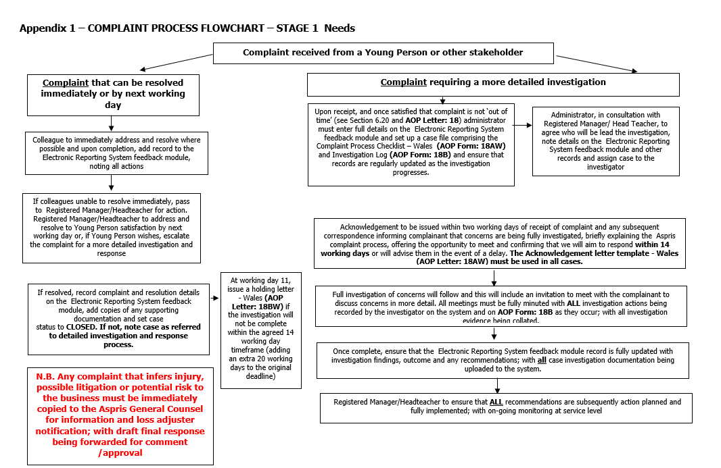

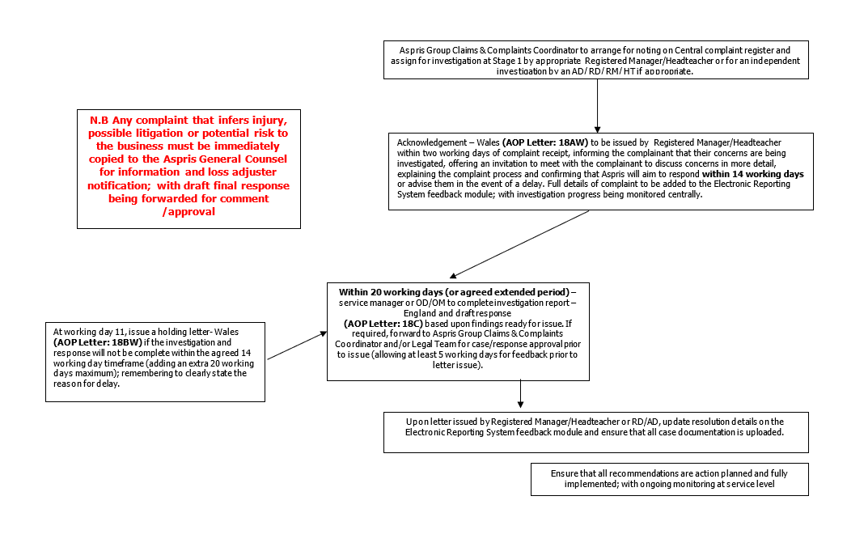

Contents Checklist (Local Services may add additional items – this is a core list)
Statement of Purpose |  | Stage Three
Definitions of Complaint |  | Stage Four
Objectives |  | Additional Information
Key Principles |  | Legislation and Guidance
Complaint Process |  | Complaint Process Flowchart
Stage One
Stage Two

Local Procedure Review History:
Date Reviewed | Reviewer | Summary of revisions

