
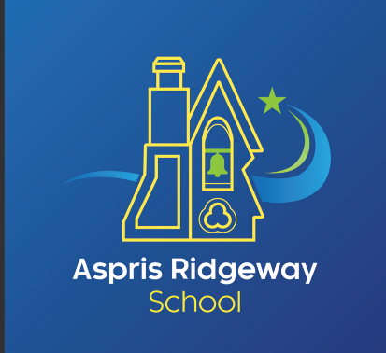
Local Procedure Title | Remote Learning Policy
Site | Ridgeway School
Local Procedure date | 17.11.2025
Local Procedure review date | 16.11.2026
Local Procedure Author(s) | Penny King
Local Procedure Ratification | Checked and Approved by: Gail Prince

Aims
This remote learning policy for staff aims to:
  - Ensure consistency in the approach to remote learning for learners who aren’t in school
  - Set out expectations for all members of the school community with regards to remote learning.

Roles and responsibilities
All learners at Aspris Ridgeway School have EHC plans and are identified as vulnerable within the Covid 19 pandemic arrangements. Since March 2020 arrangements at Aspris Schools have enabled young people to attend school remotely throughout the national lock down. This policy outlines arrangements should there be a further need to close schools and move to remote learning.

The Head Teacher has the responsibility for the Remote Learning Provision who ensures that colleagues effectively establish and can manage the tools to deliver a range of face-to-face, online or blended learning as appropriate. The Head Teacher will quality assure the delivery and monitor the effectiveness and impact of this provision. During remote learning, it is the responsibility of all staff involved to ensure they adhere to safe working practices adopted within the school setting.

Outreach
When providing remote learning, staff are available between 08:30 and 16:00
In the interest of transparency, decisions around the delivery of remote learning takes place in consultation with all stakeholders with a view to minimising the added pressures of home learning, whilst maintaining an ambitious learning curriculum.

When providing remote learning, teachers are responsible for:

    - Setting work that is differentiated to meet the needs of the learners in their class and acknowledges the different access arrangements required by each learner identified on their equality of access.
    - The work will focus on outcomes as identified on the learners’ EHCP plan and which takes account of their previous learning and the next steps alongside ensuring we focus on a learners’ wellbeing.
    - The amount of work will be established in partnership with the parents / carers to suit the complex needs of the students and the capacity of the parents / carers.
    - Where possible, work can be based upon practical activities and real life experiences, which means the children and young people can contribute to tasks which are manageable within the home.
    - Provide at least three contacts per week including at least one face-to-face welfare call.
    - Sending work weekly, either electronically or printed, dependent on learner and parental preference. Additionally school staff will support learners in their learning via appropriate communication channels as when required.
    - Aspris Ridgeway School will provide regular feedback on learners’ work, this will be conducted weekly.
    - Aspris Ridgeway can facilitate the loan of school laptops and Internet access should this be necessary.
Any concerns raised are to be treated in line with our safeguarding policy. Aspris Ridgeway Schools Designated Safeguarding Leads are: Penny King, Gail Prince, Emma Harris and Scott Preston

Monitoring Effectiveness
The Senior Leadership Team is responsible for:

    - Coordinating the remote learning approach across the school
    - Monitoring the effectiveness of remote learning through regular meetings with teachers and outreach workers, reviewing work set and ensuring clear diaries are recorded of all remote work.

Learners and parents / carers
Aspris Ridgeway School can expect learners learning remotely to:

    - Be contactable during the school day
    - Complete work to the deadline set by teachers
    - Seek help if they need it, from teachers or teaching assistants
    - Alert teachers if they’re not able to complete work
Aspris Ridgeway School can expect parents with children learning remotely to:

    - Make the school aware if their child is sick or otherwise can’t complete work
    - Seek help from the school if they need it – if you know of any resources staff should point parents towards if they’re struggling, include those here
    - Be respectful when making any complaints or concerns known to staff
    - Appropriate methods will be used to assess learner progress.

