  ED POTTERTON - Headteacher  Mobile: 07769 142025  Email: edwardpotterton@aspriscs.co.uk |   MAL FJORD-ROBERTS – Regional Director  Mobile: 07715 059036  Email: maldwynfjord-roberts@aspris.com
IN THEIR ABSENCE, PLEASE CONTACT
  MIKE SPINNER – Assistant Headteacher  Mobile: 07927 529815  Email: Michaelspinner@aspriscs.co.uk | 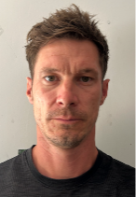  WARREN KITLEY – Deputy Headteacher  Mobile: 07851 112598  Email: warrenkitley@aspriscs.co.uk
  LISLE SMITH – Assistant Headteacher  Mobile: 07860 643983  Email: Lislesmith@aspriscs.co.uk | 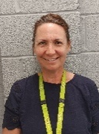  REBECCA SHEEN – Assistant Headteacher P16  Mobile: 07585 902985  Email: Rebeccasheen@aspriscs.co.uk
  JO MARTIN – SENCO  Mobile: 07355 627196  Email: Jomartin@aspriscs.co.uk |   RICHARD CARRELL – P16 Skill Centre Manager  Mobile: 07715 059987  Email: Richardcarrell@aspriscs.co.uk
  REBECCA EMBER – Outreach Manager  Contact No: 023 8066 9140  Email: Rebeccaember@aspriscs.co.uk |   LOU COOMBES – Assistant SENCO  Contact No: 023 8028 3633 ext: 8720  Email: Louisecoombes@aspriscs.co.uk

