
.EASTWOOD GRANGE SCHOOL

CAREERS, EDUCATION, ADVICE, INFORMATION AND GUIDANCE PROCEDURE



Eastwood Grange Vision Statement:
"Supporting young people to thrive by giving them the skills to navigate challenges and understand their emotional needs, fostering independence and fulfilment beyond education."
Overview

Eastwood Grange School is an independent, special day school for up to 60 boys and girls aged 5-19 years. The students present with a variety of differing complex to severe educational, social, emotional and mental health needs and have experienced many different school environments, many of which have been unable to meet their needs. This has impacted their personal and educational development, often resulting in our children and young people feeling very unsettled within the school context. We aim to support children and young people with their educational, social, emotional and mental health and wellbeing needs in a way which supports them to feel safe in school and thrive in their learning.
Related Policies | Curriculum Procedure  PSHCE Procedure  SRE Procedure  Alternative Provision and Quality Assurance Procedure
Issue date: June 2021
Review date: January 2027
Author: Sam Littlewood (Deputy Head Teacher)

Local Procedure Title | Careers, Education, Advice, Information and Guidance Policy
Site | Eastwood Grange School
ECS Policy number and title | ECS 57 Careers Guidance
Local Procedure template reference | ECS LP 57
Local Procedure date | June 2021
Local Procedure review date | January 2027
Local Procedure Author(s) | Sam Littlewood (Deputy Headteacher)
Local Procedure Ratification | Checked and Approved by: Tony Armstrong, Operations Director

- Rationale
Reason for the policy and definitions of key terms.

- Aims
What the policy seeks to achieve for our students.

- Student entitlement
What every student can expect from careers guidance.

- Information
The outline of content from our programme.

- Advice
Points of contact in-house.

- Guidance (including Local Specialist Advice, record keeping and GDPR)
Record keeping arrangements in relation to careers guidance; arrangements for the use of local specialist advisers external to the school;

- Work experience (including local partnerships)
Any arrangements for the use of local partnerships; arrangements for risk assessing work experience opportunities
- Equality and Diversity
A statement of purpose discussing the intent whilst discharging careers education and guidance.

- Focus by year group
A breakdown of the curriculum by year group; Arrangements for consultation which children/young people in relation to their careers guidance learning and experiences
- Parents and carers
Arrangements for consultation which parents/carers/advocates in relation to children and young people’s careers guidance learning and experiences.
- Management and monitoring
Key Responsibilities: Including named Careers Guidance Co-ordinator

- Staffing
Responsibilities to discharge this policy effectively.

- RATIONALE
Careers education and guidance programmes make a major contribution to preparing students for the opportunities, responsibilities and experiences of life. A planned progressive programme of activities supports them in choosing 14 – 18 pathways from year 7 that suit their interests and abilities and help them to follow a career path and sustain employability throughout their working lives. In addition our children who are still in the primary stage of their education have opportunity to explore different employment opportunities through exploration days and an embedded curriculum.

For the purposes of this policy the following definitions have been used:
Information
Information is data on opportunities conveyed through different media, both mediated and unmediated including face-to-face contact (individual, group, class etc.), the class work will incorporate WOW (World of Work) Curriculum, this will be taught every morning as a core subject to all students, including careers advice, written or printed matter, telephone help lines, ICT software, websites and virtual learning etc.

Advice
This involves helping a student to understand and interpret information; to provide information and answers to questions and clarify misunderstandings; to understand their circumstances, their abilities and targets; to advise them on their options or how to go about a given course of action; to identify needs and to signpost and refer students who may need more in depth guidance and support. Advisory work is provided in small class groups.

Guidance
Guidance aims to support students to better understand themselves and their needs; to confront barriers to understanding, learning and progression; to resolve issues and conflicts and to support them to develop new perspectives and solutions to problems and be able to better manage their lives and achieve their potential. Guidance may also involve advocacy on behalf of some students and referral for specialist guidance and support. This involves more in-depth one-to-one work conducted by staff trained and competent in guidance work. Guidance usually involves the exploration of students’ circumstances - their ideas, values, needs and beliefs in relation to opportunities or issues that are confronting or confusing them.

- AIMS

Self-Development

Students should be able to understand themselves and the influences on them. Students should be able to:
- Assess their achievements, qualities and skills
- Present information as appropriate
- Use this information for personal development
- Set career and learning targets
- Recognise and deal accordingly with influences on their attitudes, values and behaviour in relation to work

Career Exploration

Students should be able to investigate opportunities in learning and work. Students should be able to:
- Understand the nature of work and people’s attitudes to it
- Use a variety of sources of career information
- Use work experience to improve chances
- Understand employment trends

Career Management

Students should be able to make and adjust plans to manage change and transition. Students should be able to:
- Employ decision making techniques
- Understand and use sources of help
- Make informed and appropriate choices at the ages of 14, 16 and 18
- Make and manage change as appropriate
- Understand job and further learning application forms and the requirements at interviews
- Understand rights and responsibilities in the work place
- STUDENT ENTITLEMENT
Careers Education and guidance (CEAIG) is a timetabled weekly session for students in Key Stage 4 and 5. It is also offered to Key stage 2 and 3 students through PSHCE. As part of timetabled sessions. Students will complete relevant National Open College Network (NOCN) units of work around careers, work experience and employment.

- INFORMATION
Students will receive lessons to help develop information handling skills. Students are encouraged through ICT to explore information available to them electronically. Research skills are developed across a wide range of subject areas. Information on issues of health and relationships (including bullying) is provided in SMSC, PSHCE, SEAL and SRE lessons. Students will be supported to visit further educational establishments, training centres and places of work.

- ADVICE
Tutors offer informal advice during tutor times and through their daily 1 to 1 contacts with students. Tutors are well placed to understand the varied needs of their students and have an in depth knowledge of the student and their circumstances. The tutor is usually the first point of contact for a student who may have an issue they wish to discuss however each student has a learning mentor who offers regular student voice sessions. Advising a student on options will often involve signposting an individual to the relevant information resource or source of help.

- GUIDANCE (including Local Specialist Advice, record keeping and GDPR)
This consists of a number of planned interventions, which enables students to make and implement well-informed and realistic decisions about their path through life and manage the subsequent transitions. Guidance may take place 1 to 1 or in small groups. Guidance sessions are provided by class teachers, learning mentors and our CEIAG co-ordinator and the Teacher in charge of this area, further support may be sought from the SLT. Further specialist advice and guidance is provided by a CIAG officer from a company called Ideas4Careers, where an Independent Careers Advisor makes regular fortnightly visits to the school to support the children in their views about careers beyond Eastwood Grange School

The Independent Careers Advisors are provided with initial information, e.g. the student’s EHCP, current attainment levels and predicted grades in order to initiate discussions with the student. After each careers session, the advisor provides an up to date report that is shared with relevant staff, including the classroom teacher. This is used to undertake interventions between sessions and as a starting point for the following meeting.

- WORK EXPERIENCE (including local partnerships)
The majority of our work experience is undertaken in house. This is due to the fact that we can provide a variety of experiences, including catering, construction, woodland management, manufacturing, etc. and that our students are better placed in an environment they know and are known within by staff.

When using a local partnership, an outside organisation or company for work experience, such as when independent advice indicates we can’t meet a need in-house, we use our quality assurance mechanisms in place for alternative provision when establishing a relationship with the provider. This involves visits to the organisation or company and a clear set of criteria to ensure the safety, welfare and development of the student.

- EQUALITY AND DIVERSITY
Careers education is provided to all students and provision is made to allow all students to access the curriculum. Students are encouraged to follow career paths that suit their interests, skills and strengths with the absence of stereotypes. All students are provided with the same opportunities and diversity is celebrated.

The curriculum at Eastwood Grange is personalised to support individual needs and their pathway plan. Where students wish to pursue a course not currently provided by the school we maintain links with local colleges and providers that allow these talents and interests to be nurtured.

- FOCUS BY YEAR GROUP:

KEY STAGES 1 and 2

The components of the PSHCE, RSE, SMSC and the CIAG curriculum are taught explicitly through assigned lessons, using the curriculum laid out in associated PSHCE and RSE Schemes of Work. These lessons are approximately 1.5 hours in length. In the Primary Curriculum PSHCE and RSE are also often taught in a cross-curricular approach to learning, e.g. through topic, English and science sessions.
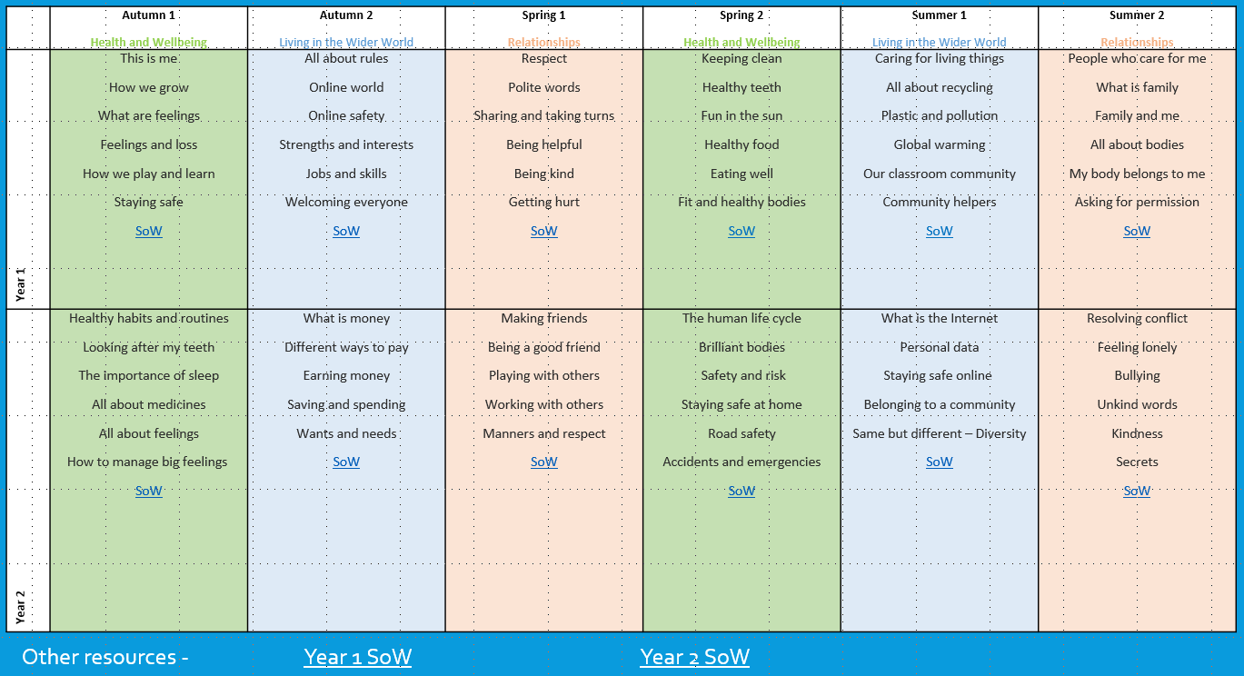

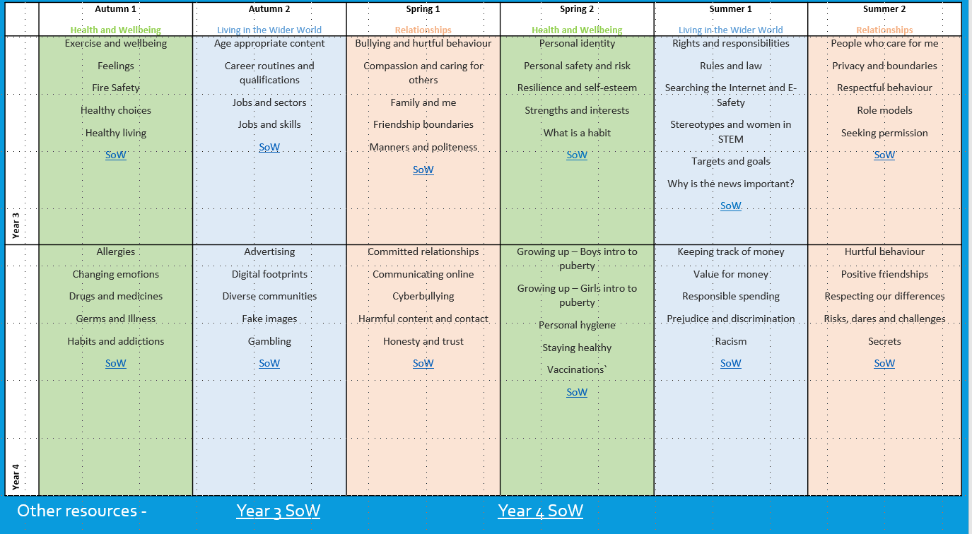

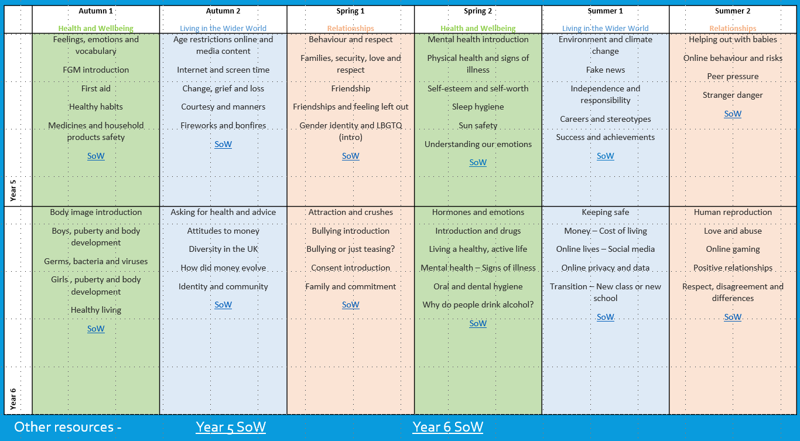

KEY STAGES 3 and 4

The components of the PSHCE, RSE, SMSC and CIAG curriculum are taught explicitly through assigned lessons, using the curriculum laid out in associated PSHCE and RSE Schemes of Work. These lessons are approximately 1.5 hours and length.

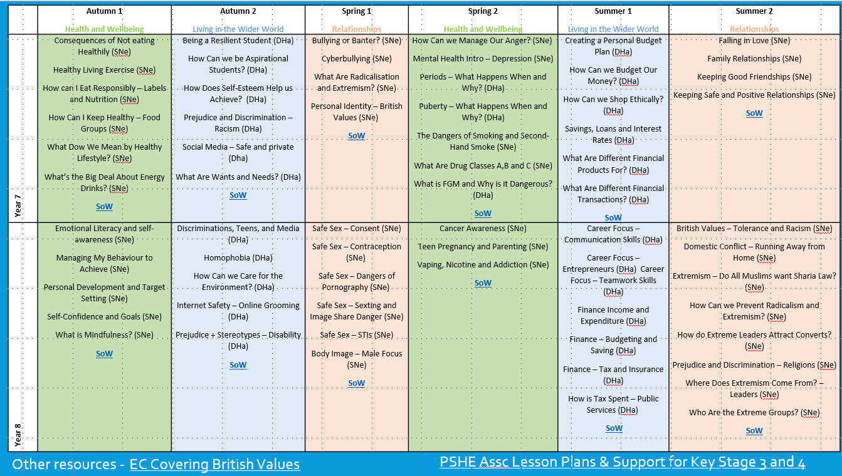

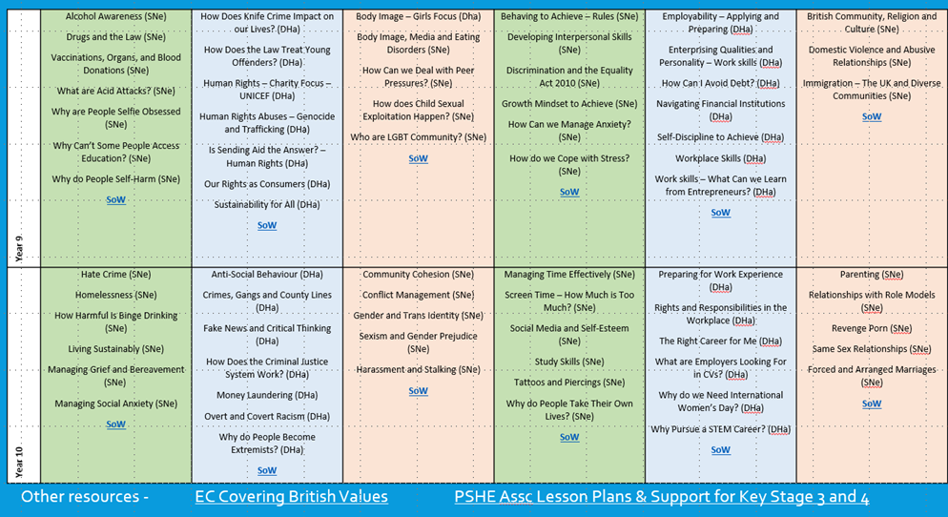

KEY STAGE 5
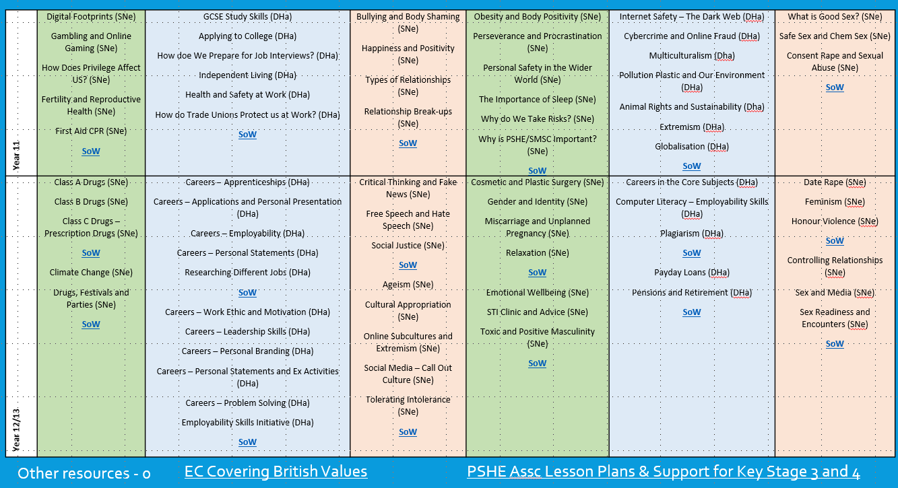
The components of PSHCE, RSE, SMSC and CIAG are either taught explicitly or with a cross curricular focus dependant on need.

TEACHING
CIAG is suited to a wide variety of teaching strategies and styles, which should be reflected in the planning. There will be a blend of class teaching and outside teaching when possible; group work, paired work and individual work. Within class teaching there can be a range of approaches including circle time, debates and games.

- PARENTS AND CARERS
Parental involvement is encouraged at all stages. Parents are kept up to date with careers related information through regular review meetings, weekly telephone calls and open evenings. Parents are welcome at careers interviews and where necessary are invited.

- MANAGEMENT and MONITORING
Rebecca Beard and Cara Pearce co-ordinates the CEAIG programme as part of his role. Rebecca and Cara can be contacted at the school on 01246 590 255 for further information about our careers education provision. See also our Careers, Education, Advice, Information and Guidance Policy, published on our website.

- STAFFING
- All staff contribute to CEAIG through their roles as tutors and subject teachers.
- The Careers Education Programme is planned, monitored, and evaluated by the CEAIG Co-ordinator.
- The current Independent Careers Adviser that the school employs is from a company called Ideas4Careers who the school sees for 18 weeks of a 29 week year.
- The CEAIG Co-ordinator will liaise and consult with the Derbyshire LEA to ensure that specialist career guidance is available from years 7 – 11.

Local Procedure Review History:
Date Reviewed | Reviewer | Summary of revisions
28/2/2019 | Eric Knutsen | Updated information under the suggested core list. Added local information based on the material change. Altered named responsible people.
10/03/20 | Sam littlewood | Updated responsibilities
26/05/21 | Rebecca Beard | Updated responsibilities
September 22 | SLe | Added Careers teaching sequence at each KS
26/06/23 | SLe | Updated new Careers Adviser Information
15/01/26 | Sam littlewood | Accuracy check and review

