
EASTWOOD GRANGE SCHOOL

RELATIONSHIP AND SEX EDUCATION PROCEDURE



Eastwood Grange Vision Statement:

"Supporting young people to thrive by giving them the skills to navigate challenges and understand their emotional needs, fostering independence and fulfilment beyond education."
Overview

Eastwood Grange School is an independent, special day school for up to 60 boys and girls aged 5-19 years. The students present with a variety of differing complex to severe educational, social, emotional and mental health needs and have experienced many different school environments, many of which have been unable to meet their needs. This has impacted their personal and educational development, often resulting in our children and young people feeling very unsettled within the school context. We aim to support children and young people with their educational, social, emotional and mental health and wellbeing needs in a way which supports them to feel safe in school and thrive in their learning.
Related Policies | PSHCE Procedure  SMSC Procedure  Curriculum Procedure  Science Procedure
Issue date: January 2021 (following review)
Review date: January 2025
Next review: January 2027
Author: Kirsteen Moss (DSL), reviewed by Alasdair Duncan (Sept 2024)
Amended to new Procedure: S Lees (HT)
Local Procedure Title | Relationship and Sex Education
Site | Eastwood Grange School
ECS Policy number and title | ECS 20 Relationship and Sex Education
Local Procedure template reference | ECS 20
Local Procedure date | November 2020
Local Procedure review date | January 2027
Local Procedure Author(s) | Kirsteen Moss (DSL)
Local Procedure Ratification | Checked and Approved by: Anthony Armstrong (OD)

- Defining RSE
- Principles and Values
Information on parents’ / carers’ rights to withdraw and how to expedite this

- Three Main Strands Of SRE At Eastwood Grange School
- Aims
- Curriculum
Describes how RSE is provided; Explains who is responsible for providing RSE; Outlines the training and support offered to staff delivering RSE
- Inclusion
- Concerns and Confidentiality
- Monitoring and Evaluation

- DEFINING RSE

RSE is lifelong learning about the understanding of the importance of stable and loving relationships, respect, love and care, and family life. It involves acquiring information, developing skills and forming positive beliefs, values and attitudes.

- PRINCIPLES AND VALUES

Eastwood Grange believes that RSE should:
- Provide a framework in which sensitive discussions can take place
- Be an integral part of the lifelong learning process, beginning in early childhood and continuing into adult life.
- Be an entitlement for all students.
- Help students develop feelings of respect, self-respect, confidence and empathy,
- Encourage every student to contribute; to make our community and aims to support each individual as they grow and learn.
- Be set within this wider school context and supports family commitment and love, respect and affection, knowledge and openness. Family is a broad concept; not just one model, e.g. nuclear family. It includes a variety of types of family structure, and acceptance of different approaches.
- Encourage students and teachers to share and respect each other’s views. We are aware of different approaches to sexual orientation, without promotion of any particular family structure. The important values are love, respect and care for each other.
- Generate an atmosphere where questions and discussion on sexual matters can take place without any stigma or embarrassment.
- Recognise that parents/carers are the key people in teaching their students about relationships, sex and growing up. We aim to work in partnership with parents, carers and students, consulting them about the content of programmes.
- Create a positive culture around issues of sexuality and relationships
- Prepare students for puberty, and give them an understanding of sexual development and the importance of health and hygiene
- Support students to understand how to keep themselves safe.
- Recognise that the wider community has much to offer and we aim to work in partnership with health professionals, social workers, peer educators and other mentors or advisers.
- Students, parents and carers with views that they should withdraw from all or part of the RSE provision should approach the school’s leadership team. The school will support their stated wishes following that discussion and consultation.

- Context and aims

Developing pupil character is intrinsic to the many aims for our children at Eastwood Grange School; this is embedded through our Identity curriculum which consists of five different subject areas: PSHCE, SMSC, RSE, CAIG (Careers) and SEAL. There are opportunities within these subjects for children to learn, about the values of Respect, Resilience and being in the Right Place at the Right Time. The three R’s also form part of our hidden curriculum and are seen as key aspects around supporting children’s success in life after school. The Three R’s form part of the norms, values, and beliefs conveyed around not only the classroom but in social environments as well. The elements of the SEAL curriculum and Identity curriculum form part of the central part of our curriculum, and recognise the importance of addressing children’s social and emotional needs alongside learning: RSE forms part of our Identity curriculum and aims to develop the following values and skills in our young people.

Attitudes and Values
- the importance of values, individual conscience and moral choices;
- the value of family life, stable and loving relationships, marriage and civil partnership;
- the nurture of students;
- the value of respect, love and care;
- exploring, considering and understanding moral dilemmas;
- developing critical thinking as part of decision-making
- respecting & valuing difference & diversity
- rights and responsibilities, for self and others
- commitment to personal safety and that of others
- gender equality
- that violence and coercion in relationships are unacceptable

Personal and Social Skills
- managing emotions and relationships confidently and sensitively;
- identifying emotions in themselves and others;
- developing self-respect and empathy for others;
- making choices with an absence of prejudice;
- appreciating of the consequences of choices made;
- managing conflict;
- managing change;
- identifying risk;
- making and carrying out informed decisions;
- recognising and avoiding exploitation and abuse;
- empowering students with the skills to be able to avoid inappropriate pressures or advances (both as exploited or exploiter)

Knowledge and Understanding
- physical development at appropriate stages;
- human sexuality, reproduction, sexual health, emotions and relationships;
- the positive benefits of loving, rewarding and responsible relationships;
- contraception and the range of local and national sexual health advice, contraception and support services;
- a safe and healthy lifestyle based on accurate information;
- how to seek appropriate help and advice;
- reasons for delaying sexual activity, and the benefits to be gained from such delay;
- pregnancy and the avoidance of unplanned pregnancy;
- legal aspects of RSE

The aims will be met through the teaching of the following subjects at Key Stage 1 and 2:

- Families and People Who Care For Me
- Caring Friendships
- Respectful Relationships
- Online Relationships
- Being safe.

The aims will be met through the teaching of the following subjects at Key Stage 3 and 4:

- Families
- Respectful Relationships, Including Friendships
- Online and Media
- Being Safe
- Intimate and Sexual Relationships, Including Sexual Health

- CURRICULUM

The RSE curriculum, based on the national curriculum, is delivered by classroom staff, with support from senior leaders, the therapy team and the Group schools with whom we may liaise for further development of this area. The curriculum that follows indicates the topics covered discretely. However, there is further support from the Positive Behaviour Manager in charge of anti-bullying and student voice. Less formally, but again in support of the discrete curriculum is the work of the Designated Safeguarding Lead to direct provision from a safeguarding perspective.
KEY STAGES 1 and 2

The components of the PSHCE, RSE, SMSC and the CIAG curriculum are taught explicitly through assigned lessons, using the curriculum laid out in associated PSHCE and RSE Schemes of Work. These lessons are approximately 1.5 hours in length. In the Primary Curriculum PSHCE and RSE are also often taught in a cross-curricular approach to learning, e.g. through topic, English and science sessions.
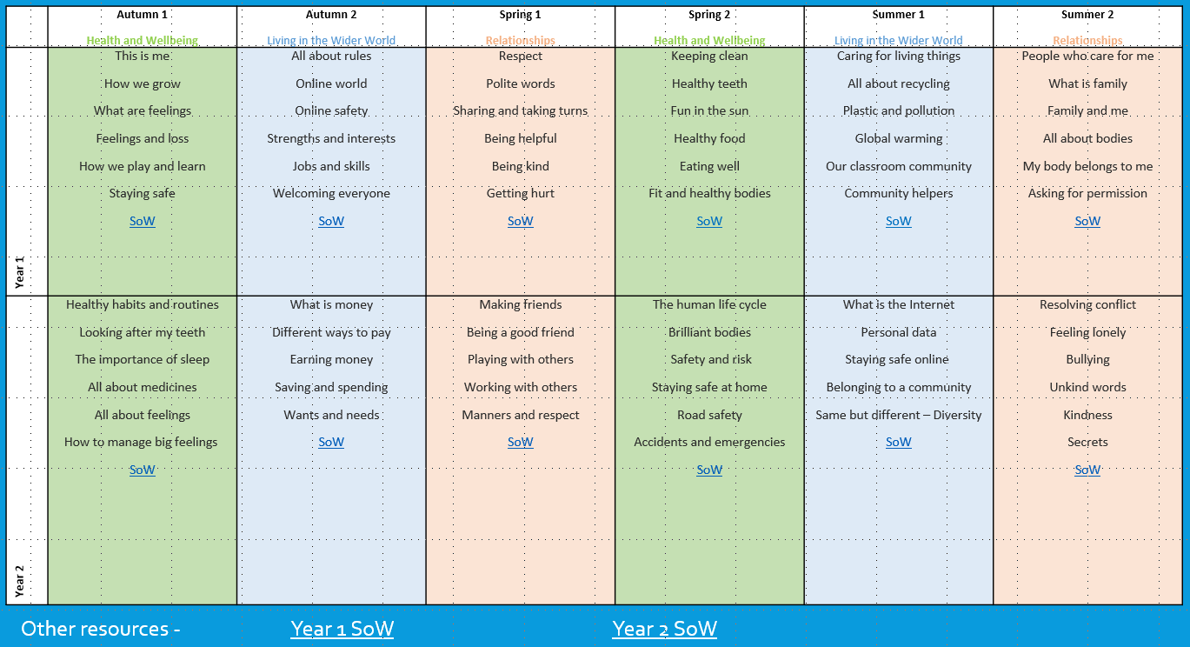

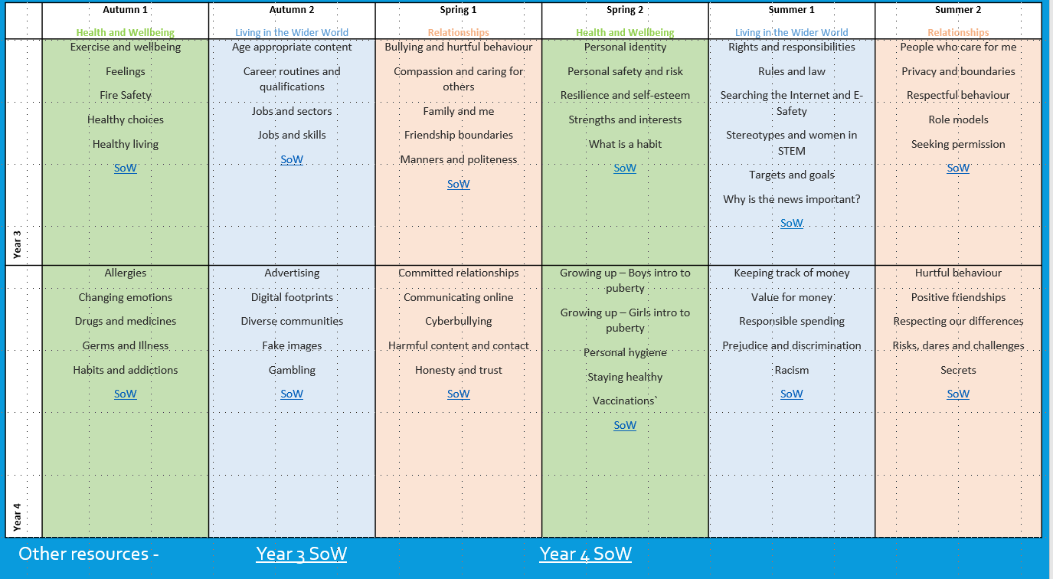

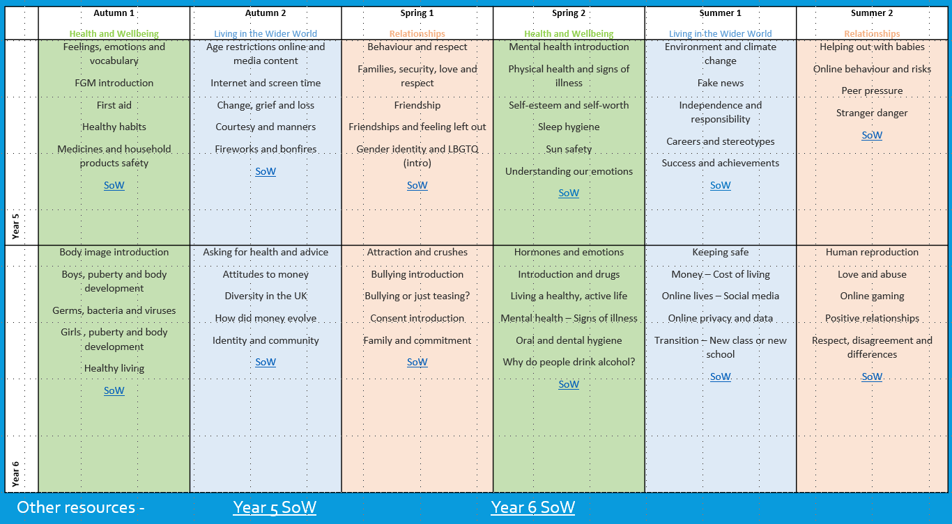

KEY STAGES 3 and 4

The components of the PSHCE, RSE, SMSC and CIAG curriculum are taught explicitly through assigned lessons, using the curriculum laid out in associated PSHCE and RSE Schemes of Work. These lessons are approximately 1.5 hours and length.

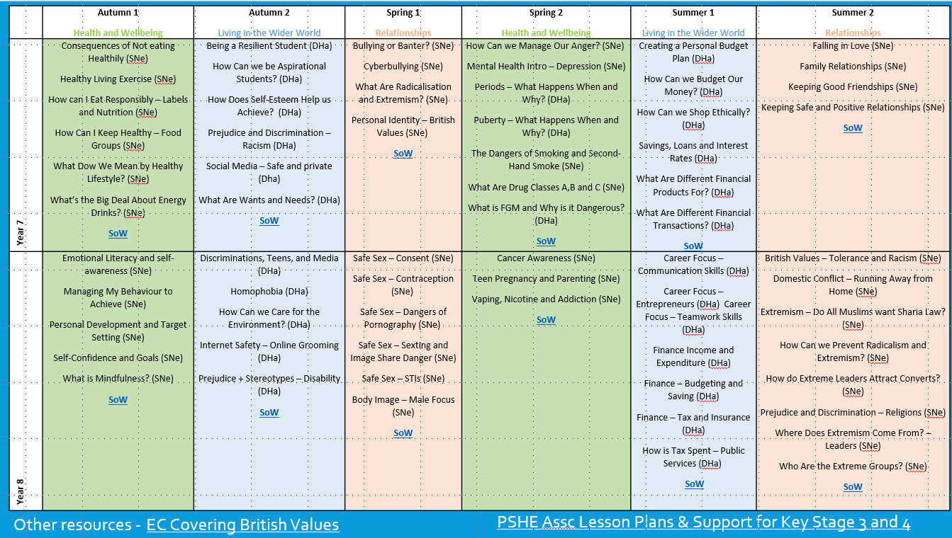

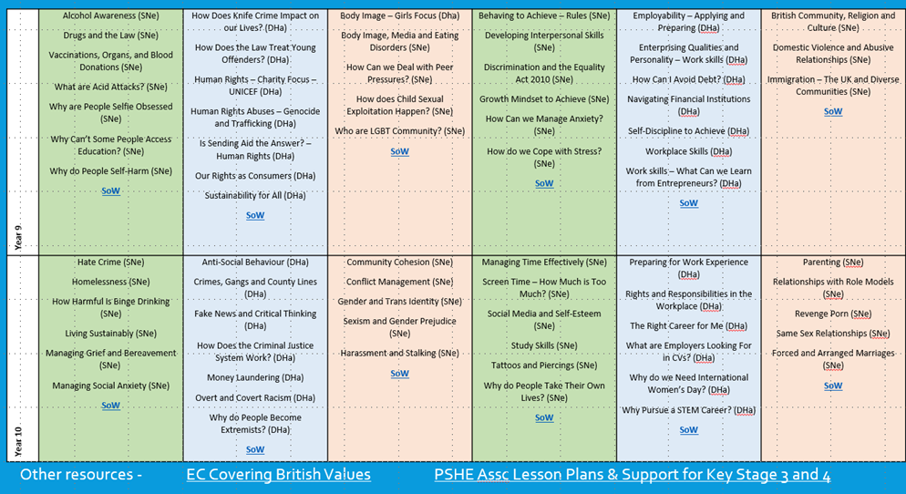

KEY STAGE 5
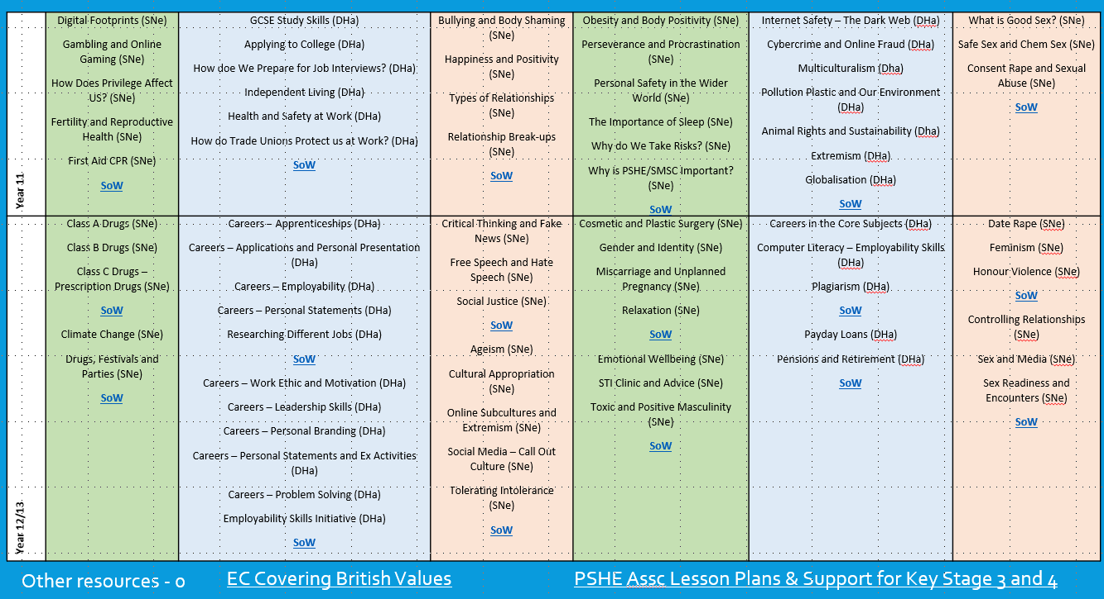
The components of PSHCE, RSE, SMSC and CIAG are either taught explicitly or with a cross curricular focus dependant on need.

- INCLUSION

Ethnic and Cultural Groups
We intend our procedure to be sensitive to the needs of different ethnic groups. For some students it is not culturally appropriate for them to be taught particular items in mixed groups. We will respond to parent/carer requests and concerns.

Sexual Identity and Sexual Orientation
We aim to deal sensitively and honesty with issues of sexual orientation, answer appropriate question and offer support. Students, whatever their developing sexuality need to feel that sex and relationship education is relevant to them. We will ensure that our school strives to do the best for all of the pupils, irrespective of disability, educational needs, race, nationality, ethnic or national origin, pregnancy, maternity, sex, gender identity, religion or sexual orientation or whether they are looked after children. We will comply with the Equality Act 2010 under which sexual orientation and gender reassignment are amongst the protected characteristics.

- CONCERNS AND CONFIDENTIALITY

In a case where a teacher learns from an under 16-year-old that they are having or contemplating sexual intercourse:
- the student will be persuaded, wherever possible, to talk to parent/carer and if necessary to seek medical advice.
- student protection issues will be considered, and referred if necessary to one of the safeguarding officers at Eastwood Grange, under the school's procedures.
- the student will be properly counselled about contraception, including precise information about where students can access contraception and advice services.

In any case where student protection procedures are followed, the teacher will ensure that the student understands that if confidentiality has to be broken, they will be informed first.

Health professionals in school are bound by their codes of conduct in a one-to-one situation with an individual student, but in a classroom situation, they must follow the school's confidentiality procedure.

- MONITORING AND EVALUATION

This area of the curriculum is monitored and evaluated in line with the policies for the delivery of other areas of the curriculum. The outcomes from this area are predominately less rigid given the discussion and workshop nature of the work.

Changes are brought in from, but are not limited to, stories in the national press, safeguarding issues relating to RSE and government policy changes.

APPENDIX 1: Parents’/Carers’ right to withdraw
Parents’ (or those with parental responsibility) have the right to withdraw their children from the non-science components of RSE.
Requests for withdrawal should be put in writing and addressed to the Headteacher.
A copy of withdrawal requests will be placed in the pupil’s educational record.
The Headteacher will discuss the request with parents and take appropriate action.
The local procedure will outline the actions the Headteacher will take in these circumstances.
Alternative work will be given to students who are withdrawn from RSE.

Appendix 2: Parent form: withdrawal from sex education within RSE

To be completed by Parents
Name of child |  | Class
Name of Parent |  | Date
Reason for withdrawing from Sex Education, with Relationship and Sex Education
Any other information you would like the school to consider
Parent/carer signature |  | Date

Local Procedure Review History:
Date Reviewed | Reviewer | Summary of revisions
6th March 2019 | Eric Knutsen | Updated information based on material change; ensured that local procedure document is reflected in this procedure; corrected errors.
16th March 2020 | Sam Littlewood | Check relevance and up to date information
17th September 2021 | Alasdair Duncan | Minor revisions and relevance check
September 2022 | Stuart Lees | Included SoW utilised to teach all ID Curriculum subjects

