

Fromefield Manor School

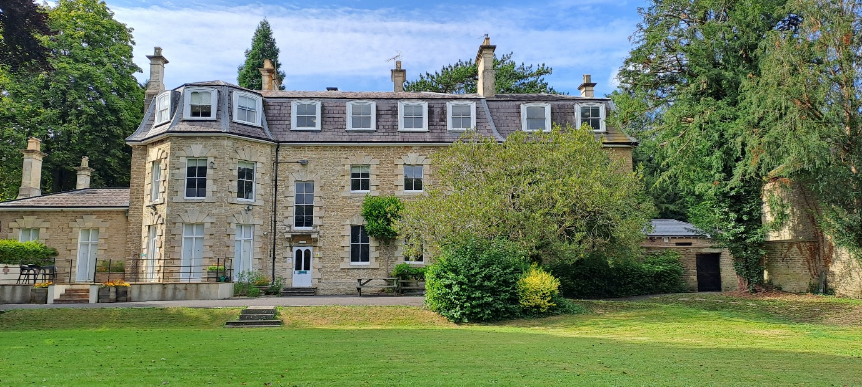

Complaints Local Procedure
November 2025

Local Procedure Title | Complaints
Site | Fromefield Manor School
Local Procedure date | November 2025
Local Procedure review date | September 2026
Local Procedure Author(s) | Head Teacher (Gemma Drury)
Local Procedure Ratification | Checked and Approved by: Regional Director – Rebecca McArthur

Contents:
Introduction
PART 1: Managing Children’s Complaints
PART 2: Managing External Complaints
PART 3: Managing Staff Complaints

Appendices
- Complaints procedures display
- Procedure: Child/PUPILS Complaints
- Panel Guidelines - Pupil Complaints
- External Complaints Form

Introduction
Fromefield Manor School fully recognises that it has responsibilities to all children, their parents and carers, placing agencies, employees and the community at large. This document is designed to make it easy for matters of concern to be raised.
The school aims to promote an atmosphere of mutual trust where concerns can be raised and addressed without fear of retribution.
Where concerns are raised, they are addressed promptly. The school aims to achieve efficient effective resolution, embracing the opportunity to develop and improve practice where need is indicated.

PART 1: Managing Young Peoples Complaints

Pupils have a strong and supportive system for making complaints managed by the Head Teacher and other education members of staff. The school has forms prominently displayed and readily available. Staff will assist pupils in the completion of complaint forms as necessary. Any person may make a complaint on behalf of a child/pupils.
Pupils have access to use the ‘Complaints Log’ to record informal concerns and complaints. The school review the comments made within this book on a regular basis and where appropriate and necessary, feedback to all parties concerned with the complaint.
Fromefield Manor School takes complaints seriously and implements appropriate action to ensure both staff and children/ Pupils feel complaints are listened to and acted on. The Head Teacher will report to the Operations Director any complaint/concerns raised so that a quick and effective resolution can be implemented.

PART 2 : Managing External Complaints

Scope
There are no restrictions on the scope of issues that may be the subject of a complaint. All will be investigated, carefully considered, and the findings made known to relevant individuals and groups with due respect for the appropriate confidentiality. Many issues may involve lack of information, poor communication or misunderstandings and can be addressed with an appropriate degree of informality. In such cases resolution can be sought at source with a member of staff working at the school. If the concern or complaint cannot be immediately and informally addressed, then more formal representations need to be made.

Who to notify of a Complaint
Minor issues may well be discussed directly with any member of staff in the school as all of these will have an overview of the School and how its procedures operate. All children also have an allocated teacher, who is in regular contact with placing authority representatives and parent/carers. They may well be in a position to informally deal with matters of concern or minor forms of complaint and act quickly in order to resolve difficulties.
Fromefield Manor School ensures all young people participate in weekly 1:1 sessions during tutor time and this provides the opportunity for any concerns to be raised and dealt with in the first instance. Young people’s views are also collected at the end of each term and any concerns discussed with the young person.

Young people can also raise any concerns they may have:

- At the weekly community meeting
- During 1:1 sessions with education staff
- During sessions with the independent advocate
- During discussions with the pastoral and well-being team.

All complaints, whether verbal or in writing, and whether informal or formal, are recorded on Engage.

More serious Complaints
Where matters of complaint are felt to be more serious the Head Teacher should be contacted directly. At this stage the complaint may have to be in written form. In the absence of the Head Teacher or where the complaint involves the Head Teacher, matters should be referred to the Operations Director.
If the complaint is about or directly related to the Head Teacher, then matters should be referred to the Operations Director responsible for Fromefield Manor School.
Should a complaint be raised that is not related to the education provision, the Head Teacher will forward these issues to the Operations Director where local procedures will be followed. The concern will not need to be reported and logged in the Education Complaints Log.

If a young person raises a concern with a member of the education team, the school will forward the complaint to either the Head Teacher or the Operations Director in order for the concern to be dealt with and logged in the Education Complaints Log.

Child Protection
Concerns related to Child Protection can be addressed directly to the Head Teacher. In exceptional circumstances contact may be made directly with the Operations Director, the local Child Protection department, the Police, Somerset Children’s Services or Ofsted.
All child protection matters should be raised with the Schools Safeguarding Lead.

Procedure (See also Appendix v)
- Staff addressing and resolving informal complaints are responsible for ensuring that the Head Teacher is informed of the complaint, in order that it can be entered into the Complaints Log.
- Where it has not been possible to resolve a complaint informally, a Written Complaint Form (See Appendix iv) should be submitted. (This may be scribed by a staff member on behalf of a parent/carer/other party as necessary).
- The Complaints Form is submitted to the Head Teacher. Receipt is recorded in the Complaints Logbook and a reference number is allocated by the Head Teacher and uploaded onto Engage - the electronic recording system.
- The Head Teacher then allocates the complaint to the appropriate Senior Staff Member (See Appendix vi) for resolution or may choose to resolve the issue personally if appropriate.
- Allocation should take place within two working days of receipt of the Complaints Form.
- The allocated Senior Staff Member should inform the complainant that they have been allocated to resolve the issue. This should occur within two working days of the complaint being allocated.
The Senior Staff Member should:
(i) outline how they initially plan to investigate the issue.
(ii) give a realistic estimate of the time this will take, indicating when contact will be made with the complainant to outline progress and discuss resolution. Except in exceptional circumstances and with the express approval of the Head Teacher, this should occur within ten working days of the complaint being allocated.
- All actions taken by the Senior Staff Member in investigating and resolving the issue are recorded on the Complaints Form.
- Verbal feedback and a proposed resolution are provided to the complainant (as above). The date of contact is recorded in the Complaints Logbook and on Engage and is confirmed in writing to the complainant.
- Should the complainant be unsatisfied with the proposed resolve, the request for a Complaints Panel to review and address the issue may be made. Such a request should be received by the school within ten days of receipt of the written proposal and may be made in writing or verbally. The date of request is recorded in the Complaints Logbook.
- The Head Teacher is responsible for arranging any Complaints Panel Hearing. The Panel is identified by the Head Teacher and will consist of two Senior Staff Members, and a third person who has no role in the School's Management. None of those identified as Panel Members will have had any prior involvement in the issue. The Chairperson will be provided with all the relevant information by the Senior Staff Member initially allocated to resolve the complaint and is responsible for seeking clarification and further information as necessary.

- The Panel Hearing will be held at Fromefield Manor School, at a mutually agreed time, within ten working days of the request being received, except where in exceptional circumstances the complainant agrees with the Head Teacher to extend this period.
- The complainant has the right to be accompanied to the Panel Hearing by a supporter.
- Panel Meetings are fully minuted, and the outcome confirmed in writing to the complainant within seven working days of the hearing, including details of any findings and recommendations made by the Panel.
- The Panel may identify their findings and make recommendations. These should be recorded on the Complaint Form and in minutes.
- The date of the Panel Meeting is recorded in the Complaints Logbook and on Engage.
- Fromefield Manor School will assume after ten working days of the date of the confirmation letter that the issue is considered resolved unless contact to the contrary is made by the complainant. Resolution will be recorded in the Complaints Logbook and on the Complaint Form which is retained in the Complaint File and uploaded to Engage.
- With all due respect for confidentiality, the completed Complaint Form and minutes from the Panel Hearing are copied to the Operations Director, Head Teacher and Complainant(s) and the subject(s) of the complaint.

If any complaint is not felt to be managed in a satisfactory manner, then it can be reported to Ofsted.
Fromefield Manor School - In the first instance the Head Teacher will follow the above procedure for any complaints received about the education provision. However, if necessary, the Head Teacher will also consult the Operations Director.

PART 3: Managing Staff Complaints

Fromefield Manor School has a number of well-established systems for addressing staff concerns.
Staff should refer to:

- Workplace Concerns
- Grievance Procedure
- Conduct Policy

Should these procedures fail to achieve resolve, then the issue should be addressed through the Complaints System as outlined in Part 1 herein.

Details of the Complaints Policy and Procedures are covered in the Induction Period for all new employees. Copies are readily available for staff reference, together with other policies within the school.

The same procedure will apply for staff at the school who wish to make a complaint.

FURTHER INFORMATION AND MONITORING
Pupils’ complaints are recorded in the Complaints Log, maintained by the Head Teacher and this person will be responsible for the regular monitoring of the Pupil Complaints System.
Any serious complaint about the school or its employees shall be reported to the placing authority and Ofsted as outlined in Part 7 of the Independent Schools Standards.
The Head Teacher will regularly review all records of complaints and take any necessary further follow-up action in relation to individual cases.
An annual audit of complaints detailing the number of complaints received by the School and indicating the level at which they are resolved is undertaken and is available upon request. The audit is numerical and does not contain confidential details (See Appendix vii). More detailed analysis will be used to develop and inform practice.
There will be a specific opportunity at all pupil reviews for any matters of discontent, however minor, to be raised by parents/carers, placing authorities or any other outside agency.
Fromefield Manor School: All complaints will be entered into the Education Complaints Log and Engage and reported to the Head Teacher.

For serious complaints the same procedure as outlined above will occur.

Please Remember

Complaints may well be constructive for the school; it is important for all concerns to be shared in order for our service to pupils to be constantly appraised. Fromefield Manor School welcomes views and comments from pupils, parents and carers, placing agencies, national inspectorate bodies, employees and the public.

Problem!
Complaints







Gemma Drury (Head Teacher) to listen and take action.



Regional Director will deal with the problem

Appendix i
CHILD/ YOUNG PERSON COMPLAINTS PROCEDURE

Child/PUPILS
co
mplaint

A child/PUPILS complaints form is
completed by the PUPILS and
logged into the complaints
Log on Engage

Child/PUPILS happy with
resolution.

Child/PUPILS signs off
complaint

An assigned
member of senior
staff will meet with the child/PUPILS
and involved parties regarding
their complaint.

Resolution put forward.

Child/PUPILS is unhappy with
resolution.

Complaint is referred to the
complaints panel.

Child/PUPILS is unhappy with
resolution.

Supported to seek advice from

SW/independent
advocate/Regional
Manager/OFSTED.

Appendix ii

Appendix iii
PUPILS COMPLAINTS PANEL – GUIDELINES

Purpose of Panel

A Complaints Panel is convened with the intention of resolving issues for the pupils, when the Head Teacher has been unable to do so.

Members of Panel

The Panel Meeting (date/time/members/venue) will be arranged by the Head Teacher and/or the Operations Director.

The panel should consist of two senior members of staff, one of whom chairs the meeting and a third party not involved with the management of the school. One panel member should be allocated to take minutes.

Preparation

The panel should be provided with available and accurate information by the Head Teacher to facilitate an objective overview of the matter in question. The panel should receive this documentation at least an hour before the meeting.

Hearing

* All parties must be assured of the panel’s confidentiality.

* Should the pupil(s) choose to attend, with or without a staff representative (i.e. the person who has completed the complaints form for/with them), they should be given the opportunity to explain the situation and to add supporting information, if they wish to do so.

* The panel may ask questions but must be sensitive to the pupil(s), who may be anxious.

* Where the pupil(s) chooses not to attend but is represented by a staff member, the panel must recognise that they may only ask questions of that staff member that they would ask of the pupil(s).

* Any speculative details, i.e. information not relating directly to the complaint should not be considered.

* The panel should aim to be entirely objective and try to discount historical/previous knowledge of the individuals concerned.

Panel Outcomes

The panel may recommend a number of options which it feels will help resolve the issue for the pupil(s). They should recognise that an element of “Repair and Rebuild” work will almost certainly need to take place. This should be guided by the pupil(s) readiness to participate in the process. If this is possible and acceptable to the child/PUPILS, the Head Teacher can facilitate this process.

All recommendations must be verified by the Head Teacher and/or Operations Director.
The panel may decide that it is unable to resolve the issue and may opt to pass it back to the Head Teacher. Alternatively, the panel may conclude that the matter in question is beyond its remit and refer the issue on to the Operations Director for further action.

Feedback Process

* Minutes of the Complaints Panel will be passed on to the Head Teacher who will retain the minutes with the other documentation relating to the complaint.
* The Chairperson of the meeting will feedback outcomes to the Head Teacher, who will then be responsible for notifying:
1. The Head of Care, who will be responsible for taking any other appropriate action.
2. The pupil(s) (and where appropriate, the staff representative).
3. Any staff involved in the issue.

* The responsibility of the panel then ends, and panel members should not respond to any requests for justification of outcomes by parties involved. All matters should remain confidential.

Appendix iv
EXTERNAL COMPLAINTS PROCEDURE
Contact made with Fromefield Manor School

Complaint
received and
reviewed by
Head Teacher

Written
documentation
stored and log
book/complaints
File & Engage updated.

Local Procedure Review History:
Date Reviewed | Reviewer | Summary of revisions
November 2025 | M Watch | P2. RD updated

