

HURWORTH HOUSE SCHOOL

Admissions Procedure

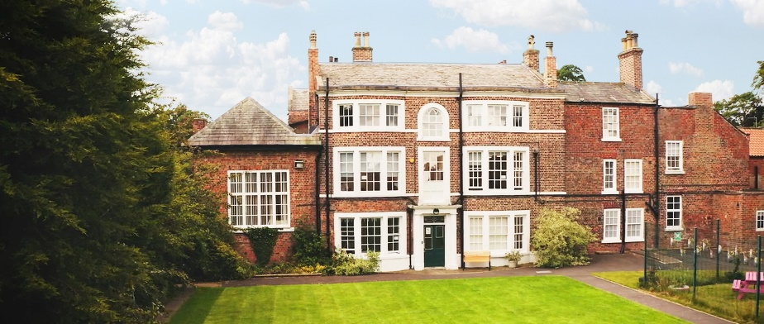

The Hurworth Way is unique, we strive to develop moral character and purpose, coach for endless possibilities beyond the expected and creatively inspire to learn

Issue date: July 2026

Review date: July 2027

Author: Danielle Mullen

Admissions Overview
Hurworth House School is a special day school for up to 80 boys and girls aged 5-19 years. The young people exhibit a variety of severe and complex educational, social, emotional and mental health difficulties, which have impeded personal developmental and educational success. Many have a number of diagnoses. Our young people have failed in, or been failed by, a variety of settings prior to their time at Hurworth House School. They often arrive very disengaged with education and life after having experienced many crises and trauma.

Children are referred by either Social Services and or Education Departments.
The referral can be written and sent via secure email to Hurworth House Admin adminhurworthhouse@AsprisCS.co.uk or enquires will also be taken over the phone; 01325 729080.
Where possible it is always helpful to include all recent and relevant reports, i.e. social history report, psychologist report, recent reviews, Attendance data, Statement of Special Educational Needs/EHCP.

Referral Process
- The school will review an application and if we feel we may be able to offer a placement to a child, we will arrange an assessment visit to gain further information. This will usually take place in school, but we can conduct visits to your home, if we feel this is more appropriate.

- If we feel that Hurworth House school can support your child and their specific needs, we will make a placement offer to the referrer. This will include how we envisage meeting the young person’s needs, any additional support we feel will be required for the placement and what the anticipated outcomes for the child might be. The authority will be notified of the outcome as soon as possible.

- A discussion will take place with the child’s Social Worker, local authority representatives and others, as necessary, regarding the placement and what we can offer to meet needs, agreeing next steps.

- The young person and their family/carers will be contacted and a visit to Hurworth House school arranged. During the visit they will be shown around the school and meet with a senior member of staff who will discuss previous education history, aspirations and support the needs in placement. This is an opportunity to ask any questions about our school and our admissions process and for us to find out more about your child and their needs.

- During the visit the staff member will complete a risk assessment and then meet with the SLT to discuss if the appropriateness of the placement with consideration to current cohort and what we need to put in place to meet needs.

- Once a placement is accepted by the young person, their family and any involved professionals, we will make arrangements to transition them into school. As the
young person begins to settle into Hurworth House School, we will undertake baseline. assessments that will enable us to track and measure their development and progress going forward.

- A home school agreement and consent forms will be sent to home address and signed before admission to school can take place.

- A Transition plan will be made for the young person, setting the pace for a smooth transition into an appropriately identified group, based on collective needs.

- Throughout the transition process there will be continuous liaison with the young person and key stakeholders ensuring the child is feeling safe and settled, any concerns may require the timetable to be adapted, this will be agreed in full consultation.

- The school operates a strict zero-tolerance regarding weapons of any kind. No student, parent, visitor, or member of staff may bring, attempt to bring, or be found in possession of any item that could be reasonably considered a weapon onto school premises or during school-related activities. This includes, but is not limited to, knives, firearms, replicas, sharp objects, or any item intended or adapted to cause harm or intimidation. Any violation of this policy will result in immediate action, which may include confiscation, parental meetings, fixed-term or permanent exclusion, and, where appropriate, referral to the police. The safety and wellbeing of all members of our school community is paramount, and this is enforced without exception.

