
Hurworth House School

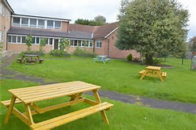

Positive Behaviour Procedure
The Hurworth Way is unique, we strive to develop moral character and purpose, coach for endless possibilities beyond the expected and creatively inspire to learn

Hurworth House School
Westfield Road
Hurworth
Darlington
County Durham
DL2 2AD
Registration Number 841/6006

Tel: 01325 729080
Email: Adminhurworthhouse@AsprisCS.co.uk

This procedure embodies our culture and ethos. Our ideal is to build on this using the Trauma Informed approach, where relationships are at the heart of every interaction. The procedure outlines the philosophy of Hurworth House School in relation to supporting positive emotional regulation of young people with special educational needs.

No one policy can exist as a discrete entity and this policy should be viewed in line with other policies and documents which reflect the culture and expectations of the school, its staff, learners and key stakeholders. Those policies are:

- Admissions Policy
- Code of conduct
- Hurworth School ‘Mission Statement’
- Anti-Bullying / Peer on Peer Abuse Policy
- Home-School Agreement
- Police involvement Procedure
- Complaints Procedure Exclusions Procedure;
- DFE (2013) Guidance ‘Use of Reasonable Force’
- Whistleblowing Procedure
- Safeguarding Policy
- Behaviour in Schools (DfE)
- Suspension and Permanent Exclusion Guidance (DfE)
- Searching, Screening and Confiscation Guidance (DfE)
- Mobile Phones in Schools Guidance (DfE)

Procedure for | Positive Behaviour Policy
Associated Priory policy | Behaviour Management | Number | ES04 HHS019
Associated Regulation/Standards |  | Number
Unit | Hurworth House School | Signature (Author) | Claire Blackett/ Richard Juillerat
Issue date | Sept 2026 | Review date | Sept 2027
Purpose
The Hurworth Way ethos provides the framework for our collective beliefs, understanding and insight into human relationships and attitudes and how it relates to our learners with complex learning needs. We believe how our learners behave gives us important information about how they are feeling. Our Learners with complex needs require a personalised approach to support them to manage their behaviour and consideration must be given to sensory and emotional needs.

Our relational practice is underpinned by PACE: Playfulness, Acceptance, Curiosity and Empathy. PACE describes the stance adults adopt to create psychological safety, strengthen relationships and support regulation. Acceptance means recognising and validating a learner’s feelings and internal experience; it does not mean accepting unsafe, unkind or inappropriate behaviour. Clear boundaries, high expectations and accountability remain central to the Hurworth Way.

The Hurworth Way believes in providing every student with the opportunity to creatively coach character and experience an outstanding education academically, emotionally, and socially.

We strive to create a feeling of being
- valued promotes cooperation.
- cared for enhances understanding and compassion.
- respected promotes respects for others and willingness to listen to them.
- included raises commitment and motivation
- fun relieves stress and fosters belonging.
- belonging builds resilience

At Hurworth House School we believe that:
- Our learners want to behave well, build character, contribute to communities and help each other to achieve.
- Behaviour is a means of communication we must ensure that all learners are supported to communicate their needs safely and appropriately using their preferred communication systems.
- With the right support and intervention, learners can learn to self-regulate and manage their behaviour.
- Mistakes are part of the learning process, and we recognize that all of our learners are at different stages of the developmental process.
- All staff must be given the opportunity to learn, understand and have insight into why our learners become dysregulated, and reflect on how/why it impacts on their behaviour.
- To work collectively with our learners, their parents/caregivers and other professionals to develop strategies as part of a positive behaviour support plan to support them to self-regulate and manage their behaviour in a positive manner.

INTENT
We strongly believe that by identifying the barriers to learning, we can provide an inspiring and relevant curriculum that considers the whole child and provides the necessary support for students to achieve, develop and reach their true potential. We are committed to ensuring that our school develops a Trauma and Mental Health Informed Approach to ensure that all our students develop positive mental health and resilience, enabling them to fully engage in life and learning.

We believe that our learners are happy when their needs are understood and met allowing them to self-regulate and behave well, and that their effort to manage themselves and their behaviour should be recognised and acknowledged by adults and their peers. We consider their communication styles, social interaction skills, sensory and emotional needs as well as the role we play in supporting them to develop these skills.

Through a trauma informed approach our focus is not only the physical environment, but the relational environment and the very culture and ethos of our school. This requires emotionally regulated and available adults who can provide essential calming for our students, their parents/carers or each other when they are overwhelmed by an event, a situation or their feelings.

We recognise that the impact of trauma can be presented in different ways, including through behaviours that challenge. There is a growing body of research and understanding of the impact of Adverse Childhood Experiences (ACE) on long term mental and physical health and the protective factors that mitigate the potential impact. It is our aim to maximise the protective factors of school by creating an environment of safety that has strong, positive and supportive relationships at its heart.

We incorporate a holistic trauma informed (evidence-based practice), whole person approach to ensure we are reflecting and planning for the needs of all our learners with complex layered needs. We consider that challenges to regulation happen for a reason and might be the only way a learner can communicate arise for different reasons which are personal to the individual.

At Hurworth House School we want our students to be self-motivated and curious about the world in which they live. They deserve an engaging curriculum and a caring atmosphere so they can act on their natural desire to find out about the world. All staff have completed training on trauma-informed practice in order to better understand behaviour; new staff will complete this training as part of their induction.

Whole School Approach – the Hurworth Way
Our school vision is to creativity, coaching and character, the 3c cog cycle aligned to behaviour represents the universal targeted and specific work that we do to reach the desired outcomes for all our students. Whilst the ambition is linear young people can revisit and return to areas in the cycle at any point in their journey when further consolidation is required.

Behaviour interventions are framed within our Creatively Coaching Character vision. We apply this ethos when working with our learners around positive behaviour and wellbeing. We are constantly finding creative ways to problem solve with students, and coaching both learners and staff so we can build character together that will stay with students long after they leave our school.

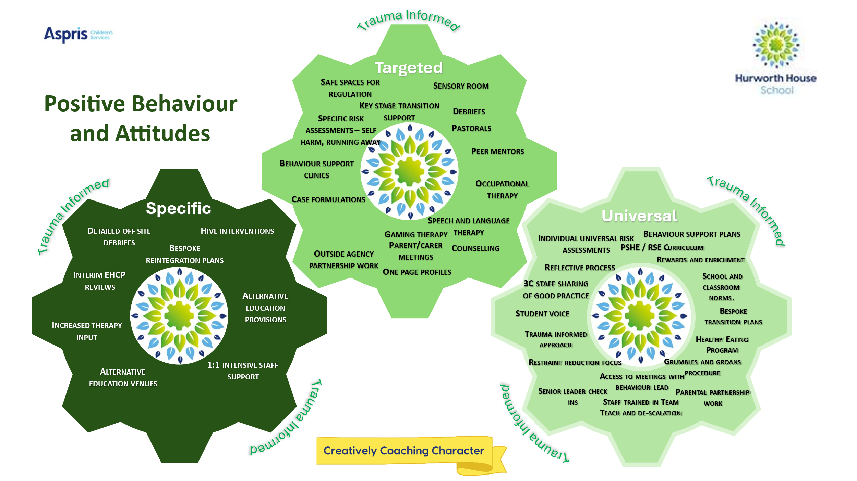

PACE and WINE bring our three school values to life in everyday behaviour practice.
- Creativity means adapting relational strategies to the individual learner and finding safe, effective ways to support regulation.
- Coaching means using calm, curious and reflective dialogue to help learners understand behaviour and develop alternative responses.
- Character means supporting learners to take responsibility, recognise the impact of their actions, repair relationships and develop resilience, empathy and self-discipline.
Our values are to be Reflective, Responsible, Respectful and Ready to learn provide the framework for all young people to give positive recognition of their behaviours in line with our ethos. Our school norms inform the behaviours we expect to see across our school community. Positive 3C recognition norms are tracked, and students are offered opportunity to acquire additional recognitions, therefore supporting the trauma informed premise of positive praise.

It is the expectation at Hurworth House School, that all staff, regardless of role act and model the Hurworth Way. In order to ensure our young people are respected, supported and valued by promoting positive relationships, and with everyone accepting responsibility for their behaviour, the aims of this policy are as follows:
- Promote high expectations of positive behaviour, courtesy, mutual respect and consideration of others, within and beyond the school environment.
- Help all students grow in a safe and secure environment, to become positive, responsible and increasingly independent members of the school community and, ultimately, of wider society.
- Help all students to understand, regulate and manage emotions, to apply thinking between feeling (sensation and emotion) and action, and to increasingly show empathy and understanding to others.
- Encourage and celebrate individual strengths and achievements of children and staff.
- Promote self-esteem.
- Build a community which values kindness, care, good humour, respect and empathy for others.

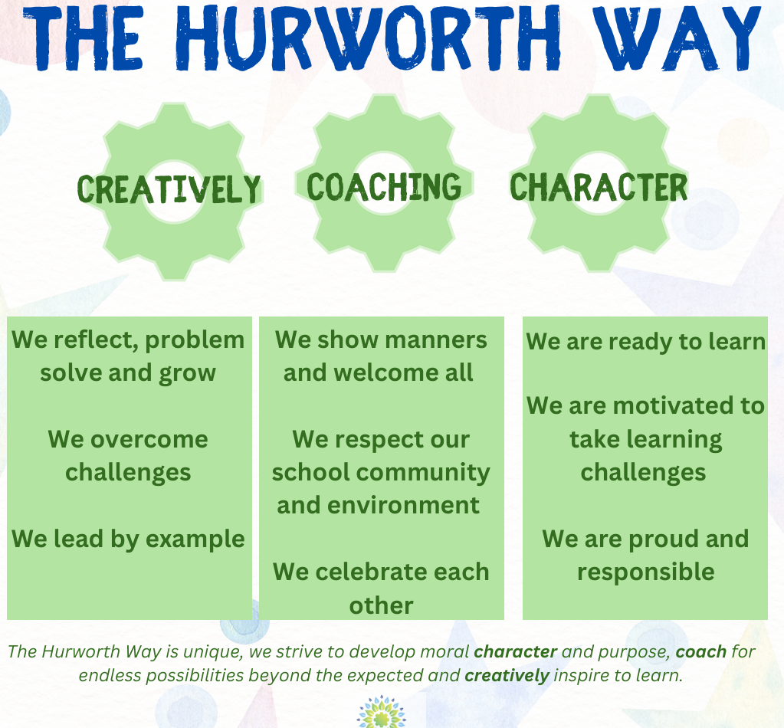

The behaviour curriculum at Hurworth defines the expected behaviours in a school. The behaviour curriculum outlines the values of the school and the intended behaviour culture. It is supported by a programme of assemblies and dedicated character-building days.

All staff are responsible for adhering to positive practise that promotes a student’s ability to engage in and access their learning. This is based on the understanding that student’s best achieves, develops and reaches their true potential when staff are: fair, flexible, trustworthy, respectful, and model positive relationships. At Hurworth House School we encourage staff teams to creatively problem solve and reflect on what functions of behaviour drive or trigger learners, and to think about ways to proactively support or respond to that challenge in a non-judgemental and supportive way.

It is important to recognise the positive effects of praise and encouragement and the power of positive reinforcement. The identification and creation of opportunities for young people to experience success and to receive praise and encouragement for their achievements, however small, is of crucial importance in forming a positive and trusting relationship. As a result, at the end of each school day, positive reflection sessions are held to reinforce positive behaviours and raise self-esteem, and our rewards and sanctions policy is built on this premise.

We believe our learners can strive to improve their behaviour. Learners at Hurworth House School can find learning difficult: Learning new behaviour is a task, just like learning to read or write. As adults, we must consider the learning styles and needs of children and young people; we must also have realistic expectations about the rate of progress a learner will make when learning to adapt or develop new behaviours. Our students at Hurworth learn at a variety of paces. Some of our learners learn in small, incremental steps over a very long period of time.

We believe that our parents/carers know their child best and we are committed to working in partnership to identify the best ways of providing support for everyone within our school. We aim to develop positive, non-judgemental working alliances with all our parents/carers and multi-agency teams.

Staff can support our learners by:
- Being mindful and reflecting on the quality of our relationships with each other, adopting the Hurworth Way ethos in coaching and supporting others.
- Reflecting and being committed to continuously improve on the quality of our provision.
- Reflecting with parents and carers and other professionals so we are well informed and have insight and understanding of their individual needs.
- Reflecting and planning the creative strategies to support them to learn self-regulation skills.
- By observing, gathering and analysing data on behaviour to ensure our interventions are personalised, well informed and planned according to the needs of each individual within the context of their class or within particular lessons on and off site.
- To work in close partnership with our learners, their parents and carers, and other
- Professionals working with them e.g. occupational therapy, speech and language therapy, CAHMS etc.
- To invest time and allow safe spaces and opportunities for learners to practise these skills and make mistakes from which they can learn, develop and grow their individual character.

Expectations of Staff are outlined in the ‘code of conduct’ which all members of staff are required to read on an annual basis, and this is monitored through the staff annual appraisal system. These expectations are also regularly reiterated in staff briefing meetings, training and Professional Development Sessions. In addition, staff training in relation to Team teach and safeguarding is monitored and updated within allocated timeframes. Staff development and training helps students move from ‘behaving’ their trauma/painful life experiences, to reflecting on those experiences. Staff learn to do this through empathic conversation, addressing students’ negative self- referencing and helping them develop positive, coherent narratives about their lives.

PACE and WINE: Shared Relational Language
PACE is the relational stance used throughout the school: Playfulness, Acceptance, Curiosity and Empathy. WINE is a reflective language framework: Wonder, Imagine, Notice and Empathy. PACE is used throughout everyday interactions and responses to behaviour; WINE is most effective when a learner is regulated enough to reflect. Neither framework replaces safeguarding action, agreed consequences, risk management or reasonable boundaries. They guide how adults maintain relationships while supporting responsibility, repair and learning.

Teachers and support staff are expected to act as role models for students, in terms of their behaviour, appearance and modelled relationships. Students have the responsibility to work together and have the right to enjoy respect and friendship. To support these responsibilities and rights, it is important that there is consistency in practice across the school.
This includes consistency in.
- language and response – using Playfulness, Acceptance, Curiosity, Empathy responses
follow-up – ensures certainty in the classroom; problems are never passed up the line, with all adults taking responsibility for behaviour interventions – support from more senior staff can be given but never delegated.
- positive feedback – routine procedures for reinforcing and encouraging students learning. consequences – defined, agreed, and reflected upon
- respect from adults.
- routines and expectations– in the classroom, on the playground, dining hall, routines should be the same.
- environment – positive, visual messages need to be given.
- Staff use WINE (Wonder, Imagine, Notice and Empathy) where appropriate to structure reflective conversations. WINE is not a script and should be adapted to the learner’s communication needs, developmental level and current state of regulation.

Monitoring and Governance
Leaders monitor the effectiveness of this policy through analysis of behaviour incidents, restrictive practices, suspensions, attendance, safeguarding concerns, pupil voice, parent feedback and progress against individual behaviour targets. Information is reviewed by senior leaders and governors to evaluate impact and identify areas for further improvement.

Success will be evidenced through reductions in incidents of dysregulation, restrictive interventions, suspensions and bullying; improvements in attendance, engagement and wellbeing; positive pupil and parent feedback; and progress towards individual Behaviour Support Plan targets. Leaders review this information regularly and report findings to Governors

The trauma-informed approach to building and maintaining healthy relationships is based on the following 4 areas.
PROTECT
- Increased ‘safety cues’ in all aspects of the school day, e.g. ‘meet and greet’ at the classroom door, staff around at break time and lunchtimes for positive interactions.
- Staff assigned duties during lunchtime: e.g., role play leaders, football, chess, indoor sports club to ensure that students have opportunities to develop relationships across school.
- Staff being warm, empathic, playful and curious to enable our young people to move out of flight/flight/freeze positions and into relationships and trust.
- Knowing colleagues’ strengths and working to them
- Ensuring contact with ‘every family, every week’
- we ensure that interactions with students, parents/carers external agencies and one another are engaging.
- A whole-school commitment to using positive and complimentary language in a calm and controlled approach
- Staff aim to ‘interactively repair’ occasions when they themselves move into defensiveness.

Staff to get to know students better on an individual basis when staff complete Pupil Portraits. This is key to enabling students to feel safe enough to talk, if they wish, about painful life experiences, which are interfering with their ability to learn and their quality of life.

Vulnerable students have easy and daily access to a member of their Tutor Team, and our behaviour coach who act as emotionally available adult(s) and students know when and where to find that adult. If the student does not wish to connect with the allocated adult, an alternative person is found. The Positive Behaviour Coach supports children BY providing organised and specific points in the day to work proactively with children who may be having social and emotional issues that are impacting upon theirs or others learning, and a sequence of timetabled meetings are organised to address and work with issues that children may have away from the classroom, to help regulate behaviours at a low level.

Hurworth House School staff adjust expectations around vulnerable students to correspond with their developmental capabilities and experience of traumatic stress. This includes supporting vulnerable and traumatised students in a kind and non-judgmental way from situations they are not managing well (e.g. students who are continually triggered into outside during dinner time can access a calmer, smaller inside provision with an emotionally regulating adult with the behaviour coach and or the Hive room).

RELATE
A whole-school commitment to enabling students to see themselves, their relationships, and the world positively, rather than through a lens of threat, danger or self-blame. Staff work alongside the therapy team at Hurworth who provide additional advice and guidance to staff on strategies via briefing and or targeted case formulation.
Hurworth House School commits to offering a wide variety of therapeutic interventions to support students. These include but are not limited to therapeutic interventions e.g. CBT, talking therapies, gaming pro social sessions, enrichment activities (monstropism) and Sensory resource and circuits,

REGULATE
Relational interventions specifically designed to bring down stress hormone levels (e.g. from toxic to tolerable) in vulnerable students, enabling them to feel calm, soothed and safe. This is to support learning, quality of life and protect against stress induced physical and mental illness, now and in later life.

The emotional wellbeing and regulating of staff are treated as a priority to prevent burn-out, stress-related absence, or leaving the profession through stress-related illness, secondary trauma and/or feeling undervalued, blamed, or shamed. Staff can access our wellbeing team where issues are raised regularly and supported by SLT.
- Senior leaders create flexibility to allow staff to regulate post incident.
- Staff are given the opportunity to discuss further support in a calm, and private environment.

The emotional wellbeing and regulating of staff are treated as a priority to prevent burn-out, stress-related absence, or leaving the profession through stress-related illness, secondary trauma and/or feeling undervalued, blamed, or shamed. Staff can access our wellbeing team where issues are raised regularly and supported by SLT.
• Senior leaders create flexibility to allow staff to regulate post incident.
• Staff are given the opportunity to discuss further support in a calm, and private environment.

REFLECT
Staff development and training in the art of good listening, dialogue, empathy and understanding (instead of asking a series of questions/giving lecture). Staff to support all students with Emotional Literacy – enabling them to communicate their feelings without expressing through anger or behaviours that challenge.

WINE provides a shared framework for reflective and restorative dialogue once a learner is regulated. Adults may use: Wonder - “I wonder if…”; Imagine - “I imagine…”; Notice - “I notice…”; and Empathy - language that communicates understanding of the learner’s experience. Staff avoid assuming or imposing emotions and give the learner time and space to agree, disagree or offer a different explanation.

A reflective conversation should move, at an appropriate pace, from understanding towards responsibility and repair. Staff help the learner consider what happened, what they were communicating or needing, who was affected, what could help next time, and what is needed to repair the situation or relationship. This reflects our Coaching and Character values while protecting the learner from shame-based responses.

Trauma informed debriefs have been devised by the school to enable students to reflect on their feelings and emotions, these are delivered by the behaviour coach and key staff that the young people feel able to talk to. We actively support learners to reflect on their behaviour and to repair relationships with another person(s) involved/affected. Learners with complex difficulties can be supported to repair; this will look different for each learner. We do not make assumptions about what learners feel. Unresolved difficulties can make learners very anxious, and this can cause behaviour to escalate or become habitual.

The school provides a further forum for students to air their ‘Grumbles and Groans’. These forms allow students to write any concerns they have and pass to staff to be resolved by Key Workers or senior leaders. Furthermore, Student representatives are invited to meet with senior leaders to discuss all aspects of school life. We recognise that young people need to feel involved in decisions relating to their school and this will help them feel part of our community.

Within the context of an established and trusted relationship with a member of staff and or therapists, students are given the means and opportunity to symbolise painful life experiences through social stories, images as well as words, as a key part of ‘working through’ these experiences and memory re-consolidation. Means include the provision of different modes of expression, e.g. art/ play/ drama/music/sand-play/emotion worksheets/ emotion cards.

Our Positive Behaviour Policy models enquiry, reflection, resolution and interactive repair (such as restorative conversations), only using ‘actions’ where appropriate to the context. The resources, interventions and learning consist of:
- A variety of individualised and accessible modes of communication.
- 3C charter -Clear and realistic expectations.
- Rules and boundaries.
- School norms -Routines.
- Rewards and consequences.
- Restorative practices wherever possible and appropriate.
- Descriptive praise.
- Fair and predictable responses to both negative and positive behaviour.

Most learners at the school will respond positively when staff work within these guidelines but some of our learners need additional support to learn to self-regulate and manage their behaviour in a positive manner.
We do this by:
- Working in line with this Policy
- Putting in additional support, tailored to the specific needs of each learner.
- Multi agency reviews and team around the child meetings to review strategies
- Case formulations led by the school clinical team meets on a weekly basis where complex cases are discussed, problem-solved, additional referrals made, or current provision reviewed).
- Observations by key staff to identify any changes in behaviour and presentations that may identify a medical and or safeguarding need.
- Educational and clinical interventions in a range of contexts, including home visits.
- Revisions to Risk Assessments and Positive Behaviour Support Plans detail action to be taken when identified behaviour occurs. This is shared with the learner, parent and other staff/professionals working with the learner.
- Parental and family support to implement changes in strategies.

Behaviour Support and Risk assessment
Every young person at Hurworth House School has a Behaviour Support Plan and Risk assessment. A behaviour support plan and Risk Assessment is comprised through describing the environmental change, antecedents, teaching and replacement behaviour strategies that will need to take place to bring about changes and/or maintain a young person’s behaviour. Ultimately behaviour support plans/Risk Assessments will impact the nature of instruction, curriculum, and other aspects of the school routine for students. All plans provide a holistic approach to managing behaviours, which aims to support the young person’s individual needs for example, age, diagnosis, cognitive ability, medical needs and individual characteristics such as race or ethnicity. Behaviour support Plans are fluid and dynamic which can be evolved and adapted as a learner’s behaviour changes. Each learner should be aware of their behaviour management plan and have discussed it with their keyworker. Plans are designed to suit the age and ability of each young person.

It is each staff member’s responsibility to be aware of the Behaviour Support Plan and risk assessments for any young person they are likely to have contact with. The plan highlights historic and current antecedents for behaviours that challenge displayed by the individual. It outlines all the effective de-escalation/ diversion strategies that are specific for each individual and the most effective approach to support a young person’s behaviour.

Where appropriate, Behaviour Support Plans should identify individualised PACE strategies, known safety cues, approaches that support co-regulation, language to avoid, preferred emotionally available adults, and WINE-informed prompts that are accessible to the learner. These strategies should be reviewed alongside incident patterns, learner voice, parent/carer input and multidisciplinary advice.

All school staff can contribute to each young person’s plan by communicating with the young person’s tutor. The learners themselves and their parents/carers and other professionals are encouraged to contribute also. Any changes or amendments are communicated to staff through staff meetings.

Where appropriate, Behaviour Support Plans and positive behaviour targets will be aligned to identified EHCP outcomes. Progress will be reviewed regularly through annual reviews, multidisciplinary meetings, behaviour monitoring and pupil progress discussions to ensure that behaviour support contributes to wider educational, social, emotional and independence outcomes.

Combating Bullying
The school has an Anti-bullying and child on child abuse Policy which was drawn up in consultation with staff and student voice. Anti-Bullying protocols are at the center of daily life at Hurworth House School through assemblies, form periods and day-to-day learner management. Our policy is reviewed each year. All incidents of bulling are monitored and tracked by our Safeguarding team.

To help prevent cyber-bullying, we will ensure that pupils
- understand what it is and what to do if they become aware of it happening to them or others.
- know how they can report any incidents and are encouraged to do so, including where they are a witness rather than the victim.

The school will actively discuss cyber-bullying with pupils, explaining the reasons why it occurs, the forms it may take and what the consequences can be.
Teaching staff are also encouraged to find opportunities to use aspects of the curriculum to cover cyber-bullying. This includes personal, social, health and economic (PSHE) education, and other subjects where appropriate.
All staff, governors and volunteers) receive training on cyber-bullying, its impact and ways to support pupils, as part of safeguarding training.
The school sends information/leaflets on cyber-bullying to parents so that they are aware of the signs, how to report it and how they can support children who may be affected.
In relation to a specific incident of cyber-bullying, the school will follow the processes set out in the Anti bullying Child on child abuse policy. Where illegal, inappropriate or harmful material has been spread among pupils, the school will use all reasonable endeavours to ensure the incident is contained.
The DSL will consider whether the incident should be reported to the police if it involves illegal material and will work with external services if it is deemed necessary to do so.

Mobile Phones and Personal Electronic Devices
Principles
At Hurworth House School, we are committed to creating an environment that is calm, safe and free from unnecessary distractions so that all learners can engage successfully in learning and personal development. Our approach to mobile phones is informed by our values of Creativity, Coaching and Character and our commitment to trauma-informed practice.
We recognise that for some young people, personal devices may provide a sense of familiarity, security or connection. We therefore seek to balance individual needs with our responsibility to maintain a safe and purposeful learning environment. Staff will always seek to understand the reasons behind behaviour’s and respond in a respectful, relational and restorative manner.

Mobile Phone Expectations
Hurworth House School operates an "Away for the Day" approach to mobile phones and personal electronic devices. As outlined to parents and carers, students should either:
- Not bring a mobile phone to school; or
- Ensure that the phone is switched off and stored securely in their bag throughout the school day.
This expectation applies from the point that students enter the school site until they leave at the end of the school day.
Mobile phones, smart watches and other internet-enabled devices must not be used during:
- Lessons
- Social times
- Breaktimes
- Lunchtimes
- Movement around the school site
unless specifically authorised by a member of staff for an identified educational, communication or therapeutic purpose.
Students must not:
- Photograph, record or film others without permission.
- Access inappropriate online content.
- Use electronic devices to intimidate, threaten, bully or harass others.
- Use devices in a way that compromises safeguarding, privacy or dignity.

Trauma-Informed Response
Responses to mobile phone concerns will also be informed by PACE. Staff will maintain the “Away for the Day” boundary while responding with acceptance of the learner’s feelings, curiosity about any underlying need and empathy for difficulties such as anxiety around separation from a device. Where reflection is required, WINE can be used once the learner is regulated to support understanding, accountability and successful re-engagement.

Consistent with our behaviour philosophy, staff will view any difficulty in adhering to mobile phone expectations as an opportunity for coaching, support and learning.
When responding to concerns, staff will:
- Remain calm, curious and regulated.
- Seek to understand the function of the behaviour.
- Consider any SEND, communication, emotional or therapeutic needs.
- Use restorative and coaching conversations to support reflection.
- Reinforce expectations through positive relationships and consistent boundaries.
Where a learner experiences anxiety around separation from their phone, staff will provide reassurance, clear explanations and appropriate support whilst maintaining agreed expectations.

Responding to Breaches of Expectations
Where a student is seen using a mobile phone or personal electronic device contrary to school expectations:
- A member of staff will provide a calm reminder of expectations.
- The student will be asked to hand the device to a member of staff.
- The device will be stored securely for the remainder of the school day.
- The incident will be recorded.
- A restorative conversation will take place to support reflection and future success.
Following a first confiscation, the phone may be collected by the student at the end of the school day.
Following a second confiscation, a parent or carer will be required to collect the device from school.

Responses will always remain proportionate and focused on restoring learning, maintaining safety and supporting positive behaviour change.

Safeguarding
Where there is concern that a device contains material which presents a safeguarding risk, staff will follow the school's safeguarding procedures and immediately inform the Designated Safeguarding Lead (DSL).
Examples may include:
- Online bullying.
- Threatening communications.
- Harmful or inappropriate images.
- Content indicating a risk of harm to self or others.
Any action taken will be proportionate, lawful and in accordance with safeguarding guidance and school policy.

Reasonable Adjustments
The school recognises that individual students may require specific arrangements regarding mobile phones due to identified SEND needs, therapeutic recommendations, risk assessments or Education, Health and Care Plans (EHCPs).
Any agreed adjustments will be:
- Clearly documented.
- Communicated to relevant staff.
- Regularly reviewed.
- Balanced with the safety and wellbeing of the wider school community.

Links to the Hurworth Way
Our mobile phone expectations support students to demonstrate:
- Character through responsibility, honesty and respect.
- Coaching through reflection, learning from mistakes and developing self-regulation.
- Creativity through active engagement in learning, relationships and experiences without unnecessary digital distraction.
By maintaining clear expectations alongside compassionate and trauma-informed support, we help young people develop the skills, resilience and self-discipline needed for success both in school and beyond.
This version is deliberately written in the same language and philosophy as the rest of your Positive Behaviour Procedure, so it feels like an extension of your trauma-informed practice rather than a standalone sanctions section. It also directly incorporates the operational arrangements from the parent letter's "Away for the Day" approach.

