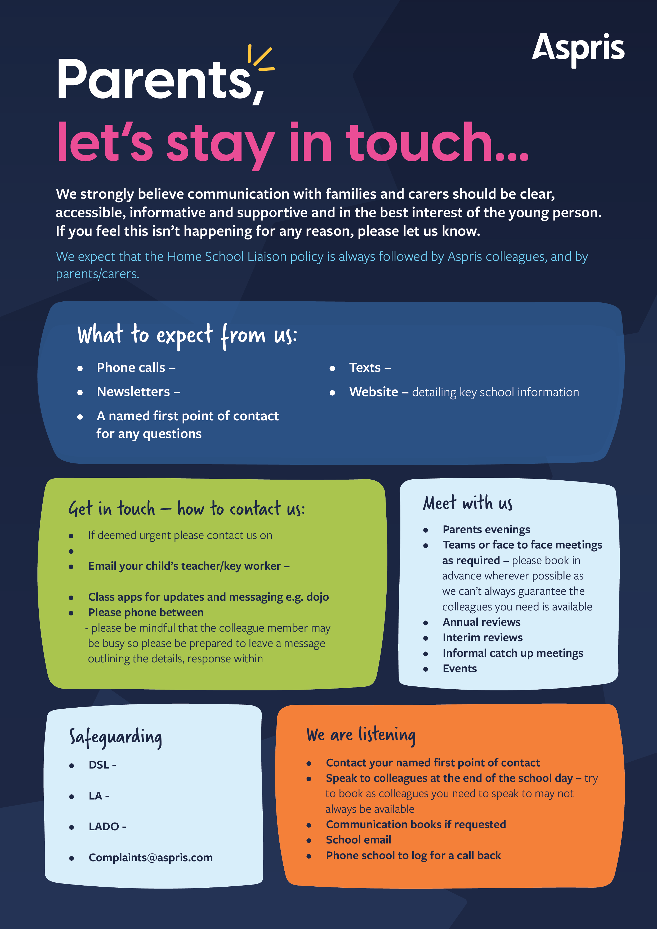
Kimberely Clarke
KimberleyClarke@AsprisCS.co.uk
response within (4 days) latest for non-urgent
NewburyManorSchool@AsprisCS.co.uk
4 days
Somerset Council
childrens@somerset.gov.uk

0800-1600
SSCP
Somersetsafeguardingchildren.org.uk

01373 814980
Termly
When required
Weekly

