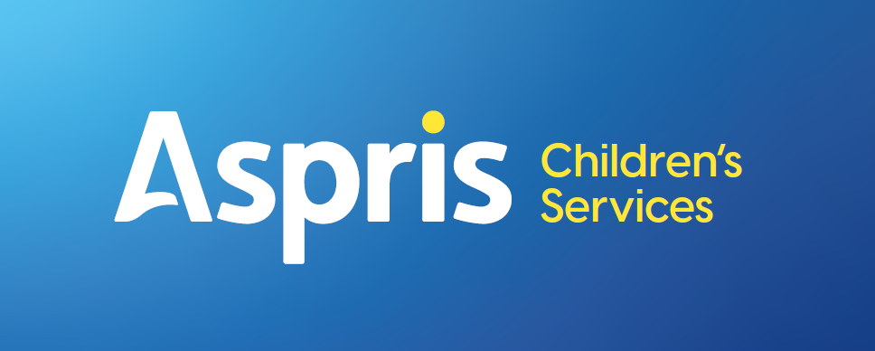

Newbury Manor School



Equal Opportunities and English as an Additional Language
March 2026
Local Procedure Title | Equal Opportunities and English as an Additional Language
Site | Newbury Manor School
ECS Policy number and title | ECS 26 Equal Opportunities & English as an Additional Language
Local procedure template reference | ECS LP: EAL
Local procedure date | March 2026
Local procedure review date | March 2027
Local procedure author(s)
Local procedure ratification | Checked and approved by: Paul Gorham

- Introduction
The term EAL is used when referring to pupils where the mother tongue is not English. This document sets out the Local Procedure with regard to meeting the needs of EAL pupils within Newbury Manor school.

It is recognised that pupils at Newbury Manor School with EAL also have a SEN and this is targeted with additional support. This means that pupils at Newbury Manor School will work on an adapted curriculum to suit their personal and individual needs.

The School’s English as an Additional Language (EAL) local procedure was developed in consideration of the Special Educational Needs (Information) Regulations (Clause 65). It is written as guidance for staff, parents and children and with reference to: SEN Code of Practice (which takes into account the SEN provisions of the SEN and Disability Act 2001) September 2014, ISI Integrated Handbook – Regulatory Requirements, January 2015).
- Aim
At Newbury Manor School we aim to ensure that:
- The school “makes adequate provision for groups of pupils with … other specific needs, such as English as an additional language.” (ISI Integrated Handbook – Regulatory Requirements January 2015,.37)
- EAL children are identified, and teachers are aware of their pupils’ language needs, to ensure they are able to access a broad curriculum and are supported in achieving their potential.

Newbury Manor School recognises that:
- EAL pupils’ ability to access the curriculum may be ahead of their English language skills
- EAL is not SEND (“special educational need / disability”) or a “learning difficulty”
- EAL pupils may have additional needs in accessing the language used by staff and peers, with related learning issues, which can lead to underachievement and isolation
- All teachers are teachers of pupils with individual needs, and are responsible for developing children’s spoken and written language skills to raise pupils’ achievement
- Language is effectively developed in a purposeful context across the curriculum
- Teaching and support staff play a crucial role in modelling uses of language
- Language is central to identity, and the views of the pupil and parents are considered in supporting a pupil’s learning

Newbury Manor School will:
- Ensure the School meets the full range of need of pupils who are learning English as an additional language; EAL
- maintain pupils’ self-esteem and confidence by acknowledging their Skills in their own languages
- welcome and value the cultural and linguistic experiences that EAL pupils bring to the wider school community
- encourage and enable parental support in improving their child’s academic and social progress
- help EAL pupils to become confident and able to fulfil their academic and social potential
- be able to assess the skills and needs of pupils with EAL and to give appropriate provision to individuals throughout the school
- Objectives
In providing for the needs of pupils with English as an Additional Language the School:
- Recognises that pupils with English as an additional language will need more time to process and respond to instruction and direction
- Gives newly arrived pupils time to absorb English, when they may show that they understand more English than they use
- Recognises the pupil’s mother tongue; boost the pupil’s self-esteem by allowing them to use their mother tongue to explore concepts
- Identifies individual pupils’ strengths and encourage them to transfer their knowledge, skills and understanding of one language to another
- Uses collaborative learning techniques including augmentative communication systems such as pictures and symbols
- Where possible, groups pupils so that EAL pupils hear good models of English
- Can manage the level of stimulation, as the classroom needs to be socially and intellectually inclusive, valuing cultural differences and fostering individual identities
- Role of the Teacher
At Newbury Manor School, it is expected that teachers will:
- Be knowledgeable about pupils’ abilities and needs in English
- Use this knowledge effectively for planning, pupil grouping and use of resources
- Build up a caring, trusting and supportive relationship where different points of view are listened to, and self-esteem is developed
- Be sensitive to differences in pupil’s learning styles and rates of learning
- Provide augmentative communications such as pictures / symbols to clarify instructions and support understanding for EAL pupils
- Maintain the student’s individual plan.
- Be aware of own language use and position as a role model
- Use effective questioning to promote all aspects of learning
- Be aware of the need for planning progressively across the curriculum, differentiating for all individual needs
- Re-enforce vocabulary across the curriculum
- Keep records and monitor progress
- Direct learning support assistants, with clear and informed instruction, how to work with EAL pupils
- Access and Support
Monitoring and evaluation will take place regularly through termly progress reports, review of the student’s individual plan, an annual report and review of EHCP.

- The organisation and management of the classroom environment is crucial to support the learning of all pupils and must incorporate the diverse SEN/ASD/EAL needs within each class group. Each pupil will access the full school curriculum linked to individuals as assessed and which will be reviewed regularly
- The organisation of learning spaces will vary to suit the purpose, context and pupils involved. The needs of all pupils will be identified and met through effective curricular programmes and support arrangements
- Attention will be given to classroom layout, wall displays, access to a diverse range of resources including resources from other cultures.
- For pupils who are functioning below that of their peers in English, withdrawal support will take place to address specific language or learning needs
- At Newbury Manor school, pupil’s learning of English as an additional language will build on pupil’s experiences of language at home and in the wider community allowing pupils develop their understanding and use of English
- Pupils will have opportunities to engage in speaking and listening activities in English with peers and adults
- Where appropriate, an interpreter will be sought in order that communication between the school and family effectively supports the home school relationship and programme continuity for individual pupils
- SLT
At Newbury Manor School, the role of the SLT is to:
- Ensure that all staff are aware of the school’s policy/procedure on pupils with EAL
- Ensure relevant information on pupils with EAL reaches all staff
- Monitor the effectiveness of the teaching of pupils with EAL is monitored and assessed regularly.
- Give guidance and support to set appropriate targets and plan appropriate work
- Ensure targets for pupils learning EAL are set and met
- Monitor standards of teaching and learning of pupils with EAL
- Monitor progress and identify learning difficulties which may be masked by EAL
- Role of ICT in Supporting and Developing EAL
We aim to make maximum use of ICT to promote pupils’ English, as well as developing competence in ICT skills. All pupils will have the opportunity to access computers and other appropriate technology such as I-pads. The Internet opens a whole new world to our pupils, and it can be used to develop and foster skills and interests such as reading, listening, thinking, writing, and researching to name but a few.
- Parental Involvement
We believe that the education of our pupils is a collaborative enterprise involving teachers, parents and carers, pupils and the wider community. Regular and positive communications will be made between teachers and parents and carers, on a formal and informal basis.

We aim to harness the support of the family / residential home and to stimulate greater support in order to enhance all pupils’ English development.

Opportunities to promote parental involvement include:
- Daily / weekly communication for both day and residential pupils via a communication book or e-mail dependent on parental preference
- Regular phone contact
- Parents / Carers will be invited to attend their child’s Annual Review / LAC etc.
- Progress reports will be shared with parents / carers every term / 2 times per year
- Parents / Carers will be invited to whole school social events such as the summer fair and sports day
- Equal Opportunity Statement
All staff will aim to treat every child as an individual, and will respect their individuality, regardless of gender, race, sexual orientation, academic or physical ability or socio-economic background. The staff will be aware of stereotyping in their selection of resources.
- Monitoring and Evaluation
Monitoring and evaluation take place regularly through termly progress reports, review of the student’s individual plan, an annual report and review of EHCP, to ensure that:
- The effectiveness of the English as an Additional Language provision provided by the school is evaluated by the Head Teacher and SENCO.
- The English Lead has input into the EAL policy.
- The English as an Additional Language policy is a working document and is kept under constant review. Feedback on the policy is welcomed by all staff. The policy will be formally reviewed annually by the Head Teacher and SENCO.

