

Newbury Manor School

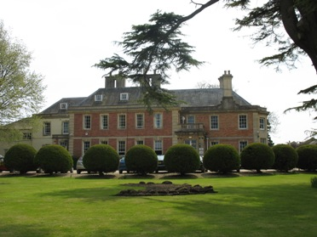

Equality, Diversity & Inclusion Statement and Objectives
March 2026

Introduction

Aspris has a statutory responsibility to have due regard for the Equality Act 2010 and the Human Rights Act 1998. It is therefore essential that Aspris achieves a culture where unlawful discrimination is not tolerated. Aspris is committed to ensuring that equality, diversity and inclusivity is the responsibility of all colleagues and so make the following commitment.

Aspris Policy AHR04.1 Equality, Diversity and Inclusion

What does Equity, Diversity & Inclusion mean at Aspris?

At Aspirs equity, diversity, and inclusion mean creating an environment where everyone belongs and feels, valued, respected and empowered to thrive.
Equity ensures everyone has fair opportunities to succeed by addressing barriers and providing the right support based on individual needs. This means ensuring policies, career progression and workplace adjustments are accessible and applied consistently across all schools, homes, colleges and teams.
Diversity recognises and celebrates the unique perspectives, skills and experiences everyone brings. Our difference makes us stronger, and we’re committed to fostering a workplace that represents the communities we support.
Inclusion means everyone can belong at work without fear of discrimination or exclusion. It’s about embedding inclusive behaviours in everyday interactions, leadership and decision-making, ensuring that regardless of role, everyone has a voice and feels part of the wider Aspris community.
At Aspris, EDI isn’t just about compliance or occasional initiatives, it’s about doing the right thing by embedding fairness, connection, and belonging into our culture every day.

Aspris Equality Objectives

- Empower, engage and support colleagues
- Provide inclusive leadership at all levels
- Ensure that our recruitment and selection process is fair and consistent throughout
- Deliver better outcomes, improved access and outstanding service levels
- Have a representative and supportive workforce

Newbury Manor School Vision

Newbury Manor will be a place where all children feel safe, loved and valued, where they will be given the tools, guidance and support to meet aspirational goals focused on developing independence, life skills, employment and fulfilling a positive contribution within their community.

Newbury Manor School Values

At Newbury Manor School our ‘Peacock’ Values are Perseverance, Equality, Aspiration, Compassion, Opportunity, Courage, and Knowledge. Our aims is that diversity and inclusion are at the heart of what we do, and we celebrate and meet individual needs so that all members of our school community are free to live, learn and achieve to their full potential. We aim to:

- Lead by example in showing respect and inspire others to practice it.
- Maintain and promote positive working partnerships between the school, parents and the wider school community which fosters respect, honesty, co-operation and tolerance.
- Empower students to explore and understand the world around them and embrace diverse values and mutual respect.
- Provide opportunities for students to explore their own culture and identify, and that of others.
- Create an inclusive environment where everyone’s needs and abilities are respected and supported.
- Provide every student with the best opportunities to thrive and achieve their full potential.

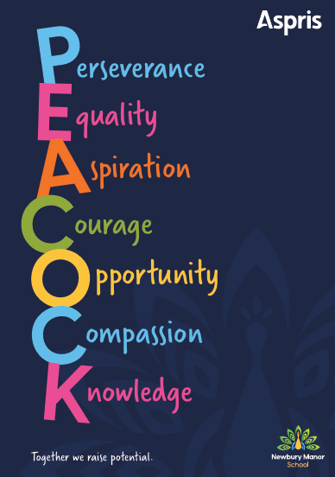

Equality, Diversity and Inclusion Objectives, Newbury Manor School

Objective | How will we achieve this objective
To ensure that all colleagues and students are able to access the environment and that reasonable adjustments are made to cater for individual needs. | Ensure that students and staff are able to feel comfortable in their school and access all areas of the school successfully. Procedures and documents to support this include PEEPs, Risk Assessments (individual students or staff), therapy referrals and support (students), support for colleagues to access EAP / Occupational Health if required.
To ensure all students, staff and stakeholders to feel valued, included and understood in their school environment. | Celebrate differences and promote inclusion through promotion of awareness days and events. Student assemblies, rewards systems, promoting student voice groups and Diversity Rocks group.
To ensure accessibility across the school for students, staff and visitors with disabilities, including access to specialist teaching and support. | Regular environment walks and working collaboratively with H&S / Estates teams. Student centred planning for any reasonable adjustments.
To provide appropriate and early pastoral interventions for students to promote positive behaviour and inclusion for all groups. | All staff to be trained in TIS (trauma informed schools) with lead practitioners working collaboratively with Pastoral Manager, Teachers and Support Staff. MDT Meetings to be held to identify planned interventions and support. Therapy and ELSA support.
To promote and monitor involvement of all groups of students in the extracurricular activities of the school. | Provide a holistic curriculum that includes life skills sessions and opportunities, cooking / food technology, therapy support including ELSA and social skills groups. Promoting Wellbeing Wednesdays and Diversity Rocks group.
To promote cultural understanding and awareness, valuing and celebrating various cultures, religious beliefs and LGBTQ+ within the NHH community. | Celebrate differences and promote inclusion through promotion of awareness days and events. Student assemblies, rewards systems, promoting student voice groups and ‘Diversity Rocks’ group. Provide a curriculum that offers PHSE and Personal Development.

