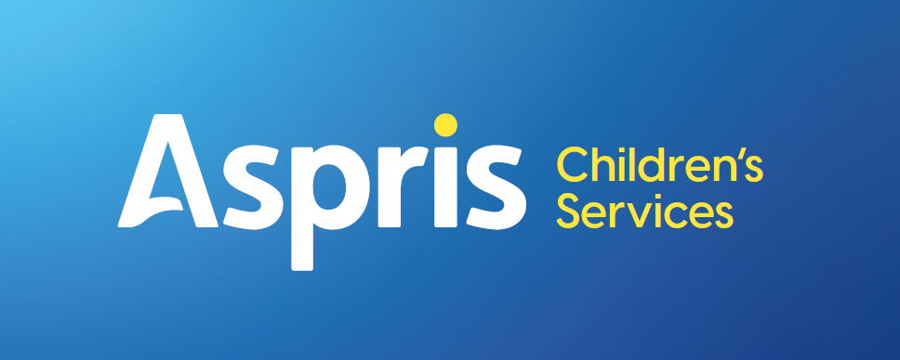

Newbury Manor School



Remote Education / Home Learning
March 2026

Introduction

Where home learning/remote education is deemed appropriate or necessary to support students, teachers will provide an individualised home learning pack. Using the knowledge of each student, prior evidence of learning and termly assessment, the pack will provide appropriate resources to maintain and continue learning. This will be through a mixture of face-to-face support, Microsoft Teams meetings and independent work. This will be agreed on an individual basis with the parents/carers and any professionals involved.

Organising the Remote Learning

An initial phone call or meeting with the parent/carer will take place to discuss what work/activities/learning will be taking place and what resources will be needed. Where the student will engage in a Microsoft Teams or face to face learning this will be organised, and a set schedule adhered to. Where face-to-face learning is taking place, this will be set out as an agreement between the parents/carers and professionals detailing the expectations and lengths of the visits or calls.

The Curriculum

At Newbury Manor School students will follow a bespoke home learning curriculum that will be guided and set to meet the learners needs. Wherever possible it will match the learning that takes place in school however, where this is not possible staff will make appropriate adaptations.

Teaching Time

At Newbury Manor School, whilst we aspire for our students to engage in 3 to 4 hours home learning per day this will always be dependent upon the how the child will respond to working with the parent/carer or staff in the home environment. The priority is to keep our students calm and safe whilst supporting them through a period of home/remote learning.

Accessing Remote Education

The resources sent home will be bespoke to the individual student and their level of learning. The resources that will be sent home will be paper based/practical resources to engage the SEN pupils in their learning. For those pupils able to access new technology links to on- line learning activities such as Maths games/English activities will be sent home, connected to the skills they are learning. Where students will be accessing individual home learning, packs will be posted out to parents/carers. Where practical activities are unable to be posted, these will be delivered to the home by a familiar member of staff. It will then be organised that these packs are returned to school once completed, marked and feedback given and a new pack will be sent out.

Engagement and Feedback

The expectations for the child’s engagement and the support parents and carers should provide at home

• To keep the pupil safe when at home and encourage engagement in learning through the appropriate learning activities provided by the school.
• Where able to comment on the work completed, which can be done through a phone call with the teacher or via email. Where student’s home learning is more practical photographs can be taken of them completing the activity as evidence.

At Newbury Manor School we will monitor how the student is engaging with the work and discuss any concerns the parents/carers may have through the following:

• Twice weekly phone calls with the parents/carers and emails from the teacher
• Completed work that is returned to school for the teachers to mark and inform future work set. If work is posted from school to home, a stamped addressed envelope will be included in the pack for the parents / carers to return the work to school in if the child is remote learning for longer than a week.
• Parents/carers can send photographs of the pupil completing an activity, particularly if it is practical. These can then be emailed to the teacher with a comment on how the pupil completed the activity.
• For a student who is struggling to engage in home learning with parents/carers a discussion will take place between the parent/carer and teacher as to how the activities can be adapted to encourage engagement from the student.

Assessing students’ work and progress at Newbury Manor School will be undertaken through
• The work returned to school by the parents/carers
• Photographic evidence recorded by parents/carers with comments from the par ents / carers and emailed to the teacher/Instructor.

Additional Support

At Newbury Manor School we recognise that some students may not be able to access remote education. We acknowledge the difficulties this may place on families, and we will work with parents and carers to support those pupils in the following ways:
• Regular communication with the parent/carer, twice weekly phone calls.
• Liaison with the Therapy team and appropriate small sensory resources purchased to send home to support the pupils to engage in learning and help them to self-regulate.
• Daily online calls with the students, where appropriate, in order to help engage them in their learning. The regularity of the zoom call will be discussed with the parent/carer on an individual basis.
• Pupils who have direct time with a Speech and Language Therapist and Occupational Therapist will receive:
- A weekly phone call/ online call to discuss support and resources required at home.
- A home learning activity to continue their communication/ sensory learning
- A weekly review to agree any amendments required to continue achieving outcomes.

