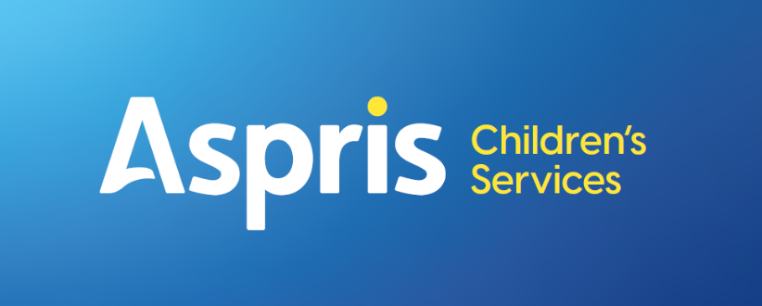
Newbury Manor School

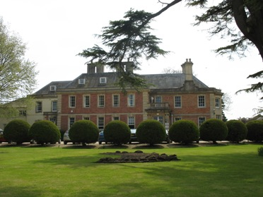

PSHRE Procedure
September 2025-26

Newbury Manor – Personal, social and health education Local procedure

All pupils at Newbury Manor School have an Education, health and care plan (EHC). The EHC communicates to us that these students have a variety of diagnoses. These include ASD, PDA, ADHD, dyslexia, dyspraxia, anxiety, sensory processing difficulties, language and communication disorders and behaviour difficulties. All programmes of study are carefully planned in order to engage pupils in learning, whilst lowering their anxiety and ensuring there are maximum opportunities for success. These individualised, bespoke programmes may initially start from pupils’ own interests and may incorporate the outdoor environment and work in the wider community.

Aims and objectives

Personal, social and health education (PSHE) and relationships and sex education (SRE) enables children to become healthy, independent and responsible members of society. We encourage our pupils to play a positive role in contributing to the life of the school and that of the wider community. In so doing we help develop their sense of self-worth. We teach them how society is organised and governed. We teach them about rights and responsibilities. They learn to appreciate what it means to be a positive member of a diverse multicultural society.
The aims of PSHRE are to enable the children to:
- Know and understand what constitutes a healthy lifestyle
- Be aware of safety issues
- Understand what makes for good relationships with others
- Have respect for others
- Be independent and responsible members of the school and wider community
- Be positive and active members of a democratic society
- Develop self-confidence and self-esteem, and make informed choices regarding personal and social issues
- Develop good relationships with other members of the school and the wider community
- Work as part of a small group taking turns, negotiating and problem solving.
- Acquire a basic knowledge of sex and relationships education at a level appropriate to individuals or small groups.
Teaching and learning style
Newbury Manor uses a range of teaching and learning styles. We place an emphasis on active learning by including the children in discussions, investigations and problem-solving activities. We encourage the children to take part in a range of practical activities that promote becoming active members of society e.g. charity fundraising, the planning of school special events such as a theme lunch or involvement in an activity to help other individuals or groups less fortunate than themselves. Whole school themed events and termly charity events give children the opportunities to develop their social and cultural awareness. Pupil voice is celebrated through the school council, where elected members contribute to weekly meetings.
We organise group activities in such a way that pupils are able to participate in discussion to resolve conflicts or to set agreed classroom rules for behaviour. We provide opportunities for the children to hear visiting speakers, such as health workers, police, and representatives from the local church, whom we invite into the school to talk about their role in creating a positive and supportive local community.
PSHE/RSE Curriculum Overview
The RSE curriculum is designed to support our students to better understand themselves, the world around them, the working world and offers guidance in managing different relationships that they might encounter. Each topic covered across the RSE curriculum is planned and adapted to best meet the needs of the students and has the flexibility to offer tailored learning to focus on current affairs, personal circumstances that occur throughout the year. Across the year, all students will focus on the same overarching topic area for a term, with the content differentiated per year group and age suitability within certain topics. The three areas within the RSE curriculum are Health and Wellbeing, Relationships and Living in the Wider World. Primary students will spend time learning about different relationships, how to build positive friendships and support available around relationships.
Relationships and Sex Education
For students in Year 6 and above, each year they will have sessions within the relationship theme around sexual education. This will be tailored to the age and understanding of each group and follow the national curriculum guidance for each age group. To support our students when entering into the wider world, consent will be covered from Primary upwards and differentiated in context for each through use of the NSPCC PANTS campaign for younger students, to more direct education for Secondary students. Due to the context of the school setting and the background of many of our students, topics such as FGM are not covered until upper key stage 4. The nature of the topics covered in RSE can be quite challenging for students to access at times therefore RSE is delivered in a more informal manner, with group discussions allowing for explicit and implicit teaching of content, giving students the chance to ask questions and discuss their thoughts and feelings in a safe way.
PSHRE curriculum planning
We teach PSHE in a variety of ways. In some instances, we teach PSHRE as a discrete subject where the content may be of a sensitive or emotive nature.
Some of the time we introduce PSHRE through other subjects, e.g. when teaching about local environmental issues in geography, we offer pupils the opportunity to explore who is responsible for the planning of proposed local developments. There is a large overlap between the programme of study for religious education and the aims of PSHRE, we teach many of the PSHRE objectives through our religious education lessons.
Within some classes group PSHRE lessons are taught on a weekly basis. In other classes PSHRE is taught on a one-to-one basis.
Equals curriculum
For those students following the Equals curriculum: pre formal and semi formal, planning will be based upon the outcomes stated in their individual EHCP. Equals curriculum supports learning based around:
- Social Emotional and Health,
- Communication,
- Cognition and Learning,
- Physical and independence needs. All these areas involve elements of PSHE.

The Equals curriculum compliments these needs by its’ focus on planning for the following.
- My Independence
- My Physical Well-Being
- The World about me
- My Arts
- My Outdoor
- My Play
- My Thinking and problem solving.
They are based on a holistic style of learning that encompasses the engagement, motivation, and greater need for each individual student.
Assessment and recording
Teachers assess the children’s work in PSHE by making informal judgements as they observe them during lessons or within the school during less formal learning activities. We have clear expectations of what the pupils will know, understand and be able to do at the end of each key stage often linked to individual EHCP’s. These observations and link into the social progress assessments that is undertaken twice yearly via the assessment tools outlined in the curriculum procedure.. Progress is also tracked their TLG’s taken from the Golden Thread documents- data is collected three times per year from these documents across the school. to assess, show progress and highlight gaps. The TLG targets are often linked to PSHE outcomes.
Resources
We use various resources to teach PSHE including those connected to the PSHE association following the three core themes.
CORE THEME 1: HEALTH AND WELLBEING CORE THEME 2: RELATIONSHIPS CORE THEME 3: LIVING IN THE WIDER WORLD Resources are held by the individual teachers and, but key documents are held by the class teachers.
Equals curriculum.
Links to other curriculum documents

Priory Curriculum Policy ES08
Newbury Manor curriculum – local procedure
Local procedure – Guide to Marking and Feedback

Date written: September 2020
Last reviewed: September 2025
Added by Nina Clayton September 2022
Review date: September 2025
Next review: September 2026

