Local Procedure Title | Attendance
Service | Newbury Manor School
ACS Policy number and title | ACS 61 Attendance
Local Procedure template reference | ACS LP 61
Local Procedure date | March 2026
Local Procedure review date | March 2027
Local Procedure Author(s) | Paul Gorham
Local Procedure Ratification | Checked and Approved by: Rebecca McArthur

- Aims
Newbury Manor School believes that regular attendance at school is vital to young people achieving their full potential academically, socially, and personally. We understand that individual students may have had a disrupted education prior to joining Newbury Manor and that they may require a phased transition into school to be successful and our goal is to support fulltime attendance within 6 weeks. While we appreciate that some young people with Autism suffer from anxiety that may affect their school attendance, our aim with partnership with parents, is that all our students will ultimately attend school on a full-time, regular basis to take full advantage of the opportunities that are open to them.

Our school aims to meet its obligations with regards to school attendance by:
- Promoting good attendance and reducing absence, including persistent absence (attendance of less than 95% of timetabled sessions).
- Ensuring every pupil has access to full-time education to which they are entitled
- Acting early to address patterns of absence
We will also support parents to perform their legal duty to ensure their children of compulsory school age attend regularly.

- Legislation and Guidance
Our attendance procedure meets the requirements of the school attendance guidance from the Department for Education (DfE), and refers to the DfE’s statutory guidance on school attendance parental responsibility measures. These documents are drawn from the following legislation setting out the legal powers and duties that govern school attendance:
- The Education Act 1996
- The Education Act 2002
- The Education and Inspections Act 2006
- The Education (Pupil Registration) (England) Regulations 2006
- The Education (Pupil Registration) (England) (Amendment) Regulations 2010
- The Education (Pupil Registration) (England) (Amendment) Regulations 2011
- The Education (Pupil Registration) (England) (Amendment) Regulations 2013
- The Education (Pupil Registration) (England) (Amendment) Regulations 2016
- The Education (Penalty Notices) (England) (Amendment) Regulations 2013
Working together to improve school attendance 2022 (Updated Aug24)

- School Procedures
3.1 Attendance register
By law, all schools (except those where all pupils are boarders) are required to keep an attendance register, and all pupils must be placed on this register. The attendance register will be taken at the start of the first session of each school day and once during the second session. It will mark whether every pupil is:
- Present
- Attending an approved off-site educational activity
- Absent
- Unable to attend due to exceptional circumstances

The school day starts at 08.45, although the registration period is between 8.45 and 9.15am as children arrive at staggered times.

3.2 Unplanned absence
Parents must notify the school on the first day of an unplanned absence (for example, if their child is unable to attend due to ill health) by 08.30 or as soon as practically possible (see also section 6). Parents/Carers should contact the school by phone by 08.30 and either notify a member of the administrative staff or leave a message on the school answerphone (Tel: 01373 814980). Messages must be clear and state both the child’s name and the reasons for absence. Messages must not be passed through taxis or escorts and must come directly from the legal parent or guardian. The decision to authorise absence rests with the Head Teacher. The reasons must be clear and acceptable. Newbury Manor School recognises that working with parents to identify reasons for absence, trends and early decline in attendance will help support our students maintain high attendance. Staff phoning about poor attendance will ask sensitive but probing questions to support all the family in the process.

In this example one can see how small amounts of lost time can build.
- 90% attendance means that a student is absent from lessons for the equivalent of one-half day every week.
- If a student had 90% in a school year, they have missed the equivalent of four whole weeks (a month).
- If the student continued this pattern over five years they will miss the equivalent of about one half of a school year.
- Habits of poor attendance and lateness in school are often repeated in working life which is why employers ask the school for such information as part of references.

On the rare occasions where school is not satisfied about the authenticity of the illness, the absence will be recorded as unauthorised, and parents will be notified of this in advance.

3.3 Medical or dental appointments
Missing registration for a medical or dental appointment is counted as an authorised absence; advance notice is required for authorising these absences. However, we encourage parents to make medical and dental appointments out of school hours where possible. Where this is not possible, the pupil should be out of school for the minimum amount of time necessary (e.g. attend school in the morning and leave for the medical appointment in the afternoon).

Parents/carers should notify the school in advance of medical or dental appointments by email or letter. A copy of the appointment card/email will be required by the school. Applications for other types of absence in term time must also be made in advance. Information relating to whether the school can authorise such absences can be found in section 4.

3.4 Lateness and punctuality
A pupil who arrives late but before the register has closed 09:15 in the morning will be marked as late, using an L code. A pupil who arrives after the register is closed will be marked a U code- (arrived in school after registration closed) This means they are present in school but goes as an absence. (Gov. guidelines)
In exceptional circumstances the Head Teacher can authorise a change of code such as taxi or transport issues, in which case they will be marked as late but present. Where transport issues repeatedly result in lateness, we will notify the parent / carer and the relevant Local Authority transport team.

3.5 Following up absence
The school will follow up any absences to ascertain the reason, ensure proper safeguarding action is taken where necessary, identify whether the absence is approved or not, and identify the correct attendance code to use. If the school has not been notified of the reason for absence by 09.15, we will attempt to contact parents/ carers by phone. If the child has a child protection plan, we will also notify the child’s social worker of the absence.

3.6 Reporting to parents
Attendance will be reported to parents /carers in the written termly report that is issued at 2 points in the year, Christmas and summer.

3.7 Lesson attendance
Teachers will monitor and record attendance at each of their lessons using the Peacock Points spreadsheet. Teachers are responsible for managing the pupils throughout this lesson. Where a pupil fails to turn up or leaves prior to the end of the lesson teachers will either manage this between them and their TAs i.e. they go and locate the student and support them and or engage support to locate the student.

3.7a Support to locate the student not in lessons

- Term time leave
4.1 Granting approval for term-time absence
The school considers each application for term-time absence individually, considering the specific facts, circumstances and relevant context behind the request. A leave of absence is authorised entirely at the Head Teacher’s discretion.

A parental request must be made in writing prior to the date of the proposed term time absence and be agreed in writing by the Head Teacher. The Head Teacher will specify the number of days that the absence is authorised – any child not returned to school on the expected date will be considered a ‘Child Missing from Education’ and will be referred to their Local Authority as a safeguarding concern.

4.2 Valid reasons for authorised absence
These may include:
- Medical /dental appointments – as explained in sections 3.2 and 3.3
- Religious observance – where the day is exclusively set apart for religious observance by the religious body to which the pupil’s parents belong.
- Traveller pupils travelling for occupational purposes – this covers Roma, English and Welsh Gypsies, Irish and Scottish Travellers, Showmen (fairground people) and Circus people, Bargees (occupational boat dwellers) and New Travellers. Absence may be authorised only when a Traveller family is known to be travelling for occupational purposes and has agreed this with the school, but it is not known whether the pupil is attending educational provision
- Leave of absence approved by the school.
- Mental health and wellbeing.
4.3 Unauthorised absences
These include:
- Term time leave without prior approval
- Refusal to attend school that is not considered to result from medical needs or anxiety linked to Special Educational Needs
- Leave for student birthdays

Newbury School will address unauthorised absence by:
- Contacting parents / carers / meeting with them to follow up the reasons for absence
- Monitoring attendance patterns
- Working with young people, parents and carers to address the reasons for the absence
- Instigating attendance plans where necessary
- Notifying the Local Authority where there are attendance concerns
- Contacting Children’s’ Social Care where there are safeguarding concerns
4.4 Persistent absence
Persistence absence is defined as an absence record of less than 85% attendance. Data will be reviewed at safeguarding meetings, and the circumstances of the individual student looked at. In the first instance tutors will look to support pupils and families in identifying reasons and addressing these. This supportive process will start when attendance drops below 85%. The impact of this intervention will be monitored for positive trends.
If the absence % continues to fall i.e. below 80% then other agencies will be informed, e.g. local authority. SLT will coordinate therapy, teacher and residential (where relevant) meetings to discuss further supportive steps which will be communicated with parents and relevant stake holders. Plans will be put in place to monitor absence over a 6-week period. If the % continues to decline the Local Authority will be notified and an emergency annual review will be called.
See appendix 1
- Strategies for promoting attendance
Good attendance is rewarded through end of term attendance certificates. Certificates are also awarded to students who have made the greatest improvement to their attendance. Where there are concerns about attendance, the student’s tutor plays a critical role in working in partnership with parents/ carers to identify possible causes for non-attendance and to implement agreed strategies to improve the child’s attendance.

- Attendance monitoring
Our Teachers and Admin monitor pupil absence daily. Parents /Carers are expected to call the school before 08.30 if their child is going to be absent due to ill health (see section 3.2). If a pupil’s absence extends beyond 5 days, we will contact the parents to discuss the reasons for this. If after contacting parents /carers, a pupil’s absence continues to rise, we will notify the Local Authority. The persistent absence threshold is 15%. If a student's individual overall absence rate is greater than or equal to 15%, the pupil will be classified as a persistent absentee. Pupil’s attendance data is reported each term to parents via reports and annual via reviews. Our attendance is recorded within our governance reports. We use a secure online management information system to record and store attendance data. Senior leaders regularly track and analyse attendance data of individuals and cohorts and identify concerns and trends. We utilise the data to inform the need for interventions and support.

- Roles and responsibilities
7.1 Governance
The Regional Director is responsible for monitoring attendance figures for the whole school on, at least, a termly basis. They hold the Head Teacher to account for the implementation of this procedure.

7.2 The Head teacher
The Head Teacher, Paul Gorham, is responsible for ensuring this procedure is implemented consistently across the school, and for monitoring school-level absence data and reporting it to governance. The Head teacher also supports other staff in monitoring the attendance of individual pupils.

7.3 Engagement Leads
Teachers: (supported by Admin)
- Checks registers twice daily and liaises with parents /carers and tutors regarding absence and lateness
- Records attendance data provided by Alternative Providers
- Monitors attendance data at the school and individual pupil level
- Reports concerns about attendance to the Head Teacher
- Arranges calls and meetings with parents to discuss attendance issues

Teachers are responsible for recording attendance daily on the school information management system, using the correct codes (see appendix 2). They are also responsible for liaising with students and parents / carers regarding attendance.

7.4 Administrative staff
Administrative staff take calls from parents concerning absence and convey messages regarding attendance to the Teacher/Tutor, Pastoral Support Team or the Senior Leadership Team as appropriate.

- Welfare Checks
Parents and Carers will need to be aware that for persistent and long-term absence, regular welfare class and check-in will need to be made in accordance with local and wider safeguarding arrangements. These welfare calls will take part daily unless other arrangements have been made and are designed to ascertain the child’s welfare. In addition to this, face-to-face welfare calls either virtually or in person will need to be completed to ensure that we have seen the child in person and can vouch for their safety/wellbeing.

- Monitoring arrangements
This policy is reviewed annually by the Head Teacher and is approved by the Regional Director.

10. Nominated Attendance Champions
Our nominated attendance champions are:
Kimberley Clarke
Paul Gorham
Danielle Boorer

  - Part time timetables
There are occasions when students are unable to manage attending school all day or even every day, this could be for medical issues, or for anxiety issues. We all value the importance of being at school and making the most of the time which is why we use Part time timetables or Reduced Education Programmes (REPs) as a last resort and as part of a planned reintegration programme.

If attendance falls below our threshold of 85% and there has been no improvement following both an ‘Attendance Letter’ and an ‘Attendance Meeting’, the decision will be made to call a review meeting with the local authority, parents and the school to discuss how to progress. Collectively a carefully designed six-week plan will be created demonstrating how attendance can return to 100%. This will be reviewed after six weeks unless the steps are not being met in which case an Interim Review will be called to discuss the placement at the school. Part of this timetable planning might include the use of an Alternative Provider (AP) if this is deemed appropriate. Attendance will be monitored at both school and the AP and reviewed frequently (half termly).

Sometimes new students will start on a phased entry or transition into the school. These are planned to be successful within 6 weeks. Our expectation is that students will settle into the school routines smoothly within this time and will be recorded as C2.

  - Links with other policies
Safeguarding Children OP06
Running Away / Missing ECS06
Missing Child Procedure ECS06

Contents Checklist (Local Services may add additional items – this is a core list)
Aims of Local Procedure |  | Reporting to Parents/Carers
Local Responsibilities |  | Authorised and Unauthorised absence
Unplanned Absence |  | Strategies for promoting attendance
Following up Unexplained Absence |  | Attendance Monitoring
Persistent and Severe Absence |  | Revised DfE attendance codes and explanatory notes box
Penalty fines |  | Commissioning an Education Welfare Officer
Nominated Attendance Champions |  | Part- time timetables (C2)

Local Procedure Review History:
Date Reviewed | Reviewer | Summary of revisions

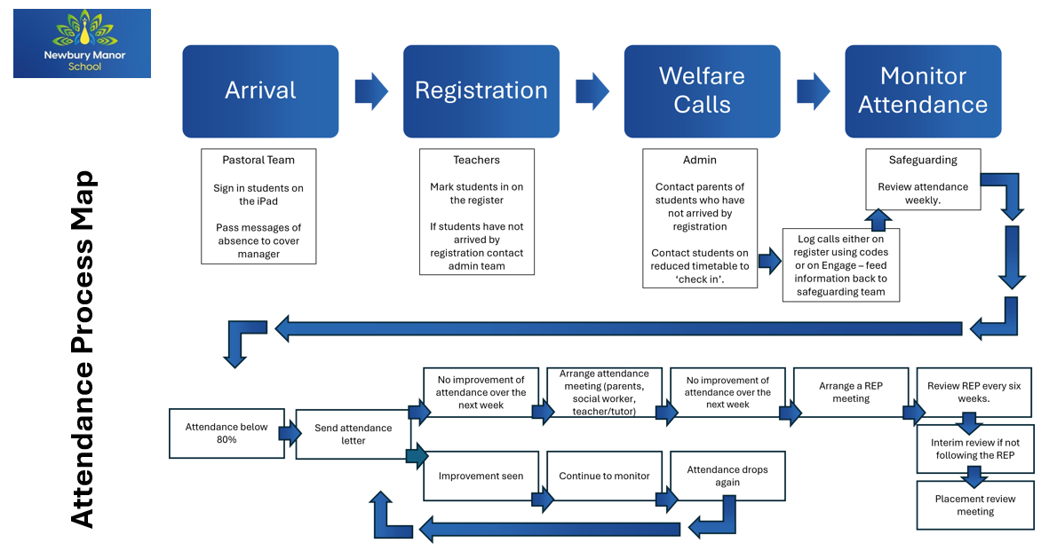
Appendix 1 – Attendance Process Map

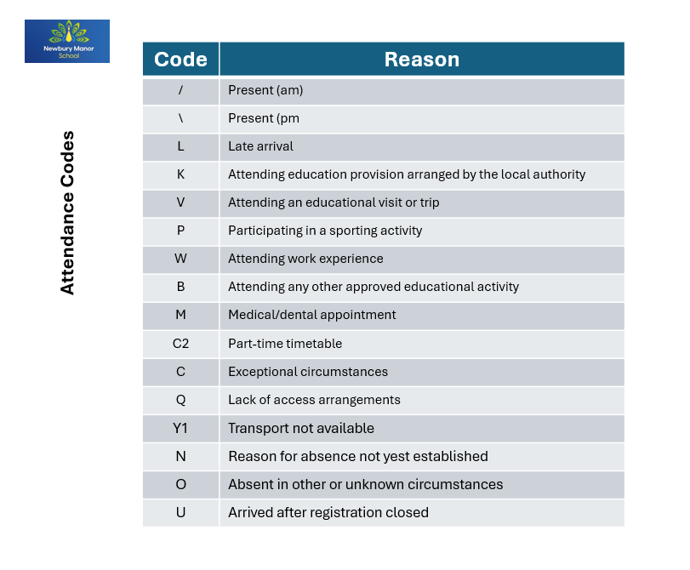
Appendix 2 – Attendance codes

Appendix 3 – Recording Welfare Checks
Name | Date Last Attended Session | Date of Welfare Call | Date of Welfare Visit

