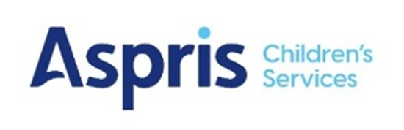

Newbury Manor School

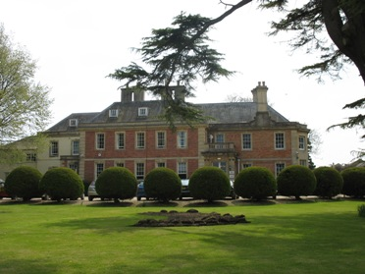

Complaints Procedure

Careers Education Local Procedure
September 2026

Newbury Manor School
Newbury Manor Local Procedure for Careers Curriculum, Careers Information, Advice and Guidance (CIAG) and Work Experience

Rationale
We aim for our careers education programme to make a major contribution to preparing our young people for opportunities, responsibilities and life experience to help them make decisions and manage transitions as learners and workers. It is vital that all pupils who attend Newbury Manor School have the opportunity to develop the knowledge and skills they need to make informed choices and achieve economic wellbeing in later life.

Aims
Newbury Manor School is committed to offering a planned careers programme for all pupils through implementing a whole-school approach. In line with the Gatsby Benchmarks (revised November 2024) our aim is that “Every year, in every subject, every pupil should have opportunities to learn how the knowledge and skills developed in that subject helps people to gain entry to, and be more effective within, a wide range of careers.” (“Good Career Guidance; The Next 10 Years”, 2024).
The careers offer at Newbury Manor School, which includes careers education, aims to assist pupils to develop a positive self-image, increase self-confidence and to raise personal aspirations. The school aims to provide opportunities for:
- receiving appropriate careers advice and guidance
- gaining up to date labour market information
- supporting pupils’ development at key points throughout their education.
Our careers offer aims to prepare all young people at Newbury Manor for the ever-changing opportunities, responsibilities and experiences of adult life and equip them with the skills to manage the choices, changes and transitions ahead of them.

Curriculum Philosophy
Our curriculum has been intentionally designed around research and employer-led evidence, ensuring that our students develop the knowledge, skills and personal qualities needed for successful adult lives. In line with the Somerset Local Skills Improvement Plan (2026), we place a strong emphasis on communication, resilience, teamwork, problem solving, confidence and professional behaviours, as these are identified by employers as being essential for long-term success in education, employment and the wider community. Through a blend of academic learning, life skills, careers education and real-world experiences, our curriculum reflects our school values and prepares pupils not only to achieve qualifications, but to become independent, employable and active members of society.

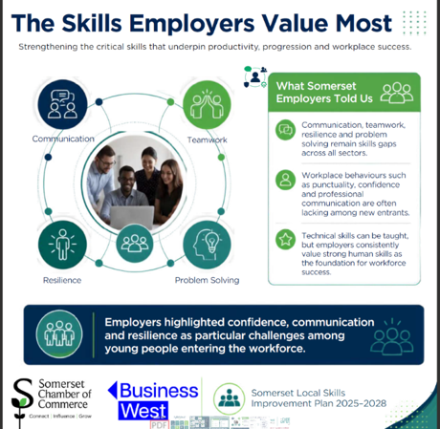

Curriculum
At Newbury Manor School, careers education is delivered through a carefully planned programme that prepares pupils for adult life, employment and greater independence. In line with current guidance, careers learning is embedded within our afternoon curriculum through ASDAN short courses, life skills challenges and, where appropriate, accredited qualifications.
Careers education is taught explicitly through our ASDAN offer, enabling students to develop key employability, independence and workplace skills aligned to the skills employers value the most. It is also woven throughout our PSHE curriculum, where pupils explore future aspirations, personal development, relationships, community participation and preparation for adulthood.

Where possible, all pupils have the opportunity to undertake work experience in Year 10 to Year 12 – this is frequently for the equivalent of a week, with the specific timings planned to best meet the needs of both the individual pupil and the employer.
Links to local F.E colleges provide the pupils from Year 10 upwards the opportunity to explore the variety of courses on offer. Visit days occur throughout Years 10, 11 and 12, in preparation for transition to local F.E colleges when appropriate.
Where possible, and according to pupil ability, level of anxiety, risk assessment and level of interaction the following may take place:
- Work experience/shadowing
- Work-related learning
- Visits to local employers
- Visits to careers fairs
- Mock interviews
- Visits to local colleges
- Interaction with local careers providers, apprenticeship providers and supported internship providers where appropriate

Careers Information, Advice and Guidance Delivery
Individual careers information, advice and guidance (CIAG) meetings will be delivered by appropriately trained, L6 qualified staff and be both person-centred and impartial. Combined with careers education activities which are embedded in the curriculum, this programme will raise aspirations, challenge stereotyping and promote equality and diversity. In line with the Gatsby Benchmarks (revised November 2025) every pupil will be offered at least one personal guidance meeting with a careers adviser by the time they are 16 and a further meeting by the age of eighteen.
All pupils will:
- Understand their education, training and employment opportunities
- Be offered the opportunity to develop the skills they need to plan and manage their own personal development and career progression
- Have access to relevant information and learning gained through visit days and work-experience
- Be encouraged to contribute to ways in which they can improve their career pathway
- Be provided with information and advice that is up to date, impartial and individualised
- Have advice and guidance offered by experienced careers advisers who have the relevant L6 qualification.

Work Experience
Work experience, including work shadowing, is one of the most important links between local employers and schools. This exposure to work is a significant step in preparing young people for adult and working life by developing their personal and social skills as well as the key skills they will need for the world of work. Work experience that is well planned and well organised has an important role in developing a student’s personal and social skills and gives them opportunities to learn directly about the world of work in preparation for their life after they leave school.

Work Experience; Responsibilities:
The Headteacher and Governing Body have overall responsibility to ensure the health, safety and welfare of students on work experience. They will ensure that:
- the suitability of work experience placements has been assessed by a competent person
- an individual risk assessment is written for each pupil prior to starting a work experience placement
- employers offering work experience have current public liability insurance in place
- there is clear communication with all key parties involved with the work placement
- health and safety procedures are followed
- arrangements are in place to provide placement providers with information regarding any additional needs of the student
- lead staff are familiar with the risk assessments for placements being visited
- any identified personal protective equipment or clothing is worn
- staff comply with the school’s incident reporting procedure and that all parties understand their responsibilities.

Successful ongoing management of work experience programmes relies on a process of evaluation; we ensure, therefore, that we gain feedback on each placement from both the employer and the student.
Outcomes for pupils
At Newbury Manor School we aim to raise aspirations, challenge stereotypes and encourage pupils to consider a wide range of future pathways and careers. We do this by using the Gatsby Benchmarks (revised November 2024) as a framework for our careers policy and local procedure. Senior leaders audit progress against the Gatsby Benchmarks via the Compass self-assessment tool; this is carried out termly. For more information on the Gatsby Benchmarks click here

Links with other policies and procedures
This local procedure is underpinned with a variety of other Aspris policies and local procedures. These include Curriculum policy, Teaching and Learning, SEN, and subject specific procedures.

Shelley Callomon
Date: September 2026
Review: March 2027
Updated: xxxx
Next update due: xxxx

