

Newbury Manor School
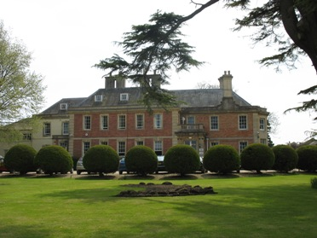

Curriculum local procedure

September 2026

Local Procedure Title | Curriculum
Site | Newbury Manor School
Local Procedure Date | September 2025
Local Procedure Review Date | September 2026
Local Procedure Author (s) | Head Teacher and Assistant Head Teacher
Local Procedure Ratification | SLT

Aims of the Curriculum
Our aim is to provide a nurturing, structured and aspirational environment where every pupil is empowered to flourish academically, socially and personally. We are committed to reducing barriers to learning, embedding robust communication and regulation systems, and working together to create a culture in which pupils develop the knowledge, skills and confidence to lead meaningful, connected and fulfilling lives within their communities.
This vision is enacted daily through strong relationships, high expectations, specialist expertise and a commitment to each pupil’s EHCP outcomes.
The curriculum at Newbury Manor School is designed to ensure that every pupil, regardless of need or starting point, is supported to become a confident, capable and increasingly independent young adult. Our curriculum aims to:

1. Strengthen Emotional and Sensory Regulation
Support pupils to understand themselves as learners, manage anxiety, and use effective regulation strategies through predictable routines, sensory programmes and emotionally nurturing relationships.
2. Develop Functional Communication
Enable all pupils to communicate their wants, needs, thoughts and preferences effectively using their personalised communication systems, ensuring their voice is central to school life and future planning.
3. Build Independence and Self-Advocacy
Provide structured, progressive opportunities to develop independent skills, decision-making and problem-solving skills so pupils can become as independent as possible in school, at home, and in the community.
4. Promote Inclusion, Belonging and Personal Development
Create an inclusive and respectful environment where differences are celebrated, relationships are central, and every pupil is recognised for their strengths, contributions and potential. Pupils access a meaningful PSHE and enrichment curriculum which broadens their experiences, develops their character, and equips them with the personal, social and emotional skills needed to thrive in school, in the community and into adulthood.

5. Secure Knowledge and Skills for Adulthood
Ensure all pupils progress towards Preparation for Adulthood outcomes (Employment, Independent Living, Community Participation and Health), through real-life learning, accreditation and purposeful curriculum design and a bespoke careers programme.
6.Strong Foundations
Foundational learning in reading, writing and mathematics is prioritised to ensure all pupils acquire the essential skills needed for future independence, communication and problem-solving. These core skills are embedded across the curriculum, taught through meaningful, functional contexts that help pupils apply their learning in real-life situations and prepare them for life beyond school.
7. Provide Broad, Balanced and Ambitious Learning
Deliver a rich, relevant and aspirational offer across formal, semi-formal and informal pathways, ensuring all pupils access a challenging curriculum matched to need, interest and developmental level.

The Peacock Values
Our curriculum is underpinned by the Peacock values, which we actively teach, model and reference throughout school life. These values shape pupils’ character development and guide staff in designing learning that promotes resilience, citizenship and aspiration.
Perseverance
We encourage pupils to keep trying, practise over time, and celebrate small steps of progress, acknowledging perseverance and recognising that learning is non-linear and success looks different for every pupil.
Equality
We promote equality by ensuring every pupil has equitable access to learning through personalised pathways, adaptations and high-quality specialist teaching.
Aspiration
We aim high for every pupil and support them to discover their interests, talents and aspirations, including future employment and independence goals.
Courage
We teach pupils to take safe risks, try new experiences, and develop resilience and courage by practising skills in supportive and real-life environments.
Opportunity
We offer opportunities through meaningful experiences inside and beyond the classroom, including Diversity Rocks, community access and enrichment activities.

Compassion
We model compassion through kindness, empathy and understanding, supporting pupils to develop respectful relationships and positive social communication.
Knowledge
We equip pupils with the foundational knowledge and transferable skills they need to navigate school, community and adulthood successfully.
We aspire for the Peacock values to be woven throughout the curriculum. They provide a shared language and a consistent framework for promoting personal development, character, behaviour, and long-term independence across all pathways.
We have four curriculum pathways at Newbury Manor School. (Overview on following page)
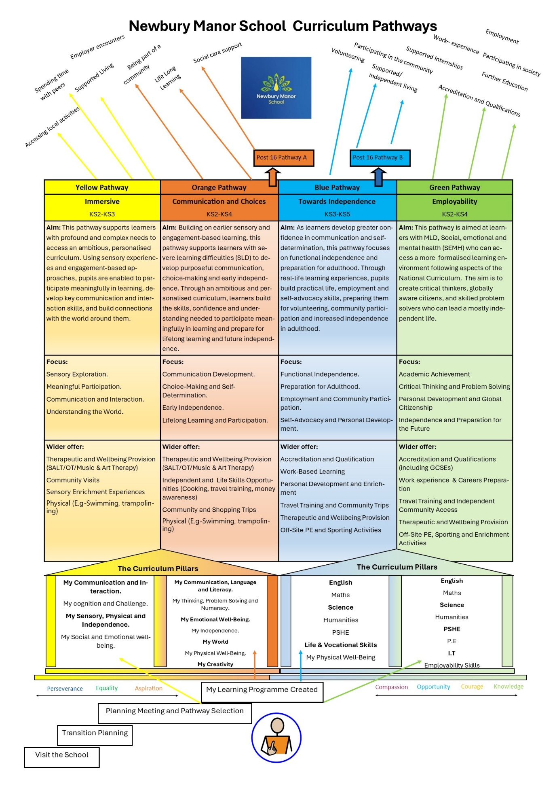
How Intent Drives Implementation and Impact
The curriculum intent forms the foundation for all subsequent sections. It drives:
- what we teach (knowledge, communication, independence, regulation)
- how we teach (specialist approaches, therapy-informed practice, personalised pathways)
- why we teach it (long-term outcomes, lifelong learning, preparation for adulthood)
This clarity ensures consistency across classrooms, pathways and phases, enabling leaders and staff to articulate a shared purpose and deliver a curriculum that meets need while fostering aspiration.
Curriculum Implementation
The implementation of the curriculum at Newbury Manor School is grounded in high-quality specialist teaching, structured routines, strong relationships and personalised approaches that meet pupils’ developmental, sensory, communication and learning needs. Curriculum delivery is designed to ensure pupils can access learning in a meaningful, functional and motivating way every day. The following principles guide how the curriculum is enacted across the school.
Our Three-Tier Approach: Universal, Targeted and Specialist Offer
Universal Offer – what every pupil receives
All pupils benefit from a consistent, communication-rich, structured and nurturing learning environment that includes:
- Predictable routines, visual supports and clear expectations
- Explicit teaching of communication, vocabulary and social understanding
- Embedded opportunities to rehearse reading, writing and mathematical skills through meaningful contexts
- Sensory-aware practice including movement breaks, regulation opportunities and personalised adjustments
- High-quality relationships that prioritise safety, trust and emotional well-being
- Access to learning beyond the classroom, whole-school events and cultural experiences that broaden horizons and develop cultural capital
The universal offer provides the stable foundation on which personalised planning and targeted intervention are built.

Targeted Offer – additional support for identified needs
Some pupils require further targeted approaches to ensure they can engage successfully in learning. This may include:
- Personalised resources, adapted tasks and scaffolded instruction
- Explicit pre-teaching or over-learning of key concepts
- Communication interventions aligned with individual EHCP outcomes
- Structured programmes to develop self-regulation, emotional literacy or social communication
- Adaptations to sensory environments, working spaces or daily routines
- Targeted support is planned, monitored and reviewed regularly in partnership with teaching staff, the SENCO, therapists and families.

Specialist Offer – highly personalised provision for complex profiles
Some pupils require intensive specialist input due to complex physical, sensory, communication, medical or learning needs. Specialist provision includes:
- Therapy-integrated learning (SALT, OT, music, art)
- Highly structured informal curriculum designed for pupils with profound and multiple learning difficulties
- Individualised sensory diets and personalised regulation plans
- Priority access to alternative and augmentative communication systems
- Work with external agencies, including health and social care partners
- Bespoke timetables to manage anxiety, dysregulation or medical needs

What Teaching Looks Like in the Classroom
Teaching at Newbury Manor School is structured, explicit and highly personalised. Classrooms across all pathways use consistent routines and specialist approaches while meeting the sensory, communication and developmental needs of our learners.
Revisit Prior Knowledge
Teachers begin sessions with:
- short retrieval tasks (matching, symbol identification, quick questions)
- recap of key vocabulary, signs or AAC symbols
- sensory-regulation warm-ups for readiness
This reinforces knowledge, supports memory and prepares pupils to access new learning.

Small Steps, Explicit Instruction & Clear Modelling
Teaching approaches include:
- concise verbal input paired with visuals, signing or AAC
- step-by-step modelling of skills
- explicit scaffolds (colour coding, sentence starters, worked examples)
- clear routines (Now/Next, visual timetables, structured transitions)
Guided Practice
During learning:
- teachers and TAs provide guided practice using prompts, modelling and co-activity
- pupils practise skills in supported, hands-on contexts
- communication is embedded
- regulation strategies are rehearsed in real time

Independent Application
Independence looks different across pathways:
- Application of skills with reduced prompts
- Tasks are structured so pupils can work with increasing autonomy
- Staff step back to allow safe, independent attempts
- Pupils practise skills in meaningful contexts

Structure & Adaptation
Teachers ensure success by:
- breaking tasks into clear, reachable steps
- providing repetition and over-learning
- using visuals to reduce cognitive load
- embedding literacy and numeracy functionally (lists, timetables, money, signs)

Scaffolds, Supports and Gradual Release
Scaffolding is gradually reduced based on pupil readiness. Supports include:
- symbol-supported instructions
- structured workstations
- chunked activities
- tailor-made communication systems
- support scaffolds appropriate to task

Ongoing Formative Assessment
Teachers assess continuously through:
- live verbal or visual feedback
- checking comprehension using AAC, symbols, gestures or writing
- quick reviews of work samples or practical outcomes
- observation of communication, independence and regulation

Reading, Writing and Mathematics Across the Curriculum
Foundational literacy and numeracy skills are taught explicitly and embedded across all subjects and pathways. Implementation includes:
- Daily reading, writing and maths opportunities matched to need
- Functional and life-skills-based application (e.g., shopping, timetable reading, routes, instructions, money)
- Phonics or communication-based literacy development depending on profile
- Numeracy integrated into cooking, travel training, problem-solving and daily routines

Learning Outside the Classroom
Learning is extended beyond classrooms to build independence, generalisation and real-life skills:
- Community visits and travel training
- Whole-school events such as celebrations, festivals, arts weeks and national themed days
- Residential experiences, outdoor learning and enrichment activities
- Forest school
Careers and Preparation for Adulthood
Careers education is embedded across school, supporting pupils to develop self-awareness, aspirations and an understanding of future possibilities. Linked to the Gatsby Benchmarks this includes:
- Careers-linked learning in daily curriculum
- Vocational experiences, ASDAN modules and work-related learning
- Preparation for adulthood pathways aligned to employment, health, independence and community participation
- Independent careers advice
Curriculum Impact
The curriculum at Newbury Manor School delivers impact when pupils leave with the communication, independence, regulation, knowledge and qualifications needed to thrive in further learning, the community and adult life. Impact is evaluated through a combination of academic achievement, personal development, functional skill acquisition, and long-term destination data.

Roles, Responsibilities and Monitoring
The Operations Director board
The Operations Directors will monitor the effectiveness of this policy and hold the Head Teacher to account for its implementation.

The Operations Directors will also ensure that:
• A robust framework is in place for setting curriculum priorities and aspirational targets
• Enough teaching time is provided for students to cover the curriculum and other statutory
requirements
• All courses provided for students that lead to qualifications, such as BTEC and Entry Level
certificates, are approved by the secretary of state
• The school implements the relevant statutory assessment arrangements
• It participates actively in decision-making about the breadth and balance of the curriculum
• It fulfils its role in processes to dis-apply pupils from all or part of the National Curriculum,
where appropriate, and in any subsequent appeals

Head teacher
The Head Teacher is responsible for ensuring that this procedure is adhered to, and that:
• All required elements of the curriculum, and those areas which the school chooses to offer,
have aims and objectives which reflect the vision/mission statement/values of the school and
indicate how the needs of individual students will be met
• The amount of time provided for teaching the required elements of the curriculum is adequate
and is reviewed by the governing board
• The school’s procedures for assessment meet all legal requirements
• The governing board is fully involved in decision-making processes that relate to the breadth
and balance of the curriculum
• The governing board is advised on whole-school targets in order to make informed decisions
• Proper provision is in place for students with different abilities and needs placed at Newbury
Manor and the EHCP targets identified inform teaching and learning approaches

Other staff

Teaching staff will ensure that the school curriculum is implemented in accordance with this
procedure.
The Deputy Headteacher will have specific oversight of Teaching and Learning and the Curriculum.

Monitoring arrangements
Operations Directors monitor coverage of curriculum areas and compliance with other statutory
requirements through:
• School visits
• Governance reports completed in conjunction with Head teacher
• Curriculum reports and presentations
• Head Teacher reports

Curriculum leaders monitor the way their area is taught throughout the school by:
• Meetings with teachers, supporting planning, observing practice, student evidence checks and support

This procedure will be reviewed annually by Senior Leadership Team. At every review, the procedure will be made available to the Operations board for ratification.

Local Procedure Review History:
Date Reviewed | Reviewer | Summary of Revision
January 2022 | Michael Pearce and Rebecca McArthur
April 2022 | Michael Pearce and Rebecca McArthur | Updated Examination and Accreditation courses
November 2023 | Kevin McKain and Sally Taylorson | Thematic table updated.
September 2024 | Ruth Glasspool | Updated whole school events table.  Added Primary Theme table.  Revised the formal learning section.  Amended accreditation.
September 2025 | Paul Gorham | Updated and amended some formatting
March 2026 | Shelley Callomon and Kerry Ollett | Updated entire policy
September 2026 | Shelley Callomon | Pathway updates

