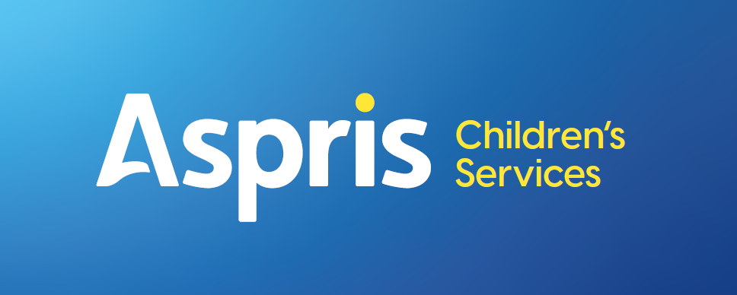

Newbury Manor School



Marking, Assessment and Feedback

September 2026

Newbury Manor Marking, Assessment and Feedback Procedure

Learner context

All students attending Newbury Manor School have a diagnosis of Autistic Spectrum Disorder. Our aim is to provide a high-quality broad and balanced curriculum, which considers the individual, personalised needs of each student. We take every opportunity to recognise achievement across a range of successes. These include, but are not limited to personal, social, therapeutic and academic successes. We aim to celebrate our students’ achievements in a variety of formal and informal ways, including comments from staff, marking and feedback, positive phone calls home to parents, positive peacock postcards sent home, school/ class reward systems (Purple points), demonstrating our core PEACOCK values and progress review meetings.

Rationale

To ensure that all pupils’ work is discussed and marked in such a way that feedback will improve their learning, develop their self-confidence, raise self-esteem and provide opportunities for self-assessment.

At Newbury Manor the focus is on each individual pupil’s learning. We strive to provide meaningful experiences that not only give learning context and wider meaning but also engage all our learners.

The critical purpose of marking and feedback is about moving learning forwards.

We ensure this by
- Highlighting and celebrating success
- Supporting improvement
- Identifying the next steps for learning

Principles

- Whenever possible, teachers should provide verbal feedback to individual pupils
- Feedback, whether written or verbal should be an integral part of lessons and should provide a dialogue between pupils and teachers that addresses errors and misconceptions at an early stage
- Marking and feedback should be linked to learning objectives, success criteria and targets
- Teachers should look for strengths before identifying improvements when marking
- Pupils should be given time to read, reflect and respond to marking and feedback where appropriate.
- Pupils, where possible, should be encouraged to mark, self-evaluate, and peer assessment.
- The outcomes of marking should be used to inform teachers’ judgments concerning pupils’ progress and to inform teacher records and reports
- Marking and feedback should be positive, proactive and enhance the pupil’s learning journey

Aims and Objectives

Effective marking and feedback should:

- Recognise, encourage and reward each learner’s effort and achievement and celebrate success overtime
- Provide an accessible dialogue between the teacher and learner
- Improve self-confidence, in order that pupils, with the teacher, can set future targets for learning
- Give learners a clear picture of how well they have met their learning objectives or targets
- Help learners identify an awareness of the standards they need to reach in order to achieve particular levels of the National Curriculum / progression steps / engagement steps
- Celebrate and reinforce expectations
- Inform future planning

Verbal Feedback

This is the discussion of the learning with the pupil/young person. It is the most valuable form of feedback for all learners regardless of age or ability, as it is immediate, focused, personal and usually more articulate than written comments.

This encourages interaction between the learner and the teacher or teaching assistant. Where possible a record of verbal feedback will be made using the guidelines at the end of this document.

Written Feedback

All written comments or corrections should be in green. (Some learners may need an alternative colour depending on needs.)

Where appropriate students should self-assess and give responses to teacher feedback in purple pen. For example, if the feedback states to “practise the use of two-part sentences”, these should be written in purple pen next to the feedback to show a learner has responded to the feedback. If the work is self-assessed corrections may be made but no ‘improvements’ are necessary.

Where written marking is appropriate, feedback should use the agreed WWW and Next Steps format, in line with the learner’s pathway and individual needs.

Example:
www: You have consistently used capital letters correctly.
: Make sure you understand the difference between their and there

Work needs to be checked against the learning objective/target. The teacher will demonstrate the fact that they have acknowledged the work by using ticks, or other notations as outlined at the end of this document.

Stamps or stickers should be used to indicate work has been checked. Stickers are a positive visual indication to the child which all children can recognise regardless of their reading skills.

Codes used across the school are

- VF = verbal feedback.
- I = independent
- SS = some support
- FS = full support.
- WWW= What went well
- = next steps

Symbols are universal, but it is expected that a brief explanation of what each symbol means is displayed for individual pupils or class groups. For different classes some support and full support might look different.

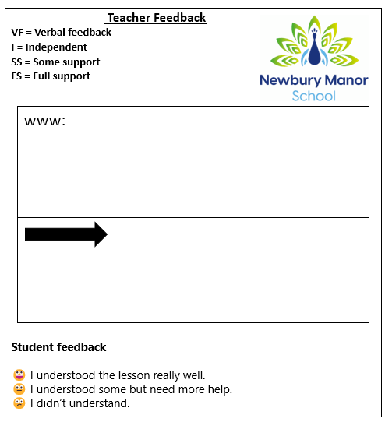

Marking and Feedback Stickers

Marking and feedback stickers are the school’s agreed format for recording written feedback where appropriate and provide pupils with clear, consistent and accessible feedback. Teachers use the agreed symbols to show the level of support provided, including independent work, some support, full support and verbal feedback. The WWW (What Went Well) section highlights achievement and reinforces successful learning, while the arrow identifies a clear next step for improvement or progression. Pupils are also encouraged to reflect on their own learning by selecting the appropriate student feedback symbol, helping them communicate their level of understanding. This approach ensures feedback is meaningful and accessible to pupils with a range of communication and learning needs.

Additional written comments

Some work will require additional written comments. These will be more detailed but must be informative in nature and intended to move learning forwards. They will

- Be positive and celebrate effort and achievement
- Relate to learning objectives
- Indicate next steps for improvement
- Allow time for reflection

Curriculum specific

These principles apply to all subjects. Some subjects such as Art, D&T, Cooking, PE and Music will require predominantly verbal feedback.

Informal teacher assessments should also be made within these subjects to show progression.
B Squared assessments are used across the pathways, to record and demonstrate progress in English, Math’s, Science, PHSE including Citizenship, Computing and PE

Learning in all of these areas may be recorded by

- Written conversation
- Post it notes
- Photographs of pieces of work linked with success criteria and commented upon
- PowerPoint with photos
- Photos of students working
- Observations slips
- Wow! moment cards

Presentation of Work

- All pupils’ work should have a clear title, date and learning objective (L.O.)
- Pupils should be encouraged to complete work in pencil or blue or black pen
- All completed work should be filed/stuck in a book ready for future recording or assessment

Corrections

- Not all work or every mistake will be corrected
- Highlight positives instead of negatives / mistakes
- A strong emphasis will be placed on appropriate presentation and correct spelling for display work
- Rubbing out will be discouraged. The ‘mistake’ is evidence of the learning process and should be valued. The error should be crossed through, using a single line and the correction written next to it

Monitoring

This is a whole school procedure. All teachers and supporting staff are expected to apply this guidance consistently. B Squared assessments will be carried out three times annually and more ongoing where appropriate. Pupils are also assessed in their progress towards their EHCP targets through the Golden Thread.

This policy will be reviewed on an annual basis by SLT with input from the teaching staff.

What feedback and marking looks like on each pathway

Yellow | Orange | Blue | Green
Feedback for these learners will be live, ongoing and continuous given verbally or using signs/ symbols.  Written feedback will be captured in tapestry and will be for the purpose of documenting progress over time. There will be little to no written feedback given to learners.  In some cases, learner work may not be explicitly marked but evidence of progress will be captured through teacher assessment and tracking tools.  Learner response: Will be captured in the form of symbols. All evidence is captured on Tapestry. | Feedback for these learners will be mostly live and given verbally or using signs/symbols where appropriate. Where evidence of learning is generated through video footage or photos, evidence that feedback has been given will be noted using the marking symbols and a short written comment by teaching staff where appropriate.  In some cases, learner work may not be explicitly marked but evidence of progress will be captured through teacher assessment and tracking tools.  Learner response: Will be captured in the form of symbols, recorded verbal feedback or some written feedback if appropriate.  Evidence is captured on and in books. | Feedback for these learners will be a combination of live feedback given verbally, or written feedback in books using the WWW and Next Steps format. Marking stickers are the school’s agreed format for recording written feedback where appropriate. Learners will be able to respond to feedback in purple pen, either themselves or with support from TA. All evidence in books will be marked in this format.  In cases where written feedback isn’t clear, the Newbury Manor marking symbols will be used to denote the type of feedback given.  Learner response: Will be captured in the form of a written response in purple pen or recorded verbal feedback if appropriate. Evidence is captured on Tapestry and in books.
Golden Threads: Feedback against termly learning goals will be written on termly target sheets for learners on all pathways. These documents will be accessible in all classrooms and can be updated during morning check-in and tutorial.
Golden threads targets will be reviewed 3 times a year and the next target will be created at this time working towards the annual goal.

Date Reviewed | Name of Reviewer | Summary of revision
September 2015
September 2024
September 2025
February 2026
September 2026 | Nicola Lickorish | Pathway information added.  B Squared information added.  Marking guidance updated.  Title of policy amended to include assessment.

Newbury Manor marking symbols

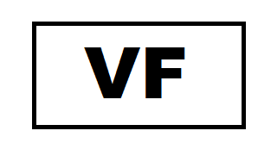







Verbal feedback
Independent
Some support
Full support

