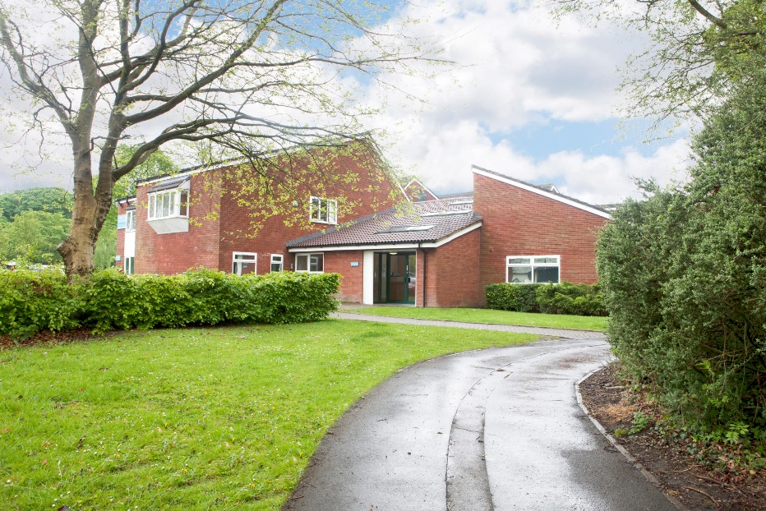


Admissions Policy
September 2025

Oliver House School
Local Procedure Title | Admissions
Home/ School/ College | Oliver House School
ACS Policy number and title | ACS 11 Admissions
Local Procedure template reference | ACS LP 11
Local Procedure date | September 2012
Local Procedure review date | September 2027
Local Procedure Author(s) | Sarah Whatmough, Assistant Headteacher
Local Procedure Ratification | Checked and Approved by: Lisa Sharrock, Headteacher

- Purpose & Philosophy
This local procedure sets out how the Admissions Policy is implemented at Oliver House School. It ensures that all admissions are safe, appropriate, and compliant with Aspris Children’s Services standards and regulatory requirements.
Oliver House School believes that all young people with special educational needs, whose parents or Local Authority wish it, should have a right to be considered as appropriate for assessment for admission.
- Scope
This procedure applies to all staff involved in the admission of children and young people to Oliver House School, including the Headteacher, Senior Leadership Team, Transitions Lead and administrative colleagues.
- Responsibilities
Headteacher: Overall responsibility for ensuring compliance with the Admissions Policy and this procedure.
Admissions Team: Responsible for gathering documentation, completing forms, and coordinating with placing authorities.
Transitions Lead: Responsible for liaising with parents and recording information from them
All Staff: Responsible for welcoming and supporting the child/young person during induction.
- Admission Process
The school will assess a pupil against the admission criteria for Oliver House School.
Step 1
- A description of the child’s special educational need will match the admission criteria.

If this is the case:
Step 2
- Senior managers from Oliver House School will meet the young person’s parents/carers and teachers and will review in detail any additional paperwork associated with the education and care of the child.

If the outcome of this review indicates that Oliver House School could be a suitable placement then:
Step 3
- An offer of an assessment is made to visit the pupil.

If the outcomes of this assessment place are positive then:
Step 4
- The pupil will be offered a place at Oliver House School.

Decisions about the school’s suitability for the child are made by drawing on the conclusions of a range of reports and information as well as on the assessment carried out by the school.
If a child is offered a place at the school, they may remain until the end of the academic year in which they are nineteen, or they may leave at an earlier point depending on their Local Authority policy and arrangements.

- Criteria
Oliver House School criteria for admission are a combination of pupil specific, family, and school environment factors:
Pupil will have:
- A diagnosis of autistic spectrum disorder or evidence of behaviours which are in accordance with such a diagnosis
- A learning difficulty within the moderate to severe range
- Appropriate family commitment to supporting and maintaining programmes at home
- Oliver House School can meet the needs of children with autism and associated complexities. The school accepts that children will have challenging behaviour as a result of difficulties with communication and social understanding. A vital element of the admission process is to ensure that the needs of the child referred can be met and that their admission does not have a detrimental effect on the well-being and safety of others.

- Transition & Welcome
Transition Process: The Transitions team will meet with the family initially to gather information and coordinate further meetings with the phase teacher/s. The phase teachers will then lead phased transitions tailored to each student’s interests and strengths. These transitions aim to support students in developing trusting relationships with key adults, building familiarity with the school environment, and growing in confidence. The transition process is carefully planned and structured, allowing students to gradually increase their time in school and engage in activities that align with their interests. This approach helps to reduce anxiety and fosters a sense of belonging from the outset. Most transitions last approximately six weeks, during which time key adults monitor progress, adjust strategies as needed, and provide consistent reassurance. However, for students requiring significant levels of support to reengage with learning, the school collaborates closely with families to design a longer phased transition plan. This extended transition period ensures that individual needs are met effectively, setting a strong foundation for positive educational experiences.

- Health & Medical
Medical information and details of General Practitioner are required at the time of admission. This is provided on the parent forms. If this is not available, admission may be delayed until this information is available in order to ensure the safety and wellbeing of the child/young person. Where a child or young person has a specific medical condition for which colleagues will require additional training, skills, and knowledge in order to safely care for the child or young person, this training must be completed prior to the admission taking place.

- Admissions information
Every admission must be recorded immediately in the Admissions Register.
Every admission must also be added to all relevant electronic recording systems which the service is routinely expected to use (companies MIS system - Engage)

- Individual Risk Assessment
Risk assessment will be completed by the Class Teacher during the initial admission/transition process. Forms will be reviewed at the end of the transition period and then annually, or in the event of significant changes.

- Monitoring & Review
Headteacher and Regional Director will monitor compliance through governance processes. This policy is reviewed at the agreed review date by the Head Teacher and is approved by the Regional Director.

Local Procedure Review History:
Date Reviewed | Reviewer | Summary of revisions

