Local Procedure Title | Attendance
Service | Roehampton Gate School and Putney Vale
ACS Policy number and title | ACS 61 Attendance
Local Procedure template reference | ACS LP 61
Local Procedure date | February 2026
Local Procedure review date | April 2027
Local Procedure Author(s) | Lucia Apicella (DSL)
Local Procedure Ratification | Checked and approved by: K Raphael

- Vision and Values
Our school values are:

Success, Confidence, Respect

Our vision is:

At Roehampton Gate School we are dedicated to supporting young people to achieve their potential,
empowering them with knowledge, skills, and opportunities. Guided by our core values of success,
confidence and respect, we create an environment where everyone can succeed. A key to this is
ensuring all young people are supported to attend and engage with school consistently, and any barriers
addressed promptly.

- ISS Standards in This Procedure
Part 3: Welfare, health and safety of pupils. 15
The standard in this paragraph is met if the proprietor ensures that an admission and attendance register is maintained in accordance with [the School Attendance (Pupil Registration) (England) Regulations 2024].

Part 6: Provision of information. 32 –(1) (g) any information reasonably requested in connection with an inspection under section 109 of the 2008 Act which is required for the purposes of the inspection is provided to the body conducting the inspection and that body is given access to the school's admission and attendance registers;

- Introduction and Context
The Department for Education (DfE) has recently released their updated guidance ‘Working together to improve school attendance’. This guidance outlines significant changes to the attendance and registration requirements for schools, which came into effect on the 19th August 2024.
- Intention and Aims
- Aims
This policy aims to show our commitment to meeting our obligations with regards to school attendance, including those laid out in the Department for Education’s (DfE’s) statutory guidance on working together to improve school attendance (applies from 19 August 2024), through our whole-school culture and ethos that values good attendance, including:
- Setting high expectations for the attendance and punctuality of all students.
- Promoting good attendance and the benefits of good attendance.
- Reducing absence, including persistent and severe absence.
- Acting early to address patterns of absence.
- Building strong relationships with families to make sure students have the support in place to attend school.
- Legislation and Guidance
This policy is based on the Department for Education’s (DfE’s) statutory guidance on working together to improve school attendance (applies from 19 August 2024) and school attendance parental responsibility measures. The guidance is based on the following pieces of legislation, which set out the legal powers and duties that govern school attendance:
- Part 6 of the Education Act 1996
- Part 3 of the Education Act 2002
- Part 7 of the Education and Inspections Act 2006
- The Education (Pupil Registration) (England) Regulations 2006 (and 2010, 2011, 2013, and 2016 amendments)
- https://www.legislation.gov.uk/uksi/2006/1751/contentsThe Education (Penalty Notices) (England) (Amendment) Regulations 2013
https://www.legislation.gov.uk/uksi/2013/757/regulation/2/madeIt also refers to:
- School census guidance
- Keeping Children Safe in Education
- Mental health issues affecting a pupil's attendance: guidance for schools

- Roles and Responsibilities
Parents and Carers
- Ensure students attend every day
- Notify school before 9:00 am if there may be an unexpected absence
- Book any medical appointments (where possible), outside of school hours
- Proactively engage with support offered if your child is struggling to attend school
Reception and Admin
- Track and monitor attendance daily
- Accurately complete attendance registers in morning registration
- Share non-attenders daily with leaders
- Report safeguarding concerns to DSL team
- Notify SLT if contact has not been made with parent or carer
Tutors
- Inform reception/ admin team of absence reported by parent or carer before 9:15 am
- Accurately and consistently complete afternoon register
- Report any safeguarding concerns to DSL team
- Make weekly contact with parents and carers and discuss attendance
- Work closely with parents and carers to identify any barriers to attending school
- Report to SLT if attendance does not improve within 2 weeks of support
- Liaise with a pastoral regarding any interventions to ensure that these are uploaded to the tracker
Teachers
- Accurately complete lesson attendance registers
- Report attendance to Pastoral for perceived longer-term challenges
- Provide work for students weekly with long term absence (either paper based or online provision)
- Report safeguarding concerns to DSL’s
Pastoral
- Undertake bespoke approaches to support attendance
- Support parents with attendance
- Report safeguarding concerns
- Undertake home visits (if required)
- Support FLO/DSL with meetings to support long term absence
- Add communication, interventions and outcomes onto attendance tracker
Family Liaison Officer/ DSL
- Track all students’ attendance
- Arrange home visits and welfare checks
- Quality assure daily attendance registers
- Work closely with Local Authorities and external partners to support poor attendance
- Send attendance reports to carers/ Local Authorities when required
- Utilise Educational Welfare Officers to support long term absence
- Implement strategic whole school approach to supporting attendance
- Add communication, interventions and outcomes onto attendance tracker
- Plan implement and assess for impact pre- emptive intervention, workshops and support packages for students at risk of a decline in attendance or at risk of EBSA
Senior Leadership
- Ensure there is a robust system in place to track attendance
- Support school, staff and students to prioritise attendance and all are held responsible for attendance to school for all pupils
- Ensure statutory responsibilities are fulfilled
- Overview of school’s attendance throughout the year
- Ensure staff are equipped to manage attendance
- Work closely with Local Authorities and external partners to support poor attendance
- Hold regular meetings with Local Authorities to support attendance needs

- Recording Attendance
- Attendance register
The school will keep an electronic attendance register, and place all students onto this register, using the management information system (Engage).
The school will take an attendance register at the start each school day at 09.00am and at the start of afternoon registration at 13.05. It will mark, using the appropriate national attendance and absence codes from the School Attendance (Pupil Registration) (England) Regulations 2024, whether every student is:
- Present
- Attending an approved off-site educational activity
- Absent
- Unable to attend due to exceptional circumstances
[See Appendix i for the DfE attendance codes.]
The school will also record:
- Whether the absence is authorised or not.
- The nature of the activity, where a student is attending an approved educational activity.
- The nature of circumstances, where a student is unable to attend due to exceptional circumstances.
The school will keep every entry on the attendance register for 6 years after the date on which the entry was made.
The school day starts at 08:45 and ends at 15:15.
- AM registration closes at 9.15
- PM registration closes at 13.25
- Unplanned absence
The student’s parent/ carer must notify the school of the reason for the absence on the first day of an unplanned absence by 09:00 or as soon as practically possible, by calling the school.
We will mark absence due to physical or mental illness as authorised, unless the school has a genuine concern about the authenticity of the illness.
Where the absence is longer than 5 days, or there are doubts about the authenticity of the illness, the school will ask for medical evidence, such as a doctor’s note, prescription, appointment card or other appropriate form of evidence. We will not ask for medical evidence unnecessarily.
If the school is not satisfied about the authenticity of the illness, the absence will be recorded as unauthorised, and parents will be notified of this in advance.
- Planned absence
Attending a medical or dental appointment will be counted as authorised as long as the student’s parent/carer notifies the school in advance of the appointment.
Leaves of absence can be made by speaking with a member of the senior leadership team who will share the necessary process of application.
However, we encourage parents/carers to make medical and dental appointments out of school hours where possible. Where this is not possible, the student should be out of school for the minimum amount of time necessary.
The student’s parent/carer must also apply for other types of term-time absence as far in advance as possible of the requested absence.
- Go to section 8 to find out which term-time absences the school can authorise.
- Lateness and punctuality
A student who arrives late:
- Before the register has closed will be marked as late, using the appropriate code.
- After the register has closed will be marked as absent, using the appropriate code.
- Following up unexplained absence
Where any student we expect to attend school does not attend, or stops attending, without reason, the school will:
- Call the student’s parent/carer on the morning of the first day of unexplained absence to ascertain the reason. If the school cannot reach any of the student’s emergency contacts, the school may need to inform external agencies including social care and potentially a multi-agency safeguarding hub/resource unit: (see appendix ii)
- Identify whether the absence is approved or not.
- Identify the correct attendance code to use and input it as soon as the reason for absence is ascertained.
- Where relevant, report the unexplained absence to external agencies involved.
- Where appropriate, offer support to the student and/or their parents to improve attendance.
- Identify whether the student needs support from external agencies/ wider partners, as quickly as possible, and make the necessary referrals.
- Where support is not appropriate, not successful, or not engaged with, the appropriate escalation process will be followed according to local agency arrangements and process.
- Reporting to parents
The school will regularly inform parents and carers about their child/young person’s attendance and absence levels via termly reports or when concerns arise about absence from school.

- Authorised and Unauthorised Absence
- Approval for term-time absence
The headteacher will allow students to be absent from the school site for certain educational activities, or to attend other schools or settings.
The headteacher will only grant a leave of absence to a student during term time if the request meets the specific circumstances set out in the 2024 school attendance regulations. These circumstances are:
- Taking part in a regulated performance, or regulated employment abroad
- Attending an interview
- Study leave
- A temporary, time-limited part-time timetable
- Exceptional circumstances
A leave of absence is granted at the headteacher’s discretion, including the length of time the student is authorised to be absent for.
The school considers each application for term-time absence individually, considering the specific facts, circumstances and relevant background context behind the request.
Any request should be submitted as soon as it is anticipated and, where possible, at least 4 weeks before the absence, and in accordance with any leave of absence request form, accessible via the senior leadership team, please call to discuss this further. The headteacher may require evidence to support any request for leave of absence.
- Students over 18
Other valid reasons for authorised absence include (but are not limited to):
- Illness (including mental-health illness) and medical/dental appointments (see section 4 for more detail)
- Religious observance – where the day is exclusively set apart for religious observance by the religious body to which the student’s parent/carer(s) belong(s). If necessary, the school will seek advice from the parent/carer’s religious body to confirm whether the day is set apart
- Parent/carer(s) travelling for occupational purposes – this covers Roma, English and Welsh gypsies, Irish and Scottish travellers, showmen (fairground people) and circus people, bargees (occupational boat dwellers) and new travellers. Absence may be authorised only when a traveller family is known to be travelling for occupational purposes and has agreed this with the school, but it is not known whether the student is attending educational provision
- If the student is currently suspended or excluded from school (and no alternative provision has been made).
- Other reasons the school may allow a student to be absent from the school site, which are not classified as absences, include (but are not limited to):
- Attending an offsite approved educational activity, sporting activity or visit or trip arranged by the school.
- Attending provision arranged by the local authority.
- Attending work experience.
- If there is any other unavoidable cause for the student not to attend school, such as disruption to travel caused by an emergency, a lack of access arrangements, or because the school premises are closed.
- Strategies for Promoting Attendance
Good and improving attendance is promoted through:
- Regular, sometimes daily tutor liaison with parents/carer and their families where appropriate.
- Ensuring effective communication between home and school to address barriers to attendance.
- Robust oversight from the Senior Leadership Team, ensuring that all non-attendance is discussed daily and actions to support a return to school or re-engagement plan
- School reward system.
- Onsite wellbeing and therapy support providing guidance and oversight of interventions to support students to transition to school, re-engage and overcome barriers.

- Supporting Students Who Are Absent or Returning to School
- Students absent due to complex barriers to attendance
- Students will be supported with a bespoke transition plan which support and understands students’ individual needs.
- Students will have a key contact in place to support this transition.
- Transitions are reviewed frequently to ensure we are meeting individual needs.
- The school will work closely with parents/carers to support the transition and value their views.
- Students absent due to mental or physical ill health
- Welfare calls from the school will remain in place at a frequency agreed with parents/ carers.
- Where appropriate opportunities to continue to access an education programme from home will be offered.
- School will support any necessary referrals to external partnerships.
- Students returning to school after a lengthy or unavoidable period of absence
- Students will be supported with a bespoke re-engagement or transition plan.
- Students will be allocated a key contact who will support the transition.

- Attendance Monitoring
- Monitoring attendance
The school will monitor attendance and absence data on a weekly basis.
The school will report individual (where there are concerns) and whole school attendance via governance reporting.
- Analysing attendance
The school will:
- Analyse attendance and absence data regularly to identify students, groups or cohorts that need additional support with their attendance, and
- Identify students whose absences may be a cause for concern, especially those who demonstrate patterns of persistent or severe absence.
- Conduct thorough analysis of half-termly, termly, and full-year data to identify patterns and trends.
- Look at historic and emerging patterns of attendance and absence, and then develop strategies to address these patterns.
- Monitor outcomes of strategies put in place to improve attendance
- Using data to improve attendance
The school will:
- Develop targeted actions to address patterns of absence (of all severities) of individual students, groups or cohorts that it has identified via data analysis.
- Provide targeted support to the student it has identified whose absences may be a cause for concern, especially those who demonstrate patterns of persistent or severed absence.
- Provide regular attendance reports to class tutors to facilitate discussions with students and families, and to the operations director and school leaders.
- Use data to monitor and evaluate the impact of any interventions put in place in order to modify them and inform future strategies.
- Share information and work collaboratively with local authorities and other partners where a student’s absence is at risk of becoming persistent or severe, including keeping them informed regarding specific students, where appropriate.
- Reducing persistent and severe absence
Persistent absence is where a student misses 10% or more of school, and severe absence is where a student misses 50% or more of school. Reducing persistent and severe absence is central to the school’s strategy for improving attendance.
The school will:
- Use attendance data to find patterns and trends of persistent and severe absence.
- Consider potential safeguarding issues and, where suspected or present, address them in line with Keeping Children Safe in Education.
- Hold regular meetings with the parents of students who the school (and/or local authority) considers to be vulnerable or at risk of persistent or severe absence, or who are persistently or severely absent, to:
- Discuss attendance and engagement at school.
- Listen, and understand barriers to attendance.
- Explain the help that is available.
- Explain the potential consequences of, and sanctions for, persistent and severe absence.
- Review any existing actions or interventions.
- Provide access to wider support services to remove the barriers to attendance, in conjunction with the local authority, where relevant
- Consider alternative support that could be put in place to remove any barriers to attendance and re-engage these students. In doing so, the school will sensitively consider some of the reasons for absence
- If persistent absence continues, individual cases to be reviewed at complex cases where individualised support plans and interventions put in place by the multi-disciplinary team.

- Attendance thresholds and response procedure
95-100% - Excellent
Students receive an attendance certificate and reward voucher termly.

90-94% - Good
Students receive an attendance certificate and item from reward shop termly.

86-89% - Cause for concern
Attendance will be closely monitored. We understand attendance may be impacted by unavoidable causes, and therefore we will implement support outlined in this procedure on a case-by-case basis. Letter of concern will be sent to parent/ carer.

85% - Persistent Absence
A meeting will be held with parents/carers, form tutor and a member of the pastoral team. Barriers to learning will be discussed and a short-term plan will be put in place to support the child to access education. The child’s case worker will be notified of this. Letter of concern will be sent to parent/ carer/LA. Tracked through the complex case review process.

Below 85% - Significant Absence
Letter of concern will be sent to parent/ carer. We may conduct home visits and begin providing home learning packs. A meeting will be held with parents/ carers and the school team to address barriers to accessing education with a plan to be put in place to support the child and their family. This will be reviewed regularly and the child’s case worker will be notified. Further referrals may be completed.

50% - Severe Absence
An emergency review may be held to discuss barriers to education and a collaborative approach to ensuring the child is accessing the education they are entitled to. Letter of concern will be sent out. We may conduct home visits and provide learning packs. Further referrals may be completed.

- Appendices
- Appendix i: Attendance thresholds

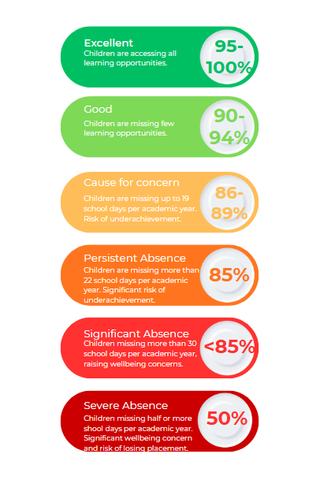
- Appendix i: Attendance codes
The following codes are taken from the DfE’s guidance on school attendance:
https://www.gov.uk/government/publications/working-together-to-improve-school-attendance
Code | Definition | Scenario | Special circumstances
/ | Present (am) | Pupil is present at morning registration | To include remote learning (via Teams, Zoom etc). If pupil does not attend, this needs to be recorded using the unauthorised codes e.g. ‘O’.
\ | Present (pm) | Pupil is present at afternoon registration | As above
L | Late arrival | Pupil arrives late before register has closed
Attending a place other than the school
K | Attending education provision arranged by the local authority | Pupil is attending a place other than a school at which they are registered, for educational provision arranged by the local authority
V | Attending an educational visit or trip | Pupil is on an educational visit/trip organised or approved by the school
P | Participating in a sporting activity | Pupil is participating in a supervised sporting activity approved by the school
W | Attending work experience | Pupil is on an approved work experience placement
B | Attending any other approved educational activity | Pupil is attending a place for an approved educational activity that is not a sporting activity or work experience | -AP e.g. Forest School  -Transition days at a new school  -Attending course at college
D | Dual registered | Pupil is attending a session at another setting where they are also registered
Absent - leave of absence
C1 | Participating in a regulated performance or undertaking regulated employment abroad | Pupil is undertaking employment (paid or unpaid) during school hours, approved by the school
M | Medical/dental appointment | Pupil is at a medical or dental appointment
J1 | Interview | Pupil has an interview with a prospective employer/educational establishment
S | Study leave | Pupil has been granted leave of absence to study for a public examination
X | Not required to be in school | Pupil of non-compulsory school age is not required to attend | If a non-compulsory school age pupil is only timetabled to attend for four days a week as part of their programme, the fifth day should be marked with code X.
C2 | Part-time timetable | Pupil is not in school due to having a part-time timetable  E.g., for pupils on a transition to the school.
C | Exceptional circumstances | Pupil has been granted a leave of absence due to exceptional circumstances | Pregnant pupil  Performances Employment
Absent - other authorised reasons
T | Parent travelling for occupational purposes | Pupil is a ‘mobile child’ who is travelling with their parent(s) who are travelling for occupational purposes
R | Religious observance | Pupil is taking part in a day of religious observance
I | Illness (not medical or dental appointment) | Pupil is unable to attend due to illness (either related to physical or mental health)
E | Suspended or excluded | Pupil has been suspended or excluded from school and no alternative provision has been made
Absent - unable to attend school because of unavoidable cause
Q | Lack of access arrangements | Pupil is unable to attend school because the  local authority has failed to make access arrangements to enable attendance at school
Y1 | Transport not available | Pupil is unable to attend because school is not within walking distance of their home and the transport normally provided is not available
Y2 | Widespread disruption to travel | Pupil is unable to attend because of widespread disruption to travel caused by a local, national or international emergency
Y3 | Part of school premises closed | Pupil is unable to attend because they cannot practicably be accommodated in the part of the premises that remains open
Y4 | Whole school site unexpectedly closed | Every pupil absent as the school is closed unexpectedly (e.g. due to adverse weather)
Y5 | Criminal justice detention | Pupil is unable to attend as they are:  - In police detention  - Remanded to youth detention, awaiting trial or sentencing, or  Detained under a sentence of detention
Y6 | Public health guidance or law | Pupil’s travel to or attendance at the school would be prohibited under public health guidance or law
Y7 | Any other unavoidable cause | To be used where an unavoidable cause is not covered by the other codes | -Bail conditions  -Court appearance
Absent - unauthorised absence
G | Holiday not granted by the school | Pupil is absent for the purpose of a holiday, not approved by the school
N | Reason for absence not yet established | Reason for absence has not been established before the register closes | See section below
O | Absent in other or unknown circumstances | No reason for absence has been established, or the school isn’t satisfied that the reason given would be recorded using one of the codes for authorised absence
U | Arrived in school after registration closed | Pupil has arrived late, after the register has closed but before the end of session
Administrative codes
Z | Prospective pupil not on admission register | Pupil has not joined school yet but has been registered
# | Planned whole-school closure | Whole-school closures that are known and planned in advance, including school holidays | Please use for half terms, bank holidays and inset days, school used as a polling station.

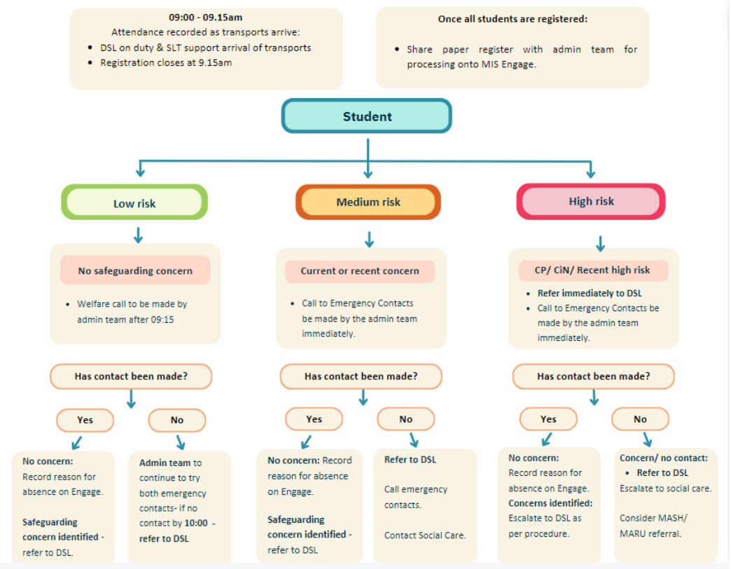
- Appendix ii: Local procedure flowchart
- Associated Reading and Further Information
For more information and further reading, the following sources are recommended:
- Working together to improve school attendance, Statutory guidance for maintained schools, academies, independent schools and local authorities, August 2024
- https://www.gov.uk/government/publications/working-together-to-improve-school-attendance

- Summary table of responsibilities for school attendance, Statutory guidance for maintained schools, academies, independent schools, and local authorities, Published 19 August 2024
- https://www.gov.uk/government/publications/working-together-to-improve-school-attendance

- School attendance and absence: Overview - GOV.UK (www.gov.uk)
- https://www.gov.uk/school-attendance-absence

Contents Checklist (Local Services may add additional items – this is a core list)
Aims of Local Procedure |  | Reporting to Parents/Carers
Local Responsibilities |  | Authorised and Unauthorised absence
Unplanned Absence |  | Strategies for promoting attendance
Following up Unexplained Absence |  | Attendance Monitoring
Persistent and Severe Absence |  | Revised DfE attendance codes and explanatory notes box
Penalty fines |  | Commissioning an Education Welfare Officer
Nominated Attendance Champions |  | Part- time timetables (C2)

Local Procedure Review History:
Date Reviewed | Reviewer | Summary of revisions
07.01.2026 | Lucia Apicella | Additions:  - Point 11 – Attendance thresholds and response procedure  - Appendix I – attendance thresholds
4.2.26 | K Raphael

