
Local Procedure Title | Curriculum
Service | Roehampton Gate School
ACS Policy number and title | ACS 31 Curriculum
Local Procedure template reference | ACS LP 31
Local Procedure date | December 2025
Local Procedure review date | September 2026
Local Procedure Author(s) | Andrew Molloy
Local Procedure Ratification | Checked and Approved by: Keziah Raphael

- Roehampton Gate School Vision and Values
Where everybody is empowered to learn, be happy and succeed.

We are a community committed to celebrating individuality and the achievement of academic success through a wealth of experiences and opportunities. We provide our young people with the self-confidence, life skills, emotional literacy and academic outcomes to transition to the next stage of education, employment and training.

We are governed by our core values of Respect, Confidence and Success.

Respect
- We leave nobody behind
- We take responsibility and learn
- We keep ourselves and others safe
Confidence
- We celebrate our superpowers
- We believe in ourselves as we grow
- We build positive relationships
Success
- We engage and aspire to achieve
- We are brave and take risks to improve
- We do the right thing at the right time
- Legislation
This policy reflects the requirements for Independent Schools to provide full-time supervised education for students of compulsory school age (construed in accordance with section 8 of the Education Act 1996), which gives students experience in linguistic, mathematical, scientific, technological, human and social, physical and aesthetic and creative education as per The Education (independent Schools Standards) Regulations 2014 and the National Curriculum where the school delivers those programs of study. It also reflects requirements for inclusion and equality as set out in the Special Educational Needs and Disability Code of Practice 2014 and Equality Act 2010, and refers to curriculum-related expectations of governing boards set out in:
• The Education (Independent School Standards) Regulations (2014)
• Education Inspection Handbook – Ofsted November 2025
• Non-association independent school inspection handbook - Ofsted October 2025
• Governance Handbook - DfE March 2019 (non-statutory guidance for academies, multi-academy trusts and maintained schools)
• A Competency Framework for Governance – DfE January 2017

- Curriculum Design: Curriculum Principles
The key principles of the Roehampton Gate School curriculum are to:
- Enable all to develop their skills and knowledge to ensure that young people are empowered to reach their full potential while in a supported and safe environment, providing clear accredited outcomes for all at the end of Yr. 11 and Yr. 12/13.
- Provide a broad, creative and engaging curriculum including real life educational experiences through work experience and enrichment
- Embed an understanding of British Values, to equip and prepare our students with skills needed in adulthood to become confident, resourceful, enquiring and independent lifelong learners
- Meet individual needs through an education programme that is supported by Trauma informed therapeutic approaches and unconditional positive regard.
- Help our pupils to make sense of the world around them, be a part of their local community, help them build positive relationships with other people and provide our pupils with the tools they need to communicate effectively, developing key skills in self-regulation, self –respect and to respect others.
- Provide an environment in which academic autistic children are given the tools they need to be successful through implementation of the provision contained within their EHCPs.

- Curriculum Design: Integrated practice model
At Roehampton Gate school we have developed an integrated practice model, this ensures that our young people make progress in all areas of their lives.
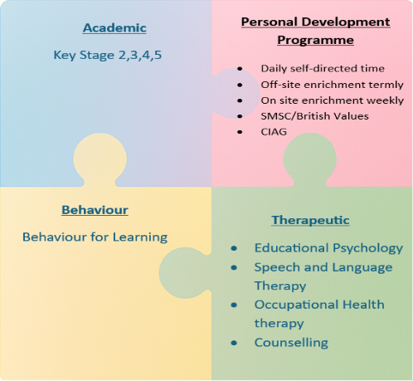

We start this process prior to a child starting via our induction program which ensures that we know all our students from their first day at school.
This information is captured on the My Passport document and supports all staff to ensure that they can always plan for universal, targeted or specific support. The My Passport document is the driver for inclusion in our school and supports all teachers to be experts in their field and SEN. Behaviour for Learning underpins all that we do and supports all children to have ownership over their progress at school.

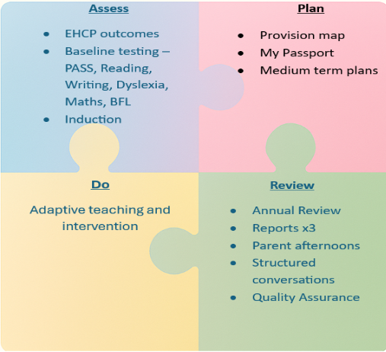

- Curriculum Design: Academic Curriculum Structure
At RGS children and young people are placed at the centre of what we do. Our children and young people have unique abilities (superpowers) and ways of learning, these are built upon to promote success in a variety of measures. We have developed clear curriculum pathways, from a broad and balanced curriculum in line with the National curriculum at Key Stage 2 and 3 to provide strong foundations and lead to more personalised ones at Key Stage 4 with the ability to move across pathways as needed to further personalise the offer and to prepare students for the next stage in education, employment or training. Our Key Stage 5 curriculum at Putney Vale is intended to reflect the needs and academic progression of the students attending there- whether that be academic or vocational accreditation to prepare them for the next stages of education, employment or training.
The senior leaders in the school ensure that the rationale for the curriculum design is effectively communicated and shared throughout the school. In developing this curriculum, careful attention is given to knowledge progression and sequencing of concepts both within and across subjects. This thoughtful approach ensures that the curriculum is equitable for all student groups and enhances their ability to access and benefit from the full range of learning opportunities.
Leaders, including governors, incorporate regular review and quality assurance opportunities into the planning process. This commitment to ongoing evaluation supports continuous improvement and ensures that the curriculum remains responsive to students’ needs.
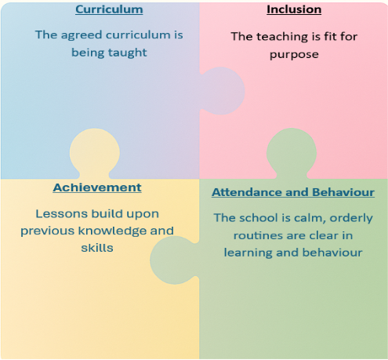

Quality assurance informs a CPD cycle linked to identified developmental needs- whether whole school, departmental or individual.
Careful consideration is given to how the curriculum prepares students for the next Key Stage. Long Term Plans (LTPs) for each subject carefully sequence the curriculum to spiral through the year groups and Key stages, giving multiple opportunities to revisit, build upon and further deepen knowledge. Medium Term Plans (MTPs) for each term identify key prior knowledge which needs to be reviewed before introducing new concepts recognising that some learners join us with significant gaps in their prior learning. They also highlight opportunities for numeracy and literacy development alongside British Values, Social, Moral, Spiritual and Cultural learning and Careers.

KS2 Curriculum
Timetabled sessions in
-English (including FFT Reading Quest for phonics delivery and intervention)
-Maths
-Science
-Humanities (to cover Geography, History and RE)
-Art + DT
-PE
-PSHE/RSE
The breadth of the National Curriculum is met through Enrichment, Drop-down days and guests (e.g. Wandsworth Music Hub) to cover the following:
-Computing
-Languages
-Music

KS3 Curriculum

In KS3 pupils follow a broad and balanced curriculum to provide foundational knowledge across all subjects whilst supporting students to develop the skills necessary for success in the classroom.

-English (4 periods)
-Maths (4 periods)
-Science (3 periods)
-PE (2 periods)
-Art (2 periods)
-Enterprise/Business/ICT (2 periods)
-PSHE (including Careers/RSE) (2 periods)
-Preparation for Adulthood (1 period)
-Foundations for Food (2 periods)
-Social Communication (covered by Votes for Schools) (1 period)
-Humanities (2 periods)
-Spanish (1 period)
-Enrichment (2 periods)

KS4 Curriculum
In KS4 pupils follow a broad and balanced curriculum and work towards qualifications. The pathway taken is determined by a combination of CAT predicted grades, ability to access the curriculum, progress through KS3 and personal needs. All children will have bespoke individualised accredited plans whilst also being part of a broad and balanced curriculum. All lessons are delivered by subject specialists and sit alongside a therapeutic offer in line with pupils’ EHCPs.

In Key Stage 4 Pupils are streamed into one of three pathways :
- Pathway A- A focus on strong foundations and Entry Level qualifications, with Preparing for Adulthood
- Pathway B- A focus on Functional Skills English and Maths, with Preparing for Adulthood
- Pathway C- A broader academic curriculum with up to 2 Option choices.

Within all pathways children are offered appropriate accreditations to allow progress to the next stage of education, employment and training.

Pathway A
The nurture curriculum with a focus on strong foundations in literacy and numeracy (through Entry Level Qualifications) and preparation for Adulthood (through ASDAN). These accreditations are taken when students are ready.
In addition, they follow a schedule in line with Pathway B to provide all students with a breadth of experience and opportunities to develop SMSC, British Values and CIAG through those subjects.

Pathway B
Accreditation in:
-English Pearson Functional Skills ELC to L1/Pearson English Language 2.0 GCSE (4)
-Maths Pearson Functional Skills ELC to L1/AQA Mathematics GCSE (4)
-AQA Science Entry Level Certificate (3)
-ICDL Award/Certificate in IT User Skills (3)
Plus:
-PE (2)
-Art (3) (Potential for OCR GCSE accreditation)
-PSHE/RSE/Careers (2)
-Preparation for Adulthood (1)
-Foundations for Food (2)
-Social Communication/Votes for Schools (1)
-Enrichment (2)

Pathway C
Accreditation in:
-Pearson GCSE English Language 2.0 (2)
-AQA GCSE English Literature (3)
-AQA GCSE Maths (4)
-AQA GCSE (Dual Award) Science (Synergy) (5)
-Option A (3)
-Option B (3)

For 2025-26 Option subjects include:
BTEC Sport
BTEC Health and Social Care
OCR GCSE Computer Science/Award in IT User Skills
OCR GCSE Art
AQA GCSE Spanish
OCR GCSE Citizenship

Plus:
-PE (1)
-PSHE/RSE/Careers (2)
-Foundations for Food (2)
-Social Communications/Votes for Schools (1)
-Enrichment (2)

KS5 – Putney Vale Campus
Purpose: To empower young people with autism spectrum condition (ASC) to develop the academic qualifications, independence skills, and personal confidence needed to lead fulfilling, healthy, and financially stable lives.
Aims By the end of their two-year programme, every student will have:
Academic achievement: A full suite of NC Level 2 qualifications including Maths and English. This would enable entry to NC Level 3 qualifications and beyond.
Preparation for adulthood: A personally tailored PSHCE and Careers curriculum focused on employment, independent living, community participation, wellbeing and health.
Specialist support: Autism-informed pastoral care and SEND provision that recognises individual strengths and needs.
Life skills: Practical independence skills for daily living, social situations, healthy eating, financial independence and transition to adulthood.
Self-advocacy: Tools to understand and communicate their needs, rights, and aspirations.
This approach ensures each student is equipped with both the formal qualifications and practical capabilities to navigate their next steps with confidence.

Accreditation in:
-English Functional Skills/GCSE advancing from previous attainment (in line with offer at Roehampton Gate School site) (6)
-Maths Functional Skills/GCSE advancing from previous attainment (in line with offer at Roehampton Gate School site) (6)
-NCFE Level 2 Award in Food and Cookery (4)
-International Computer Driving Licence (Award/Certificate)
-Option (BTEC Level 1 Sport, BTEC Level 1 Health and Social Care) (4)
-ASDAN Award/Certificate of Personal Effectiveness
Plus:
-PSHE (3)
-Careers (3)
-Enrichment (4)
- Curriculum Design: Therapeutic Programme
Our on-site Therapies team offer a holistic, comprehensive and detailed assessment and therapy provision, which is individually tailored to each child. Their invaluable insight and input provide a deep understanding of the children’s complex and multi-faceted needs and helps to formulate strategies through which children can overcome barriers and be supported to maximise their potential.
Therapy sessions take place on site in specialist rooms and are provided by our own fully qualified therapists and other professionals, as agreed with placing authorities and carers.
Our school has a dedicated team including Speech and Language Therapists (SALT), a counsellor, and commissioned Occupational Therapists (OTs), who deliver tailored therapy sessions to support each student's individual needs outlined in their EHC Plans. Having these therapists in-house allows us to be flexible and responsive, increasing therapy time beyond the scheduled sessions when necessary, to best support student progress and well-being. This integrated approach ensures that therapy is closely aligned with our curriculum and individual learning objectives as well as empowering students to be happy and succeed.

- Curriculum Design: Personal Development Programme
Our Personal Development Curriculum has 4 strands
PSHE/RSE/SMSC/Lifeskills
Enrichment
Student Voice/Votes for Schools
Careers Information Advice Guidance

These 4 strands of the curriculum aim to support our school values of
Confidence – built through enrichment opportunities to succeed outside of the classroom by participating in a variety of activities to take risks, develop areas of interest, teamwork and accessing the local community. Through the CIAG curriculum children develop an understanding of themselves, their own skills and interests and understanding of the wider world.
Respect – developed through the thematic PSHE curriculum/ RSE/SMSC/ Lifeskills. Children develop an understanding of healthy relationships, understanding others, staying safe and keeping others safe, fundamental British values. Through student voice, children experience the democratic process with school council elections and freedom of speech through pupil surveys.
Success – The impact of the personal development curriculum is that pupils know themselves and understand others. Pupils gain an understanding of the local community and wider world. Pupils have the confidence and ambition to transition to adulthood.

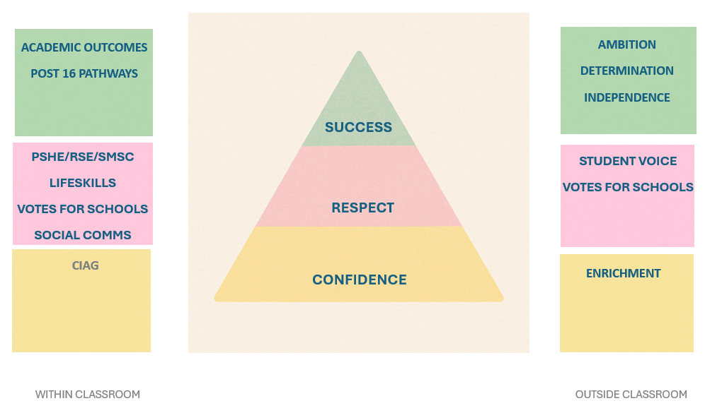
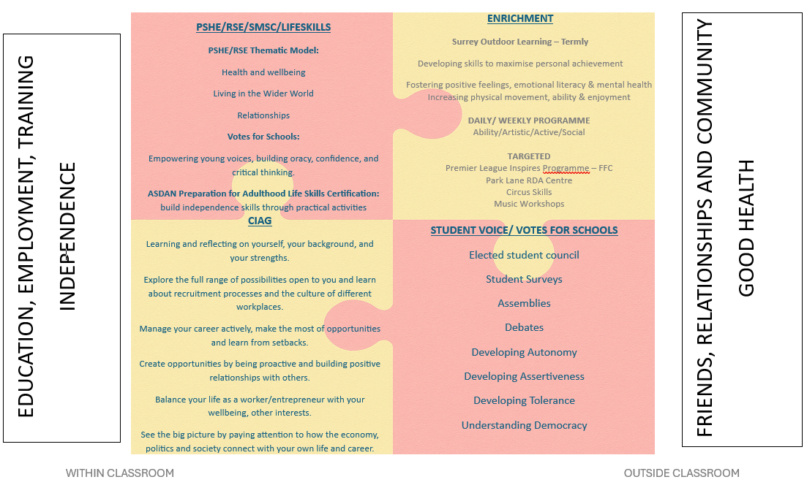
- Curriculum Design: Behaviour for Learning
The Behaviour for Learning framework is used in Key Stage 2, 3 and 4 to assess how frequently learners display behaviours which are conducive to learning and considered appropriate classroom behaviour. The framework covers three areas which are Relationship with Self, Relationship with Others and Relationship with the curriculum. The framework is designed to empower pupils to develop the required skills to achieve their potential. We aim to ensure that all children develop the necessary skills and confidence to access their preferred post 16 pathway.

When a child joins Roehampton Gate School their behaviour for learning will be initially assessed within the first four weeks. This allows for a broad and accurate assessment. The initial assessment will be completed by the whole staff team to acknowledge that pupils learning skills may vary across the curriculum. From this assessment, areas of strength and difficulty are identified, and an appropriate target is set.
Each pupil has a planner in which their current target is recorded, at the end of each lesson the classroom teacher will record how frequently the pupil has displayed the targeted behaviour on a scale from rarely (1) to always (5). During tutor time at the end of each day, teachers record the pupils score on the BFL tracker.

The BFL tracker records individual, class and whole school progress on a daily, weekly and termly basis. The weekly tracking cycle runs from Friday to Thursday to facilitate pupils receiving rewards at the end of each week. Rewards are issued in the form of a school shop (for instant reward) or banking money towards an end of term voucher which teaches children to save money. Any money that is saved by a child is recorded on the rewards sheet to ensure that this is not overlooked. Weekly progress is communicated with parents.

The tracking document builds a progress graph for each child that demonstrates progress over time.
Targets are reviewed by the form tutor every two weeks. If the form tutor believes that the target has been embedded from the tracker data, a new target is given based on the initial assessment. Where it is felt that a pupil has not made sufficient progress to consider the behaviour to have been embedded, the same target will continue. If little progress has been made the pastoral team will provide intervention for the child.
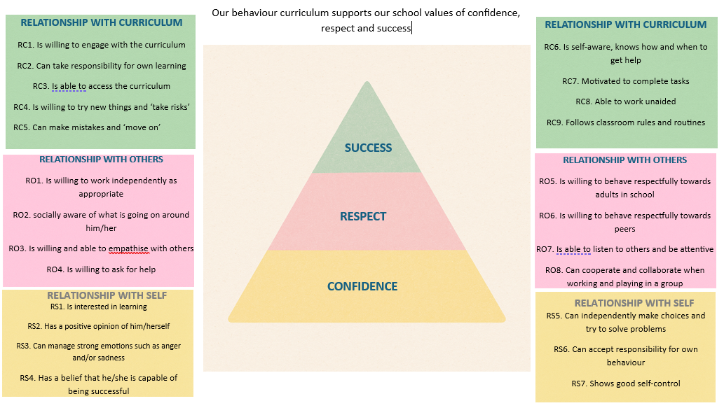

- Curriculum Delivery
Pedagogical approaches- adapted to individual

Every student completes a baseline assessment on entry to help set target grades and classroom placements. After six weeks, we create a My Passport- a personalised document that outlines the child's needs, strengths, and areas for growth. This passport is developed in collaboration with the student, parents, and staff, and incorporates targets derived from the student’s Education, Health and Care Plan (EHCP). It is reviewed termly with parents and form tutors to ensure it remains a working document that guides ongoing support and curriculum adaptations.
We aim for consistency across the school day to support students with processing their learning journeys. The day starts with meet and greet at the door and every student has their own locker to store the belongings they don’t need for the whole day. Tutor groups are purposefully small and are structured in a way to support students in developing their communication skills with their peers. Each tutor group has an assigned teacher and LSA to support building these positive relationships.
Lessons follow repeated cycles of Input, Activity, Review to ensure consistency and familiar expectations across the school whilst consolidating learning and adaptive teaching strategies are used where needs are identified. This is supported by purposefully small class sizes. LSAs are deployed to support students where needed- either within the classroom, 1:1 work outside the classroom or to help meet the individual needs of the child as per their My Passport.
Lessons are delivered within specialist classrooms with students moving from teacher to teacher over the course of the day. This allows for the classrooms to have visual learning resources available to support learning as well as to build in natural movement breaks during the day for all students. Whilst there are resources in all classrooms to support students with their sensory needs there are some classrooms which remain dedicated spaces for particular classes where students have access to their individual resources as needed during the school day to aid with regulation.

Cross-curricular reading and communication
All students undertake baseline assessments using NGRT and NGST. Where a need is identified then students are further assessed using the FFT Reading Test. Focused phonics interventions then take place using FFT Reading Quest (at all Key stages including Primary).

Key Stage 3 classes use the FFT Reciprocal Reading strategies to develop comprehension. It is a way of improving reading comprehension through a structured conversation about a text. This follows a cycle of predict, clarify, question and summarise around a short piece of text.

Subject teachers use OAK AI to generate comprehension texts linked to the topics within the medium term plan. This reinforces the concept that all teachers are teachers of literacy. This also develops a cohesive approach to reading comprehensions across the school and a familiar style for the children.

Interventions to impact barriers to learning
The Pastoral Team work across the school to support students in their readiness for learning by implementation of the language of Behaviour for Learning and through specific timetabled interventions as identified on students’ EHCPs and My Passports. These are identified and tracked as part of Provision Map.

Members of the Pastoral Team are trained as Emotional Literacy Support Assistants (ELSAs) to help address the emotional needs of pupils, ensuring they feel happier and more engaged in their learning. Other Pastoral Mentoring sessions take place both proactively and reactively in order to empower students to reflect.

LSAs support the work of the Pastoral team by directing the flow of students around the building between lessons and activities such as ‘meet and greet’ at classroom doors.

English as an additional language (EAL)
Roehampton Gate School is committed to equal treatment for all, including those for whom English is not their first language. The school recognises the importance of making provision and support for such pupils in line with their commitment to encourage applications from candidates with as diverse range of backgrounds as possible. This enriches our community and is vital in preparing our pupils for today’s world. Where necessary EAL specialists from external agencies, will be invited in to provide support through training or visits to maximise progress.

- Wider Curriculum and Enrichment
Enrichment time is explicitly built into the whole school timetable led by a member of staff with responsibility for developing a cohesive and coherent enrichment plan. This broadens experiences, increases engagement with the local community, builds independence and resilience whilst being aligned with students’ personal interests.

Social, Moral, Spiritual and Cultural/British Values
Aspects of SMSC are developed through all parts of our curriculum, though some subjects and activities are likely to be more relevant than others-in particular PSHE, Votes for Schools, and Citizenship. There are also robust school norms which support the implementation of SMSC. Our focus is to eliminate bias and encourage balance of viewpoint, opinion and understanding.

RGS is committed to supporting British values:
-Encouraging pupils to respect specified fundamental British values
-Not promoting extremist views, or partisan political views, through the curriculum and/or teaching
-Ensuring pupils are offered a balanced presentation of views when political issues are brought to their attention

Religious observances
Roehampton Gate School has no affiliation with any particular culture or faith and embraces an understanding and tolerance of all irrespective of race, culture or faith. The fostering of spiritual growth is considered to be an important aspect of a young person’s well being and the need to nurture this growth is taken seriously. The young people are supported in their wishes and the wishes of their parents regarding their particular religious observance. The young people are encouraged to explore their own spirituality through a variety of means, Included in this will be positive role modelling, multi-faith religious education within the context of the school curriculum, encouragement to participate in their own stated religious observances and encouragement to develop an understanding of the differing religious observances and practices to be found within a multi-cultural society.

Careers Guidance
Our careers education: information, advice and guidance at RGS actively supports the next steps for children’s education and future careers progression. Careers is delivered through the PSHE timetable to years 8 and 9 and as explicit careers lessons to Key stage 4 and 5.
A comprehensive review of Gatsby benchmarks informs the careers action plan- this is reviewed 3 times a year.

Preparation for Adulthood
We use ASDAN Life Skills Challenges as part of our curriculum to support pupils in developing essential personal and social skills that prepare them for adulthood. The programme is designed to promote independence, confidence, and practical competence through meaningful, real-life learning experiences. Evidence is collected as they complete activities, earning ASDAN certification which recognises their progress and achievements.

Personal Development/Enrichment at Putney Vale Campus
The enrichment curriculum at Putney Vale is designed to support children to achieve ASDAN accreditation through the Award/Certificate of Personal Effectiveness (equivalent to a GCSE). To facilitate this, Enrichment has a theme for each half term which correlates to an ASDAN short course. In addition children achieve ASDAN accreditation with Life Skills challenges that also relate to the theme of the enrichment for that period.

- Curriculum Outcomes, achievement and evaluation
Assessment, recording and reporting
On induction learners are baselined using CATs (to generate target grades) along with PASS and NGRT/NGST. The CATs tests are revisited every 2 years to ensure that the targets remain current. This data is shared with teachers so that they can plan their lessons effectively. Ongoing assessment against learning objectives within the classroom takes place with teaching adapted accordingly. Students are also provided with written feedback on their work aimed at supporting progress to the longer term objectives within a scheme. Prior knowledge for each unit of work has been identified by teachers in the medium term plans so this will also be checked by teachers either as part of the lesson or through pre-topic tests.

Half termly tracking of students (either formative or summative) is recorded centrally and informs intervention where needed. This is shared with parents through written reports and parents evenings. Pupil progress dialogue conversations happen formally three times a year, they quality assure evidence against objectives, discuss future targets, achievements of pupils and identify if any barriers to learning are present and what (if any) intervention is required. Information from these meetings is evaluated, key children who are a concern are identified, closer scrutiny of these pupils is made in between meetings.

Form tutors use each term to assess EHCP outcomes set out in the My Passport document, the team use the provision map to plan and deliver support, review progress with parents during structured conversations, and set new targets as needed. This ensures the EHCP remains current and effective.
All students have weekly Behaviour for Learning Targets and this feeds into a rewards scheme tracked on an individual, class and whole-school basis daily, weekly and termly and over the course of the year.
This demonstrates progress that students are making with behaviour both within the classroom and within the wider school community.

Pupil voice is captured in student surveys three times. Additionally Putney Vale campus has student comment boxes where students can post comments and feel heard

- Governance and Leadership
- Governance and Leadership oversee all we do at school level and are responsible for ensuring that RGS work with the framework and processes of Aspris and ISS. Governance provides structure and accountability ensuring ethical conduct and strategic alignment whilst leadership provides the vision motivation and guidance at school level.
- Senior Leaders are responsible for setting strategic direction and maintaining oversight of the curriculum’s implementation. They ensure that the vision for equity and high standards is consistently applied across the school.
- The SENCO (Special Educational Needs Coordinator) ensures that the needs of students with special educational needs are effectively addressed. This role involves coordinating resources and support to guarantee that these students have equal access to a high-quality education that aligns with the curriculum goals.
- Teachers play a key role in communicating and implementing the vision for the curriculum, ensuring that it provides equitable opportunities for all learners. They are informed by background data to plan effectively to meet the needs of all learners in their classes and to use ongoing assessment to adapt their teaching effectively.
- LSAs (line managed by teachers) are responsible for supporting students in their learning as directed by teachers. They may work with students 1:1 or with small groups in order to allow the teachers to work 1:1 with students.

Together we ensure that the curriculum is inclusive, rigorous and aligned with national expectations, driving the overall success of all students. By focusing on reading and character development we ensure a comprehensive approach to learning that enhances academic success and personal growth. Reading is a fundamental part of the school day, recognising its fundamental role in student success.

Contents Checklist (Local Services may add additional items – this is a core list)
Rationale underpinning the curriculum – design, delivery and impact | X
Reference the ISS | X
Purpose and Scope, Aims and Vision of the curriculum | X
Local Context | X
Reference qualifications and outcomes supported by the curriculum | X
Curriculum Structure | X
Progression and Adaptations | X
Assessment and tracking | x
Stakeholder Engagement | X
Reference qualifications and outcomes supported by the curriculum | x
Personal development | X | Reference how PSHE, RSE, SMSC, British/Scottish values, wellbeing, and safeguarding are embedded
Opportunities for work related learning, independent CIAG and reference to the Gatsby Benchmark | X
The role of subject coordinators if this is applicable and how the curriculum is monitored |  | Not applicable
Wellbeing and safeguarding
Reference to the process of how the curriculum is and will be reviewed | X
Post-16 as a separate section if this is applicable | x
Qualifications and accreditation | X
Implementation and Responsibilities | X
Review and Evaluation | X

Local Procedure Review History:
Date Reviewed | Reviewer | Summary of revisions
10/2/2026 | Andy Molloy | Added Diagrams following ISR

