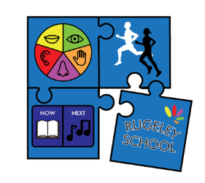


Rugeley School
Relationships Education, Relationships and
Sex Education (RSE)
and Health Education –
RSHE (PSHE and RSE)

Reviewed: Sept 2026
Next Review: Sept 2027
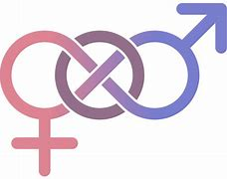

Equal opportunities lie at the heart of all that we do at Rugeley. We are committed to ensuring that every member of the school community, whatever their disability, gender, sexual orientation, age, colour, ethnic origin, culture or religious belief is given the same chance as any other to access the services and support of our school.
Associated Priory policy | Policy | Number
Associated Priory policy | Curriculum | ECS31
Associated Priory policy | Teaching & Learning | ECS32
Associated Priory policy | SMSC | ECS34
Setting  Rugeley School | L Price Head Teacher | Signature
 | J Hartley Subject lead | Signature
Quality Assured by : | C.Blackett  Operations Director | Signature
Issue date | 09/2020 | Review date | 09/2026 - Updated to reflect DfE Relationships, Sex and Health Education Statutory Guidance (September 2026)

Abstract
Rugeley School offers all students a highly bespoke curriculum that encourages them to develop their individuality, confidence, self-esteem and independence. Through effective teaching and adapted learning our highly trained staff team equips all students to gain knowledge, understanding and skills for life. The school mission statement states:

‘Making every second count!’

‘Our vision is for every pupil to feel safe, understood and supported to develop the skills they need to thrive in school and beyond.’

Students who enter the school in KS1 will go onto our developing learners pathway. These students follow an adapted EYFS style curriculum approach utilising structured sessions and continuous provision. These students are separated into progressive and sensory learners for their structured sessions. Students are working towards the early learning goals or key stage standards. Throughout KS2 to KS5 Rugeley School students will follow one of two curriculum pathways sensory or progressive. This is determined based on their individual needs, peer group and cognitive ability. Class groups consist of a maximum of six students, that have a range of ability. Students participate in a meaningful curriculum, with high expectations, where they are challenged to make at least good progress, through stimulating and dynamic lessons. Student self-regulation is embedded throughout the curriculum alongside a fully integrated model of therapeutic support.

- Aims

- To ensure that the curriculum is inclusive, informed, structured and builds upon prior learning, meeting the changing needs of all our students.
- To enable students to overcome barriers to learning through self-regulation, support strategies and a personalised curriculum.
- To recognise the individual needs and talents of each student to facilitate development of their intellectual, moral, physical, social, spiritual and creative capacities, underpinned by a respect for British values. To oppose racism, bias, stereotyping and all other forms of discrimination by challenging discrimination whenever it is found in line with the Equality Act 2010. For further information please see appendix point 1.
- To foster an environment that values the voice and views of all our students, parents and carers, staff and other professionals involved with the school.

- Curriculum Aims
The aims of RSHE at our school are:
- To equip young people with the knowledge, understanding, skills and strategies required to live healthy, safe, productive, capable, responsible and balanced lives.
- To support young people in making effective transitions, positive learning, career choices and achieving economic well-being.
- To provide opportunities to develop the skills to reflect on and clarify their own values and attitudes and explore those of others showing respect for their differences.
- To equip young people to identify and manage risk, make informed choices and understand what influences their decisions.
- To support young people to form and maintain good relationships.
- To be up to date with current affairs and be equipped to understand the world around them, making informed choices.

The aims of relationships and sex education (RSE) at our school are to:
- Support mental wellbeing, physical health and fitness, respectful relationships and being safe
- Provide a framework in which sensitive discussions can take place
- Prepare learners for puberty, and give them an understanding of sexual development and the importance of health and hygiene
- Help learners develop feelings of self-respect, confidence and empathy
- Provide knowledge and support to promote positive mental wellbeing
- Help learners to know how to be safe and healthy
- Help learners to manage their academic, personal and social lives in a positive way
- Create a positive culture around issues of sexuality and relationships
- Teach learners the correct vocabulary to describe themselves and their bodies
- Embed safeguarding into our school’s curriculum

- Statutory requirements
As an independent special school there is statutory guidance that we must provide relationships education to all learners.
In teaching RSHE, we must have regard to guidance issued by the secretary of state as outlined in section 403 of the Education Act 1996. We follow statutory guidance from the Department for Education issued under section 80A of the Education Act 2002. DfE RSHE Statutory Guidance (2026), Equality Act 2010 and KCSIE (current version). At Rugeley School we teach RSHE as set out in this policy.

- Policy development
This policy has been developed in consultation with staff, learners and parents. The consultation and policy development process involved the following steps:

- Review – a member of staff or working group pulled together all relevant information including relevant national and local guidance

- Staff consultation – all school staff were given the opportunity to look at the policy and make recommendations

- Parent/stakeholder consultation – parents and any interested parties were invited to attend a meeting about the policy

- Learner consultation – we investigated what exactly learners want from their RSE

- Ratification – once amendments were made, the policy was shared with governors and ratified

- Definition
Rugeley School believes every young person is entitled to a broad, balanced and enriched curriculum through which RSHE and life skills will be developed. The skills in RSHE provide young people with the tools for understanding their world – enabling them to lead a life after school which is as independent as possible. When teaching RSHE, we take into account that our young people:

- Have unique learning styles and require continuous support to acquire the knowledge, understanding and skills they need to manage their lives.
- Need a teaching and learning technique that is highly structured whilst also encouraging exploratory learning.
- Require work to improve their social understanding.
- Benefit from a consistency of approach from teachers, teaching assistants, parents and other professionals which require effective communication regarding individual young people.

- RSHE is about the emotional, social and cultural development of learners, and involves learning about relationships, sexual health, sexuality, healthy lifestyles, diversity and personal identity.
- RSHE involves a combination of sharing information, and exploring issues and values.
- RSHE is not about the promotion of sexual activity.

- Curriculum
RSHE is taught through the use of rolling programme of creative curriculum Topic overviews which are linked to a PHSE and RSE Overview through Key Stages 1 to 4. The long-term curriculum planning is differentiated at an appropriate level to ensure the ability of the young people is met and also challenges and stretches when necessary.

Flexibility is given to our class teacher’s to use their professional judgement with the delivery of RSHE across the curriculum throughout the school week or in a formalised RHSE lesson. Each class will have teaching and learning opportunities in RSHE/Life skills/PSHE for at least 1 hour per week and in RSE for 1 hour per week.

RSHE in the Post 16 area of the school is integrated into a range of practical and functional based subjects. Each young person will have opportunities through the Human & Social aspects of the curriculum.

Teachers should plan and teach knowledge, skills and understanding in ways that match and challenge our young people’s abilities. Teaching should provide opportunities for skills to be mastered before new content is introduced whilst providing challenge and stretch for more able pupils. Teachers will submit medium term planning for RSHE every half term to be monitored by the Senior Leadership Team.

We promote a hands-on approach to teaching and learning all elements of RSHE in addition to scheduled lessons, young people regularly access RSHE and life skills through a wider range of activities such as: shopping, cooking, enterprise and enrichment activities. Young people in Post 16 take part in work related learning as well as gaining qualifications through accredited courses, such as AQA unit awards.

The school uses a variety of different approaches and incorporates the best practice from different philosophies including Structured Teaching and Learning, PECS and Intensive Interaction to provide an education that is autism friendly.

Communication and Language is essential for our young people, so the use of visual symbols/words system is essential alongside a simplified commentary on what the activity involves. Where possible this should be functional and delivered in context of the activity.

Our curriculum is set out as per Appendix 1 but we may need to adapt it as and when necessary.
We have developed the curriculum in consultation with parents, learners and staff, taking into account the age, needs and feelings of learners. If learners ask questions outside the scope of this policy, teachers will respond in an appropriate manner, so they are fully informed and don’t seek answers online.

For more information about our curriculum, see our curriculum map in Appendix 1.

- Delivery of RSHE
Personal, Social, Health and Economic (PSHE) and Relationships and Sex education is taught within the RSHE curriculum.
RSHE education focuses on teaching pupils the knowledge, skills, and values they need to make informed decisions about their health, wellbeing, relationships, and future, while fostering respect, empathy, and personal responsibility. Flexibility is given to class teacher’s to adapt the delivery of RSHE to support learners’ knowledge and understanding.

Our RSHE curriculum is delivered in a progressive, age-appropriate, and needs-led manner, ensuring that content is adapted to pupils' developmental stage, communication needs, and cognitive ability. Key themes, including consent, personal boundaries, healthy relationships, online safety, online harms, artificial intelligence (AI) and digital literacy, grooming, exploitation, sexual harassment, sexual health, and accessing support services, are revisited and built upon throughout a pupil's journey in school – where appropriate. This approach ensures that all pupils develop the knowledge, understanding, and skills needed to stay safe, make informed decisions, and access appropriate support while reflecting their individual learning needs and levels of understanding.
The following content will be covered where appropriate for individual learners, and will be adapted as necessary to meet their specific needs:

KS1, KS2 – Relationship Education
- Families and people who care about me
- Caring friendships
- Respectful relationships
- Online safety and awareness
- Being safe

KS3, KS4, KS5 – Relationships and Sex Education
  - Families
  - Respectful relationships
  - Online Safety and Awareness
  - Being safe
  - Intimate and sexual relationships, including sexual health
  - Mental Wellbeing

KS1, KS2 - Health and wellbeing
  - General wellbeing
  - Wellbeing online
  - Physical health and fitness
  - Healthy Eating
  - Drugs, alcohol, tobacco and vaping
  - Health protection and prevention
  - Personal safety
  - Basic first aid
  - Developing bodies

KS3, KS4, KS5 - Health and Wellbeing
  - Mental Wellbeing
  - Wellbeing Online
  - Physical Health and Fitness
  - Healthy Eating
  - Drugs, alcohol, tobacco and vaping
  - Health protection and prevention, and understanding the healthcare system
  - Personal safety
  - Developing bodies

For more information about our RSHE curriculum, see Appendices 1.

These areas of learning are taught within the context of family life taking care to ensure that there is no stigmatisation of children based on their home circumstances (families can include single parent families, LGBT parents, families headed by grandparents, adoptive parents, foster parents/carers amongst other structures) along with reflecting sensitively that some children may have a different structure of support around them (for example: looked after children or young carers).

- Roles and responsibilities
9.1 The governing board
The governing board will approve the RSHE policy, and hold the Head Teacher to account for its implementation.
9.2 The Head Teacher
The Head Teacher is responsible for ensuring that RSHE is taught consistently across the school, and for managing requests to withdraw learners from components of RSHE (see section 8).
9.3 Staff
Jessica Hartley is the allocated lead for RSHE at Rugeley School

All class teachers/instructors are responsible for:
- Delivering RSHE in a sensitive way
- Modelling positive attitudes to RSHE
- Listening and responding to the views of young people
- Monitoring progress
- Responding to the needs of individual learners
- Responding appropriately to learners whose parents wish them to be withdrawn from the components of RSHE
- Staff do not have the right to opt out of teaching RSHE. Staff who have concerns about teaching RSHE are encouraged to discuss this with the Head Teacher.

9.4 Learners
Learners are expected to engage fully in RSHE and, when discussing issues related to RSHE, treat others with respect and sensitivity.

- Parents’ right to withdraw
Parents do not have the right to withdraw their children from relationships education.
Parents have the right to withdraw their children from the components of sex education within RSHE curriculum up to and until 3 terms before the child turns 16.
There may be exceptional circumstances where the Head Teacher may want to take a pupils specific needs arising from their SEND into account when making this decision.
Requests for withdrawal should be put in writing using the form found in Appendix 2 of this policy and addressed to the Head Teacher.
Alternative work will be given to learners who are withdrawn from sex education.

- Training
Staff are trained on the delivery of RSHE and it is included in our continuing professional development calendar.
The Head Teacher will also invite visitors from outside the school, such as school nurses or sexual health professionals, to provide support and training to staff teaching RSHE.

- Monitoring arrangements
The delivery of RSHE is monitored by Senior Leadership Team through:
Planning scrutiny, learning walks, etc.
Learners’ development in RSHE is monitored by class teachers as part of our internal assessment systems.
This policy will be reviewed by Jessica Hartley annually. At every review, the policy will be approved by the Head Teacher and Governing Body. The Governors will monitor the implementation across the setting.

Safeguarding

This school is committed to safeguarding and promoting the welfare of children and young people and expects all staff, learners, parents/carers, visitors and volunteers to share this commitment. A safer setting starts with safe individuals.
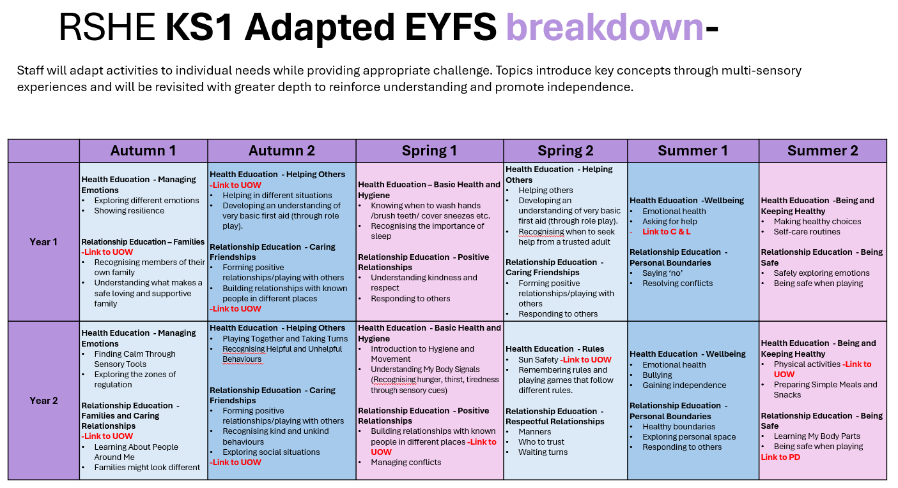
Appendix 1: Scheme of Work

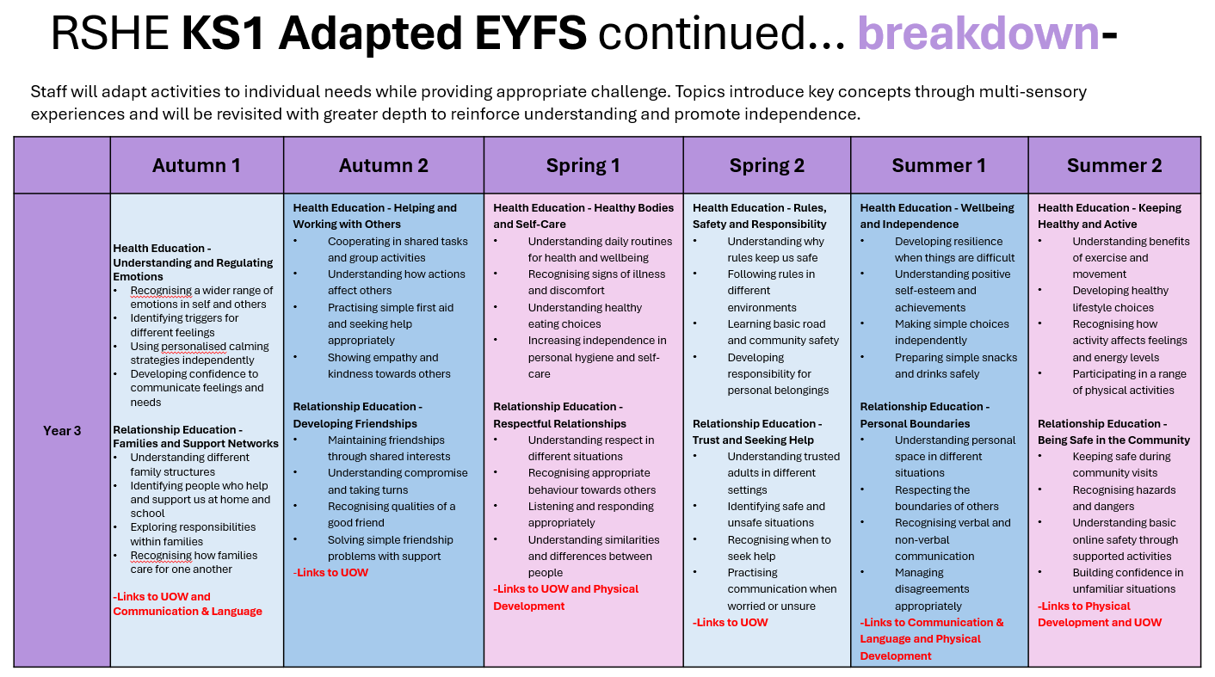
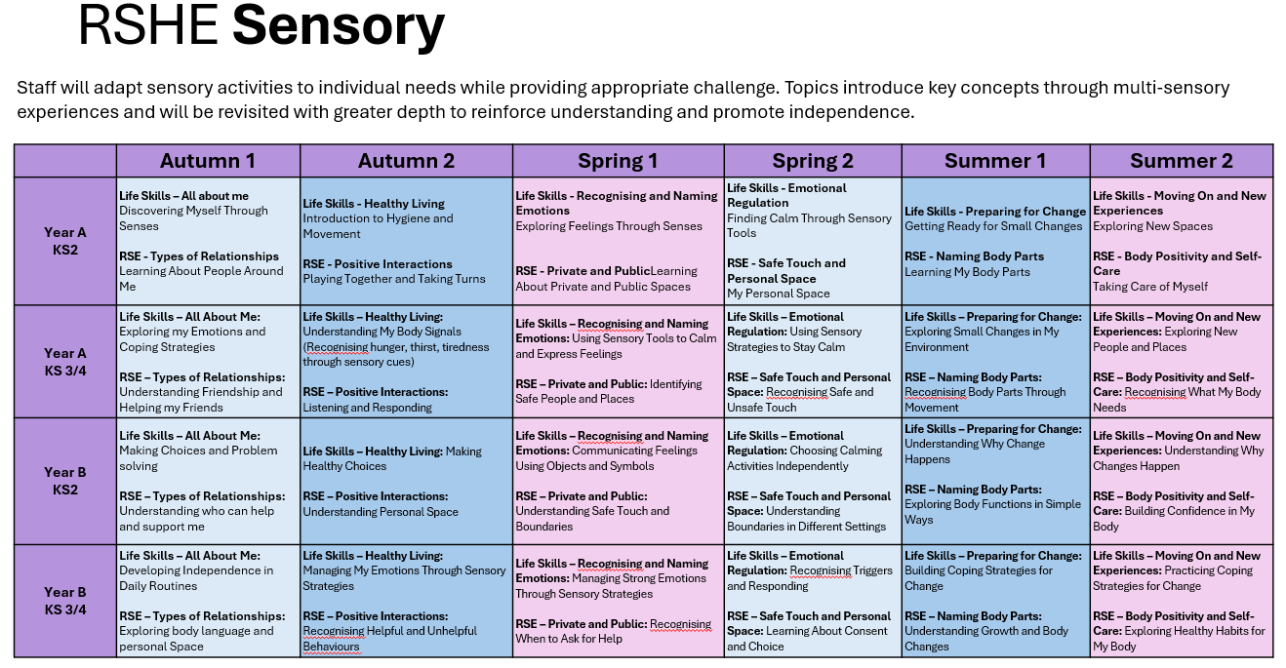
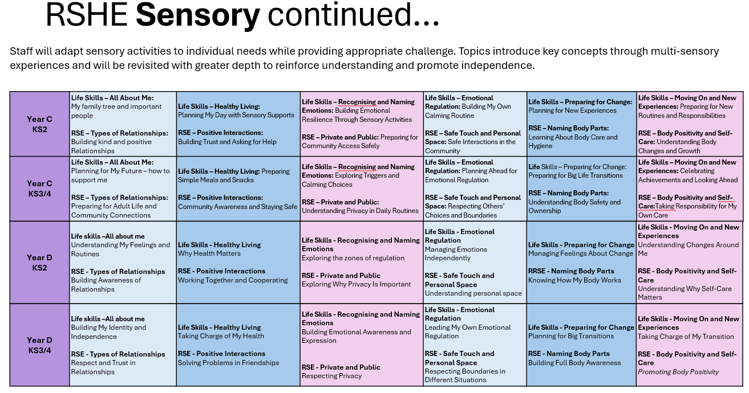
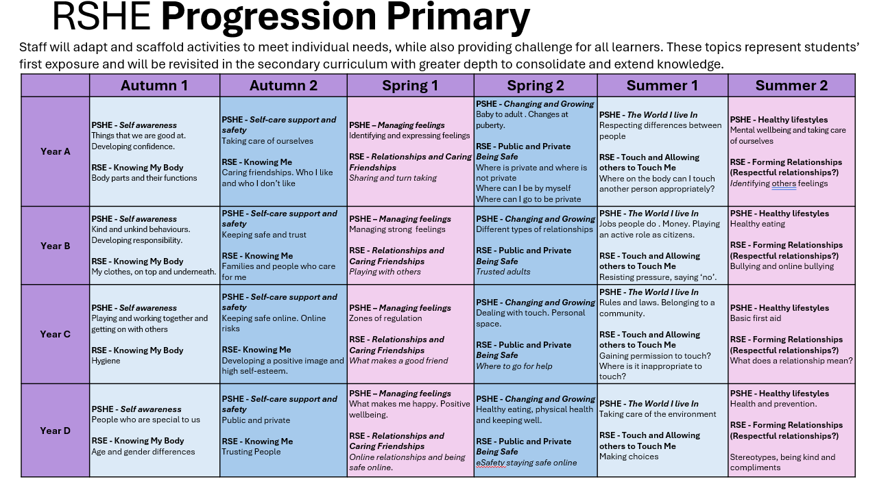
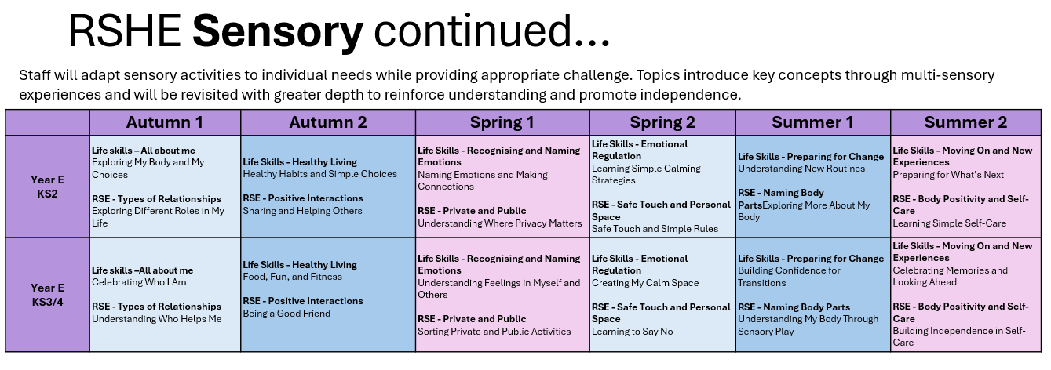

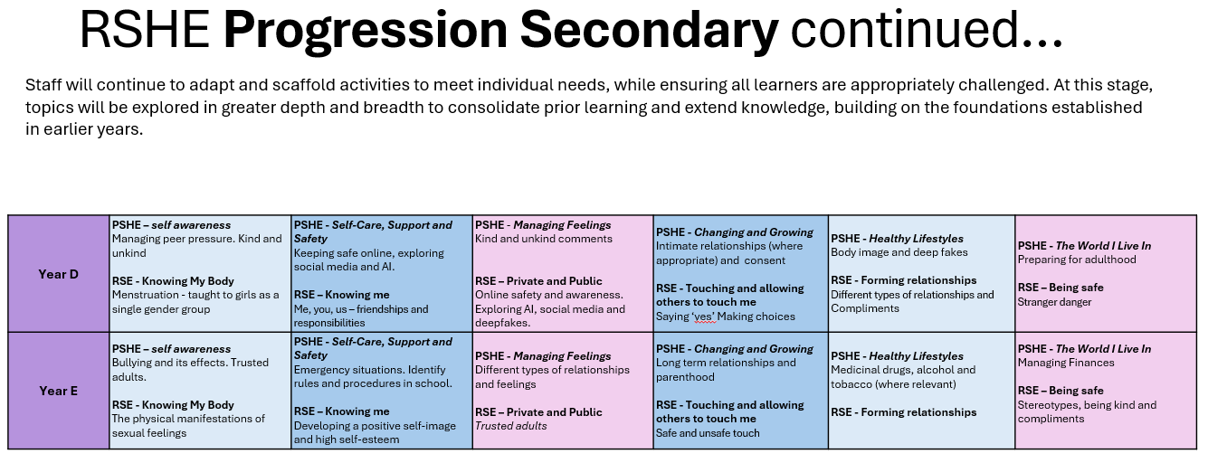
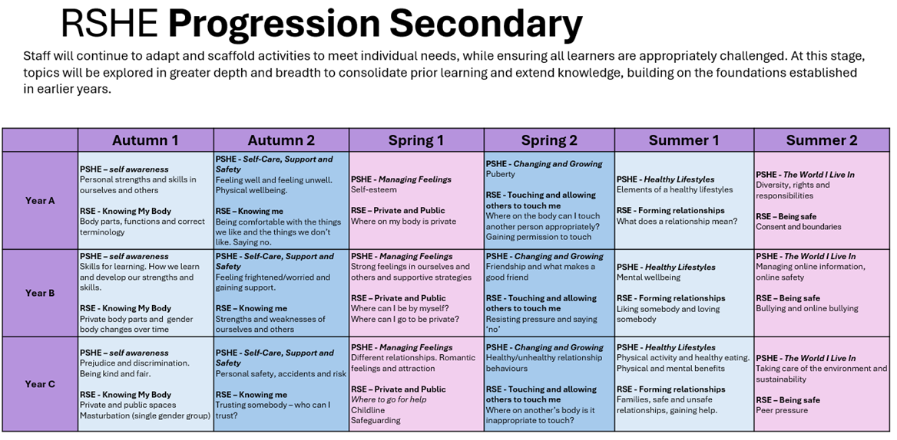

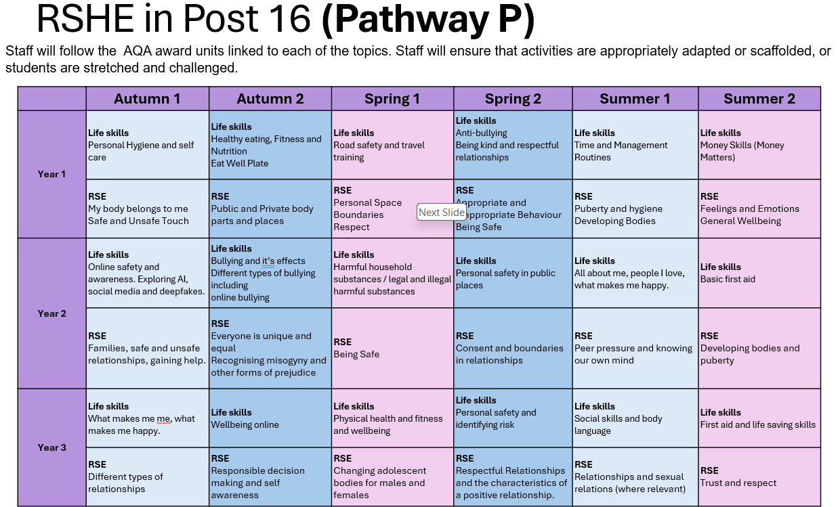
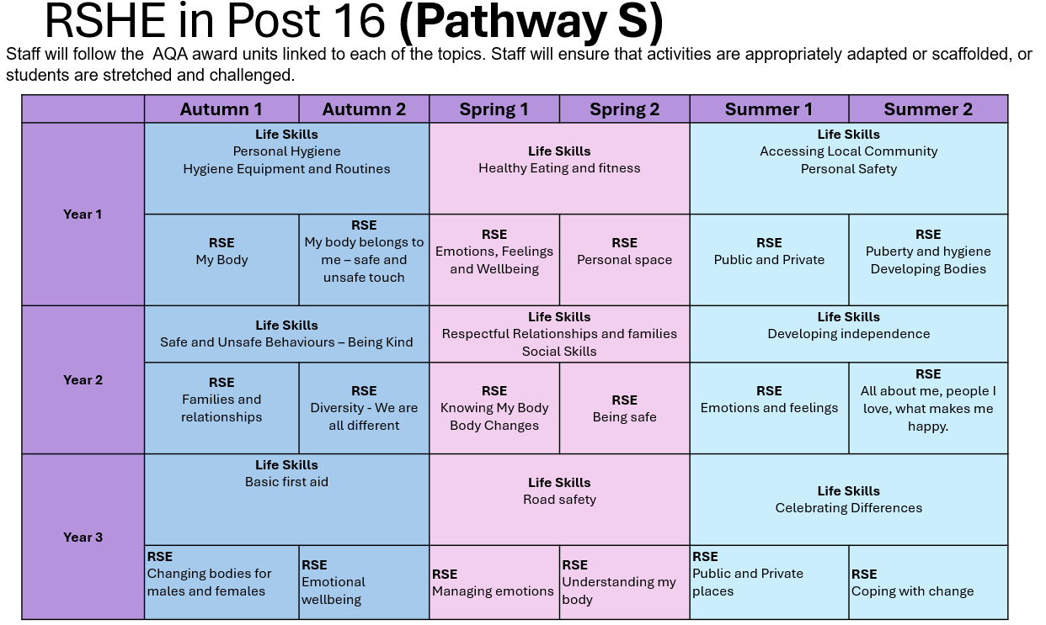

Appendix 2: Parent form: withdrawal from sex education within RSE

To be completed by parents
Name of child |  | Class
Name of parent |  | Date
Reason for withdrawing from sex education within relationships and sex education
Any other information you would like the school to consider
Parent signature

To be completed by the school
Agreed actions from discussion with parents | Include notes from discussions with parents and agreed actions taken.  Eg: Joe Bloggs will be taking part in all relationships lessons and during the sex education lessons, he will be working independently on a project in the Year 5 classroom

