Local Procedure Title | Curriculum Local Procedure
Site | Sedgemoor Manor School
ECS Policy number and title | ACS 31 Curriculum
Local Procedure template reference | ACS LP 31
Local Procedure date | 10/09/26
Local Procedure review date | 10/09/27
Local Procedure Author(s) | Rebecca Sheppard
Local Procedure Ratification | Checked and Approved by: John Gordon

- Purpose
This procedure outlines how Sedgemoor Manor School implements, delivers, monitors and evaluates the curriculum to ensure that all children and young people receive an ambitious, inclusive and personalised education that meets their individual needs and prepares them for adulthood. The procedure should be read alongside the school's Teaching and Learning Policy, Assessment Policy, SEND Policy and Positive Behaviour Policy.
This procedure applies to:
- All students from Key Stage 2 to Key Stage 5.
- All teaching and support staff.
- Therapists and intervention specialists working within the school.
- Senior and middle leaders responsible for curriculum delivery and quality assurance.
- Curriculum Overview
Sedgemoor Manor School's curriculum is designed to provide every student with an ambitious, inclusive and personalised education that enables them to achieve their full potential. Underpinned by the National Curriculum, learning is shaped by high expectations, evidence-informed practice and a commitment to meeting the individual needs of all children and young people. Academic achievement is valued alongside communication, emotional wellbeing, independence and preparation for adulthood, ensuring students develop the knowledge, skills and confidence needed to thrive as successful learners and active members of their communities (see Appendix 5).
Our curriculum provides meaningful and engaging learning opportunities that are tailored to individual strengths, interests and needs. Through carefully planned teaching and learning experiences, students are challenged to make the best possible progress whilst developing social and emotional resilience. Therapeutic approaches, enrichment opportunities and personal development are woven throughout the curriculum, creating a supportive environment in which children and young people feel safe, motivated and able to enjoy learning.
Recognising the needs of 21st-century learners, our curriculum is ambitious and future-focused, equipping students with the knowledge, skills and learning behaviours required for lifelong learning and successful adulthood. At Sedgemoor Manor School, the curriculum is central to our ethos and reflects our philosophy, aims and values. It provides the framework through which children and young people with autism and associated needs are supported to achieve the best possible outcomes and realise their full potential.
- Curriculum Vision and Aims
At Sedgemoor Manor School, we encourage children and young people (CYP) to follow their passions and believe there should be no limits on what they can achieve. We provide a safe, nurturing and motivating environment where students can re-engage with learning, develop confidence and resilience, and achieve the best possible outcomes for their future. Through an ambitious, inclusive and accessible curriculum, we equip students with the knowledge, skills and personal qualities needed to thrive in school, contribute positively to society, and successfully transition to adulthood.
Our curriculum aims to:
- Provide an ambitious, broad and balanced curriculum through appropriately matched curriculum pathways that meet the needs of all students.
- Ensure learning is accessible, suitably challenged and promotes sustained progress from individual starting points.
- Deliver the National Curriculum in meaningful and engaging ways for autistic learners.
- Remove barriers to learning through adaptive teaching, reasonable adjustments and therapeutic approaches that support communication, emotional regulation and sensory needs.
- Prepare students for future education, accreditation, employment and adulthood, including developing an awareness of local and national career opportunities.
- Foster independence, confidence and resilience, enabling students to achieve the best possible outcomes and fulfil their aspirations.
- Develop students' emotional, moral, spiritual and cultural awareness, promoting diversity, Fundamental British Values and respect for different backgrounds, cultures and religions.
- Equip students with the knowledge, understanding and cultural capital needed to become respectful, active citizens who make positive contributions to society.
- Enrich learning through visitors, trips and wider experiences that inspire curiosity, broaden horizons and develop interests.
- Our curriculum Allocation
Subjects | KS2  Exploration | Y7/8  Exploration | KS3 (Y7-9)  Discovery | KS4 (Y10) | KS4 (Y11) | KS5  onsite
 | 50 min | 50 min | 50 min | 50 min | 50 min | 50 min
English | 3 | 3 | 5 | 4 | 4 | 4
Maths | 5 | 5 | 4 | 4 | 4 | 4
Project | 9 | 9
BTEC core |  |  |  | 4 |  | 4
Science |  |  | 3 |  | 6
PSHE/PD | 3 | 3 | 3 | 3 | 3 | 3
Humanities |  |  | 3
ICT | 1 | 1 | 1 | 1 | 1 | 1
Food | 2 | 2 | 2 | 2 | 2 | 2
PE | 2 | 2 | 2 | 2 | 2 | 2
Enrichment | 2 | 2 | 2 | 2 | 2 | 2
Outdoor Learning | 1 | 1 | 1
Animal Care | 1 | 1 | 1
Social thinking | 1 | 1
Art/music/drama |  |  | 3
Option A |  |  |  | 4 (6-Science) | 3
Option B |  |  |  | 4 | 3
P4A/WRL |  |  |  |  |  | 8
Total | 30 | 30 | 30 | 30 | 30
 |  |  |  |  |  | 30
- Curriculum Pathways (KS2 and KS3)
At Sedgemoor Manor School, we recognise that every child is unique, and that autistic learners have diverse strengths, abilities and needs. Students learn in different ways and at different paces, so our curriculum pathways are designed to provide learning that is appropriately challenging, meaningful and aspirational.
To meet this diversity, we offer two curriculum pathways across Key Stages 2 and 3, providing different routes towards the same goal: enabling every student to achieve the best possible educational, personal and social outcomes (Appendix 1).
In the Exploration Pathway (see Appendix 6), students develop curiosity, understanding and foundational skills through connected, meaningful projects. In the Discovery Pathway (See Appendix 7), students build subject-specific knowledge, skills and ways of thinking while developing their individual strengths, interests and aspirations. Together, these pathways support students to progress from exploring the world around them to discovering future opportunities and destinations.

5.1 Pathway Placement and Review
Pathway decisions shall be informed by:
- EHCP outcomes.
- Academic attainment and progress.
- Communication needs.
- Emotional regulation and wellbeing.
- Learning profile.
- Readiness for subject-specific or project-based learning.
- Preparation for next stages of education and adulthood.
The Headteacher, SLT and relevant school staff shall review pathway placements regularly. Pathways are not fixed. Pupils may move between pathways where this better meets their needs.

5.2 Exploration Pathway (KS2 and Year 7/8)
The Exploration Pathway (See Appendix 6) is designed for all Key Stage 2 students and for Key Stage 3 (Year 7 and 8) students who are working significantly below age-related expectations. Using the Cornerstones Curriculum Maestro, it provides a carefully sequenced, project-based curriculum that develops knowledge, communication, independence and personal skills through meaningful, cross-curricular learning. Students explore the world through connected projects that bring learning to life, helping them make links between subjects, develop curiosity and apply their knowledge in real-world contexts. Alongside academic learning, students build strong foundations in communication, independence and life skills.
Exploration is about:
- Learning through meaningful, real-life contexts
- Making connections across subjects
- Developing curiosity, inquiry and understanding through hands on experiences
- Building foundational knowledge and skills
- Applying learning through purposeful projects

Who follows the Exploration Pathway?
All Key Stage 2 students follow the Exploration Pathway. Some Key Stage 3 students continue on this pathway where it remains the most appropriate curriculum offer.
To ensure learning is suitably challenging and age-respectful, students access projects matched to their developmental stage rather than their chronological age.
Chronological Year Group | NC Project Level Followed
Year 3- 4 | Year 1-2 projects
Year 5-6 | Year 3-4 projects
Year 7-8 (where appropriate) | Year 5-6 projects
This approach enables students to develop secure knowledge and skills at a pace that reflects their individual needs whilst maintaining high aspirations.

How is learning structured?

The curriculum combines:
- Project-Based Learning- cross-curricular topics including English (literacy), History, Geography, Science, RE, Computing, Music, Art and Drama.
- Four Project Phases- Engage, Develop, Innovate and Express, which support students to build, apply and communicate their learning.
- Discrete Subject Teaching- Mathematics, English skills (handwriting, phonics if appropriate, spelling), PSHE/RSHE, Home Cooking and PE.
- Personal Development and Therapeutic Opportunities- Animal Care, Outdoor Learning, Social Thinking, careers education, travel training, financial education, independence and self-care skills and weekly enrichment activities.
Together, these experiences support academic progress, EHCP outcomes, and the development of the confidence, independence and life skills needed for successful adulthood.
5.3 Discovery Pathway (Key Stage 3)
The Discovery Pathway (See Appendix 7) is designed for students in Key Stage 3 (Years 7- 9) who are working at or around age-related expectations. Through discrete subject teaching, students access the Key Stage 3 National Curriculum, developing secure substantive knowledge and disciplinary skills in preparation for Key Stage 4 qualifications. Teaching is adapted to meet the needs and addresses barriers associated with autism, including differences in communication, executive functioning, sensory processing and emotional regulation.

Discovery is about:
- Developing subject-specific knowledge, skills and concepts in increasing depth.
- Discovering how different disciplines work and learning to think like a historian, scientist, mathematician or geographer.
- Building the disciplinary skills that underpin future academic success.
- Identifying personal strengths, interests and aspirations that may influence future pathways.
- Understand the knowledge, skills and qualifications required to achieve long-term goals, including Key Stage 4 options, further education, employment and independent adulthood.
Through the Discovery Pathway, students move beyond broad exploration to develop deeper subject understanding, recognise their individual talents and make informed decisions about their future learning and aspirations.

Who follows the Discovery Pathway?
The Discovery Pathway is designed for students who are able to access learning through discrete subject disciplines. It provides an ambitious, subject-based curriculum that develops the knowledge, skills and understanding needed for success at Key Stage 4 and beyond.
Students in Year 7 and 8 each follow a one-year programme aligned to the Key Stage 3 National Curriculum. In Year 9, all students access a one-year Key Stage 3 programme that prepares them for their chosen Key Stage 4 pathway.

How is learning structured on the Discovery Pathway?
Learning is delivered through discrete subject teaching, with students developing both subject knowledge and the skills needed to think, work and communicate within different disciplines. Wherever possible, lessons are taught by subject specialists and adapted to meet individual SEND needs, including communication, sensory, executive functioning and emotional regulation differences.
The curriculum includes:
- Broad National Curriculum Subjects- including English, Mathematics, Science, History, Geography, RE, Computing, Music, Art, Drama, PE and PSHE/RSHE.
- Subject-Specific Disciplinary Skills- enabling students to use subject vocabulary accurately, think critically, analyse information, solve problems and engage with increasingly complex texts and data.
- Personal Development and Therapeutic Opportunities- which could include Animal Care, Outdoor Learning, Social Thinking, careers education, travel training, financial education, independence skills and weekly enrichment activities.
Together, these experiences provide a broad, balanced and ambitious curriculum that supports EHCP outcomes and prepares students for future qualifications, employment, independence and successful adulthood.
- Curriculum Pathways (KS4)
Year 10 and 11 will follow a 2 Year programme of study on a vocational or academic pathway gaining externally accredited qualifications. The core subjects at Key Stage 4 are to prepare students to further their education either at sixth form, college or an apprenticeship.
In Key Stage 4, students follow one of three pathways (See Appendix 2):
- Academic Pathway- includes GCSEs and Level 1 and 2 BTECs for students working at that level.
- Vocational Pathway- focuses on Functional Skills, Level 1 BTECs and ASDAN short courses, supporting life skills and employability.
- Hybrid Pathway- combines elements of both academic and vocational routes, based on students’ strengths, interests and aspirations.

All student’s access enrichment, PSHE, PE, home cooking and personal development. These lessons support healthy lifestyles, personal growth, and preparation for adulthood.

Year 10 and 11 will have the opportunity to select 2 optional courses which includes GCSE’s, BTECs, City and Guilds and ASDAN. Assessment is carried out by classroom teachers and monitored through regular data collections, moderation meetings and evidence measuring progress towards EHCP targets. They will also study for appropriate modules of the ASDAN courses.

We offer recognised qualifications and CYP will be encouraged to take externally-accredited courses leading to recognised qualifications commensurate with their academic ability and attainment. Our CYP can choose from a selection of option subjects at the end of Year 9 to follow as accreditation courses.
- Curriculum Pathways (KS5- Year 12 and 13)
Students in Year 12 and 13 (Post-16), will follow a curriculum focused on preparation for adult life and includes individual programmes designed to enable CYPs to continue academic study in line with their abilities and prior attainment, as well opportunities for vocational education, maths and English GCSE/ FS resits and an emphasis on preparation for independent living and moving on to further education, training or employment (See Appendix 3).
Young people may attend a college placement which will lead to accreditation in an area suited to their skills, interests and aspirations. In addition, around these courses, young people will study a range of vocational subjects which will lead to accreditation and development of skills for living independently, being a valuable member of the community and gaining employment.
- Curriculum Planning
The curriculum is planned and implemented through a structured hierarchy of long-term, medium-term and short-term planning to ensure progression, consistency and adaptation to individual needs (See Appendix 8). All planning can be found in ‘staff shared/ teaching and learning/ master curriculum plans/ long term plans/ Teachers plans.’

8.1 Subject Leaders
Subject Leaders are responsible for:
- Developing and maintaining long-term curriculum plans.
- Producing and updating progression maps.
- Supporting the development of schemes of learning.
- Ensuring curriculum sequencing and progression.
- Monitoring curriculum implementation and impact.

8.2 Teachers
Teachers are responsible for:
- Delivering the planned curriculum.
- Developing short-term planning where required.
- Adapting learning according to pupil needs.
- Implementing strategies identified within EHCPs, PLPs and therapeutic recommendations.
- Monitoring pupil progress and maintaining assessment records.
- Teaching and Learning Expectations (Quality First Teaching)

At Sedgemoor Manor School, teaching and learning are designed to help every student acquire, apply and retain the knowledge, skills and understanding needed to achieve their full potential. Underpinned by high expectations, inclusive practice and evidence-informed approaches, learning is meaningful, engaging and tailored to individual needs while preparing students for future learning, accreditation and adulthood.

We believe students learn best in a positive, calm and consistent environment where they feel safe, valued and confident to take risks in their learning. Clear routines, supportive relationships and high expectations promote engagement, independence and success for every learner.
  - Quality First Teaching
Quality First Teaching is at the heart of our approach, ensuring all learners can access, engage with and make progress in the classroom. Through inclusive, appropriately challenging teaching, staff support students to achieve their individual outcomes from their starting points. Teachers adapt curriculum plans and teaching to meet students' individual strengths and needs, using information from EHCPs, Individual Pupil Passports, Personal Learning Plans, assessments and therapeutic recommendations. This ensures all students can access an ambitious, inclusive curriculum and achieve their best possible outcomes.
All staff will implement Quality First Teaching by:
- Using clear, explicit and well- sequenced instruction.
- Breaking learning into manageable steps to reduce cognitive load.
- Modelling and guiding practice using approaches such as I Do, We Do, You Do.
- Using effective questioning and regularly checking for understanding.
- Revisiting prior learning, using retrieval practice and addressing misconceptions.
- Scaffolding through writing frames, key vocabulary, worked examples and cloze activities, with support gradually removed as independence develops.
- Providing visual supports, including dual-coded resources, visual timetables and vocabulary mats.
- Appropriately using of technology and assistive resources.
- Adapting the pace, challenge and level of support provided.
- Strategically deploying staff to maximise learning and independence.
  - Adaptation and Inclusion for Individual Learners
While Quality First Teaching meets the needs of most learners, some students may require additional targeted support to help them make progress at a pace that reflects their individual abilities and needs.
Staff must:
- Adjust the level of challenge, pace and depth of learning.
- Pre-teach (if appropriate) and revisit key concepts and vocabulary.
- Provide visual, sensory and communication supports.
- Make reasonable adjustments to meet sensory, communication, executive functioning and emotional regulation needs.
- Offer alternative ways for students to record, communicate and demonstrate their understanding.
- Incorporate students' interests and motivators to support engagement.
- Adapt learning environments, routines and resources to reduce barriers to learning.
- Embedding strategies recommended by Speech and Language Therapists, Occupational Therapists and other professionals.
Further strategies and adaptations may include:
- Adapting pace and challenge/ change of resources or source prompt
- Increasing scaffolding and explicit instructions given
- Carefully selecting and scaffolding questions
- Offering alternative methods for recording e.g. mind mapping, writing frames, word processing or voice recognition.
- Encouraging students to plan, record and revise using mnemonics, mind maps, post its, IT etc.
- Using visual strategies to support understanding, e.g. task management boards, now and next, visual timetables, cue cards, dual coded information/ worksheets.
- Having learning/ movement breaks built in as required, including leaving lessons earlier than other students if required.
- Giving students extra time to process, understand and respond.
- Being able to work at their own pace and not have to listen and write at the same time.
- Breaking down instructions into small chunks, supported by visuals when appropriate with staff routinely checking for understanding.
All staff will draw upon and apply advice from Speech and Language Therapists, Occupational Therapists, Art Therapy and any other external expertise.
- Teaching and Learning Principles
At Sedgemoor Manor School, we create learning environments that enable every student to engage, succeed and develop independence. Our approach is built on understanding individual needs, promoting positive relationships and maintaining high expectations for all learners.
Key features include:
- Engagement Strategies that support regulation, reduce anxiety and cognitive overload, and encourage participation through personalised approaches such as sensory supports, outdoor learning, alternative learning spaces and staff scaffolding.
- Understanding Individual Needs, with staff trained to support autistic students and those with additional needs, adapting teaching to ensure every learner can succeed.
- Supportive Classroom Environments that are calm, organised and autism-friendly, with visual supports, sensory adaptations and predictable routines that promote independence and wellbeing. Class sizes of 6.
- Effective Communication through clear, accessible language, visual supports and strong partnerships between staff, students and families.
- Challenge and High Expectations, ensuring all students are appropriately stretched, build resilience and develop confidence in their abilities.
- Promoting Independence and Choice, with planned opportunities for decision-making, problem-solving and the development of practical life skills.
- Positive Behaviour Support, using proactive, consistent and supportive approaches that promote positive behaviour, reduce anxiety and help students self-regulate successfully.
Together, these principles create a safe, inclusive and ambitious learning environment that supports positive outcomes for every student.

- Therapeutic Provision
Therapeutic support is delivered through personalised 1:1 interventions and targeted group sessions, including weekly social communication groups, ensuring students develop the skills and confidence needed for success in the classroom and beyond.
Therapeutic support may include:
- Speech and Language Therapy.
- Occupational Therapy.
- Thrive interventions.
- Art Therapy.
- Emotional literacy interventions.
- Trauma informed support.
- Mindfulness support.
- Social communication groups.
- Academic interventions.
- Family liaison support
Therapeutic provision will be planned in line with EHCP outcomes and reviewed regularly.
Students who require additional therapeutic support, including Speech and Language Therapy (SaLT) and Occupational Therapy (OT), receive personalised interventions to help them access learning and thrive in school. Individual and group sessions focus on developing communication, speech and language, motor, sensory and functional skills, while also supporting social, emotional and mental health needs such as anxiety, self-esteem and self-regulation.
- Preparation for Adulthood
Our curriculum plays a key role in preparing pupils for adulthood. It supports:
- Employment- developing subject knowledge, work habits, independence and responsibility
- Further Education and Accreditation- preparing pupils for qualifications where appropriate
- Independent Living- applying literacy, numeracy and problem-solving skills
- Community Participation- understanding the world, society and citizenship
- Health and Relationships- developing self-awareness, safety and communication
As pupils progress through the school, learning becomes increasingly functional and applied to real-world contexts.
- Assessment
The school will use both formative and summative assessment methods, including:
- Assessment for learning.
- Observation and evidence collection (e.g. work samples, photographs)
- Work and book scrutiny.
- Pupil voice.
- Standardised assessments where appropriate.
- Progress towards EHCP outcomes.
- PRISUM assessment and progress tracking.
We use a variety of strategies to ensure that learners are part of the assessment process such as:
- Verbal feedback – teacher / support staff and learner.
- Quality/focused written marking with time for follow-up.
- Whole class feedback
- Self-assessment.
- Planned opportunities for discussion either as a whole class or in groups.
We use a mixture of strategies to motivate and encourage pupils’ enthusiasm to learn through:
- Suggesting alternative ways in which they can improve their work.
- Positive acknowledge
- Encouraging comments on areas needed to develop.
Progress data shall be collected and reviewed three times per academic year.
Subject reports will be sent in February for Year 11, 12 and 13 and July for Year 3-10.

- Monitoring and Quality Assurance
Curriculum effectiveness will be monitored through:
- Lesson observations.
- Learning walks.
- Book and work scrutiny.
- Curriculum reviews.
- PRISUM assessment moderation.
- Progress meetings.
- Data analysis.
- Pupil voice activities.
- Parent and family feedback.
- Destination data.
- Internal and external quality assurance visits.
The impact of the curriculum is measured through:
- Pupil progress in knowledge, skills and understanding across curriculum areas using PRISUM progression lines
- Increased engagement and motivation in learning
- Improved communication, independence and social interaction
- Progress towards EHCP targets and personalised outcomes
- Improved emotional regulation and readiness to learn
- Successful transition into KS4 pathways, including GCSE courses

- Home School Partnerships
There is valued importance of the home-school link to achieve better outcomes for all children and young people and their families. We have a dedicated Family Liaison team to ensure that partnerships remain strong:
- All staff can demonstrate effective home-school working through the development of strong parent-class team partnerships.
- You will see positive, supportive working relationships between home and school through regular direct contact (phone calls, meetings or home visits).
- Effective strategies are shared between school to home and vice versa.
- ILP: An ILP is written for the child and progress reviewed at the impact review meetings and the annual review. It is shared with parents and discussed at parents evening. ILP’s
- Parents Evenings – These are held 4 times per year. 2 are with teachers and review individual progress in individual subjects. 2 are based with the class team and review ILP progress.
- Annual Reviews: These are held once per year and review all aspects of a student’s provision.
- TAC/TAF meetings: Where progress cannot be secured using the strategies from the impact review meetings a team around the child meeting is arranged to discuss the issues in more detail. Where professional from outside school are needed this becomes a team around the family meeting.

- Roles and Responsibilities

Headteacher
- Overall responsibility for curriculum quality and statutory compliance.

Senior Leadership Team
- Assistant Head Teacher has strategic oversight of curriculum implementation and impact.
- Monitoring standards, progress and outcomes.

Subject Leaders
- Curriculum design, implementation and monitoring within their subject areas.

Teachers
- Delivery of high-quality teaching and assessment.

Therapists and Intervention Staff
- Providing specialist advice and interventions.
- Supporting curriculum access and pupil outcomes.

Learning Support Assistants/ HLTAs
- Supporting learning, independence and engagement in line with teacher direction.

References
Please also see
Sedgemoor Manor School Curriculum Statement
Sedgemoor Manor School Teaching and Learning LP

Appendices
Appendix 1- Key Stage 2 and 3 Curriculum
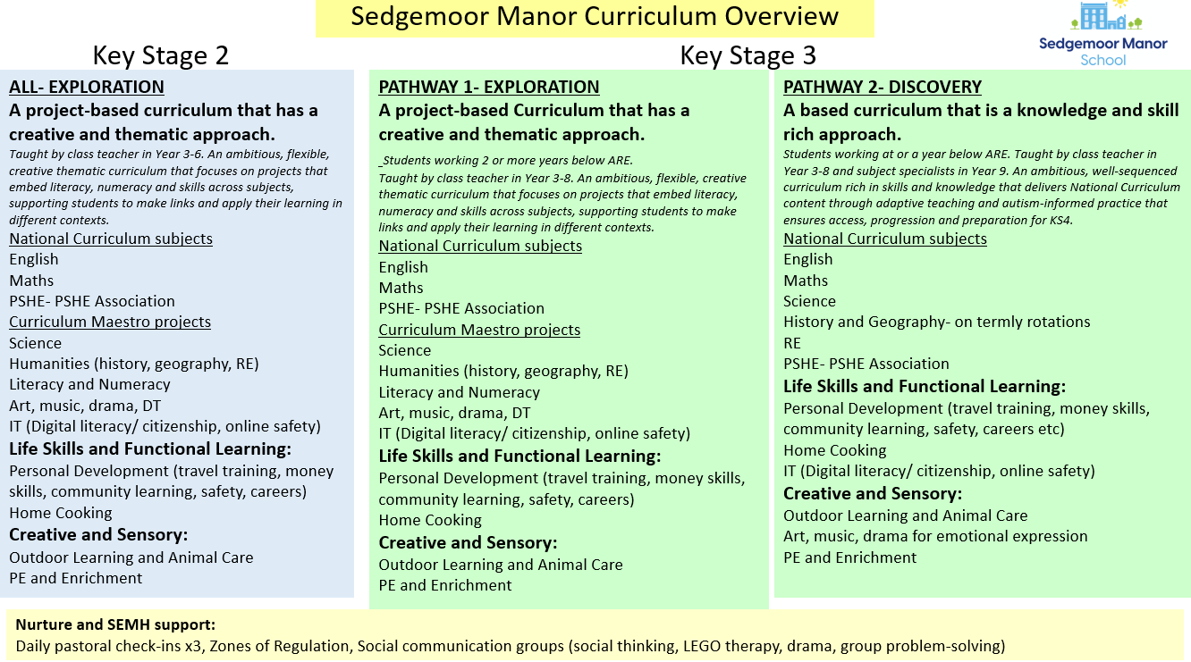

Appendix 2- Key Stage 4 Curriculum
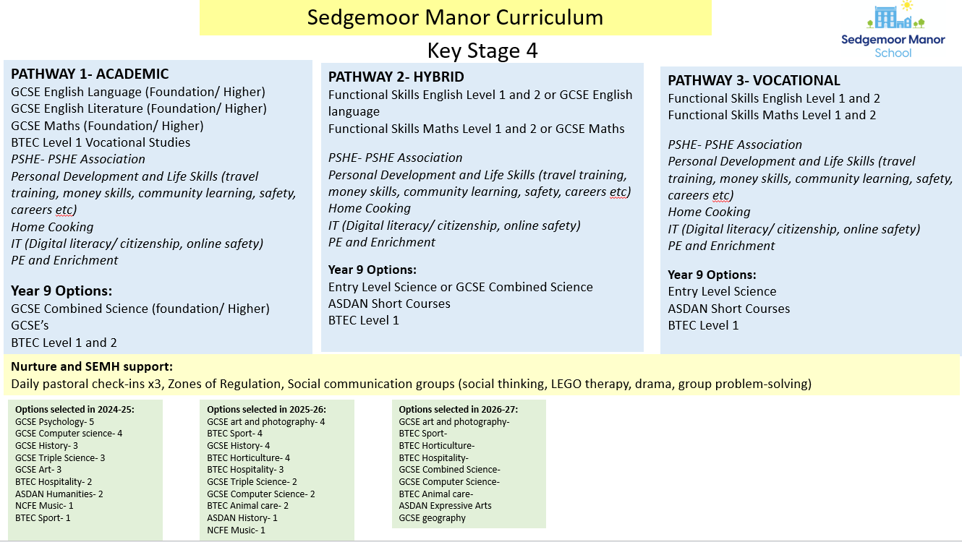

Appendix 3- Key Stage 5/ Post 16 Curriculum
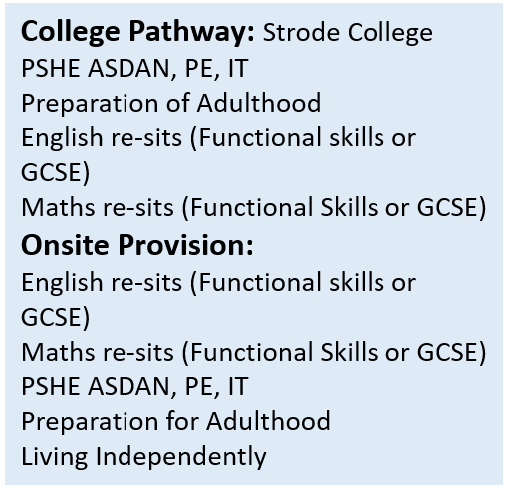

Appendix 4- KS2 and KS3 Pathway Comparisons
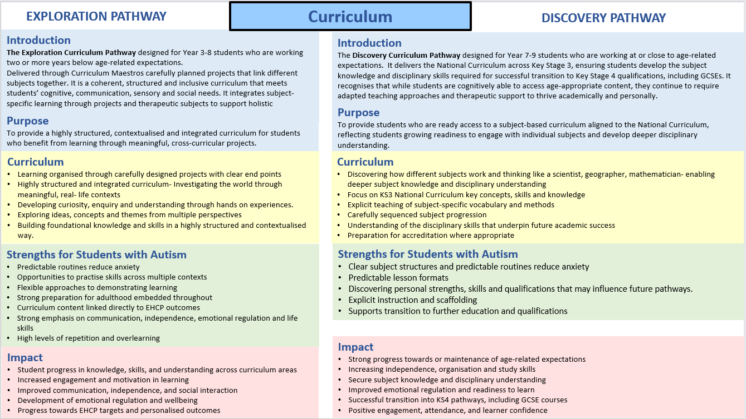
Appendix 5- Curriculum Model
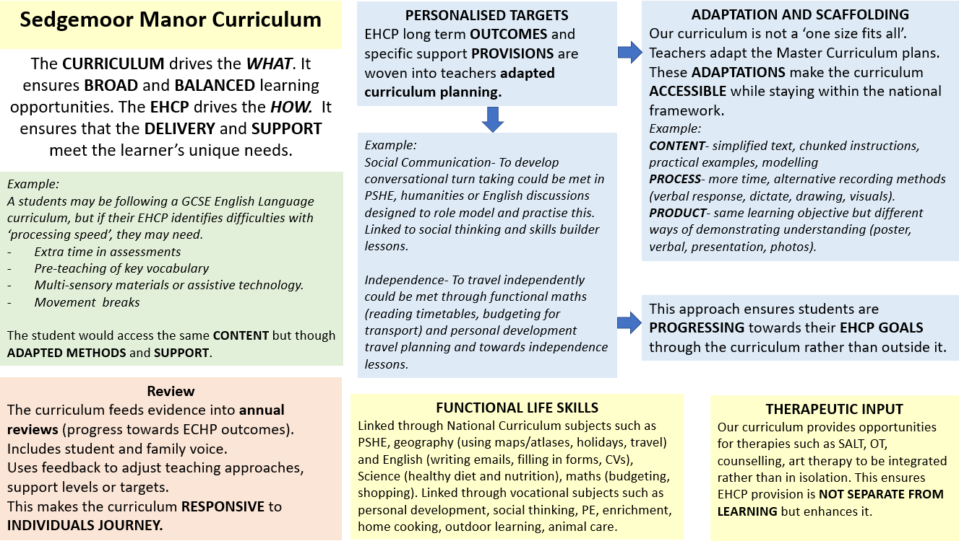
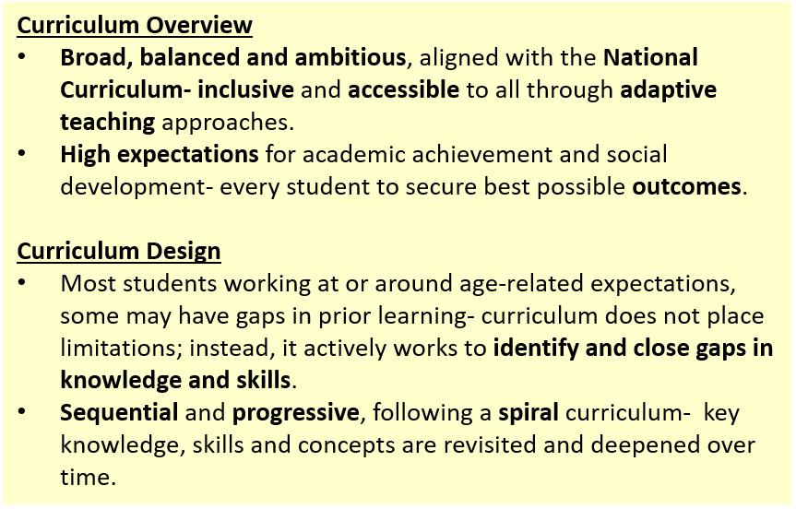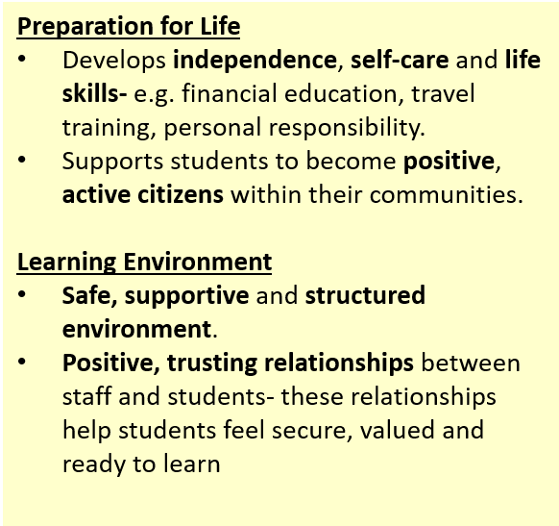

Appendix 6- The Exploration Pathway
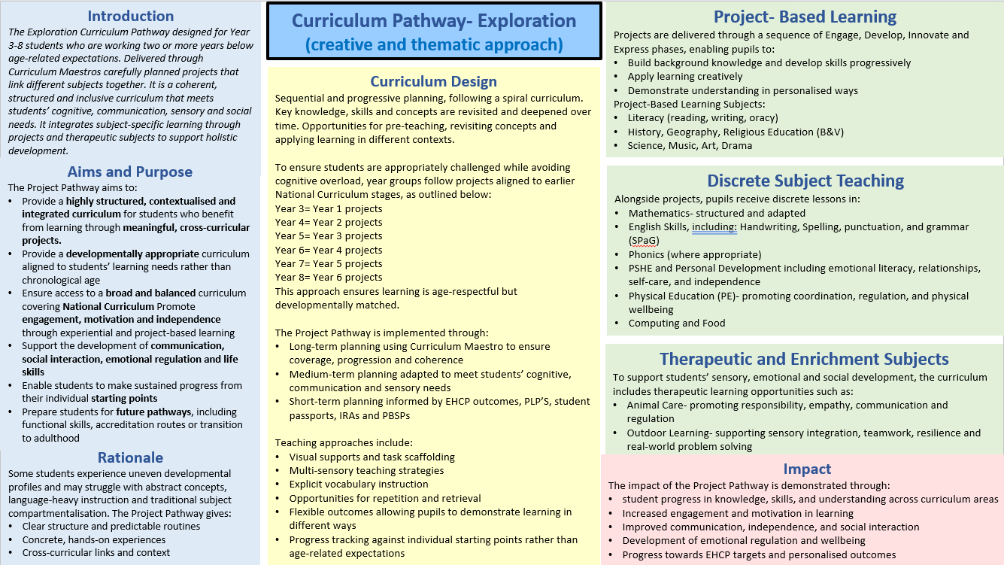
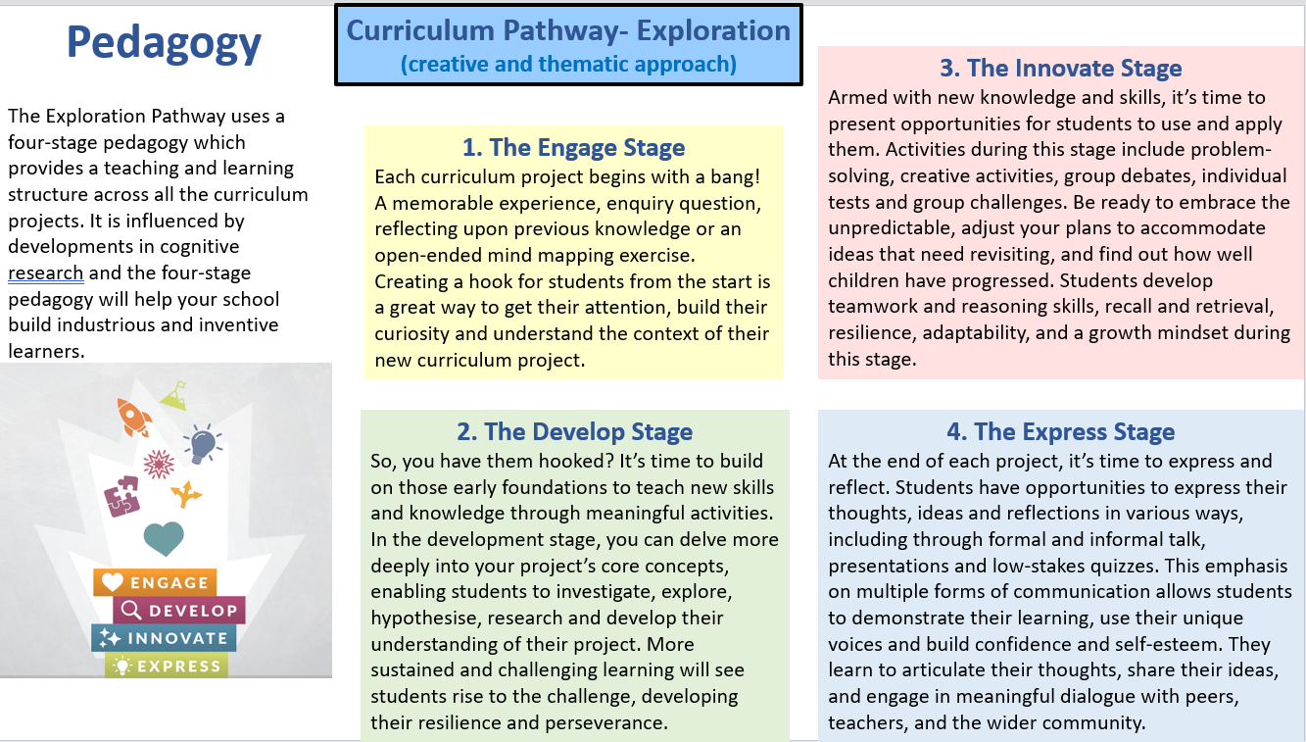
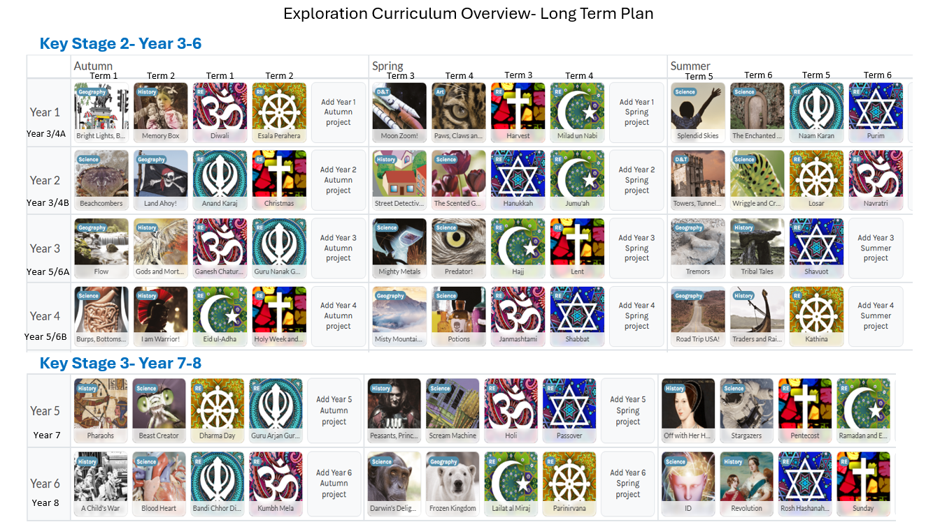

Appendix 7- The Discovery Pathway
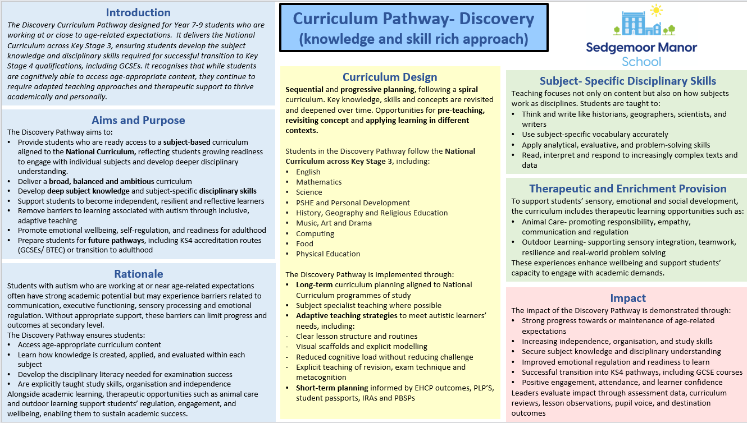

Appendix 8- Curriculum Planning
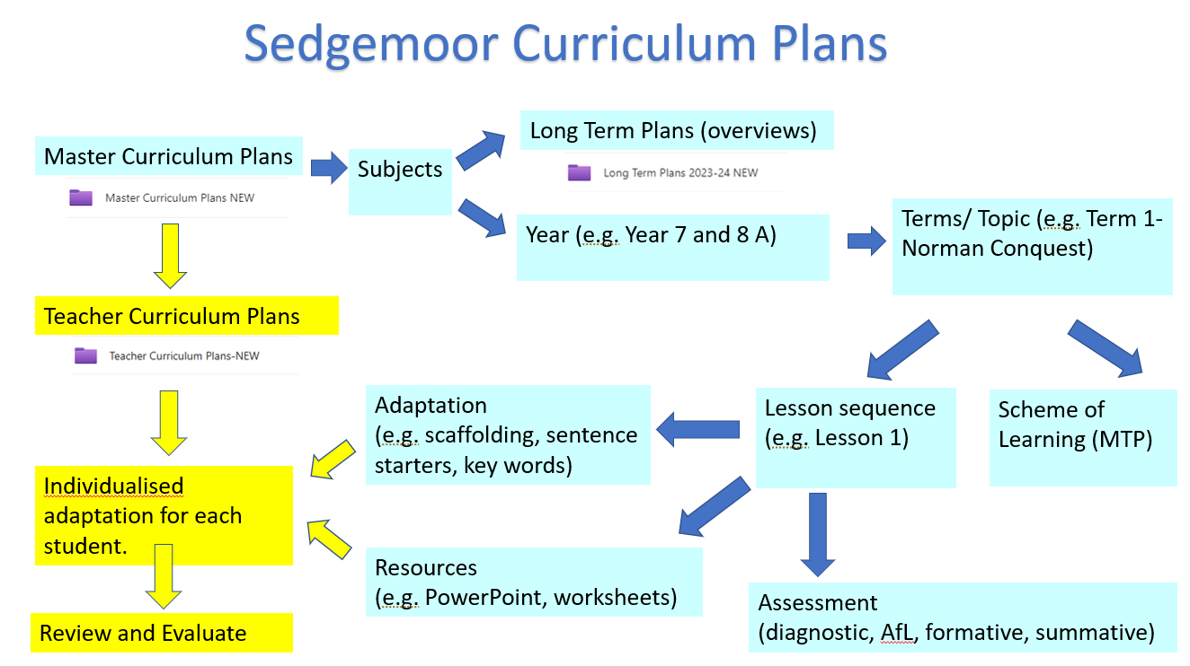

Contents Checklist (Local Sites may add additional items – this is a core list)
Rationale underpinning the curriculum – Intent, Implementation, Impact | ü | Opportunities for work related learning, independent CIAG and reference to the Gatsby standards | ü
Reference the ISS | ü | Post-16 as a separate section if this is applicable | ü
Reference qualifications and outcomes supported by the curriculum | ü | The role of subject coordinators if this is applicable and how the curriculum is monitored | ü
Reference relationships and sex education and how this is taught | ü | Reference to the process of how the curriculum is and will be reviewed | ü

Local Procedure Review History:
Date Reviewed | Reviewer | Summary of revisions
12.02.25 | Rebecca Sheppard | Updated curriculum aims 2.1  Re-wrote 2.2  Re-wrote 2.6  Added reading 2.11  Edited 2.4  Added info about careers. Info about Gatsby standards added 2.9  Re-wrote 3.2  Added word reading and spelling training 3.7
12.12.25 | Rebecca Sheppard | Post 16 curriculum changes  Lesson timetable updated
10.09.26 | Rebecca Sheppard | Complete re-write of the curriculum LP to include vision and aims, curriculum pathways, QFT, engagement, communication, environment etc.

