

Sheridan School
Teaching and Learning Procedure

Date of procedure: April 2026
Reviewed: April 2027

“High quality teaching is the most important lever schools have to improve pupil attainment, with every teacher supported to deliver high quality teaching by achieving the best outcomes for pupils.”
Education Endowment Foundation (2022)

Safety Caring Achievement Resilience Friendliness
Contents

Part 1: Teaching and Learning in Theory
- Vision and Values
- Sheridan: Three strategic Priorities
- Roles and Responsibilities
- Sheridan Teaching and Learning Principles
- How Learning Happens
- Sheridan School Learning Cycle

Part 2: Teaching and Learning in Practice
- Components of the Sheridan Cycle
- SEND and Adaptive Teaching
- Literacy
- Assessment
- Feedback
- Behaviour for Learning
- Presentations Expectations
- CPD
- Quality Assurance

Teaching and Learning Procedure

Vision and Values
Our vision of Teaching and Learning (T&L) is "Empowering Every Student to Excel in a Safe, Caring, and Inclusive Environment." Our values of:
Safety: We prioritise the physical, emotional, and psychological safety of every student, staff member, and visitor within our school community. Safety measures are paramount in creating an environment where everyone can thrive and learn without fear.
Caring: We foster a culture of compassion, empathy, and kindness, where each individual feels valued, supported, and respected. Through genuine care and concern for one another, we build strong relationships and a sense of belonging.

Achievement: We are dedicated to helping every student reach their full potential academically, socially, and personally. We set high expectations and provide the necessary support and resources to enable students to succeed and excel in their endeavours.

Resilience: We promote resilience by teaching students to adapt positively to challenges, setbacks, and adversity. Through resilience-building activities and a growth mindset approach, we empower students to persevere, learn from failures, and emerge stronger.

Friendliness: We cultivate a warm and welcoming atmosphere where positivity, cooperation, and inclusivity thrive. Students, staff, and visitors are encouraged to interact with kindness, respect, and openness, creating a supportive community where friendships flourish.

These values and the Thrive Approach serve as the guiding principles that shape our school culture, inform decision-making processes, and inspire all members of our community to uphold the highest standards of conduct and achievement. We work with socially vulnerable pupils to prepare them for post 16 education.

Research demonstrates that the quality of T&L is the largest determining factor in pupil achievement¹. Academic attainment and social enhancement are the keys out pupils need to lead fulfilling and enriching lives. At the heart of this procedure are our young people and their futures.

Our approach is informed by the most available evidence, using research outcomes to select strategies which are most likely to improve pupil attainment³.

Our teachers adapt their lessons to be inclusive by design, rather than as an afterthought so that all pupils can make excellent progress⁴. Pupil needs, listed on their one-page profiles and EHCPs drive the inclusivity of our pupils.

Our pupils are entitled to excellent, memorable learning experiences through well-taught lessons. Teachers at all levels must meet the teachers’ standards⁶. If we feel that the quality of education does not meet those standards, then we will use a combination or targeted professional development and coaching to improve their practice for the benefit of our pupils.







Victoria Rowlands
Headteacher

¹Major, L. E. & Higgins, S. (2019). What Works? London: Bloomsbury. ²Wiliam, D. (2016). Leadership for Teacher Learning. West Palm Beach, FL: Learning Science International. ³Hendrick, C. & Macpherson, R. (2017). What Does This Look Like in the Classroom: Bridging the Gap Between Theory and Practice. Woodbridge: John Catt. ⁴EEF. (2019). Special Educational Needs in Mainstream Schools: Guidance Report. London: ⁶Department for education. (2011). Teachers’ standards. London: DFE.

Sheridan School: Three Strategic Priorities
High -quality Teaching and Learning support the school in achieving its three strategic priorities.
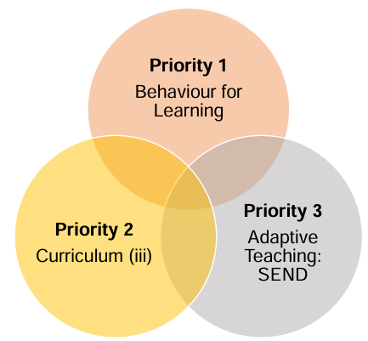

Priority 1
Adaptive Teaching: SEND Pupils thrive in lessons with consistent routines, adaptive planning and effective organisation, free from distractions and disruptions⁷.

Priority 2
Effective teaching allows all pupils to access the curriculum, deepening the knowledge stored in their long-term memory⁸.

Priority 3
All pupils with SEND are in most need of excellent teaching, which is inclusive by design and not as an afterthought.

⁷Bennett, T. (2020). Running the Room. Woodbridge: John Catt. ⁸Ashbee, R. (2021). Curriculum: Theory, Culture and Subject Specialisms. Oxon: Routledge.
Roles and Responsibilities
Fulfilling our vision, living our values and achieving our three strategic priorities involves every member of staff.
Classroom teacher | Implementation - To plan and develop individual and sequences of lessons adapted appropriately for the needs of every student and class that you teach following the principles and components outlined in the curriculum statement and following The Sheridan Way.
Subject Leads | Implementation – to ensure the T&L procedure is implemented consistently in their areas of responsibility. To plan and develop individual and sequences of lessons suitable and adapted appropriately for the needs of every student and class you teach.  Quality assurance – To conduct quality assurance, including but not limited to reviewing and providing feedback on individual and sequenced lessons, quality assurance of the curriculum and assessments, quality assurance of teaching and learning (through learning walks, book scrutiny and lesson observations).  CPD – To actively participate in development CPD to recognise that we are all learners and that we can all improve in our practice by keeping up to date with pedagogical changes.
SEND Managers/LSAs  Senior Leadership Team | Implementation – To ensure the T&L procedure is implemented consistently to support students with specific needs. To ensure that one page profile’s, IEPS and EHCPs are up to date to meet the needs of the pupils.  Quality assurance – To conduct SEND specific learning walks against one-page profiles and EHCPs and book scrutinies to ensure students access and are successful across the curriculum.  CPD – To actively participate in developmental CPD, to recognise that we all learners and that we can improve in out practice and pedagogy. To collaborate with the T&L lead, SLT and curriculum leads to plan and deliver high-quality CPD using the T&L framework to support out learners.  Implementation – To ensure the T&L procedure is implemented consistently in their areas of responsibility and across the whole school. To create a culture of great teaching and learning where professional dialogues about pedagogy and practice are facilitated, encouraged, and celebrated. Assistant Headteacher to keep up to date with research and to refine pedagogies considering this. To support curriculum leads to improve and develop the consistency and effectiveness of their curriculum implementation.  Quality assurance - To conduct regular quality assurance within your remit and for departments which you line manage. This will include quality assurance of the curriculum and assessments, quality assurance of teaching and learning (through learning walks, deep dives in subjects (this will include book scrutiny). To conduct collaborative quality assurance with middle and senior leaders to ensure agreement and standard judgements.  CPD – To actively participate in developmental CPD, by recognising that we are all learners and that we can all improve in our practice and pedagogy. To support and lead in the delivery of high-quality CPD using the T&L procedure to upskill those whom they line manage and all staff. To coordinate, deliver and quality assure high-quality, research informed CPD which is appropriate to the needs of teachers. To ensure CPD provided is of the highest possible quality.

Sheridan School T&L Framework Principle
Within all classrooms at Sheridan School, pupils are entitled to an experience where the new content is delivered through effective teaching practice. There have been many attempts to define teaching and learning. Teaching and Learning is the purpose of our school. It is the method through which we offer a curriculum which is broad, balanced and relevant and meets the requirements of the National Curriculum (DfE, 2014), Independent School Standards, and EHCP Requirements. As a school we agree: “The aim of all instruction is to alter long-term memory. If nothing has changed in long-term memory, nothing has been learned.” (Kirschner, Sweller & Clarke, 2006).

Using the above, we can define learning as a change in long-term memory and teaching as the instructional processes that lead to these changes taking place. The core principles that form the teaching and learning framework at Sheridan School are underpinned by the science of learning. This includes a simple model of memory, and how this is related to cognitive load. (Evidence Based Education, Science of Learning Programme, 2022).
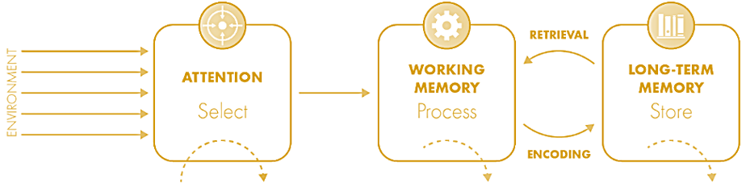

Cognitive Science
Cognitive load is limited; effective processes must be put in place to direct pupils’ attention to select the right knowledge, chunk knowledge appropriately to ensure efficient processing in working memory and store these chunks with prior learning in long-term memory.
The simple model of memory contains three main processes:
• Selecting the right information from the environment, which involves the direction of attention.
• Processing this information within working memory, alongside the retrieval of linked prior knowledge.

- Storing this information in long-term memory through the process of encoding. This allows the development of schema, mental maps that allow the organisation of knowledge structures for specific concepts.
Working memory is made up of three main parts:
• Extraneous load, which distracts working memory away from processing new information
• Intrinsic load, which is related to the complexity of the information
• Germane load, which is devoted to the deep processing of this new information by relating it to prior learning.
Effective instructional design ensures that new content is delivered using methods that lead to long-term retention.
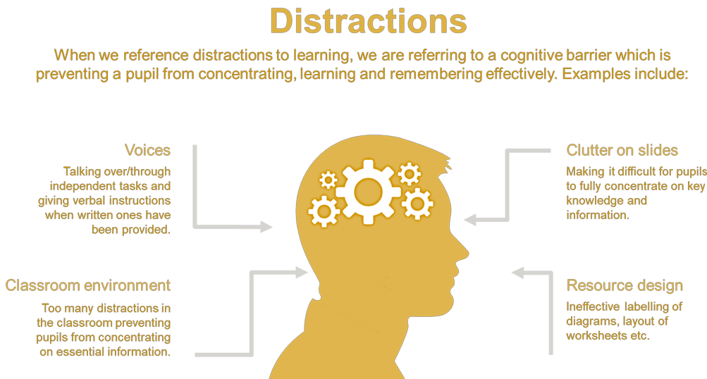

In the classroom, during the learning process, we will:
• Reduce extraneous load via distraction and disruption-free learning.
• Simplify intrinsic load whilst maximising germane loads through effective instructional design.
If learning is a change in long-term memory, it is important to consider, once the stage is set, how we can make this as efficient as possible.
The two main processes to consider are retrieval, where prior learning is reactivated before new learning is added to it, and encoding, where schema is developed around ideas and concepts. Through a consistent process of retrieving knowledge, pupils can recall this information fluently and will be more likely to embed this knowledge.
In the classroom, during the learning process, we will:
• Through effective instructional design, maximise the encoding process.
• Use effective retrieval strategies to recall and embed prior knowledge.
A point to note about retrieval is that during the learning process, the retrieval of unrelated knowledge can be problematic. Retrieving unrelated knowledge is useful as a desirable difficulty during the testing process. However, during instruction, retrieval should be based on related knowledge, that can then be built upon within the lesson.
Findings from cognitive science can link to key areas in teaching and learning, each with its own related principle. These are the key principles at Sheridan School:
1. Removing distractors
2. Establishing routines
3. Directing attention
4. Relating to prior knowledge
5. Responsive teaching
6. Adaptive teaching
7. Success and motivation

- Removing Distractors
Distractions exist in multiple forms within the classroom. They can be displays on the walls, resources around the room, or even how the teacher presents information or interrupts students’ learning. Numerous areas of research support the removal of distractors from the learning process.
Eliminate the redundancy effect
The redundancy effect occurs when information is presented concurrently in multiple forms or is unnecessarily elaborated on. It suggests that redundant material interferes with, rather than facilitates, learning. Examples of the redundancy effect include having too many words on slides, narrating over your slides rather than giving time for pupils to read it, having too many PowerPoint animations or having music playing while pupils are learning or revising. The redundancy effect can be reduced by eliminating unnecessary information.
Reduce the split-attention effect
The split-attention effect is where multiple sources of information are competing for attention. Research into this suggests that information presented from multiple sources leads to pupils having to switch between stimuli, which takes time, energy, and cognitive effort. The split-attention effect can be reduced by combining information. An example of the split-attention effect is when a labelled diagram has a separate key when the labels can be present on the diagram itself:
Reduce transient information
Transient information is impermanent (such as speech). Multi-step tasks should always be presented in a permanent (written) form to reduce cognitive load. Ensure detailed instructions are presented in an accessible, written format. When a detailed series of instructions are verbally stated, pupils would try to remember the instructions in their working memory, while also retrieving prior learning about the set task.
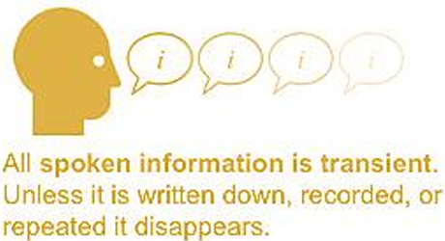
The transient information effect can be reduced by limiting how often pertinent information for learning tasks disappears, and when unavoidable, ensure that it is presented in small chunks so pupils can hold it in their working memory.

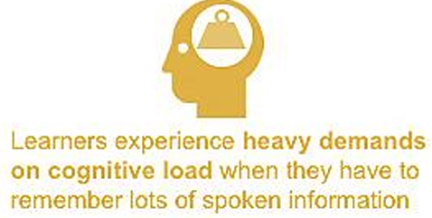

Utilise the modality effect
The modality effect occurs when information is presented via auditory and visual channels in tandem to eliminate visual split attention to free up working memory capacity. The spoken word should dominate auditory attention, while the visual displayed should dominate spatial attention. Because of this, it is important that visuals, when first introduced, do not contain many words. Note that reading and being spoken to both take up the same space in the pupil’s auditory loop and so expecting students to do both simultaneously should be avoided where possible. Examples of where this can be utilised effectively include where text and visuals are used together.

- Establishing Routines
Habitualised routines save time and free up space in working memory. This allows pupils to focus more on learning, and staff to concentrate on the multitude of decisions effective teaching requires.
As McCrea (2020) describes, “instructional routines help pupils make the most of learning opportunities. For example, carefully designed questioning or discussion protocols… Routines make the process of learning easier, which allows the content to maintain a level of challenge.”
He also describes the process of creating routines. They contain a cue, to prompt an initial action, which will lead to a chain of events. It is important to note that for routines to be effective across a school, the explicit nature of the cue, action and chain need to be devised centrally and shared. An example of an effective learning routine could be using mini whiteboards. The question that pupils are set to answer could be asked twice, before being followed by the cue to write “in 3, 2, 1… go”. Once pupils have completed the action of writing their answers a secondary cue of “3, 2, 1… show me” could be used to prompt the action of all pupils showing their answers at once which begins the chain of the teacher responding to the emerging needs of the pupils.
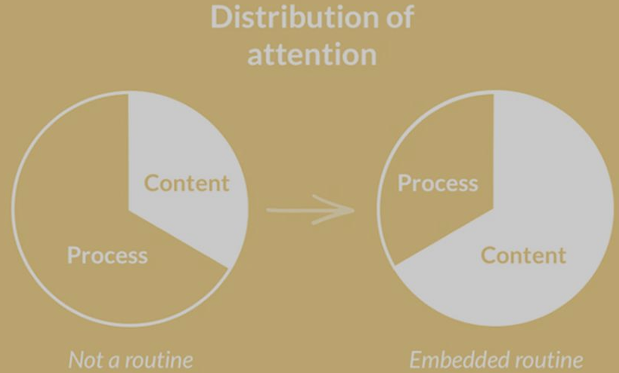

- Directing Attention
When we’re clear about where we’re headed, we get there quicker. Explicitly state what you want pupils to learn from each phase of learning.
“Memory is the residue of thought. To teach well, you should pay careful attention to what an assignment will make pupils think about (not what you hope they will think about), because that is what they will remember.”
D.T. Willingham
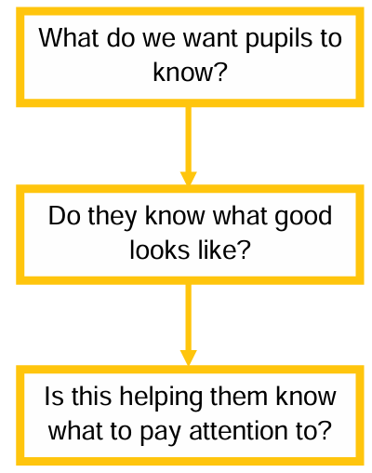
Removing distractors is an important step to maximise attention. However, we must also direct pupils’ attention. A common misconception that some teachers have, is that pupils know what they should focus on. Often this is not the case, and without explicit instruction, clear learning goals and success criteria, our pupils’ attention could be anywhere, and their interpretation of success could be anything.
A key conclusion from the quotes above is that a pupil’s attention not only needs to be directed, but it also needs to be framed in line with a learning goal, or success criteria.

An example of this would be creating and sharing success criteria with pupils. Before the lesson, the teacher will know what they want the lesson outcome to be and plan for it appropriately. Pupils will then be able to track their progress and, where appropriate, either the pupil or a teacher may re-direct attention towards these success criteria throughout the lesson.

- Relating to Prior Knowledge
Knowledge builds on knowledge. Activate relevant knowledge before learning and build new ideas within existing.
“When we experience something new, information enters the brain through processes of sensation and perception, giving rise to certain patterns of neuronal activity. At the same time, already existing patterns are activated as one attempts to decipher the new experience in terms of the things that are already stored in the brain. Potentially, following the learning experience, a new representation of a new concept will be formed, as well as new connections to existing information.”
E. Furst
The conclusion from this quote is that new learning builds seamlessly into previous learning. The process of learning requires links to be made between what key knowledge is known about the topic being taught (prerequisite knowledge), and what new learning is taking place.
An example of this would be to use the start of the lesson to activate prerequisite knowledge whilst identifying and addressing any gaps before delivering new content in a lesson. A GCSE lesson on photosynthesis requires prior knowledge that pupils know what a plant is (KS1 and 2), know that photosynthesis is a chemical reaction (KS3), and that the reaction requires carbon dioxide to diffuse into the leaf (KS4). The activation of all these building blocks in their schema will allow pupils to have a deep understanding of photosynthesis. Gaps in any of these blocks can prevent a fully developed schema from being produced and allow misconceptions to develop.
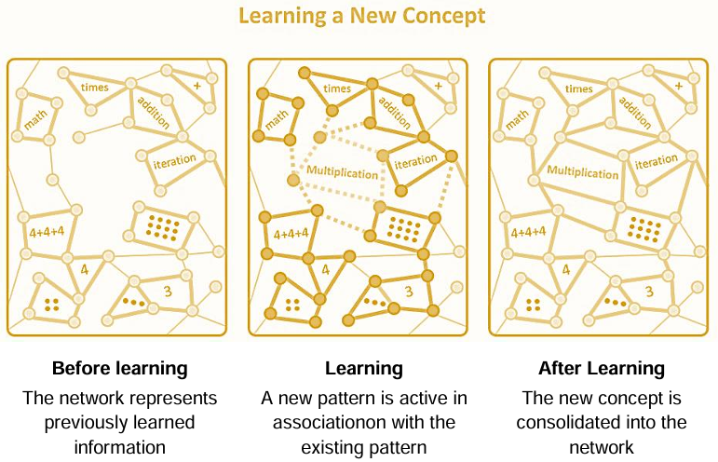

- Responsive Teaching
Instruction can be misunderstood. Check for understanding and respond to the emerging needs of pupils.
“The more effective teachers frequently checked to see if all the pupils were learning the new material. These checks provided some of the processing needed to move new learning into long-term memory [and] to let teachers know if pupils were developing misconceptions.”
B. Rosenshine
When summarising his principle of “check for pupil understanding”, Rosenshine stated, “The more effective teachers frequently checked to see if all the pupils were learning the new material. These checks provided some of the processing needed to move new learning into long-term memory [and] to let teachers know if pupils were developing misconceptions”. Effective checks for understanding mean that pupils and teachers obtain real-time information about learning, which they can respond to in the moment. This is different to the kind of information included in graded assessments and will be largely made up of in-class questions and answers. Staff should use this information to adapt their instruction, responding to the needs that their questioning identifies. Dylan Wiliam reminds us that “If students learned what they were taught, we would never need to assess; we could instead just keep records of what we had taught. But as every teacher knows, many students do not learn what they are taught. Indeed, when we look at their work, we sometimes wonder if they were even present in the classroom. That is why assessment is the bridge between teaching and learning.”
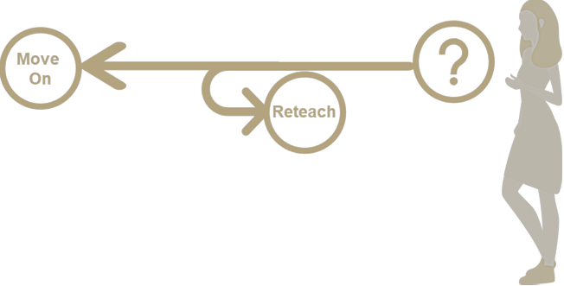
Where assessments, either in-class or otherwise, show that the desired learning hasn’t happened yet, the need to be responsive is then essential in delivering the aims of any curriculum.

- Adaptive Teaching
Pupils are all different and will all learn at different rates. Adapt teaching material and instruction so all pupils access the curriculum equitably.
The needs of all our pupils may go beyond that of responsive teaching due to additional requirements that the pupils may have. While responding to the knowledge gaps of pupils should always be considered, pupils with special education needs and disabilities may need resources or instruction adapting to allow them to access the curriculum content at the same level as their peers.
When implementing these adaptations, it is important to consider whether they would benefit all pupils. If this is the case, then adaptations should be made for all. If it is not the case that this is beneficial to all pupils but solely an individual, it is still our duty as inclusive practitioners to make those adaptations.
Barriers
Plan to address

Gaps in prior knowledge
Gaps in vocabulary
Support with skills e.g. writing
Limited working memory
A common misconception

Read text in advance
Contextualize vocabulary
Discussions within the class
Utilise verbal, written and visual or scaffolds
Deploy targeted TA support

- Success and Motivation
Motivation is fuel for learning. Secure high success through scaffolding content and the encouragement and recognition of hard work, as well as ability.
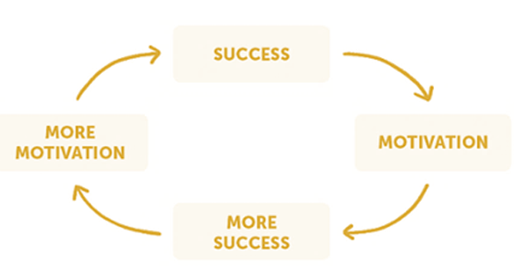
Motivation Success Cycle

It is our belief that every pupil has the potential to learn and develop their understanding of all concepts. We are aware that pupils may have had experiences in their life which have led them to believe that they may not be able to be successful in their ventures, academic or otherwise. In these cases, we must get pupils into a success/motivation cycle.
If pupils are lacking motivation, it is our job to remedy this. If, in the short term, it means making them feel successful by altering the pace of curriculum delivery, then we know that this can pay off in the long run and is worth the initial investment in time. Where possible, this feeling of success will come from appropriately pitching the content from the curriculum through scaffolding content, and clearly defining what success looks like so pupils can recognise it when they achieve it.
McCrea states in Motivated Teaching that we should frame success by stating what it looks like and what it doesn’t look like, use the right metric so we are focussing on the learning behind the performance and ensure learners self-reference against themselves, rather than comparing to their peers. This will ensure that all learners can experience success, which will motivate them to experience more success.
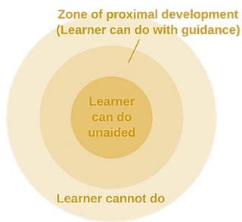
Zone of Proximal Development
We are aware that new learning happens best when content is placed just at the periphery of pupils’ current schema. To ensure that all pupils have the best possible experience with us, all learning is pitched to an appropriate level or adequate intervention is in place to ensure that, when in class, pupils are always working in their Zone of Proximal Development (ZPD). Vygotsky defines the ZPD as:
"The distance between the actual developmental level as determined by independent problem solving and the level of potential development as determined through problem-solving under adult guidance, or in collaboration with more capable peers" Effective scaffolding of curriculum content and its delivery will ensure that pupils are consistently working in their ZPD. Work pitched outside of this will most likely not be successfully completed by pupils and may lead to them becoming demotivated. Examples of scaffolding for tasks which may seem daunting include the use of sentence starters, structure strips and successful retrieval questions.

How Learning Happens

At its heart, successful teaching is intentional, inclusive and priorities strategies that secure the most successful outcomes for all pupils¹⁰.

Successful learning is incremental, desirably difficult by changes to pupils’ long term memory¹¹.
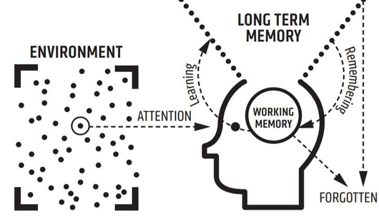

Information from the classroom environment enters the working memory. Working memory has limited capacity and so some information is forgotten. The information which is learnt enters the long-term memory.
The information which is explicitly taught in a well-sequenced curriculum and then revisited often is more likely to enter long-term memory¹². This principle underpins the Sheridan School cycle.

¹⁰ Kirschner, P., & Hendrick, C. & Heal, J. (2022). How Teaching Happens. Oxon: Routledge. ¹¹ Willingham, D. (2021). Why Don’t Students Like School? A Cognitive Scientist Answers Questions About How the Mind Works and What It Means for the Classroom. Hoboken: Jossey-Bass. ¹² Jones, K. (2019). Retrieval Practice: Research and Resources for Every Classroom. Woodbridge: John Catt.
The Sheridan School Learning Cycle
The Sheridan School Learning cycle is a Teaching and Learning framework. It aims to maximise the level of information stored in pupils’ long-term memory.
Each phase of the cycle is grounded in the common daily practice of many teachers. They are informed by the steps of cognitive science and how learning happens.
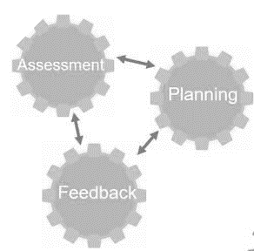
Engage
Review
Intent



Apply

Content

Question
Respond and adapt.

Model

Part 2
PLAN
All pupils benefit from lessons that are well-planned, adapted for the class or individual pupil and prepared within a wider sequence of learning¹³.
At Sheridan School, teachers always consider planning lessons that unlock curriculum content for pupils. They consider planning tasks that support pupils to meet their needs as well as those of the lesson aim whilst securing knowledge and consolidating learning¹⁴.
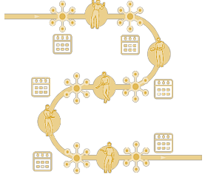
Teachers always consider the position of the lesson within the sequence of the Sheridan School curriculum¹⁵. Their knowledge of the curriculum is underpinned by the expertise of contributing to planned resources as directed from the subject lead, alongside all other department expectations.
Teachers follow the Planning and Teaching Lessons for Learning – the Benchmark criteria. This under pins consistency across the school and sets high expectations for our pupils at Sheridan School. This covers: Load, Activate, Expertise, Link, Rehearsal, Practice, Feedback, Assessment, Long-term, Objective, Participation, Literacy, Present, Scaffolding, Metacognition and Questioning.
Teachers must use pupil one-page profiles and EHCP’s to plan with the needs of all pupils in mind, including the most able pupils. They consider what the learning objective or aim will be and how all pupils will be supported to meet it.
Learning Objectives in practice
Learning objectives (LOs) are statements that communicate the purpose of instruction to students, other instructors, and an academic field (Mager, 1997; Rodriguez and Albano, 2017). They form the basis for developing high-quality assessments for formative and summative purposes. Once LOs and assessments are established, instructional activities can help students master the material (Fink, 2003).
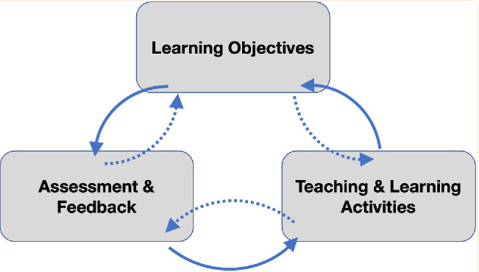
When deciding on learning objectives, consider your overall curriculum plan and pupils’ prior knowledge to decide the broader objectives for a series of lessons, not just one lesson at a time. Good learning objectives will include specific facts, concept or procedures pupils should know and understand. The skills pupils should be able to perform independently or with increased support.
Whilst lesson planning is extremely important, it is also essential that teachers can adapt their lessons in the moment to respond to emerging pupil needs, rather than continuing to follow their original plan regardless. For example, a teacher might stop the whole class to address a misconception communicated by a few.

¹³Nuthall, G. (2007). The Hidden Lives of Learners. Wellington, NZ: NZCER Press. ¹⁴ Kirschner, P., & Hendrick, C. (2020). How Learning Happens. Oxon: Routledge. ¹⁵Howard, K. & Hill, C. (2020). Symbiosis: The Curriculum and the Classroom. Woodbridge: John Catt.
ENGAGE

At Sheridan School, teachers greet pupils when they enter the classroom. Teachers reinforce classroom expectations by adopting the classroom behaviour rules.

Pupils complete a starter activity once they entered and settled in the classroom. Whilst all starter activities involve an element of retrieval practice; the exact nature of the activity is determined upon work completed from the previous lesson.
A starter activity tests the knowledge learnt from previous lessons, allowing the teacher to address arising issues at the beginning of the lesson.

Do Now activity in Practice
A starter activity is a short activity that is either written on the board or handed to pupils in printed form. Either way, pupils start and complete the starter activity automatically and with minimal teacher instruction, allowing the teacher to address emerging issues. Pupils entering the room should not have to ask themselves “What am I supposed to be doing?” The answer, every day, should go without saying: “You should be doing the starter activity because we always start with a starter activity”.
Further Guidance - WalkThrus Volume 1: Page 9

¹⁶Bennett, T. (2020). Running the Room. Woodbridge: John Catt. ¹⁷Lemov, D. (2015). ¹⁸Refer to the feedback policy of the relevant subject area, available from the Curriculum Lead.
INTENT
All pupils benefit from understanding how one lesson fits within the sequence of the curriculum, building knowledge over time¹⁹.

Ashbee, R. (2021). Curriculum: Theory, Culture and Subject Specialisms. Oxon: Routledge.
At Sheridan school, teachers always consider explaining the lessons intent at the start of every lesson. This means that pupils understand how the lesson links to what they have previously been taught and what they will learn in the future. This unlocks the curriculum journey for all pupils²⁰.
Teachers always consider referring to subject curriculum plans and lesson learning objectives to ensure their lessons accurately deliver the powerful knowledge the curriculum intends.

At Sheridan School, teachers always consider using appropriate texts to explain ideas and the concepts within them. Teachers consider how this provides an opportunity to increase abilities amongst the pupils.
Teachers always provide an explicit Learning Objective to frame the lesson intent. Teachers will get pupils to write this in their exercise books to inform the lesson intention.
Coherent Mapping in Practice
A coherent curriculum weaves knowledge and skills so that pupils gain a strong understanding of the links between new and previously acquired knowledge. Teachers need a strong understanding of the main areas of learning, the hierarchy of core concepts and the sequence in which they should be taught.
Further Guidance - WalkThrus Volume 1: Page 54

Pupils looking ‘busy’ within a lesson task is a poor proxy for learning. Be mindful of confusing ‘doing’ with ‘learning’. Tasks should help to achieve the lesson objective and focus on supporting knowledge acquisition.

¹⁹Ashbee, R. (2021). Curriculum: Theory, Culture and Subject Specialisms. Oxon: Routledge. ²⁰Allison, S. & Tharby, A. (2015). Making Every Lesson Count. London: Crown House.

CONTENT
All pupils benefit from powerful knowledge which is built through a well sequenced and robust curriculum²².

Hirsh, E. D. (2018). Why Knowledge Matters. Cambridge, MS: Harvard University Press.
At Sheridan School, teachers always consider how they deliver new curriculum content to their classes. They consider presenting knowledge in small chunks, dependent upon pupils’ prior knowledge so that it is coherently mapped. The agreed curriculum supports teachers who are accountable for the progress pupils make in lessons.

Teachers always consider how they use oracy skills to ensure that they speak at a volume that is audible and understandable to all pupils. Teachers deliver content with the accuracy and specificity they expect from their pupils, providing a scholarly example of their subject.
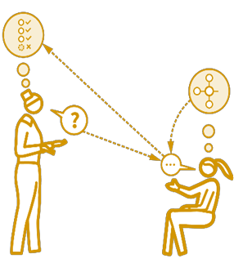
Teachers always consider checking for understanding by questioning pupils about what they have understood. This alerts the teacher to the pace and respond accordingly. For example, by stopping the class and addressing a misconception or aspects of the material that might need to be completely retaught in a future lesson.
Check for Understanding in Practice
It is important that teachers ask direct questions such as “what have you understood?”, rather than rhetorical questions such as “have you understood?”. Articulation supports pupils to demonstrate knowledge, rather than providing a superficial ‘yes’ or ‘no’ response.
Further Guidance - WalkThrus Volume 1: Page 10

The secure, confident answers of the most able pupils can give the impression that the whole class has understood the lesson content. Teachers should use cold calling²³ to strategically select a variety of pupils to increase the validity and accuracy of pupils’ understanding.

²¹Young, M. & Muller, J. (2013). ‘On the Powers of Powerful Knowledge’, Review of Education, 1(3), pp. 229 – 250. ²²Hirsh, E. D. (2018). Why Knowledge Matters. Cambridge, MS: Harvard University Press. ²³Lemov, D. (2015). Teach Like a Champion 2.0. San Francisco: Wiley.
MODEL
All pupils are supported to build schema when teachers model, scaffold and think aloud to narrate their decisions and choices²⁴.

At Sheridan School, teachers must talk through the learning process by explicitly modelling and explaining the learning process. Teachers ensure that the explanations are accurate and articulated to reflect on the high expectations by the teacher.
Teachers consider achieving this using a whiteboard or interactive board, sentence starters or preprepared resources amongst other pedagogical strategies that demonstrate to pupils how to complete a task independently. Teachers consider using metacognitive talk to narrate their thinking through the task to encourage pupils to think hard about the underlying concepts they could use to problem solve.
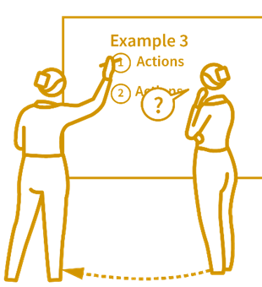
Worked Examples
Teachers must release the nature of the task/question to the pupils gradually. Pupils are never set extended writing tasks without explicit modelling first. For example, by using I do, We do, You do²⁵.
Modelling in Practice
The teacher draws a concept or writes a response under the visualiser, explaining it aloud to pupils. The teacher gives pupils time to read their labels and annotations, perhaps asking them for feedback on the teacher produced work. The teacher explains and draws attention to key parts of the response. Pupils are then asked to complete a partially completed response alongside the teacher.
Further Guidance - WalkThrus Volume 1: Page 68

Modelling is not simply providing pupils with an exemplar essay answer. Instead, modelling requires pupils to observe the construction of an answer whilst the writer’s thinking is narrated out loud.
²⁴Sweller, J., van Merriënboer, J. J., & Paas, F. (2019). ‘Cognitive Architecture and Instructional Design: 20 Years Later’, Educational Psychology Review, 31(2), pp. 261 – 292 ²⁵Sherrington, T. (2021). The Art of Modelling… It’s All in the Handover. (Online).
APPLY
All pupils benefit from independent practice which builds the fluency and recall they require to attain well²⁶.

At Sheridan School, pupils must be allowed to apply what they have learnt in every lesson. In addition, pupils must be regularly allowed to complete extended independent practice. For example, a longer exam question, a complete recipe or a full game in PE.


Teachers must set activities and questions like those previously modelled and remove scaffolds gradually. Teachers must evaluate pupils’ work throughout the lesson to formatively assess understanding and address misconceptions. Teachers can check for understanding using mini-white boards, questioning or live marking amongst other pedagogical strategies. Teacher marking must be completed in a green pen.

Teachers must check the work pupils have completed in the lessons to determine next steps, catch up and the targets the pupils are working towards from their one-page profiles and EHCP targets.
Applied Learning Time in Practice
Following a modelled exemplar exam response, the class or individual pupils then work with the teacher to complete a similar question. Pupils are now given a similar third question and asked to complete it independently. During this time the teacher checks the work of all pupils and given feedback.
Applied learning is not simply any task pupils complete on their own. Rather, it is when pupils independently practice a similar or identical task to the one that has been previously modelled for them.

²⁶Lovell, O. (2020). Sweller’s Cognitive Load Theory in Action. Woodbridge: John Catt. ²⁷Refer to the feedback policy of the relevant academic department.
Review
All pupils benefit from regularly reviewing learning to attenuate forgetting, make connections and secure long-term recall²⁸.

At Sheridan School, teachers must review the extent to which the lesson’s intent has been achieved at the end of every lesson and by whom, to inform their planning of the next lesson. Regular checking for understanding and feedback throughout the lesson will help to inform the delivery of this final phase of learning.
Teachers always consider the most effective way of assessing pupils given the nature of that particular lesson. For example, by using mini-whiteboards, using probing questions to pupils who have previously misunderstood key concepts.


Teachers always consider normalising errors to encourage a high challenge, low threat environment to ensure they experience high expectations without fear of failure²⁹. Books are collected in an organised manner and placed on the teacher’s desk in the classroom. Once pupils have been given their reward points for the lesson, they can then exit the classroom under the direction from the teacher.

Building a Culture of Error in Practice
The teacher asks a pupil to name problems they would like to review. A pupil asks for clarification on a piece of challenging vocabulary. “Great question” the teacher responds. The teacher asks a classmate to provide the solution and then another and so on. The teacher’s tone doesn’t waver – calm, steady, non-judgemental – which implies it is normal to struggle with this vocabulary.

It can be thought of as ‘kinder’ not to correct pupils. However, in the long run, failing to address misconceptions facilitates pupils providing the wrong answers in exams and ultimately leads to underachievement.

²⁸Fletcher-Wood, H. (2018). Responsive Teaching. Oxon: Routledge. ²⁹Myatt, M. (2016). High Challenge, Low Threat. Woodbridge: John Catt.
SEND and Adaptive Teaching
SEND and Adaptive Teaching Pupils with SEND are in most need of excellent teaching and benefit most when their learning needs are fully understood³⁰.

Teachers at Sheridan School must adapt their lessons to be inclusive by design, rather than as an afterthought. This means that teachers plan lessons with ambitious content and then scaffold them for the needs of pupils, rather than plan a one-size-fits-all lesson with ‘bolt on’ activities. This is the most effective way of supporting pupils to achieve their potential³¹.

Adaptive teaching is harmful to no one, helpful to everyone and vital for pupils who have a special educational need.
Teachers must use resources such as Teaching Assistants (TAs), EHCPS, One-page profiles to adapt their lessons to maximise impact.

One-page profiles
At Sheridan School, teachers must read, understand and apply the guidance listed on one-page profiles. Teachers must comply with the targets and adopt these in the lessons being taught.
The SEND managers are crucial members of the T&L team because they are responsible for updating, disseminating and quality assuring the use of EHCPS and one-page profiles. Teachers always consider the needs of their students and provide feedback to the SEND managers.
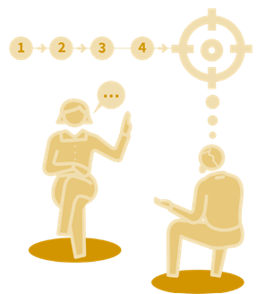
Teaching Assistants
The SEND managers, line manage the teaching assistants. The Headteacher, Deputy Headteacher and Assistant Headteacher are responsible for the CPD and deployment of Teaching Assistants. For lessons in which TAs support, they will have access to medium term plans and lesson content in advance to prepare for their role in the classroom. SLT will decide if Teaching assistants have specialisms where they will be best situated to a class or individual.

Scaffolding

Teachers always consider scaffolding work so that it is desirably difficult for all students³². They provide scaffolds for the remaining pupils to reach the same standard, albeit with more help, guidance and time.
Setting the most ambitious goals for all pupils and providing scaffolds, raises the attainment and expectations of the whole class³³.

Scaffolding in Practice
Following the first two stages of an I Do, We Do, You Do activity, the teacher now provides all pupils with a writing frame, expecting all pupils to complete an independent answer. More able pupils can work through their answer at a faster pace and complete the entire extract, whereas others complete the same work, but do not get quite so far.
Further Guidance – WalkThrus Volume 2: Page 68

Adapt is a term often used to describe the way in which work is changed to suit different pupils. This can lead to the idea that pupils should be given different work, which creates an additional workload and limits pupil progress.
Resources
Teachers at Sheridan School always consider the use of adapted resources such as PowerPoints that are dyslexia-friendly backgrounds, exercise books have cream paper and other resources such as over lays are used within the classroom. The use of worksheets is kept to a minimum, where possible.

³⁰EEF. (2019). Special Educational Needs in Mainstream Schools: Guidance Report. London: EEF. ³¹Rowland, M. (2021). Addressing Educational Disadvantage. Woodbridge: John Catt. ³²Myatt, M. (2016). High Challenge, Low Threat. John Catt: Woodbridge. ³³Sherrington, T. (2019). Rosenshine’s Principles in Action. John Catt: Woodbridge.
Literacy
All pupils benefit from explicit literacy instruction, both within lessons and through bespoke interventions³⁶.

At Sheridan School, all teachers must explicitly teach subject specific (tier 3) vocabulary, which are specifically linked to the curriculum and listed in medium- and long-term plans.
Teachers pre-teach keywords by explaining their meaning and use through many strategies including the Frayer model³⁷. Including keywords throughout the lesson and in pupils’ written work enables them to unlock the curriculum³⁸.

Teachers always consider the reading ages of their pupils, which are collected and disseminated three times per year. For example, teachers may simplify text for it to become more accessible for pupils.

Tiered Vocabulary in Focus
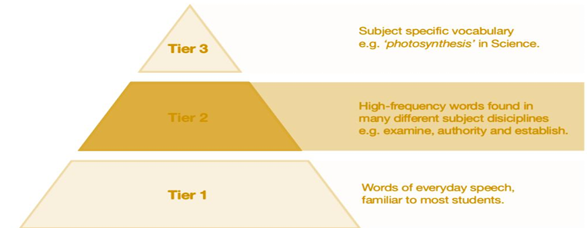

Teachers should prioritise teaching Tier 2 and 3 vocabularies, which pupils are unlikely to encounter in everyday speech.
It is easy to think that literacy teaching is the sole responsibility of an English department, but this isn’t true. Pupils learn best when every teacher seeks to unlock the curriculum by teaching vocabulary, whichever subject they teach³⁹.

³⁶Murphy, D. & Murphy, J. (2018). Thinking Reading. John Catt: Woodbridge. ³⁷Quigley, A. (2018). Closing the Vocabulary Gap. Routledge: Oxon. ³⁸EEF. (2018). Improving Literacy in Secondary Schools. EEF: London. ³⁹Mortimore, K. (2020). Disciplinary Literacy. John Catt: Woodbridge.
Assessment

All students benefit from regular and meaningful summative assessments to help them to achieve their full potential⁴⁰.
At Sheridan School, teachers always consider assessment information to address gaps in pupils’ knowledge, skills and understanding.
Pupils are supported to develop the resilience and stamina needed for external, end-of-course examinations.

Assessment at Sheridan School focuses on the premises that we don’t over assess and not for the sake of it. Assessment at Sheridan school is considered carefully and completed to inform teachers and pupils of where their starting point and currently working. At Sheridan school we follow the six principles inspired by Dylan William. These are:
Learning intentions and success criteria
Eliciting evidence of learning
Feedback for forward progress
Students’ involvement in the assessment process
Adaptability and responsiveness
Building a culture of continuous improvement


End of Unit and End of Term Assessments
Curriculum leaders carefully plan and sequence End of Unit and End of Term Assessment points which are clearly mapped on curriculum statements. Teachers are clear on when assessments will take place and the curriculum content to be included.
At Sheridan school, Curriculum Leaders and teachers can understand which parts of the curriculum need to be revisited or retaught, identify which students need additional support and improve practice across their team. Data drops are provided three times a year.


Setting by Year groups
Throughout the school all pupils are grouped according to their age which determines the year group they are in. Baseline assessments are completed when students start at the school with assessments continuing throughout the school year.
At KS4, students continue in their year groups but are grouped within this to determine whether a student continues to GCSE or moves to a Functional Skills qualification for Mathematics, English or Science.

⁴⁰Chiles, M. (2020). The Craft of Assessment. John Catt: Woodbridge.

Feedback

All students benefit from timely and purposeful formative feedback in every lesson⁴¹.
At Sheridan School teachers adhere to the assessment procedure, which outlines exactly how formative feedback, including written feedback and verbal, looks in their subject. Pupils need feedback to learn, but that doesn’t always mean this has to be written. Written feedback tends to have a low impact: time ratio – time – consuming for the teacher, with little effect on students learning. Verbal, interactive feedback is often more useful for students and more time-efficient for teachers. (The Teaching Delusion 2, Bruce Robertson)
Departmental feedback policies include strategies such as mini-whiteboards, targeted questioning, as well as self and peer assessment supported by clear success criteria.
At Sheridan School teachers follow the Six Principles inspired by John Hattie and Grant Wiggins. This identifies the following:
- Objectives
- Constructive
- Actionable
- Optimal timing
- Transfer
- Ongoing


Subject curriculums clarify when End of Unit Assessments happen, the frequency of written feedback and the form it takes. Teachers act immediately through responsive and adaptive teaching within every lesson to address expectations in response to these assessments.

Departments
To help ensure that misconceptions are addressed, whole class feedback must follow key summative assessments following this feedback cycle:

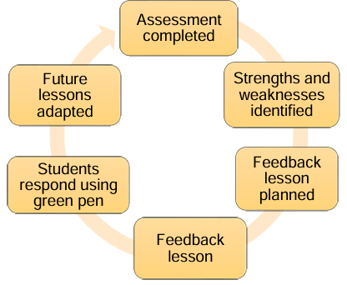

purple

Peer and Self-Assessment
Students peer and self-assess their work in purple pen. Peer and self-assessment must be evident in students’ books.

⁴¹Jones, K. (2021). Five Formative Assessment Strategies in Action. John Catt: Woodbridge.
Behaviour for Learning
All students at Sheridan School benefit from safe and secure classroom environments, free from disruptions and distractions⁴³.
At Sheridan School, teachers must model excellent preparation for learning by ensuring their classroom is organised for the effective delivery of lessons. This includes desks, walls and storage spaces that are clutter and distraction free.
The reward system (Sheridan pod)
Student’s behaviour and lesson engagement is tracked during their lessons throughout the school day, to include unstructured times such as break and lunch time. Points can be earned for following the five school rules (linked to SCARF) and working towards their three individual education plan targets. Rewards are open to all and are not exclusive, however, they must be earned and not used to appease students or situations. Sheridan School uses rewards to encourage the frequency of positive behaviours to increase self-esteem and ingrain behaviour that will improve students’ experiences at Sheridan School and enabling them to fully engage with their learning and therefore make progress. Teachers are expected to congratulate and praise students as required and follow the rewards system with their individual classes.

The Thrive Approach
At Sheridan School we understand that all behaviour is a means of communication and signifies an unmet need. The Thrive Approach is a dynamic, trauma-informed approach designed to meet the emotional and social needs of all children and young people.
The Thrive approach allows us to support all our students, many of which have experienced early childhood trauma, to build relationship connections and positive experiences, learning to regulate emotions and build resilience.
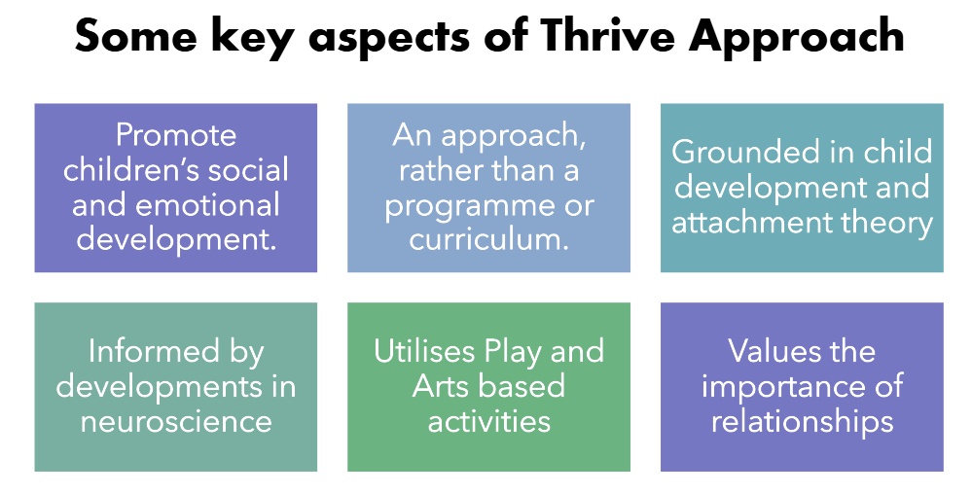

We recognise that for our pupils to achieve academic success they first need to be ready to learn. We use the Thrive approach to direct how to be with our students to manage relationships effectively and thoughtfully, planning for next steps and being pro-active in our approach.

Engage: Starting a lesson
The engage section listed earlier in this procedure provides an overarching view of this phase. The table listed below provides more detail about the actions completed by teachers and students which encourage positive behaviour for learning.
Teacher | Students
The teacher is present at the door to greet the pupils. | Students enter the classroom calmly and take their seats ready to learn.
The teacher ensures all students are properly equipped. | Students have their own pencil cases on their desks.
The teacher will hand out the exercise books and makes sure the date and learning objective is on the board. | Once students have their books they copy down the date and learning objective.
The teacher will have displayed on the board a starter activity. | Students are encouraged once the date and learning objective has been written they move onto the starter activity.

Ending a lesson
At Sheridan School, every minute counts and lessons are never concluded early. The final minutes of a lesson are to sum up the learning that has taken place and last two minutes are spent giving pupils their reward points for the lesson.
Teacher | Student
The teacher will indicate to the students the end of the lesson. | The students finish the task they are completing.
The teacher instructs the pupils to close their books. | Students will close their books and wait.
The teacher will verbally give the students their reward points | The students listen and understand why they have achieved the points given.

Whether it the teacher or LSA to leave the classroom they lock the door unless another staff member enters to teach the next lesson. It is essential safeguarding never to leave an unsupervised room unsecured.

⁴³Bennett, T. (2020). Running the Room. Woodbridge: John Catt.
Presentations Expectations
All students benefit from teachers’ high expectations of the pride and care students are expected to take in the quality of their books.

At Sheridan School, teachers must reinforce high presentation standards in students’ books. Students are expected to take pride and care in the presentation of their work and teachers must pick up any issues as they arise.
Students always write in their neatest handwriting using a black or blue pen. Self or peer assessment is in purple pen, whilst teacher marking is written in green pan. Drawings and graphs are completed in pencil. Mistakes are crossed out using a single line.
The practise of writing on worksheets is kept to a minimum, where possible, so that students can practise writing on the line, supporting hand writing fluency and development.

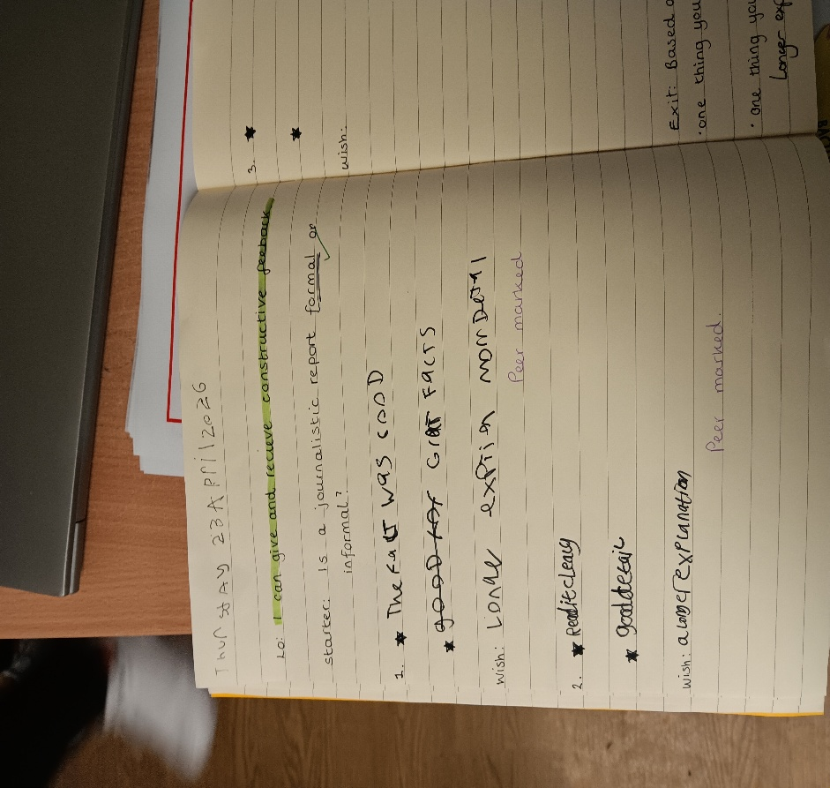
Date is fully written out
Learning Objective copied out

Self and peer assessment written in purple pen

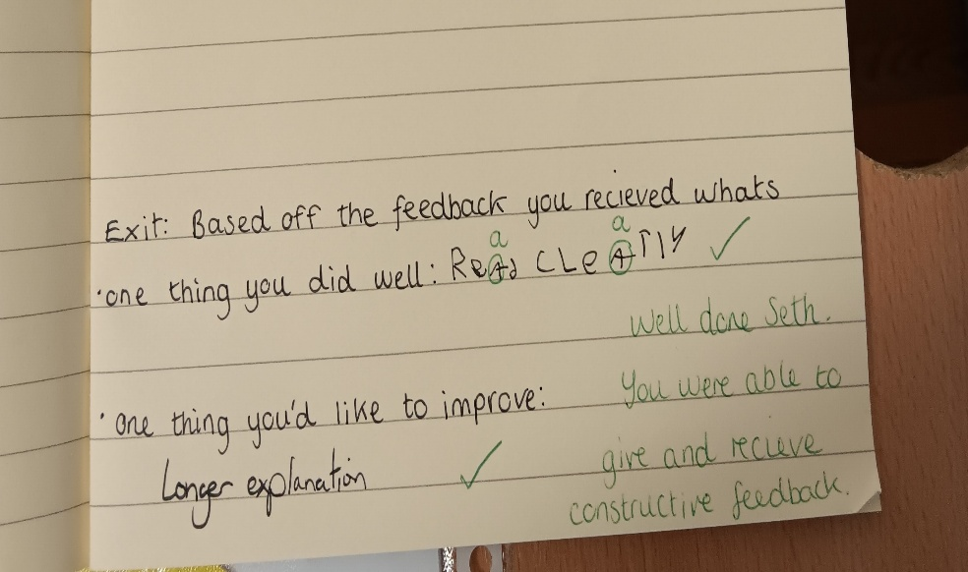

Teacher marking in green pen

Cover work
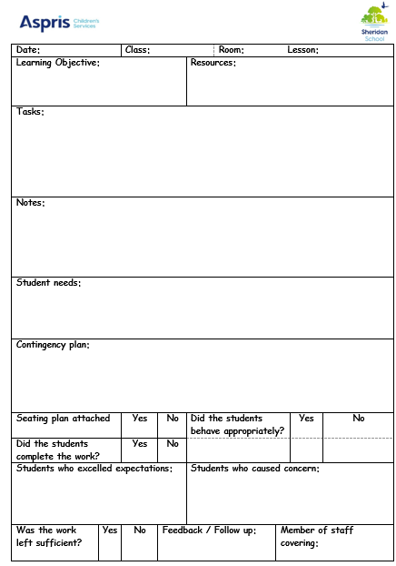
The need for cover arises when a teacher is absent from school or lesson they are timetabled to teach. If a teacher cannot attend school, they will follow the procedure by emailing the Headteacher and Deputy Headteacher with an explanation. The Headteacher or Deputy Headteacher acknowledges this and then a plan is put into place. The next step is for teachers to email work using the cover template document to the Deputy Headteacher for this to be delivered to the class. Long-term/short term absences will be covered using teachers within the school. Careful consideration is given to which member of staff will deliver the lesson along with those teachers who are not teaching.
Care will be taken to ensure that, in any one day, classes do not have a series of lessons delivered by Teaching Assistants. Lessons will be delivered by Qualified teachers or in some instances HLTA’s. Only in the case of an absolute emergency will teaching staff be asked to cover for absent colleagues out of non-contact time and only after all other avenues have been explored. Appropriate work will be set by the teacher. In the case of absence known in advance, this will normally be the teacher of the class unless due to other reasons work will then be given by the Head of Department or another teacher in the same subject. In the case of absences not known in advance, this will normally be the relevant Head of department. The work set will be such that all members of the class in question can undertake it with appropriate supervision and assistance (such as would be expected from an experienced TA) from the person assigned to cover the class and any other persons in support roles who would normally be in attendance (e.g. TA support for SEND students).

CPD

All students benefit from teachers, leaders and support staff who engage in a process of continuous professional learning⁴⁴.
At Sheridan School, teachers always consider the learning points raised and considered in CPD activities. They actively participate in developmental CPD, displaying humility, openness and the highest sense of professionalism by recognising that we can all improve in our practice.

Teachers have regular CPD with multiple strands suited to their needs, e.g. subject specific or a whole school approach. CPD is always evidence-informed, drawing on the latest educational research to ensure that the strategies and approaches promoted have the most significant impact on student attainment. CPD for all staff personal development is conducted through the Steplab, National College or STEPS, whereas company training is delivered through the online portal “Learning Lounge” by completing modules which are regularly updated. Teaching and Learning approaches across the school are delivered face to face by the Headteacher or Assistant Headteacher.
Walkthrus
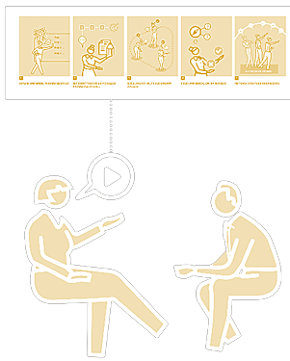
Teachers at Sheridan School always consider guidance offered by Tom Sherrington’s Walkthrus, which is an accessible training resources provided for all the staff. The CPD of directed areas are delivered booklets for all teachers using the Walkthrus books which are situated in the staff work room library and can be accessed via Steplab. Teachers can discuss research, common misconceptions and find solution to challenges based on peer discussion and pedagogical conversation.

STEPLAB
Teachers at Sheridan School also have access to the training and resources through Steplab. This forms the basis of our structured professional development programme through termly target setting, drops ins, shout outs and coaching, delivered by the Senior Lead team and Middle managers. Sharing best practise, exploring pedagogy, working alongside peers and observed implementation ensure teaching remains high quality.

Quality Assurance
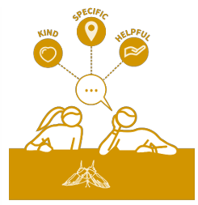
All students benefit from the highest Quality of Education which is consistent across their experience of the day⁴⁶.
Curriculum Leaders uphold and drive the highest standards in the Quality of Education. Regular and ongoing Departmental QA ensure they feel empowered to celebrate their teams’ achievements.
Curriculum Leaders
Our QA model ensures that Curriculum Leaders complete termly pupil progress meetings with Teaching and Learning Lead. These include Learning Walks, Book Looks, Student Voice, Assessment Analysis and Behaviour Analysis.
Support is given to allow Curriculum Leaders to do this effectively. In addition, it is reviewed as part of the Curriculum Review during the whole school QA.
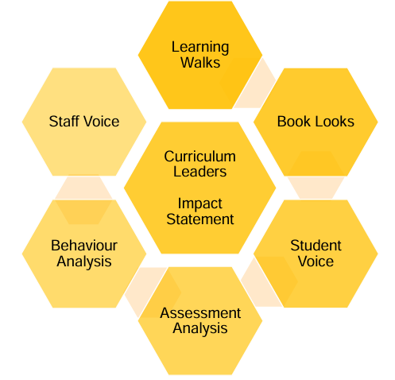

Deep Dives

⁴⁶ Didau, D. (2020). Intelligent Accountability: Creating the Conditions for Teachers to Thrive. Woodbridge: John Catt

