Local Procedure for Governance Monitoring and Reporting
Wales and West England
Policy ACS16
Contents
Vision and Aims 1
Policy Overview – ACS16 V05 (Issued 20/06/2025) 2
Introduction 2
Aims of Governance 2
Group Governance Structure 3
Key Governance Roles, Responsibilities and Processes 3
Regional Director as Chair of Governors 3
Central Services 4
Proprietorial Governance Structure 4
Operational Support Functions and Structure 4
Overview of Local Core Meeting Cycle 5
Local Governance Reporting and Monitoring 5
Other Meetings of Significance 7
Local Meetings 7
Emergency Reporting 8
Central Meetings 8
Education Quality Team 8
Education Quality Team Visits 9
Additional Quality Activities to support Governance 9
School Improvement Partner 9
Termly Governance Dates – 2024/2025 9

Vision and Aims
Our Vision: ‘Supporting each young person to achieve their potential’
Our Belief: When their individual needs are met, we see them shine above all expectations and achieve their aspirations
Our Values: our ‘go forward values’ are: ‘Dedicated, Resilient, Fun & Uplifting, Aspirational and Courageous’
Our Ambition: Rise To Our Best; Reach For Brighter Futures and Act With Care And Compassion

Policy Overview – ACS16 V05 (Issued 20/06/2025)

Introduction
Aspris is committed to providing high-quality provision underpinned by a robust governance framework. We nurture a culture of continuous quality improvement that goes beyond compliance, assurance and innovation to deliver exceptional standards through our Aspris Quality Assurance Standards (AQAS). This framework aspires to achieve outstanding outcomes for pupils and learners in all educational settings, ensuring they reach their full potential.

Schools and colleges are organised into broadly geographical portfolios, each overseen by a Regional Director (RD), who also acts as the Chair of Governors. The Regional Directors are line-managed by the divisional Chief Operating Officer (COO), who reports to the Aspris Group’s Chief Executive Officer (CEO), responsible for the overall management of the Group.

Within the education division, the Quality Team, led by the Head of Quality for Education, is line-managed by the Director of Governance and Risk, who has oversight of both the Education and Care divisions and also reports to the Aspris Group’s CEO.

The following principles underpin our governance framework:
- Governance ensures that the safety of pupils, staff and stakeholders is prioritised in all decision-making.
- Governance supports all aspects of the Education Service Delivery Model and follows a structured framework to ensure systematic assurance over quality.
- Governance provides strategic and operational oversight of a continuous improvement cycle, ensuring schools and colleges achieve GREEN or BLUE AQAS ratings. Where this is not the case, progress from RED to AMBER and AMBER to GREEN is accelerated within expected timeframes.
- Governance aims for excellence, fostering a high-expectations, solution-focused culture.
- Governance is collaborative, purposeful and precise, ensuring effective risk management.
- Governance uses data and intelligence effectively to support accurate, evidence-informed decision-making across schools and colleges.

Aims of Governance
Aspris Governance: ‘Aim to be Perfect’
Aspris Governance is committed to achieving excellence by embedding the following principles
and processes:
- A robust and highly effective safeguarding culture ensures absolute compliance, prioritising the safety and well-being of all pupils.
- Leadership is highly visible, approachable and agile in responding to risk, fostering a culture of continuous improvement aligned with Aspris' core values.
- Leaders demonstrate a comprehensive understanding of statutory responsibilities, including EHCPs/IDP/CSPs, governance, health & safety, performance, safeguarding, and finance.
- Leaders and staff actively engage in research-informed professional learning, driving sustained excellence in teaching, pedagogy, and overall school performance.
- Effective governance underpins the delivery of high-quality education, ensuring accountability and strategic oversight across all stakeholder groups.
- Self-evaluation is rigorous, evidence-informed, and seamlessly integrated into the school/college improvement strategy, setting clear goals for growth and development.
- All necessary documents are easily accessible, providing transparent and compelling evidence of compliance with statutory and regulatory requirements.
- Stakeholder feedback is overwhelmingly positive, with an ambitious goal to exceed 85% satisfaction, reflecting strong engagement and trust in the school.
- Complaints are valued as opportunities for reflection, fostering a culture of continuous learning and improvement.
- There are minimal or no adverse contextual factors impacting the strategic or operational effectiveness of the school, ensuring smooth and efficient leadership.

Group Governance Structure
Executive | Executive Committee Meetings
Divisional | Divisional Performance Reviews  Strategic Operations meetings  Regional Director strategic meetings  Regional Director and Central Service Leads meetings  AQAS review meetings  Head Teacher & Service Leads briefings  Governance and Specialist Areas Committees  Commercial Reviews  Quality Reviews  Group Health and Safety/IPC committee  Safeguarding committee  Policies and Procedures Committee  Task and Finish Groups as appropriate  Enhanced School/College Support  Average Daily Census – ADC  Connections workstream  Insights
Portfolio | Regional Cluster Meetings (aligned to Divisional meeting cycle and determined by the Chair of Governors)
Service | Service SMT Meetings  Governance Meetings  Service Business Reviews  Other Service Operational Meetings

Key Governance Roles, Responsibilities and Processes

Regional Director as Chair of Governors
Operationally, all Aspris schools and colleges are line-managed by a Regional Director (RD) who also acts as a Chair of Governors (CoG). Regional Director (RD) Responsibilities:
- Line-manages and provides operational support and challenge to Head Teachers and College Leads and ensure regional nuances for England, Wales, Scotland and including Colleges are supported through local procedures.
- Holds responsibility as Regional Lead for Safeguarding and must ensure that supervision is provided to all Designated Safeguarding Leads at the schools and colleges within their portfolio.
- Chairs at least three formal governance meetings per year (one per term). Forms ACS Form 16G and ACS Form 16GA must be used and retained as formal governance records for regulatory purposes.
- Reviews the Independent School Standards trackers with Head Teachers and College Leaders termly, ensuring this data informs the AQAS review cycle.
- Undertakes regular visits to all schools and colleges in their cluster, providing challenge and support as appropriate.
- Maintains regular communication with Head Teachers and College Leads, providing specific feedback in a timely manner (verbal and/or written) when requested or as part of an ongoing process (e.g., Head Teacher weekly updates, monthly or termly reports).
- Provides assurance to the C.O.O., Board of Directors, and Head of Quality (Education) regarding operational integrity (e.g., regulatory inspection readiness, compliance, and risk management). The monthly Performance Review process serves as a key mechanism for this.
- Undertakes additional visits to schools and colleges requiring enhanced support (e.g., those designated as Enhanced Support Sites), offering targeted challenge and support.
- Chairs emergency governance meetings when necessary with associated stakeholders.
- Ensures that all schools and colleges in their portfolio meet statutory compliance requirements (Red category in AQAS) relevant to their service type (e.g., Equalities Duty, Independent School Standards, Pupil Premium compliance).
- Provides regular communication and feedback (verbal and/or written) to the C.O.O., Specialist Directors, and Head of Quality (Education) as appropriate.
- Considers and commissions additional support when necessary.
- Works closely with Central Services Teams, commissioning enhanced challenge and support when needed.

Central Services
Aspris has a comprehensive Central Services structure that supports and challenges local governance through specialist teams. These central teams provide frontline services and operational leaders with effective frameworks to ensure high-quality provision, as well as robust monitoring and support networks. The diagram below illustrates the specialist teams within this structure.

Proprietorial Governance Structure

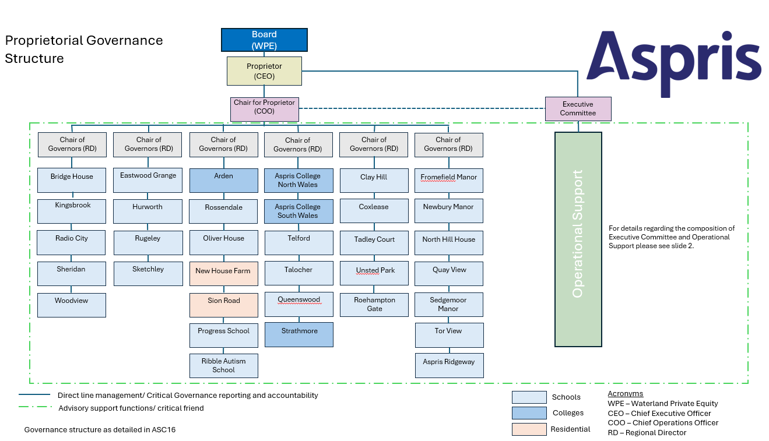

Operational Support Functions and Structure

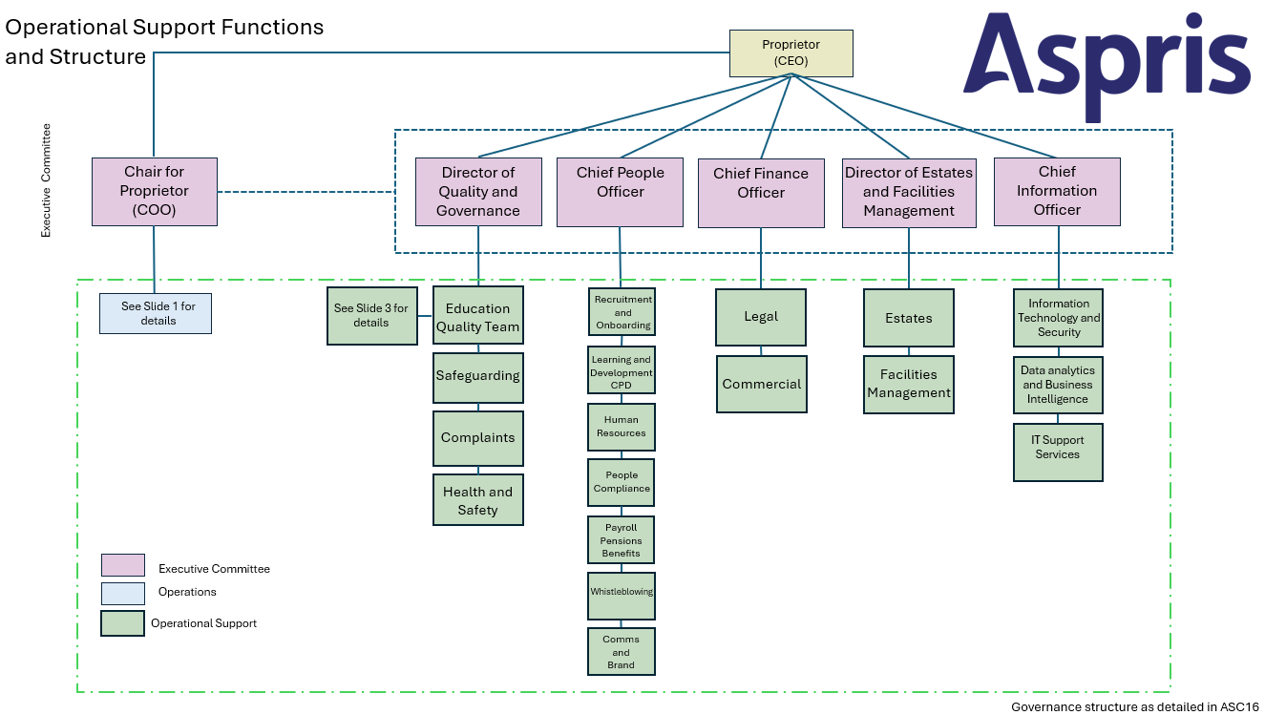

Education Quality Team
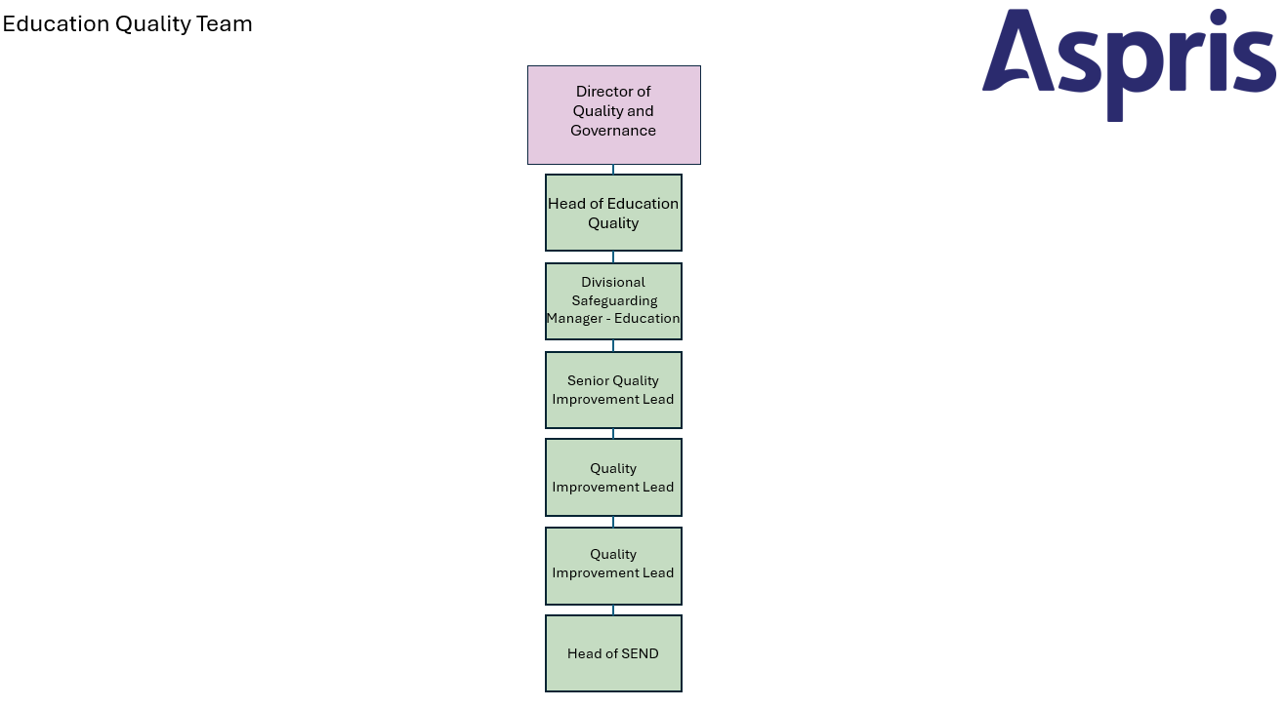

Overview of Local Core Meeting Cycle

Local Governance Reporting and Monitoring
 | Description | Documentation | Staff Responsible | Frequency
SLT / Team Meetings | Each HT or Manager to hold their own meeting with their team.  Informed by Action Plan etc.  Cascade national and local company directives  Drive continuous improvement and quality  Feed into overall portfolio | All local formats for evidence plus:  SDP / SEF – education  Action Plan – SEND  Action Plan – Support Services  Action Plan – Business  Action Plan – ISS  Health Check / Capacity Model  H&S/ Maintenance Team – meet with HT | HT – SLT  Senior admin  SENDCO | Weekly
Cluster Headteacher Meetings | Strategic Operations and Governance overview  Business development and action planning.  Shared strategic agenda to inform site action plan and team meeting agenda.  Informs commercial review, ADC and operational performance | Agenda  Business development plan for the region  Shared central documentation. | Regional Director  Head Teachers  And any other professional invited at the discretion of the RD | Fortnightly
Monthly Report | Overview of all aspects of local site operations including safeguarding.  Highlight issues or blocks for RD attention | Monthly Report Template ASC Form 16GC | HT- SLT  Managers  Extended leadership team in schools to contribute | Monthly
Sub-Governance Meeting | Overview of requirements and updates from central colleagues | Agenda | HT  Central Colleagues | Monthly
Commercial Review | Operations and expenditure; considered against ADC and budget forecast.  Report on monthly spend in line with budget  Informs strategic discussions  Reporting to COO and Finance Director | Commercial Review Proforma.  Insights data | Regional Director presents to Director of Finance/ Head of Finance/ COO  Regional Business Manager  Head Teachers | Monthly
Environmental check | Environmental walk documented.  Issues escalated | ACS Form 16R ENVIRONMENT WALK AROUND template 2022 colleges  H&S > feeds into full annual audit | HTs / Senior Admin / Maintenance Manager | Monthly
Governance Meeting | Strong local model of Governance.  Detailed support and challenge  Regulator evidence  Enviornmental walk documented  QA cycle reviewed and documented  SCR reviewed by RD | ACS16G Termly Governance Report Education  ACS16GA Termly Governance Meeting Notes | Governance Chair: Scott Preston  Head Teacher plus SLT/ ELT as appropriate.  Regional and National Governance members as per organisational structure and dependant on need can include QIL  And any other professional invited at the discretion of the RD | Tri-annually  Report to be received 10 days before schedule date
H&S Committee meeting | Review of H&S audits in align with reporting and monitoring  Academy Compliance | ACS 14 | HT to chair with relevant staff to include:  Senior Admin  H&S Staff  Pupil representative  Note Taker: Senior Admin | Quarterly
Budget Forecast / Banding review Annual | Annual overview.  Projected Income from Fees / ADC growth  Projected spend:  Staffing costs, recruitment in line with ADC growth  Commercial review monitoring  Potential Projects to support ADC  Banding review – all pupils | Aspris Accounts Budget format  Audit of Needs | Regional Director  Regional Business Manager  Aspris Accountants and Finance Team  Head of Finance (Education)  Head Teachers  SEND lead | Annually  Usually in T3
Safeguarding | Creating a culture of Safeguarding, weekly site meetings, reporting, escalations, review, lessons learnt – open and transparent  Regular training / compliance  Audits: Quality team company, commissioner, Governance  Regional sharing of best practice through committee meetings  Robust SCR process embedded. | Safeguarding Policy  KCSIE / KLS  Training Compliance for DSLs / DSPs / all staff | Regional Director – regional safeguarding lead  DSL / DSP  DDSLs / DDSPs  HT  Head of Safeguarding | On demand / built in points for review as part of local process/ Governance checks / proprietorial Governance.  Quarterly Safeguarding committee meetings

Other Meetings of Significance

Local Meetings
Description | Responsibility | Frequency
Operational meetings | RD > COO | Weekly: Mon/Fri
Referrals Meeting | RD / All Site Leads, referrals co-ordinator | Weekly: Mon
Ad-hoc SLT meetings with RD | RD / HTs / SLT | At least once per month
Cluster Strategic Meeting | RD / HTs | Termly ( x 3)
Banding Review | RD, HT, finance team | Annually
Performance Management Reviews | All Line Managers | T1/2 ( target set) T3/4 ( mid-term) T5/6 (Review)
HR Employee Relations | RD / local HR / Senior Admin / HTs/ HRBP / HRA | Weekly: Thurs
Recruitment | RD / Senior Admin / HTs/ Aspris Recruiter | Weekly: Fri
Safeguarding Audit | RD / DSL / DSP / HTs | Annually
ISS Audit | HTs / RD / Quality Team | Annually
Ignite Forum | All staff / Site representative / Site Leads / Senior Admin | Termly
Cluster Ignite Forum | RD / Site Reps | Termly
H&S / Maintenance / HTs – site action review | HTs/ Maintenance Manager | Weekly
H&S Audits | Site Leads / Maintenance Manager / external audit | Bi-annual site visit/ monthly monitoring
Commissioner Quality Assurance visits | Head Teachers / RD | Ad hoc
Enhanced Support Calls | RD, HTs, Quality Team, Proprietorial Governance representives | As identified and scheduled by Qteam

Emergency Reporting
Description | Responsibility | Frequency
Escalation Forms ACS58 V03– significant incident, cause for concern, serious safeguarding risk | HT/ DSL  Head of Safeguarding | As required – to RD – follow local process for incident recording
Notification form – Ofsted / regulator visit | HT | Aspris Governance
Major Incident Contingency Form HS74 Response | HT | Updated as required – review local procedures in accordance with government guidance

Central Meetings
Description | Responsibility | Frequency
Safeguarding support and reflection calls | HT/ DSL / JM | On demand
Head Teacher calls | HT / Head of Quality | Monthly
Quality Team / Safeguarding visits | Head of Quality / Safeguarding KD | On demand
Quality Review | Exec Team – RD supplies slide deck review for region | Monthly
Ex Comm meetings | Executive Committee | Monthly

Education Quality Team
The Education Quality Team sits within the Governance and Risk Team and is overseen by the Director of Governance and Risk (DoG&R). The team consists of a Head of Quality Education (HoQ), one Senior Quality Improvement Lead and one Quality Improvement Lead (QIL). Each Senior QIL or QIL is responsible for a portfolio of settings within their remit. A key role of the team is to ensure impartiality through the assurance processes that are delivered as part of the Education Service Delivery Model.

The purpose of the Education Quality Team is to:
- Improved School and College Ratings: Facilitate the progression of Schools and Colleges from RED to AMBER, AMBER to GREEN and GREEN to BLUE by delivering targeted support and implementing focused quality improvement interventions.
- Enhanced Accountability: Strengthen governance and reporting frameworks to empower Regional Directors and Head Teachers to effectively monitor, evaluate, and enhance performance standards.
- Consistency in Quality: Establish consistent expectations and practices across all Schools and Colleges, ensuring a collective commitment to excellence, aligned with the modalities through the Aspris Quality Assurance Standards (AQAS).
- Ongoing Monitoring and Adaptation: The Aspris Quality Team will conduct regular progress reviews, adjusting strategies based on measurable outcomes and feedback to drive continuous improvement and readiness for the next academic year.
- Achievement of Regulatory Excellence: Schools and Colleges will achieve a ‘good’ or equivalent rating in region-specific regulatory inspections, with an increasing number attaining an ‘outstanding’ rating by prioritising and achieving perfect quality.
- The Education Quality Team aims to work proactively with Regional Directors (RDs) as the Chair of Governors, school and/or college leads and Central teams.

Education Quality Team Visits
The Education Quality Team offers support and a range of support/challenge visits based on the AQAS. The core offer for schools and colleges is:
AQAS | Description | Type of support | Allocation
BLUE | - Exceptional school/college | - Service leader  - Minimal risk  - Below basic core offer | - Up to 1.5 days  - 1 Themed school/college review  - 1 half day follow up
GREEN | - Secure school/college | - Innovation  - Low risk  - Basic core offer | - Up to 3 days  - 1 Full or Themed school/college review  - 1 day follow up
AMBER | - Improving school/college | - Assurance  - Moderate risk  - Above the core offer | - Up to 6 days  - 1 Full school/college review  - 1 Themed school/college review  - 2 half day follow ups  - ESS support if within process
RED | - Concerning school/college | - Compliance  - High risk  - Enhanced School support – significantly above the core offer | - Up to 10 days  - 2 Full school/college review  - 1 themed school/college review  - 5 half day follow ups  - ESS support

Additional Quality Activities to support Governance
In addition to the core offer entitlement visits to a school or college, the Education Quality Team will also undertake some or all of the following activities to support the governance process at all levels as part of its core offer.
Full or Themed school/college review | Support for regulatory inspections | Enhanced School or College Support (ESS) | Head Teacher briefings
Data analysis and intelligence gathering | Reporting Ups support | Research and innovation | SEF/SDP development
Website audits | Investigations | Interviews – HT or RD | Policy development
Coaching and mentoring | Professional learning and development delivered by experts | Complaints | Bespoke support
Safeguarding

School Improvement Partner
To enhance the governance process and strengthen the support and challenge provided by the Education Quality Team, Aspris will commission visits from an external School Improvement Partner (SIP). The Head of Quality (HoQ) serves as the point of contact for engaging the SIP, ensuring alignment with the QA calendar.

Termly Governance Dates – 2025/2026
 | Chair | Autumn Term | Spring Term | Summer Term
ACNW | Scott Preston | 30/09/2025 | 22/01/2026 | 19/05/2026
ACSW | Scott Preston | 30/09/2025 | 22/01/2026 | 19/05/2026
Strathmore | Scott Preston | 30/09/2025 | 22/01/2026 | 19/05/2026
Aspris Telford | Scott Preston | 29/09/2025 | 21/01/2026 | 12/05/2026
Queenswood | Scott Preston | 18/09/2025 | 15/01/2026 | 21/05/2026
Talocher | Scott Preston | 17/09/2025 | 14/01/2026 | 20/05/2026
Aspris Ridgeway | Scott Preston | 15/09/2025 | 12/01/2026 | 18/05/2025

